
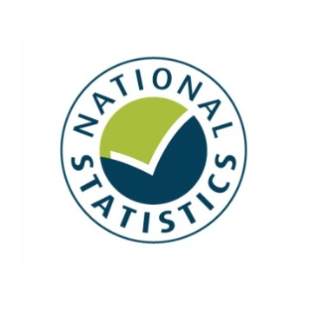

Taking Part 2011/12 Quarter 4
Statistical Release
June 2012






Taking Part is a National Statistic and has been produced to the standards set out in the Code of Practice for Official Statistics
Contents

Introduction 4
Key findings 6
Chapter 1: The 2012 Olympic and Paralympic Games 9
Chapter 2: Sport and active recreation 12
Chapter 3: Heritage 16
Chapter 4: Museums and galleries 19
Chapter 5: Libraries 22
Chapter 6: Arts 24
Chapter 7: Archives 27
Chapter 8: Big Society 29
Annex A: Background note 33
Annex B: Key terms and definitions 35
Annex C: Sector definitions 37

Introduction

This report
This report presents the latest headline results from the Taking Part Survey, incorporating the fourth quarter of fieldwork from the seventh year of the survey and covering the twelve month period from April 2011 to March 2012 (this same period is also referred to as 2011/12 Q4). Where observations are made over time, the latest data are compared with earliest available data (typically 2005/06). Key terms and definitions are provided in Annex B of this release.

The report presents headline findings for the main culture and sport estimates along with updates on data to support the 2012 Olympic and Paralympic Games and Big Society objectives. Where we have extended our analysis to look at digital engagement with our sectors, this is presented alongside the relevant sector figures.

The accompanying spreadsheets to this release are available at: http://www.culture.gov.uk/publications/9135.aspx

This release reports findings for adults only. The next update for child data will be presented in summer 2012 (see below). Taking Part users are encouraged to contribute their views on the content of this release and areas of interest for analysis to the Taking Part team at DCMS: TakingPart@culture.gsi.gov.uk .

The next Taking Part User Event will be held post-Olympic and Paralympics. Details will be sent to users in advance. Material from previous events are available on our site at: http://www.culture.gov.uk/what_we_do/research_and_statistics/7394.aspx

The Taking Part Survey
The Taking Part Survey is commissioned by the Department for Culture, Media and Sport (DCMS) in partnership with a number of our arm’s length bodies. At present, these are Arts Council England, English Heritage, and Sport England.

Taking Part is a continuous face-to-face survey with adults aged 16 and over living in private households in England. It is conducted on behalf of DCMS by TNS-BMRB. The survey has run since mid-July 2005. A child interview was added to the survey in January 2006, interviewing a randomly selected child in those households containing at least one child aged 11-15. This is also a continuous face-to-face survey. In 2008/09, the child survey was broadened to include children aged 5-10. Interviews with children aged 11-15 are carried out directly, for those aged 5-10 an interview is conducted with the adult respondent.

The survey provides a wide range of data about engagement and non-engagement in culture, leisure and sport as well as more diverse measures that support a range of Government objectives. Taking Part is the key evidence source for DCMS, providing reliable national estimates of participation and supporting the Department’s aim of improving the quality of life for everyone by providing people with the chance to get involved in a variety of these opportunities. The survey also aims to support the DCMS Structural Reform Priorities and Business Plan through the provision of data for DCMS input and impact indicators and the broader information strategy. The latest DCMS indicators are available at: http://www.culture.gov.uk/about_us/8192.aspx

The Taking Part Survey contributes to the evidence base across a wide range of topics including satisfaction and enjoyment of culture and sport, social capital, volunteering and barriers to participation. It also collects an in-depth range of socio-demographic information on respondents. A wider range of measures are included in the spreadsheets accompanying this release, while analysis of 2005/06 to 2010/11 adult data can be conducted through NetQuest, our on-line analytical tool:
http://www.culture.gov.uk/what_we_do/research_and_statistics/6762.aspx

Forthcoming releases
The next release, scheduled for mid-late August 2012, will present the annual estimates for year 7 (2011/12) for adult and children.

Future releases will follow a similar schedule, being released ahead of the Quarterly Data Summaries that will be produced by all departments. Taking Part forms part of the wider DCMS data strategy as well as supporting its impact and input indicators. Details of these are available at: http://www.culture.gov.uk/about_us/8192.aspx.

In addition, topic specific analysis will now be published throughout the year, looking in depth at particular areas of the survey. The first of these reports on the Big Society was published in November 2011 and can be found at: http://www.culture.gov.uk/publications/8612.aspx.

If you would like further information on these releases or the Taking Part Survey, please contact the Taking Part team on TakingPart@culture.gsi.gov.uk. Additional contact details are contained within Annex A.

Consultation
DCMS and Sports England are currently consulting with users and other interested parties on proposals to integrate the Taking Part and Active People surveys to change the way sport is measured. The consultation closes on 7th August 2012, and further information is available at http://www.culture.gov.uk/consultations/9062.aspx.

Key findings

2012 Olympic and Paralympic Games
- 85.6 per cent of adults intend to follow the London 2012 Olympic or Paralympic Games; with 24.4 per cent of adults actively getting involved in the Games.

- Almost two thirds (62.9%) of adults are slightly or strongly supportive of the 2012 Olympic and Paralympic Games, a significant decrease from 66.3 per cent in 2010/11 and 71.0 per cent in 2005/06.

- A significantly higher proportion of BME participants compared to participants with a white background, said they were motivated to do more sport, voluntary work or cultural activities as a result of the UK winning the bid to host the 2012 Olympics.

Sport and active recreation
- 43.8 per cent of adults participated in at least one session of 30 minutes of moderate intensity sport in the last week (1x30 MIS measure).

- Since 2005/06, participation of adults in at least one session of 30 minutes of moderate intensity sport in the last week (1x30 MIS measure) has increased significantly overall for all adults and for the following age bands:
  - 25-44 year olds
  - 45-64 year olds
  - Age 75+

- But there has been no change since 2005/06 on the 1x30 MIS measure for participation of 16-24 year olds, currently 55.9 per cent.

- 25.9 per cent of adults participated in at least three sessions of 30 minutes of moderate intensity sport in the last week (3x30 MIS measure).

- 55.2 per cent of adults participated in active sport at least once in the last 4 weeks.

Culture
- In April 2011 to March 2012, 74.3 per cent of adults reported having visited a heritage site in the last year. This is the highest proportion of adults visiting since the survey began in 2005/06 and a significant increase (3.6 percentage points) over the past year.

- 30.4 per cent of adults report visiting a heritage site at least three or four times a year, a significant increase since 2005/06.

- The top two socio-demographic groups which experienced significant increases between 2005/06 and April 2011 and March 2012 were:
  - Black or ethnic minority (an increase of 10.7 percentage points to 61.4%)
  - Social rented sector (an increase of 9.2 percentage points to 55.6%)

- Between 2005/06 and April 2011 to March 2012, the proportion of people visiting a museum or gallery in the last year significantly increased (from 42.3% to 48.9%). There has also been a significant increase over the past year of 2.6 percentage points (from 46.3% to 48.9%).

- In 2011/12 Q4, 78.2 per cent of adults had engaged in the arts in the last year, a significant increase reported since 2005/06 (76.3%).

- 38.8 per cent of adults had used a library in the last 12 months, a significant decrease from 48.2 per cent in 2005/06, but showing little change from 2009/10.

- In 2011/12 Q4, the proportion of adults visiting an archive (in their own time and voluntarily) in the last year remained steady at 3.6 per cent from the 2008/09 level.

Big Society
- In April 2011 to March 2012, the proportion of adults volunteering in the last 12 months was 23.3 per cent. 7.1 per cent of all adults had volunteered in any DCMS sector. Of those who volunteered, 8.9 per cent had done so in the arts sector which is a significant increase from 2005/06 (6.3 per cent).

- There was a significant increase in the proportion of black and ethnic minority (BME) groups who had volunteered in the last 12 months compared to 2005/06 (up from 19.6% to 24.3%).

- In 2011/12 Q4 89.7 per cent of adults had donated money (including any donations into a collection box) in the last 12 months. 25.6 per cent of all adults had donated to one of the DCMS sectors, a significant decrease to the 33.0% of adults who had donated money to a DCMS sector in 2010/11.

Digital engagement
- In 2011/12 Q4, 16.2 per cent of adults had visited a library website in the last 12 months, a significant increase from 8.9 per cent in 2005/06.

- Since 2005/06, the proportion of people visiting heritage websites has significantly increased from 18.3 per cent to 28.6 per cent.

- In April 2011 to March 2012, 26.2 per cent of adults had visited a museum or gallery website, a significant increase from 15.8 per cent in 2005/06.

- In April 2011 to March 2012, 32.2 per cent of adults had visited a theatre or concert website, a significant increase from 30.5 per cent in 2005/06.

- A higher proportion of adults visited an archive or records office online (11.6%) than in person (3.6%).

- 37.6 per cent of adults had visited sports websites in the last 12 months, which is significantly higher than 26.1 per cent of adults in 2005/06.

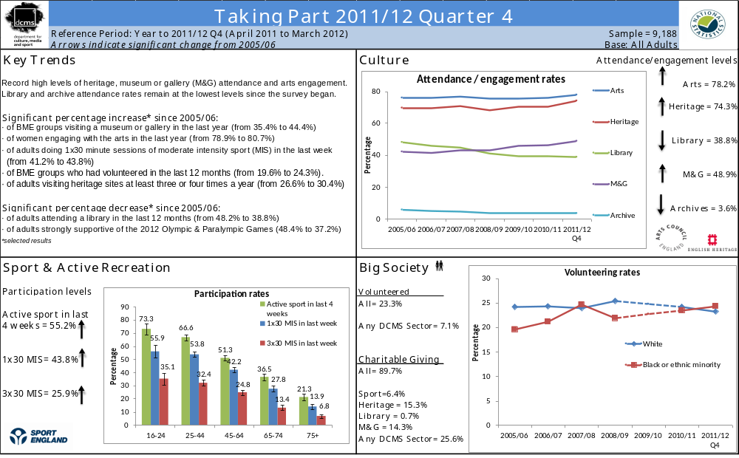
- The 2012 Olympic and Paralympic Games

This chapter explores a number of areas related to the UK hosting the 2012 Olympic and Paralympic Games, including the extent to which people in England support hosting the Games, how people intend to get involved in the Games and whether the Games has motivated people to participate in voluntary work, cultural activities or sport or recreational activities.

Key findings

    - 85.6 per cent of adults intend to follow the London 2012 Olympic or Paralympic Games; with 24.4 per cent of adults actively getting involved in the Games.
    - Almost two thirds (62.9%) of adults are slightly or strongly supportive of the 2012 Olympic and Paralympic Games. Although attitudes towards the Games have fluctuated over the period since 2005/06.
    - In 2011/12 Q4, 7.3 per cent of adults reported that the UK winning the bid had motivated them to do more sport or recreational physical activity, 3.8 per cent reported that they were motivated to do more cultural activities and 6.0 per cent reported that they were motivated to do more voluntary work.

    - A significantly higher proportion of BME participants compared to participants with a white background, said they were motivated to do more sport, voluntary work or cultural activities as a result of the UK winning the bid to host the 2012 Olympics.

The 2012 Olympic and Paralympic Games

Between July 2011 and March 2012 the Taking Part Survey asked some new questions on adults’ intended involvement in the Games. 85.6 per cent of adults intend to follow the London 2012 Olympic or Paralympic Games, either by watching on TV at home (81.4%), reading about it on a newspaper online or offline (32.1%), listening to it on the radio at home (15.6%), watching or listening on the internet at home (13.2%) or watching live events on a public big screen (12.4%).

Additionally, since July 2011 we asked adults whether they intend to actively follow or get involved in the London 2012 Olympic or Paralympic Games. 24.4 per cent of adults said they did, which includes attending a free (8.7%) or ticketed (7.9%) Olympic or Paralympic event, taking part in a Games related community event or activity, e.g. street party or local Inspire Mark project (3.6%), or using a new or improved sports facility linked to the Games (2.5%). Other active involvements include gaining Games related employment or training (1.9%), taking part in a Games related cultural event or activity (1.7%) volunteering during the Games, e.g. as a Gamesmaker or London Ambassador (1.7%), or taking part in a Games related sport or physical activity (1.0%).

Attitudes towards the Games have fluctuated over the period since 2005/06.
- In 2011/12 Q4, 62.9 per cent of adults were supportive of the 2012 Games, reporting that they were slightly or strongly supportive. This is a significant decrease from 2005/06 when 71.0 per cent reported that they were supportive and from 2010/11 where 66.3 per cent reported they were supportive.
- The proportion of those who are strongly supportive has fallen from 48.4 per cent in 2005/06 to 37.2 per cent in the latest results.
- The proportion who are slightly supportive of the Games has however increased from 22.5 per cent to 25.7 per cent since 2005/06. There has also been a significant increase from 2010/11 where 23.8 per cent of adults were slightly supportive of the games.
- The proportion who are neither against nor supportive of the Games has increased from 18.4 per cent to 25.8 per cent, as well as those slightly against the Games (from 4.7% to 5.5%) over the same period. Adults strongly against the 2012 Games remain stable at approximately 5.2 per cent (Figure 1.1).

London won the bid to host the Olympic and Paralympic games on the 6th July 2005. The Games will be staged in July and August 2012. These figures represent continuing strong support for the Games, however the fall in the proportion of people strongly supportive of the Games since 2005/06 might be due to a number of factors. These may include where we are in the cycle between announcement/anticipation of the games and delivery/staging. The change in economic climate since 2005 may also have affected people’s attitudes.

Figure 1.1: Adult’s opinion about the UK hosting the 2012 Olympic Games, 2005/06 to April 2011 – March 2012

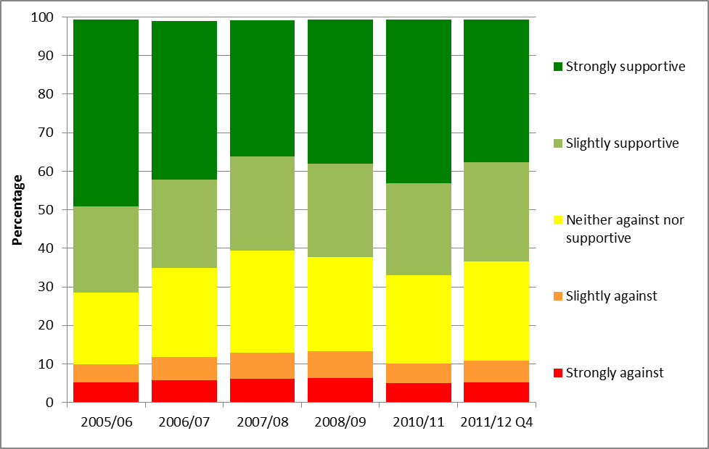
Notes
(1) Confidence intervals range between +/-0.4 and +/-1.2 from 2005/06 onwards.
(2) This question was not asked in 2009/10

A higher proportion of adults from a black and minority ethnic (BME) background were supportive of the Games than those with a white background (73.9% and 61.9% respectively). A significantly higher proportion of men were supportive of the Games than women (64.5% and 62.0% respectively) and those aged 25-44 years old were the most supportive age group (67.1%). The least supportive age group was those aged 75+ with 53.8 per cent being supportive of the Games.
A significantly higher proportion of BME participants compared to participants with a white background, said they were motivated to do more sport, voluntary work or cultural activities as a result of the UK winning the bid to host the 2012 Olympics. In 2011/12 Q4, 22.7 per cent of BME sport participants compared to 5.4 per cent of sport participants with a white background were motivated to do more sport or recreational physical activity. 20.8 per cent of BME volunteers compared to 4.1 per cent of volunteers with a white background were motivated to do more voluntary work, and 11.9 per cent of BME cultural participants compared to 2.8 per cent of cultural participants with a white background were motivated to do more cultural activities.

UK Government policy is to make use of the inspirational power of the Games and its ability to engage people from all backgrounds to increase participation across sport, volunteering and increase cultural engagement. For example, launched in 2008, the Cultural Olympiad is a four year programme of cultural activity. It includes national and local projects as part of a UK-wide Cultural Festival.

London is now the region with the highest level of support (68.5 per cent) while those in the North East are least supportive (56.5%). However, the levels of support within London vary, and between July 2005 and March 2012, 73.6 per cent of respondents in Waltham Forest (a host borough) were supportive of the Games, compared to 56.0 per cent of respondents in Bexley (Figure 1.2).

Figure 1.2: Proportion of adults who are slightly or strongly supportive of the UK hosting the 2012 Olympic Games, London, July 2005 to March 2012
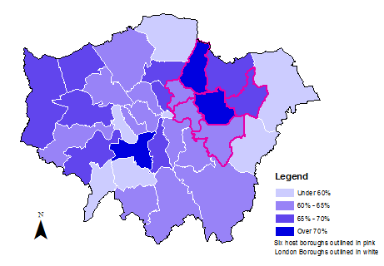

Notes
- Results for the City of London are indicative due to a small sample size.
- Sample sizes vary by London Borough (excluding City of London) from 180 to 746.

Further detail on this section can be found in the accompanying spreadsheets to this release available at: http://www.culture.gov.uk/publications/9135.aspx
- Sport and active recreation

This chapter examines sport and active recreation by a range of area-level and socio-demographic breakdowns. Key findings on swimming and cycling proficiency – that is the extent to which adults feel able to swim and cycle – are provided. Details on digital engagement as measured by visiting sports websites are also given.

Key findings

Latest results (April 2011 to March 2012) show:
- 43.8 per cent of adults participated in at least one session of 30 minutes of moderate intensity sport in the last week (1x30 MIS measure).

- Since 2005/06, participation of adults in at least one session of 30 minutes of moderate intensity sport in the last week (1x30 MIS measure) has increased significantly overall for all adults and for the following age bands:
  - 25-44 year olds
  - 45-64 year olds
  - Age 75+

- But there has been no change since 2005/06 using this measure for participation of 16-24 year olds, currently 55.9 per cent.

- 25.9 per cent of adults participated in at least three sessions of 30 minutes of moderate intensity sport in the last week (3x30 MIS measure).

- 55.2 per cent of adults participated in active sport at least once in the last 4 weeks.

Participation in sport or recreational physical activities

In April 2011 to March 2012:
- 43.8 per cent had participated in at least one session of 30 minutes of moderate intensity sport in the last week, a significant increase from 2005/06 (41.2%).
- 25.9 per cent of adults had participated in at least three sessions of 30 minutes of moderate intensity sport in the last week, an increase from 2005/06 (23.2%).
- 55.2 per cent of adults participated in active sport at least once in the last 4 weeks, an increase since 2005/06 (53.7%). (Figure 2.1).

When we look at the frequency of 30 minutes or more of moderate intensity sport undertaken in the last 4 weeks, during 2005/06 and April 2011 to March 2012:
- The percentage who did not participate at all decreased from 9.8 per cent to 9.2 per cent
At the other end of the activity spectrum:
- the percentage participating at least three times a week but not every day increased from 14.3 per cent to 15.6 per cent
- The percentage participating every day increased from 8.9 per cent to 10.3 per cent

Figure 2.1: Percentage of adults who have participated in sports, 2005/06 to April 2011 - March 2012

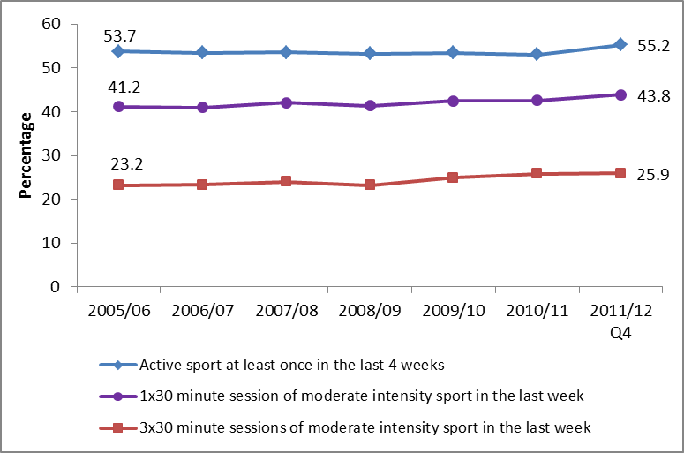

Notes
(1) Confidence intervals range between +/-0.6 and +/-1.9 from 2005/06 onwards.

Using analysis by the ACORN classification, in general, people who live in less deprived neighbourhoods are more likely than those who live in more deprived neighbourhoods to participate in sport. This pattern has not changed since 2009/10.

Rates of sports participation (active sport at least once in the last 4 weeks) have remained fairly steady across most socio-demographic groups (apart from age) since 2005/06, but there have been changes in rates for:

- People not working which increased (from 38.6% to 42.0%)
- Those in the social rented sector which increased (from 38.9% to 42.9%)
- Those with no religion which increased (from 61.5% to 65.2%)
- Those with no disability which increased (from 60.4% to 62.5%)

Since 2005/06, participation of adults in at least one session of 30 minutes of moderate intensity sport in the last week (1x30 MIS measure) has increased significantly for all adults and for the following age bands:

- 25-44 year olds (from 50.0% to 53.8%)
- 45-64 year olds (from 36.8% to 42.2%)
- Age 75+ (from 11.3% to 13.9%)
- All adults 16+ (from 41.2% to 43.8%)

Similarly since 2005/06, participation of adults in at least three sessions of 30 minutes of moderate intensity sport in the last week (3x30 MIS measure) has increased significantly for all adults and for the following age bands:

- 25-44 year olds (from 28.6% to 32.4%)
- 45-64 year olds (from 20.1% to 24.8%)
- All adults 16+ (from 23.2% to 25.9%)

However, for 16-24 year olds, on both the 1x30 MIS measure (55.9%) and the 3x30 MIS measure (35.1%) there has been no change in participtaion since 2005/06. Older age groups have lower sport participation rates (Figure 2.2).

Current UK Government policy is to focus on promoting sport for the 14-25 year old age group. This is outlined further in “Creating a sporting habit for life - A new youth sport strategy” launched in January 2012. DCMS is currently consulting on adapting sports measurement to be able to track this category consistently.

Figure 2.2: Percentage of adults who have participated in sports by age group, April 2011 to March 2012

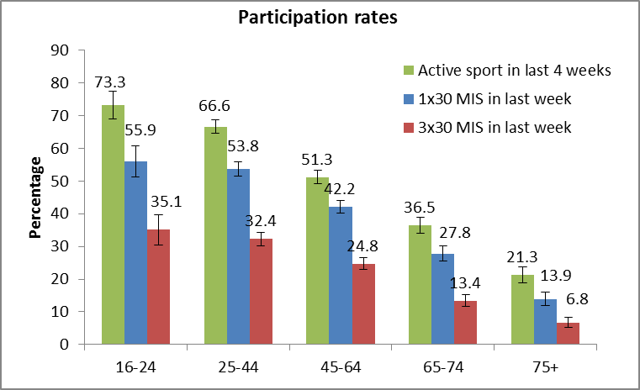
Notes
(1) Confidence intervals range between +/-1.1 and +/-4.7.

During the same period, there was also a significant increase in participation rates in the 1x30 MIS measure for men (from 46.0% to 49.8%), and also significant increases in participation rates in the 3x30 MIS measure for both men (from 26.8% to 30.5%) and women (from 19.7% to 21.5%).

Digital engagement

37.6 per cent of adults had visited sports websites in the last 12 months, which is significantly higher than 26.1 per cent of adults in 2005/06. The proportion of adults visiting a sports website in 2011/12 Q4 is the highest level reported since 2005/06.
It is UK policy to provide the public with access to information on how and where to participate in sport. It is intended that initiatives such as Sport England’s Active Places database and developments which join data across providers will provide a ‘digital legacy’ after the Olympic and Paralympic games.

Further detail on this section can be found in the accompanying spreadsheets to this release available at: http://www.culture.gov.uk/publications/9135.aspx

Cycling and swimming proficiency

- In 2011/12 Q4, 82.8 per cent of adults stated that they could swim and 86.4 per cent stated that they could cycle.
- Despite swimming being among the most popular sports for women, a higher proportion of men (87.2%) say that they can swim compared to women (78.7%). Also a higher proportion of men to women say that they can cycle (92.9% compared with 80.2%).
- A higher proportion of people from white backgrounds say that they can swim than BME groups (84.8% compared with 68.3%) and say they can cycle (87.6% compared with 77.0%).
- Like sports participation generally, swimming and cycling proficiency is also linked with the type of area people live in, with a higher proportion of people who live in the least deprived neighbourhoods saying that they can swim and cycle. It is also linked with age, with the percentage of adults saying they can swim or cycle decreasing with age.

Further detail on this section can be found in the accompanying spreadsheets to this release available at: http://www.culture.gov.uk/publications/9135.aspx
- Heritage

The survey measures adult participation in heritage by attendance at a heritage site in the 12 months prior to interview and the frequency with which they attend these types of sites. Details on the ways that people digitally engage with heritage are also given.

Key findings

- In April 2011 to March 2012, 74.3 per cent of adults reported having visited a heritage site in the last year.

- This is the highest proportion of adults visiting since the survey began in 2005/06 and a significant increase (3.6 percentage points) over the past year.

- 30.4 per cent of adults report visiting a heritage site at least three or four times a year, a significant increase since 2005/06.

- There have been significant increases since 2005/6 in the proportion of people who have visited a heritage site over the past year across all ages and socio-demographic groups.

Heritage attendance

The latest results show 74.3 per cent of adults reported visiting a heritage site in the last 12 months. This is a significant increase from 70.7 per cent in 2010/11 and from 69.9 per cent in 2005/06.

Looking at adults by how often they visit heritage sites, the group which has had the largest significant increase is
- Adults who visit a heritage site at least three or four times a year (30.4%, an increase of 3.8 percentage points from 2005/06).

The top five socio-demographic groups which experienced significant increases between 2005/06 and April 2011 and March 2012 were:
- Black or ethnic minority (an increase of 10.7 percentage points to 61.4%)
- Social rented sector (an increase of 9.2 percentage points to 55.6%)
- Other religion (non-Christian) (an increase of 9.0 percentage points to 58.7%)
- Lower socio-economic group (an increase of 6.1 percentage points to 63.2%)
- Aged 75+ (an increase of 6.1 percentage points to 58.2%)

The heritage sector has a policy to make investments in its facilities with the aim of encouraging visitor numbers. For example, the National Trust opening Tyntesfield to the public or English Heritage's improvements to the Elizabethan gardens at Kenilworth castle. The economic conditions since 2005/06 have contributed to the ‘staycation’ trend for domestic trips and holidays, which is likely to have increased heritage attendance.

Figure 3.1 shows the proportion of adults attending heritage sites over time by region.

Between 2005/06 and April 2011 to March 2012, heritage attendance increased significantly in six of the nine English regions (see figure 3.1).
- Yorkshire and The Humber (6.6 percentage points to 74.8%)
- North East (6.3 percentage points to 75.4%)
- West Midlands (5.9 percentage points to 71.7%)
- East of England (5.6 percentage points to 78.1%)
- London (4.9 percentage points to 68.6%)
- South East (4.1 percentage points to 80.3%)

Figure 3.1: Proportion who have visited a heritage site in the last year, 2005/06 to April 2011 to March 2012
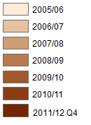
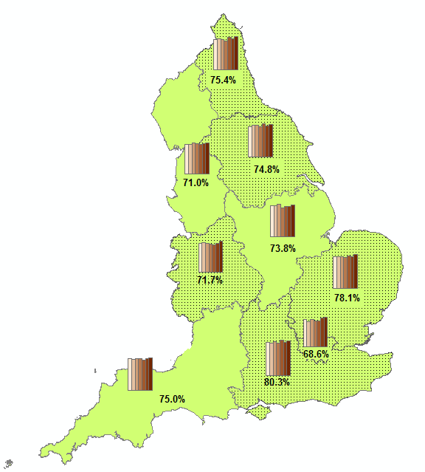
Notes
- Percentages shown on map are April 2011 to March 2012
- Confidence intervals range between +/-3.1 and +/-4.0 in 2011/12 Q4
Digital engagement

Since 2005/06, the proportion of people visiting heritage websites significantly increased from 18.3 per cent to 28.6 per cent.

The Taking Part Survey added new questions on heritage websites from July 2011. From July 2011 to March 2012, of people who visited a heritage website:
- Over half used it to plan how to get to the historic site (56.7%).
- Half used it to learn about history or the historic environment (51.5%),
- Just under a quarter used it to buy tickets to visit a historic site (24.6%).
- Less than 2 per cent of adults, who visited a heritage website, used it to discuss history or visits to the historic environment on a forum (1.8%).
- 18.9 per cent of adults had visited a heritage website to take a virtual tour of a historical site.

Further detail on this section can be found in the accompanying spreadsheets to this release available at: http://www.culture.gov.uk/publications/9135.aspx

- Museums and galleries

This chapter examines museums and galleries attendance in the last 12 months, by a range of area-level and socio-demographic breakdowns. Details on the ways that people digitally engage with museums and galleries are also given.

Key findings

- Between 2005/06 and April 2011 to March 2012, the proportion of people visiting a museum or gallery in the last year significantly increased (from 42.3% to 48.9%). There has also been a significant increase over the past year of 2.6 percentage points (from 46.3% to 48.9%).

- Attendance rates have not been higher in any year since 2005/06.

- In April 2011 to March 2012, 29.6 per cent of adults visited 1-2 times a year, 15.3 per cent did so 3-4 times a year, 3.4 per cent at least once a month and over half a per cent went at least once a week.

- Compared with a year ago (2010/11), the most recent period shows significant increases in the percentage of adults who visited a museum or gallery in the last year for the following:

  - 16-24 year olds (an increase of 6.6 percentage points to 44.4%)
  - 25-44 year olds (an increase of 3.3 percentage points to 54.9%)
  - BME adults (an increase of 6.7 percentage points to 44.4%)

Overall attendance at museums and galleries

In April 2011 to March 2012, 48.9 per cent of adults visited a museum or gallery, an increase from 2005/06 (42.3%). This is the highest proportion recorded in any given year, as shown in Figure 4.1.

The vast majority of visits were made in people’s own free time (98.1%), with a small percentage attending for paid work and for academic study (2.5% and 2.2% respectively).

There has been a UK policy to invest in regional museums via Arts Council England’s Renaissance programme, aimed at increasing visitor numbers and attracting new audiences.

Figure 4.1: Proportion who have visited a museum or gallery in the last year, 2005/06 to April 2011 - March 2012

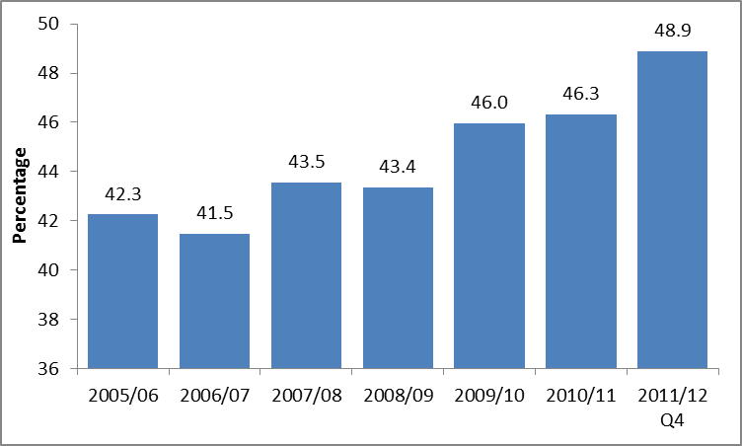
Notes
- Confidence intervals range between +/-0.7 and +/-1.9 from 2005/06 onwards.

While people who live in rural areas are just as likely as people in urban areas to have visited a museum or gallery in the last year, there are variations by region.

In April 2011 to March 2012,
- Londoners (55.3%) had the highest levels of attendance
- While those in the East Midlands (43.9%) had the lowest levels of attendance.
- Since 2005/06, the proportion of people visiting museums or galleries increased significantly in all regions except for East Midlands.
- The greatest increase since 2005/06 has been in the West Midlands (up by 11.7 percentage points).

The most recent period shows a significant increase over the last year in the proportion of black and minority ethnic (BME) groups visiting a museum or gallery in the last year, from 37.7 per cent (in 2010/11) to 44.4 per cent, an increase of 6.7 percentage points.

People in the higher ACORN groups such as Wealthy Achievers (55.7%) and Urban Prosperity (65.0%) had higher attendance rates than the Hard-pressed (34.5%), as shown in Figure 4.2.

Figure 4.2: Proportion who have visited a museum or gallery in the last year, by ACORN group

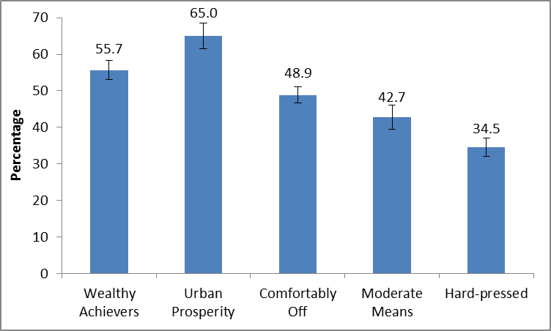
Notes
Confidence intervals range between +/-2.3 and +/-3.5

Over half (57.8%) of adults in the upper socio-economic group visited a museum or gallery compared to 35.4 per cent in the lower group. Over half of working adults had attended (54.2%) compared to 41.3 per cent of adults not working.

Digital engagement

In 2011/12 Q4, 26.2 per cent of adults had visited a museum or gallery website, an increase from 15.8 per cent in 2005/06.

Between 2005/06 and 2011/12 Q4, of those who had visited a museum or gallery website, there was an increase in the proportions of people visiting a museum or gallery website to find out about or order tickets for an exhibition or event (from 47.9% to 58.1%).There was a significant decrease in the proportion of adults who had visited a museum or gallery website to look at items from a collection (from 33.7% to 20.3%). Meanwhile the proportion visiting to find out about a particular subject remained steady over the last couple of years (47.5% in the latest period).

The Taking Part Survey added new questions on museum or gallery websites from July 2011. In this period, of those who had visited a museum or gallery website, 16.4 per cent of adults had taken a virtual tour of a museum or gallery and 13.5 per cent had viewed or downloaded an event or exhibition.

Further detail on this section can be found in the accompanying spreadsheets to this release available at: http://www.culture.gov.uk/publications/9135.aspx

- Libraries

This chapter examines library participation as measured by attendance in the last 12 months, by a range of area-level and socio-demographic breakdowns. Details on the ways that people digitally engage with library services are also given.

Key findings

- In 2011/12 Q4, 38.8 per cent of adults had used a library in the last 12 months, a significant decrease from 48.2 per cent in 2005/06, but showing little change from 2009/10.

- Since 2005/06, the proportion of people using a public library has declined in all regions.

- However, 38.9 per cent of adults aged 75 years or older attended a library in the last 12 months, which is the highest proportion reported since 2005/06 (42.3%).

Library attendance

In April 2011 to March 2012, 38.8 per cent of adults reported using a library service in the last 12 months, a significant decrease from 48.2 per cent in 2005/06, and no change from 2009/10 (Figure 5.1).

Figure 5.1: Library attendance by sex, 2005/06 to April 2011-March 2012

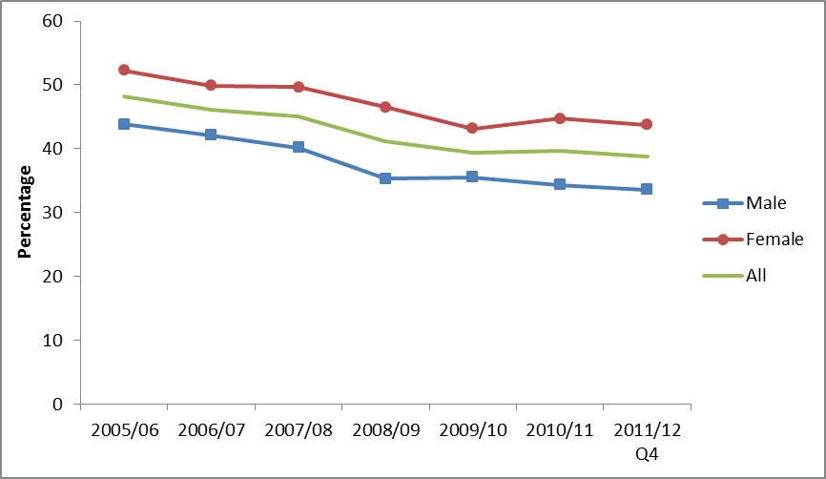
Notes
- Confidence intervals range between +/-0.7 and +/-1.8 from 2005/06 onwards.

Between 2005/06 and 2011/12 Q4, the proportion of people using a public library declined in all regions, although the North West was the only region to have a significant decrease from 43.0 per cent in 2010/11 to 37.5 per cent in 2011/12 Q4.
During 2005/06 and 2011/12 Q4, the decline in library usage has been across all socio-demographic groups. 38.9 per cent of adults aged 75 years or older attended a library in the last 12 months, which is the highest proportion reported since 2005/06 (42.3%). However there was a significant decrease in the proportion of 65-74 year olds attending a library in the last 12 months between 2010/11 (44.3%) and 2011/12 Q4 (35.8%).

The Government has a policy to champion public libraries and their value to encourage reading, act as a hub of local communities and giving access to other information and services. Individual public library services are delivered by 151 library authorities in England.

On 1 October 2011, responsibility for library development transferred from the Museums, Libraries and Archives Council to Arts Council England. Since taking on the role as development agency for libraries, Arts Council England has launched the Libraries Development Initiative, which follows on from the Government’s previous Future Libraries Programme. As part of this, Arts Council England with the Local Government Association awarded £230,000 to thirteen local projects to help them explore new ways of providing their service. The Arts Council England is currently undertaking a major research project about the future of libraries.

In 2011/12 Q4, the following patterns of library attendance were observed:

- Women (43.8%) have a higher rate of library attendance than men (33.6%).
- Adults in upper socio-economic groups (42.3%) have a higher rate of library attendance than people in lower socio-economic groups (33.5%).
- Adults who are not working (41.7%) have higher rates of library attendance than those who are working (36.8%).
- Adults from a white background (37.8%) have lower rates of library attendance than black or minority ethnic (BME) groups (46.5%).

The same patterns have been consistent since 2005/06; however the library attendance rates were higher for each category in 2005/06.

Digital engagement

In 2011/12 Q4, 16.2 per cent of adults had visited a library website in the last 12 months, a significant increase from 8.9 per cent in 2005/06. Of those who had visited a library website, 77.6 per cent had searched and viewed online information or made an enquiry. 35.6 per cent had completed a transaction, e.g. reserve or renew items or pay a fine; a significant increase from 28.1 per cent in 2006/07.

Further detail on this section can be found in the accompanying spreadsheets to this release available at: http://www.culture.gov.uk/publications/9135.aspx

- Arts

Taking Part asks respondents whether they have participated in a given range of arts activities or attended a range of activities. These two forms of activity are combined to provide the overall measure of arts engagement. Details on the ways that people digitally engage with the arts are also given.

Key findings

- In 2011/12 Q4, 78.2 per cent of adults had engaged in the arts in the last year, a significant increase reported since 2005/06 (76.3%) and 2010/11 (76.2%).

- Arts engagement significantly increased between 2009/10 and 2011/12 Q4 for the most deprived decile group, from 59.9 per cent to 69.0 per cent.

- Arts engagement increased to highest recorded levels for people living in urban areas, reaching 77.5 per cent in 2011/12 Q4. This is a significant increase from 74.9 per cent in 2005/06.

- Adults aged 65-74 and 75+ have seen a significant increase in engagement since 2005/06 (from 70.7% to 75.1% for 65-74 year olds and from 57.7% to 61.9% for aged 75 and over). However, adults aged 75 and over still have significantly lower arts engagement rates compared to other age groups.

Arts engagement

The latest results show 78.2 per cent of adults had engaged in the arts in the last year, a significant increase reported since 2005/06 (76.3%) and 2010/11 (76.2%). Women (80.7%) had higher arts engagement rates than men (75.5%). There has been a significant increase in women’s engagement with the arts since 2005/06. (Figure 6.1).

Figure 6.1: Arts engagement, by sex, 2005/06 to April 2011 - March 2012

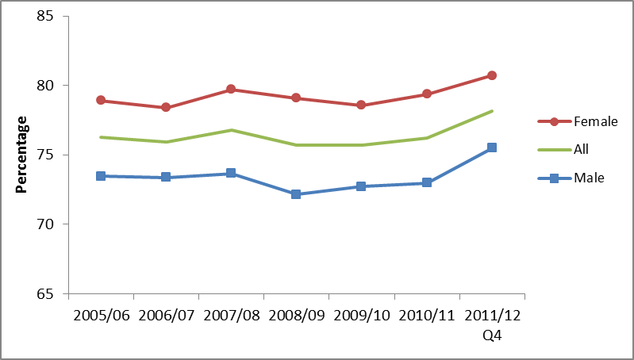
Notes
(1) Confidence intervals range between +/-0.7 and +/-3.1 from 2005/06 onwards.

In 2011/12 Q4,
- 63.3 per cent of adults had engaged with the arts three or more times in the last 12 months, a significant increase from 2010/11 (61.2%).
- 8.5 per cent of adults had engaged once in the last 12 months, a significant increase from 7.2 per cent in 2005/06.
- 21.9 per cent of adults had not engaged with the arts at all in the last 12 months, a significant decrease from 23.8 per cent in 2005/06.

Figure 6.2 shows that the proportion of adults who have engaged with the arts once in the last 12 months has increased at the greatest rate, whilst those who have not engaged with the arts in the last 12 months has decreased the most since 2005/06.

Figure 6.2: Indexed arts engagement, by frequency of attendance, 2005/06 to April 2011 - March 2012
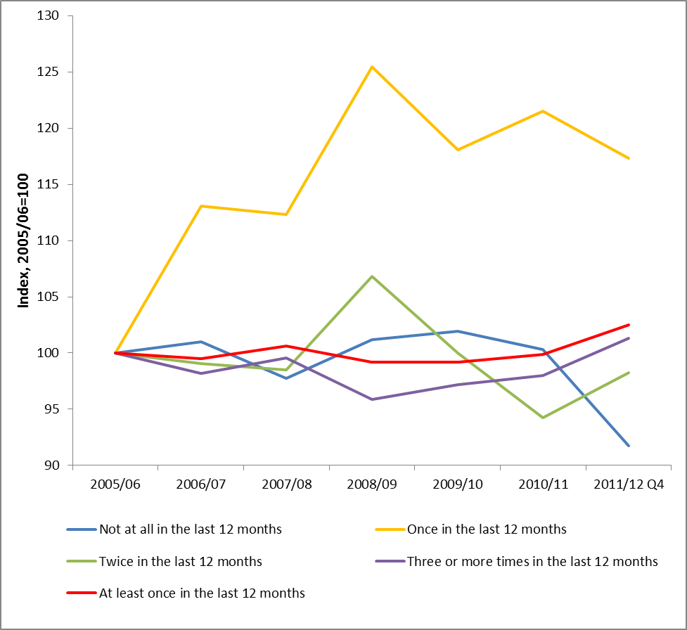
Notes
(1) Confidence intervals range between +/-0.4 and +/-2.2 from 2005/06 onwards.

There were significant increases in adults engaging in art in the North West (from 71.5% to 77.1%) and in East of England (from 79.7% to 83.4%) since 2005/06. There were also increases in arts engagement for adults living in urban areas (from 74.9% to 77.5%) during that period.

In 2011/12 Q4, the following patterns of arts engagement were observed:
- Arts engagement tends to be higher among people who live in less deprived neighbourhoods. Since 2009/10, levels of engagement have remained level in each Index of Multiple Deprivation decile group, except for the most deprived, where engagement has increased from 59.9 per cent to 69.0 per cent.
- People aged 75 and over have significantly lower arts engagement rates (61.9%) than the other age groups. Although the 65-74 and 75+ age groups have seen a significant increase in engagement since 2005/06 (from 70.7% to 75.1% for 65-74 year olds, from 57.7% to 61.9% for age 75 and over), engagement rates for other age groups have remained steady during that period.
- Arts engagement is higher among white people (79.1%) than black and minority ethnic (BME) groups (70.5%).
- People with no long-standing illness or disability had a higher arts engagement rate (80.7%) than people with a long-standing illness or disability (71.8%).

These patterns are consistent with previous years.

The Government works closely with bodies such as the Arts Council England to find different ways of increasing attendance and participation in the arts. The recent launch of the Creative People and Places scheme is intended to assist with launching new projects in the areas of lowest participation.

Digital engagement

In 2011/12 Q4, 32.2 per cent of adults had visited a theatre or concert website, a significant increase from 30.5 per cent in 2005/06. Of those who had visited a theatre or concert website, 54.7 per cent of people had bought tickets for an arts performance or exhibition, a significant increase from 43.2 per cent in 2006/07.

The Taking Part Survey added new questions about arts websites from July 2011. Between July 2011 and March 2012, of those who had visited an arts website, the most popular reason was to find out more about an artist, performer or event (72.0%), followed by viewing or downloading part or all of a performance or exhibition (20.7%). 9.0% of adults visited an arts website to find out how to take part or improve their creative skills.

UK policy is to promote good online resources as a way of encouraging participation in the arts, as well as attendance at events.

Further detail on this section can be found in the accompanying spreadsheets to this release available at: http://www.culture.gov.uk/publications/9135.aspx
- Archives

This chapter examines attendance at an archive in the last year, by a range of area-level and socio-demographic breakdowns. Details on the ways that people digitally engage with archives are also given.

Key findings

- In 2011/12 Q4, the proportion of adults visiting an archive (in their own time and voluntary) in the last year remained steady at 3.6 per cent from the 2008/09 level.

- In the last year, just under half of adults who did visit an archive, did so just once in the last 12 months.

- 6.1 per cent of adults aged 65-74 visited an archive, compared to just 1.3 per cent of 16-24 year olds.

Overall participation in archives

In this latest period, 3.6 per cent of adults had visited an archive in the last year in their own time or as part of voluntary work. This is significantly lower than 2005/06 (5.9%). Including paid work visits and academic study visits, this increases to 4.5 per cent of all adults. The trend over time is shown in Figure 7.1 below.

Figure 7.1: Percentage of adults visiting an archive or records office, 2005/06 to April 2011 - March 2012

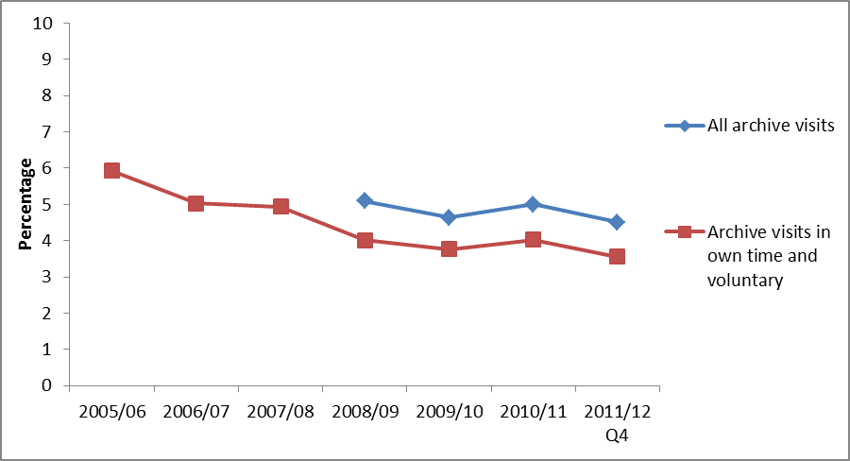
Notes
- Confidence intervals range between +/-0.3 and +/-0.8 from 2005/06 onwards.
- Some archive questions were not asked prior to the 2008/09 survey.

There were significant decreases in archive attendance rates since 2005/06 in all regions apart from in the East Midlands, East of England and the South West where rates have remained steady. The region with the lowest archive attendance rate in 2011/12 Q4 was the North East, with just 2.8 per cent of adults attending in the last year, followed by London and the South East with 2.9 per cent.

There is little variation between different demographic groups (apart from age), but adults from upper socio-economic groups had a significantly higher attendance rate (4.3%) than those in lower socio-economic groups (2.9%).

Over three quarters of all archive visits (76.6%) were in their own time, followed by 15.5 per cent visiting for paid work, and 7.2 per cent for academic study.

Digital engagement

A higher proportion of adults visited an archive or records office online than in person. In 2011/12 Q4, 11.6 per cent of adults had visited an archive or records office website in the last 12 months, a significant increase from 9.7 per cent in 2005/06. Of those who had visited an archive or records office website, 61.6 per cent had done so to view digitised documents; around a third (33.2%) of adults had searched a catalogue, over a fifth (21.4%) of adults had found information out about the archive (e.g. – opening hours) and 18.9 per cent had completed a transaction.

Further detail on this section can be found in the accompanying spreadsheets to this release available at: http://www.culture.gov.uk/publications/9135.aspx

- Big Society
Taking Part asks whether respondents have done any volunteering work in the last 12 months and whether this relates to any of the DCMS sectors. It also includes a range of questions on social capital and cohesion. Recently added questions ask about charitable donations and whether these relate to DCMS sectors.

Key findings

- In April 2011 to March 2012, the proportion of adults volunteering in the last 12 months was 23.3 per cent. 7.1 per cent of all adults had volunteered in any DCMS sector. Of those who volunteered, 8.9 per cent had done so in the arts sector which is a significant increase from 2005/06 (6.3 per cent).

- There was a significant increase in the proportion of black and ethnic minority (BME) groups who had volunteered in the last 12 months compared to 2005/06 (up from 19.6% to 24.3%).

- In 2011/12 Q4 89.7 per cent of adults had donated money (including any donations into a collection box) in the last 12 months. 25.6 per cent of all adults had donated to one of the DCMS sectors, a significant decrease from the 33.0 per cent of adults who had donated money to a DCMS sector in 2010/11.

Volunteering

In 2011/12 Q4, 23.3 per cent of adults reported that they had taken part in voluntary activities in the last 12 months and 7.1 per cent of all adults had volunteered in any DCMS sector. There was a significant increase in the proportion of black and ethnic minority (BME) groups who had volunteered in the last 12 months compared to 2005/06 (up from 19.6% to 24.3%). This time series is shown in Figure 8.1.

The percentage of black and ethnic minority (BME) groups volunteering in DCMS sectors increased from 4.4 per cent in 2005/06 to 6.2 per cent in 2011/12. This increase in BME volunteering rates could be partially explained by the UK winning the bid to host the 2012 Olympics and Paralympic Games, with 20.8 per cent of BME volunteers saying they were motivated to do more voluntary work as a result of this. There was also an increase in the proportion of BME groups volunteering in other sectors (15.6% in 2005/06 to 19.4% in 2011/12 Q4).

Government policy has been to capitalise on motivation including before the Games have taken place, to encourage more people to take part in more voluntary work as a result of the games coming to the UK. It is policy to use the inspirational power of the Games and its ability to engage people from all backgrounds.

Figure 8.1: Volunteering by ethnicity, 2005/06 to April 2011-March 2012

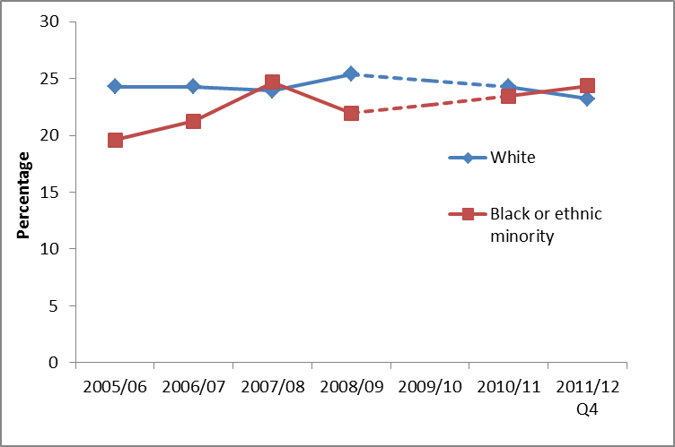
Notes
- Confidence intervals range between +/-0.7 and +/-3.9 from 2005/06 onwards
- Volunteering question was not asked in 2009/10

In the 12 months to March 2012, there were significant differences in the proportion of males and females who volunteered in heritage, libraries and sport sectors. A significantly higher proportion of males (more than double) volunteered in heritage and sport compared to females. However, 1.6 per cent of females who volunteered did so in libraries, which is significantly higher than the 0.7 per cent of male volunteers in libraries (see Figure 8.2).

Figure 8.2: Volunteering in each DCMS sector by gender, April 2011 – March 2012

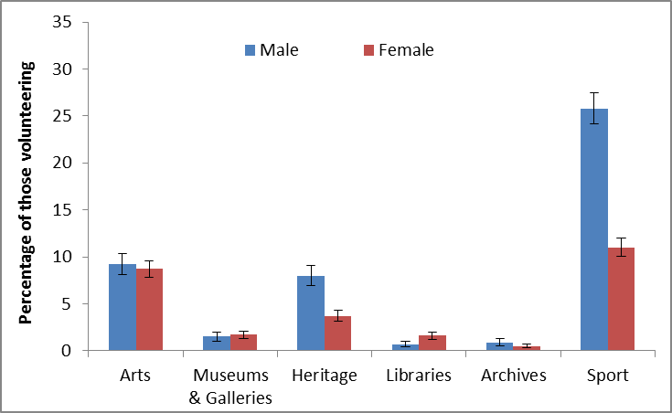
Notes
- Confidence intervals range between +/-0.2 and +/-1.7

Adults who had participated in any DCMS sector had higher volunteering rates, than adults who had not participated, e.g. of adults who had participated in sport, 26.1 per cent of them had volunteered in sport, compared with just 7.1 per cent of those who did not play sports.

The arts sector had the highest average amount of time spent volunteering during the last 4 weeks (17 hours and 34 minutes). On average 9 hours 8 minutes was spent in the last 4 weeks by volunteers in the heritage sector, followed by 7 hours and 12 minutes in the Museum and gallery sector and 9 hours 20 minutes by volunteers in the sports sector.

Charitable giving

Taking Part asks whether respondents have donated money in the last 12 months and whether this was to any of the DCMS sectors.

In 2011/12 Q4, 89.7 per cent of adults had donated money (including any donations into a collection box) in the last 12 months. 25.6 per cent of all adults had donated to at least one of the DCMS sectors. 15.3 per cent of adults had donated to the heritage sector in the last 12 months, 14.3 per cent to museums and galleries, 6.4 per cent to sport, and 5.9 per cent to the arts.

36.7 per cent of adults donated money less often than once a month but at least 3 or 4 times a year and 33.0 per cent donated less often than once a week but at least once a month.

Government policy is to encourage charitable giving across society as a whole, to make it easier to give and provide better support to organisations that facilitate giving, whether through digital technology or simplification of the tax system. Policy aims to encourage giving through a £100 million match funding programme (from 2011/12), a new Cultural Gifts Scheme to boost lifetime giving to museums, and more legacy giving to culture and sport.

Overall civic participation

Taking Part asks a series of questions on sporting and cultural facilities in the respondent’s local area.

In 2011/12 Q4, just under a quarter of adults (23.7%) had taken action to try to get something done about sporting and cultural facilities in their area. The most common action that had been taken was to contact the council, with 11.2 per cent of adults having done so. Also 5.3 per cent of adults had contacted their local councillor or MP.

42.2 per cent of adults had been involved in groups, clubs or organisations in the last 12 months. Of those adults, the most popular type of group was sports/exercise groups (48.1%), followed by hobbies/social clubs (35.0%).

Further detail on this section can be found in the accompanying spreadsheets to this release available at: http://www.culture.gov.uk/publications/9135.aspx
Annex A: Background note

- The Taking Part Survey is commissioned by the Department for Culture, Media and Sport (DCMS) and its partner arm’s length bodies (ALBs). For 2011 to 2015 these are Arts Council England, English Heritage and Sport England.

- Taking Part is a National Statistic and as such has been produced to the high professional standards set out in the Code of Practice for Official Statistics. National Statistics undergo regular quality assurance reviews to ensure they meet customer needs and are produced free from any political interference. For more information, see http://www.statisticsauthority.gov.uk/assessment/code-of-practice/code-of-practice-for-official-statistics.pdf. The Taking Part publication was assessed alongside the Department’s other statistics earlier this year and 16 recommendations were made. A copy of the published report by the UK Statistics Authority is available in report 190 at http://www.statisticsauthority.gov.uk/assessment/assessment/assessment-reports/index.html.

- Stringent quality assurance procedures have been adopted for this statistical release. All data and analysis has been checked and verified by two different members of the team and TNS-BMRB to ensure the highest level of quality.

Guidance on the quality that is expected of Taking Part statistical releases is provided in a quality indicators document at http://www.culture.gov.uk/what_we_do/research_and_statistics/7394.aspx#5. These quality indicators outline how statistics from the Taking Part Survey match up to the six dimensions of quality defined by the European Statistical System (ESS). These are: relevance, accuracy, timeliness, accessibility, comparability and coherence.

- The latest results presented here are based on interviews issued between April 2011 and March 2012. The total sample size for this period is 9,188.

- The survey measures participation by adults (aged 16 and over) and children (5-10 and 11-15) living in private households in England. No geographical restriction is placed on where the activity or event occurred.

- The median adult sample interview length for the 2010/11 survey was 40 minutes 42 seconds (mean 42 minutes 36 seconds). The median survey length for the 5-10 year old child interview was 14 minutes 3 seconds (mean 14 minutes 58 seconds) and for 11-15 year olds it was 24 minutes 16 seconds (mean 25 minutes 41 seconds).

- Participation in these activities must be for the purpose of recreation or leisure, including voluntary work. It excludes involvement in activities where the prime motivation is paid work or academic studies. The exceptions to this are attendance at historic environment sites which includes visits made for academic study, and sports participation which exclude volunteering, teaching, coaching and refereeing. Paid work visits and academic study visits are also included in one of the archive attendance measures.

- The range has been calculated using a 95% confidence interval. This means, had the sample been conducted 100 times, creating 100 confidence intervals, then 95 of these intervals would contain the true value. All estimates have been rounded to one decimal place. An overall design factor of 1.211 has been applied to the dataset for the period April 2011 and March 2012. Individual design factors have been calculated for each sector in this period, ranging from 1.188 to 1.277. Statistical significance tests have been run at the 95% level. This means the probability that any given difference happened by chance is low (1 in 20).

- All differences and changes reported are statistically significant at the 95% confidence level unless otherwise stated.

- Some figures may have been revised from previous releases, in which case the figures in this release supersede those from previous statistical releases. For more detailed information on the DCMS revisions policy and how revisions are handled for the Taking Part Survey, please see the DCMS statement of compliance on our website, at http://www.culture.gov.uk/what_we_do/research_and_statistics/4824.aspx

- The data are weighted to ensure the representativeness of the Taking Part sample. There are two types of weighting: i) to compensate for unequal probabilities of selection; and ii) to adjust for differential non-response. Weighting is based on mid-2009 population estimates from the Office for National Statistics.

- For more information about the Taking Part Survey, including previous publications, see http://www.culture.gov.uk/reference_library/research_and_statistics/4828.aspx

Versions of the questionnaire from all years of the survey are available, see http://www.culture.gov.uk/what_we_do/research_and_statistics/7387.aspx

- DCMS and Sports England are currently consulting with users and other interested parties on proposals to integrate the Taking Part and Active People surveys to change the way sport is measured. The consultation closes on 7th August 2012, and further information is available at: http://www.culture.gov.uk/consultations/9062.aspx.

- The fieldwork for the survey is being conducted by TNS-BMRB. For more information, see http://www.tns-bmrb.co.uk

- We can also provide documents to meet the specific requirements of people with disabilities. Please call 020 7211 6000 or email takingpart@culture.gsi.gov.uk

- This report has been produced by Tom Knight and Penny Allen. Acknowledgement goes to colleagues within the DCMS, partner ALBs and TNS-BMRB for their assistance with the production and quality assurance of this release.

- The responsible statistician for this release is Tom Knight. For enquiries on this release, please contact Tom Knight on 0207 211 6021 or Penny Allen on 0207 211 6106.

- For general enquiries telephone: 0207 211 6200
Department for Culture Media and Sport
2-4 Cockspur Street
London
SW1Y 5DH
enquiries@culture.gov.uk
Annex B: Key terms and definitions

Term | Definition
1 x 30 minute MIS | This refers to a person participating in moderate intensity sport for at least one 30 minute session in the last week.
2011/12 Q3 | This is the time period covering January-December 2011. It is also referred to as the 2011 calendar year.
3 x 30 minute MIS | This refers to a person participating in moderate intensity sport for at least three 30 minute sessions in the last week.
ACORN classification | A classification of residential neighbourhoods is a geo-demographic information system categorising some United Kingdom postcodes into various types based upon census data and other information such as lifestyle surveys.
Active Sport | A list of active sports is available in Annex C: Sector definitions.
Active sport at least once in the last 4 weeks | The number of days in the last four weeks the respondent has done at least one of the active sports or activities for at least 30 minutes. This excludes any walking or cycling the respondent has done for health or recreation purposes only. Walking or cycling for sport training or competition is included.
Archives | Archives are collections of documents that have been created by families, individuals, businesses or organisations and have been specially chosen to be kept permanently. Further information is available in Annex C.
Arts | A list of arts that the respondent may have participated or attended is available in Annex C: Sector definitions.
Attendance | This refers to the respondent going to a place, for example, attending a library or a swimming pool.
Big Society | This covers volunteering work, social capital and cohesion. Specific voluntary work categories are provided in Annex C: Sector definitions.
Calendar year (or Taking Part year) | The period of time beginning on the 1st January and ending on the 31st December. This is the same time period covered by 2011/12 Q3 in the Taking Part survey.
Civic participation | Actions include, contact a local radio station, TV station or paper; talk to / written to a sporting or cultural facility, contact the council, contact a local councillor or MP, join a local group or attend a neighbourhood forum, attend a protest meeting or joined a campaign group, or help organise a petition.
Confidence interval | This provides a range in which there is a specific probability that the true value will lie within. For the Taking Part survey, 95% confidence intervals are used which means, had the sampling been conducted 100 times, creating 100 confidence intervals, then 95 of these intervals would contain the true value.
DCMS sectors | The DCMS sectors are the culture, arts, sports and big society sectors.

Term | Definition
Digital participation | This refers to visiting websites for a number of reasons. These are outlined in Annex C: Sector definitions.
Digitally engage | This refers to the respondent engaging with the DCMS sectors via the internet.
Engagement | This refers to either attending and/or participating in the sport, culture or arts sector. For example, if the respondent attended an art gallery (attendance) or gave a dance performance (participation).
Historic environment | A list of all historic environments is available in Annex C: Sector definitions.
Index of Multiple Deprivation (IMD) decile group | The Index of Multiple Deprivation is a composite index which measures neighbourhood deprivation across seven domains (for example housing and income deprivation). The IMD decile group splits neighbourhoods into ten groups according to the level of deprivation (eg 10% most deprived neighbourhoods).
Moderate intensity sport (MIS) | This is any active sport or recreational activity that is continuous, raises a person’s heartbeat, makes them out of breath and sweaty. This excludes utility walking or cycling, for example to work, but does include recreational walking and cycling. Exemptions are listed in Annex C: Sector definitions.
Participation | This refers to the respondent actively taking part in the activity. For example sports participation could refer to playing football or tennis, whilst participating in the arts may refer to painting.
Public library service | A list of valid uses of a public library is available in Annex C: Sector definitions.
Significant increase/decrease | This means there is good evidence that the increase/decrease is real and not due to chance.
Socio-demographic groups | Categorising the respondents by different social classes such as age, gender, employment status, housing tenure, ethnicity, religion, disability/illness status and National Statistics Socio-Economic Classes (NS-SEC)
Taking Part Survey | A survey commissioned by the Department for Culture, Media and Sport (DCMS) in partnership with the Arts Council England, English Heritage and Sport England, looking at engagement and non-engagement in culture, leisure and sport. Further information is available at http://www.culture.gov.uk/what_we_do/research_and_statistics/7390.aspx

Annex C: Sector definitions

The following annex presents the various definitions for adult participation in DCMS sectors.

Libraries
The respondent is asked if they have used a public library service. If the respondent is unsure what is in scope, the interviewer has the following definition to refer to.
“Use of a public library can include:
- A visit to a public library building or mobile library to make use of library services (including to print/use electronic resources or to take part in an event such as a reading group or author visit)
- The use of on-line library resources or services remotely (i.e. used a computer outside the library to view the website, catalogue or databases)
- Access, and receipt, of the library service by email, telephone, fax or letter
- Receipt of an outreach service such as home delivery or library events outside a library building
Use of other libraries and archive services is excluded.”

Museum, gallery or archive
The respondent is asked if they have attended a museum, gallery or archive. If the respondent is unsure what is in scope, the interviewer has the following definition to refer to.
“Archives are documents that have been created by families, individuals, businesses or organisations and have been specially chosen to keep permanently. They can be written papers such as letters or diaries, maps, photographs or film or sound recordings. Archives are historical documents but do not have to be very old. Places that keep archives are usually called a record office or archive centre.
Registering a birth, death or marriage happens at a registry office, not at an archive centre/record office.”

Arts
The respondent is asked if they have participated in a given list of arts activities, or attended a given list of arts events. Eligible activities and events are as follows.
Participation:
- Dance – ballet or other dance (for fitness and not for fitness)
- Singing – live performance or rehearsal/practice (not karaoke)
- Musical instrument – live performance, rehearsal/practice or played for own pleasure
- Written music
- Theatre – live performance or rehearsal/practice (e.g. play or drama)
- Opera/musical theatre – live performance or rehearsal/practice
- Carnival (e.g. as a musician, dancer or costume maker)
- Street arts (art in everyday surroundings like parks, streets, shopping centre)
- Circus skills (not animals) – learnt or practised
- Visual art – (e.g. painting, drawing, printmaking or sculpture)
- Photography – (as an artistic activity, not family or holiday ‘snaps’)
- Film or video – making as an artistic activity (not family or holidays)
- Digital art – producing original digital artwork or animation with a computer
- Craft – any craft activity (e.g. textiles, wood, metal work, pottery, calligraphy etc)
- Creative writing – original literature (e.g. stories, poems or plays)
- Book club – being a member of one

Attendance:
- Visual art exhibition (e.g. paintings, photography or sculpture)
- Craft exhibition (not crafts market)
- Event which included video or digital art
- Event connected with books or writing
- Street arts (art in everyday surroundings like parks, streets or shopping centre)
- Public art display or installation (an art work such as sculpture that is outdoors or in a public place)
- Circus (not animals)
- Carnival
- Culturally specific festival (e.g. Mela, Baisakhi, Navratri)
- Theatre (e.g. play, drama, pantomime)
- Opera/musical theatre
- Live music performance (e.g. classical, jazz or other live music event but not karaoke)
- Live dance event (e.g. ballet, African People’s dance, South Asian, Chinese, contemporary or other live dance)

Historic environment
The respondent is asked if they have visited the following list of historic environment sites.

- A city or town with historic character
- A historic building open to the public
- A historic park, garden or landscape open to the public
- A place connected with industrial history or historic transport system
- A historic place of worship attended as a visitor
- A monument such as a castle, fort or ruin
- A site of archaeological interest
- A site connected with sports heritage

Active sport
The respondent is asked about their participation in active recreation and a range of sports. Eligible activities are as follows.

- Swimming or diving (indoors and outdoors)
- BMX, cyclo-cross, mountain biking
- Bowls (indoors and outdoor lawn bowls)
- Tenpin bowling
- Health, fitness, gym or conditioning activities
- Keepfit, aerobics, dance exercise (includes exercise bike)
- Judo
- Karate
- Taekwondo
- Other martial arts (includes self-defence, tai chi)
- Weight training (includes body building)
- Weightlifting
- Gymnastics
- Rugby League
- Rugby Union
- American football
- Football (includes 5-a-side and 6-a-side) [indoors and outdoors]
- Gaelic sport (e.g. camogie, Gaelic football, hurling, Irish handball and shinty)
- Cricket
- Hockey (excludes ice, roller and street hockey, but included in ‘other’)
- Baseball/softball
- Netball
- Tennis
- Badminton
- Squash
- Basketball
- Table tennis
- Track and field athletics
- Jogging, cross-country, road running
- Yachting or dingy sailing
- Canoeing
- Windsurfing or boardsailing
- Ice skating
- Curling
- Golf, pitch and putt, putting
- Skiing (on snow or on artificial surface; on slopes or grass)
- Horse riding
- Climbing/mountaineering (includes indoor climbing)
- Hill trekking or backpacking
- Motor sports
- Volleyball
- Orienteering
- Rounders
- Rowing
- Triathlon
- Boxing
- Waterskiing
- Lacrosse
- Fencing
- Other types of sport, e.g. rollerblading, street hockey, skateboarding, water polo, surfing, scuba diving, gliding, hang/paragliding, parachuting or parascending

Moderate intensity sport
To be counted as ‘moderate intensity’, the respondent must have participated in at least one 30-minute session (or alternatively three 30-minute sessions) in the past week of any of the sports (with the exception of bowls) listed above as well as recreational cycling or recreational walking. In addition, the effort put into the activity needs to be of moderate intensity, i.e. raises their breathing rate (or for walking it needs to be done at a brisk or fast pace).
The only exception to this is for those adults aged 65 and over, where some light activities are in also scope – indoor and outdoor bowls, yoga, Pilates, croquet and archery.

Digital Participation
Digital Participation includes visiting websites for at least one of the following reasons:

- Museum or gallery website – To look at items from a collection.
- Museum or gallery website – To find out about a particular subject.
- Museum or gallery website – To take a virtual tour of a museum or gallery
- Museum or gallery website – To view or download an event or exhibition
- Library website – To complete a transaction (e.g. reserve or renew items, pay a fine).
- Library website – To search and view online information or make an enquiry.
- Heritage website – To take a virtual tour of a historical site.
- Heritage website – To learn about history or the historic environment
- Heritage website – To discuss history or visits to the historic environment on a forum
- Arts Website – To view or download part or all of a performance or exhibition
- Arts Website – To discuss the arts or share art that others have created
- Arts Website – To upload or share art that you have created yourself
- Arts Website – To find out how to take part or improve your creative skills
- Archive or records office website – To complete a transaction.
- Archive or records office website – To view digitized documents online.
- Archive or records office website – To search a catalogue.

Volunteering
The respondent is asked about any voluntary work they have done, including:

- Raising or handling money / taking part in sponsored events
- Leading a group
- Being a member of a committee
- Organising or helping to run an activity or event
- Visiting people
- Befriending / mentoring people
- Coaching or tuition
- Giving advice/ information/ counselling
- Secretarial, administrative or clerical work
- Providing transport or driving
- Representing – e.g. addressing meetings, leading a delegation
- Campaigning – e.g. lobbying, canvassing, letter writing
- Conservation/restoration
- Officiating – e.g. judging, umpiring or refereeing
- Other practical help - e.g. helping out a school, religious group, with shopping/refreshments
- Work in a charity shop

The respondent is also asked whether this activity was connected to any of the following areas:

- Arts
- Museum or gallery
- Heritage
- Libraries
- Archives
- Sport
- Any other sector

2-4 Cockspur Street
London SW1Y 5DH
www.culture.gov.uk

In July 2011, this statement became part of a response list. From July 2005 - June 2011, it was asked as a single question. For this reason, this estimate cannot be compared with previous year’s estimates.
Percentages will not total to 100% as some people may have visited a museum or gallery for more than one reason.
Percentages will not total to 100% as some people may have visited an archive for more than one reason.
Actions include, contact a local radio station, TV station or paper; talk to / written to a sporting or cultural facility, contact the council, contact a local councillor or MP, join a local group or attend a neighbourhood forum, attend a protest meeting or joined a campaign group, or help organise a petition.

