
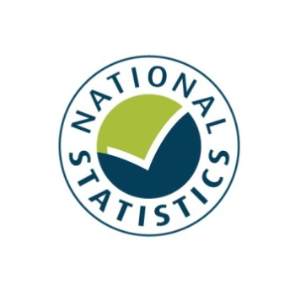

Taking Part 2011/12 Quarter 2
Statistical Release
December 2011





Taking Part is a National Statistic and has been produced to the standards set out in the Code of Practice for Official Statistics

Contents

Introduction 5
Key findings 7
Chapter 1: Heritage 11
Chapter 2: Museums and galleries 14
Chapter 3: Libraries 17
Chapter 4: Arts 19
Chapter 5: Archives 21
Chapter 6: Sport and active recreation 23
Chapter 7: Big Society 26
Chapter 8: The 2012 Olympic and Paralympic Games 28
Annex A: Background note 30
Annex B: Sector definitions 32

Introduction

This report
This report presents the latest headline results from the Taking Part Survey, incorporating the first quarter of fieldwork from the seventh year of the survey and covering the twelve month period from October 2010 to September 2011 (this same period is also referred to as 2011/12 Q2). Where observations are made over time, the latest data are compared with earliest available data (typically 2005/06).

The report presents headline findings for the main culture and sport estimates along with updates on data to support the 2012 Olympic and Paralympic Games and Big Society objectives. Where we have recently extended our analysis to look at digital engagement with our sectors, this is presented alongside the relevant sector figures.

This release reports findings for adults only. The next update for child data will be presented in summer 2012. Taking Part users are encouraged to contribute their views on the content of this release and areas of interest for analysis to the Taking Part team at DCMS: TakingPart@culture.gsi.gov.uk .

The second Taking Part User Event was held on 18th August 2011 gathering together a range of users from different sectors and backgrounds. Material from this event is available on our site at: http://www.culture.gov.uk/what_we_do/research_and_statistics/7394.aspx

The Taking Part Survey
The Taking Part Survey is commissioned by the Department for Culture, Media and Sport (DCMS) in partnership with a number of our arm’s length bodies. At present, these are Arts Council England, English Heritage, and Sport England.

Taking Part is a continuous face-to-face survey with adults aged 16 and over living in private households in England. It is conducted on behalf of DCMS by TNS-BMRB. The survey has run since mid-July 2005. A child interview was added to the survey in January 2006, interviewing a randomly selected child in those households containing at least one child aged 11-15. This is also a continuous face-to-face survey. In 2008/09, the child survey was broadened to include children aged 5-10. Interviews with children aged 11-15 are carried out directly, for those aged 5-10 an interview is conducted with the adult respondent.

The survey provides a wide range of data about engagement and non-engagement in culture, leisure and sport as well as more diverse measures that support a range of Government objectives. Taking Part is the key evidence source for DCMS, providing reliable national estimates of participation and supporting the Department’s aim of improving the quality of life for everyone by providing people with the chance to get involved in a variety of these opportunities. The survey also aims to support the DCMS Structural Reform Priorities and Business Plan through the provision of data for DCMS input and impact indicators and the broader information strategy. The latest DCMS indicators are available at: http://www.culture.gov.uk/about_us/8192.aspx

The Taking Part Survey contributes to the evidence base across a wide range of topics including satisfaction and enjoyment of culture and sport, social capital, volunteering and barriers to participation. It also collects an in-depth range of socio-demographic information on respondents. A wider range of measures are included in the spreadsheets accompanying this release, while analysis of 2005/06 to 2010/11 adult data can be conducted through NetQuest, our on-line analytical tool:
http://www.culture.gov.uk/what_we_do/research_and_statistics/6762.aspx

Forthcoming releases
The next release, scheduled for the end of March 2012, will present latest rolling estimates including the third quarter of the seventh year of the survey (October 2011 to December 2011).
Future releases will follow a similar schedule, being released ahead of the Quarterly Data Summaries that will be produced by all departments. Taking Part forms part of the wider DCMS data strategy as well as supporting its impact and input indicators. Details of these are available at: http://www.culture.gov.uk/about_us/8192.aspx
In addition, topic specific analysis will now be published on a quarterly basis, looking in depth at particular areas of the survey. The first of these reports on the Big Society was published in mid-November and can be found at: http://www.culture.gov.uk/publications/8612.aspx
The next report will be taking an in-depth look at sport participation measures and will be released in February 2012.

If you would like further information on these releases or the Taking Part Survey, please contact the Taking Part team on TakingPart@culture.gsi.gov.uk. Additional contact details are contained within Annex A.

Key findings

Culture
- In the year to 2011/12 Q2 (October 2010 to September 2011), 72.0 per cent of adults report having visited a heritage site in the last year. 3.3 per cent of adults report visiting a heritage site at least once a week, a significant increase since 2005/06.

- Between 2005/06 and 2011/12 Q2, the proportion of people visiting a museum or gallery in the last year significantly increased (from 42.3% to 47.1%).

- In October 2010 to September 2011, 39.0 per cent of adults had used a library in the last 12 months, a significant decrease from 48.2 per cent in 2005/06, but showing no further change from 2009/10.

- In the year to September 2011, the proportion of adults visiting an archive (in their own time and voluntary) in the last year remained steady at 3.7 per cent from the 2008/09 level.

Sport and active recreation
- 54.0 per cent of adults had participated in active sport at least once in the last 4 weeks.

- 25.8 per cent of adults had participated in moderate intensity sport for at least 30 minutes three times in the last week, an increase from 2005/06 (23.2%). 43.0 per cent had participated in moderate intensity sport for at least 30 minutes once in the last week, an increase from 2005/06 (41.2%).

- Since 2005/06, the proportion of 16-24 year olds participating in sport at least once in the last 4 weeks has decreased, while the proportion of people aged 75+ participating has increased.
- There have been significant increases between 2005/06 and 2011/12 Q2 for adults aged 25-44 doing 1x30 minute moderate intensity sport in the last week, (from 50.0% to 53.0%) and in the 45-64 age groups (from 36.8% to 40.5%).

Big Society
- In October 2010 to September 2011, the proportion of adults volunteering in the last 12 months remained at 23.8 per cent. 7.1 per cent of all adults had volunteered in any DCMS sector. Of those who volunteered, 8.8 per cent had done so in the arts sector which is a significant increase from 2005/06 (6.3 per cent).

- In October 2010 to September 2011 88.9 per cent of adults had donated money (including any donations into a collection box) in the last 12 months. 31.5 per cent of all adults had donated to one of the DCMS sectors.

2012 Olympic and Paralympic Games
- Almost two thirds (64.5%) of adults are slightly or strongly supportive of the 2012 Olympic and Paralympic Games.

- 85.6 per cent of adults intend to follow the London 2012 Olympic or Paralympic Games; with 25.3 per cent of adults actively getting involved in the Games.

Digital engagement
- In October 2010 to September 2011, 16.2 per cent of adults had visited a library website in the last 12 months, a significant increase from 8.9 per cent in 2005/06.

- Since 2005/06, the proportion of people visiting heritage websites increased from 18.3 per cent to 27.7 per cent.

- In October 2010 to September 2011, 25.9 per cent of adults had visited a museum or gallery website, an increase from 15.8 per cent in 2005/06.

- In October 2010 to September 2011, 39.5 per cent of adults had visited a theatre or concert website, a significant increase from 30.5 per cent in 2005/06.

- People are more likely to visit an archive or records office online than in person.

- Since 2005/06, the proportion of adults visiting sports websites has increased from 26.1 per cent to 37.4 per cent.

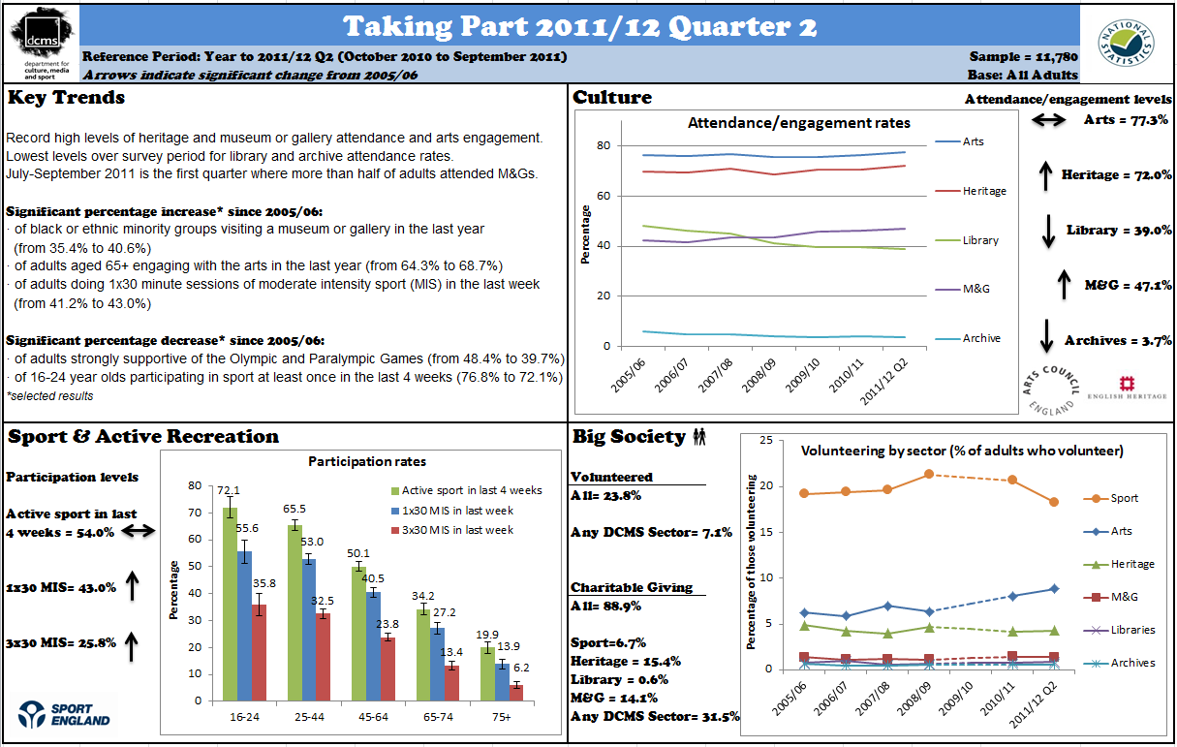

.
- Heritage

The survey measures adult participation in heritage by attendance at a heritage site in the 12 months prior to interview and the frequency with which they attend these types of sites. Details on the ways that people digitally engage with heritage are also given.

Key findings

- In October 2010 to September 2011, 72.0 per cent of adults report having visited a heritage site in the last year. This is the highest annual proportion of adults visiting since the survey began in 2005/06. 3.3 per cent of adults report visiting a heritage site at least once a week, a significant increase since 2005/06.

- There has been a significant increase in the proportion of men who have visited a heritage site, 73.3 per cent in October 2010 to September 2011, compared to 70.0 per cent in 2005/06.

Heritage attendance

The latest results show 72.0 per cent of adults reported visiting a heritage site in the last 12 months. This compares with a figure of 70.7 per cent in 2010/11 and 69.9 per cent in 2005/06. There has been a significant increase in the proportion of those visiting a heritage site at least once a week (from 2.4% in 2005/06 to 3.3 % in the latest results).

Other groups which experienced significant increases during that period include:
- men (from 70.0% to 73.3%),
- people in age groups 25-44, 65-74, 75+,
- lower socio-economic group (from 57.1% to 59.6%),
- those in the social rented sector (from 46.4% to 51.2%),
- those not working (from 61.3% to 64.1%),
- those working (from 75.5% to 77.6%),
- those without a long standing illness or disability (from 72.3% to 74.2%),
- those with a long standing illness or disability (from 63.9% to 66.6%).

Figure 1.1 shows the proportion of adults attending heritage sites over time by region.

During 2005/06 and October 2010 to September 2011, the North East and Yorkshire and the Humber regions had increased heritage attendance (from 69.1% to 76.0%, and from 68.3% to 73.4%, respectively). Both urban areas (from 68.0% to 69.9%), and rural areas (from 77.4% to 80.7%) also experienced significant increases.

Figure 1.1: Proportion who have visited a heritage site in the last year, 2005/06 to October 2010 - September 2011
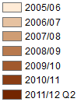
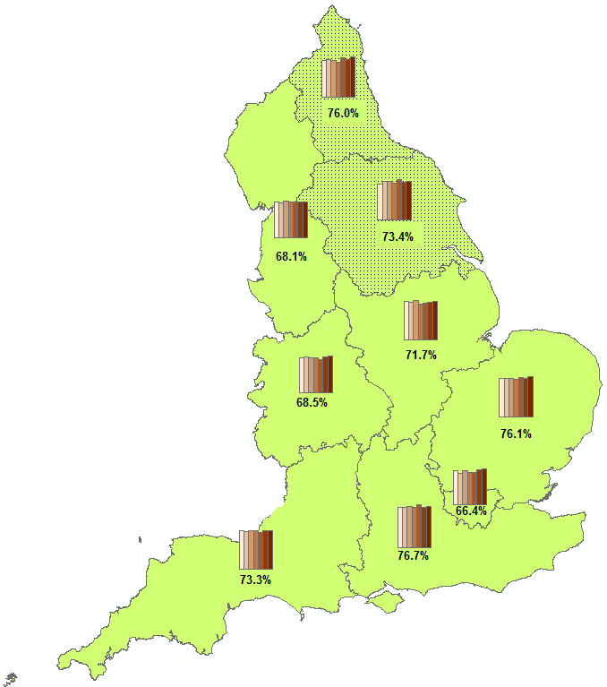
Notes
- Percentages shown on map are for October 2010 to September 2011
- Confidence intervals range between +/-2.7 and +/-3.9 in 2011/12 Q2

Digital engagement

Since 2005/06, the proportion of people visiting heritage websites increased from 18.3 per cent to 27.7 per cent.

Between 2005/06 and October 2010 to September 2011, 25.0 per cent of adults had visited a heritage website to take a virtual tour of a heritage (not significantly different to 26.9% of adults in 2005/06)

The Taking Part Survey added new questions on heritage websites from July 2011. From July 2011 to September 2011, of people who visited a heritage website, over half used it to plan how to get to the historic site, just under half used it to learn about history or the historic environment, a quarter used it to take a virtual tour and 23.7 per cent of adults used it to buy tickets to visit a historic site.

Further detail on this section can be found in the accompanying spreadsheets to this release available at: http://www.dcms.gov.uk/publications/8734.aspx

- Museums and galleries

Museums and galleries have been routinely presented alongside data on archives in previous releases. This report presents museums and galleries separately. Participation is measured by attendance at a museum or gallery in the last year. Details on the ways that people digitally engage with museums and galleries are also given.

Key findings

- Between 2005/06 and October 2010 to September 2011, the proportion of people visiting a museum or gallery in the last year significantly increased (from 42.3% to 47.1%). This has not been higher in any year since 2005/06.

- In October 2010 to September 2011, 28.4 per cent of adults visited 1-2 times a year, 14.8 per cent did so 3-4 times a year, 3.3 per cent at least once a month and over half a per cent went at least once a week.

- In October 2010 to September 2011, 53.0 per cent of adults aged 25-44 visited a museum or gallery in the last year, compared to just 27.8 per cent of 75+ year olds.

Overall attendance at museums and galleries

In October 2010 to September 2011, 47.1 per cent of adults visited a museum or gallery, an increase from 2005/06 (42.3%). This is the highest proportion recorded in any given year, as shown in Figure 2.1

Figure 2.1: Proportion who have visited a museum or gallery in the last year, 2005/06 to October 2010 to September 2011

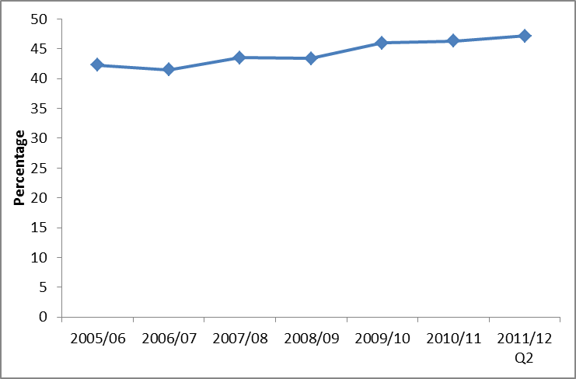
Notes
- Confidence intervals range between +/-0.7 and +/-1.9 from 2005/06 onwards.

The vast majority of visits were done in their own free time (97.7%), with a small percentage attending for paid work and for academic study (2.4% and 2.7% respectively).

While people who live in rural areas are just as likely as people in urban areas to have visited a museum or gallery in the last year, there are variations by region.

In 2011/12 Q2, Londoners (56.1%) had the highest levels of attendance, while those in the East Midlands (39.5%) had the lowest levels of attendance. Since 2005/06, the proportion of people visiting museums or galleries increased in all regions except for East Midlands, and the South West.

The most recent period shows a significant increase in the proportion of black and minority ethnic (BME) groups visiting a museum or gallery in the last year from 35.4 per cent (in 2005/06) to 40.6 per cent. However this level is significantly lower than the percentage of white adults visiting (47.9%).

People in the higher ACORN groups such as Wealthy Achievers (54.5%) and Urban Prosperity (64.2%) had higher attendance rates than the Hard-pressed (31.8%) (Figure 2.2).
Figure 2.2: Proportion who have visited a museum or gallery in the last year, October 2010 to September 2011, by ACORN group

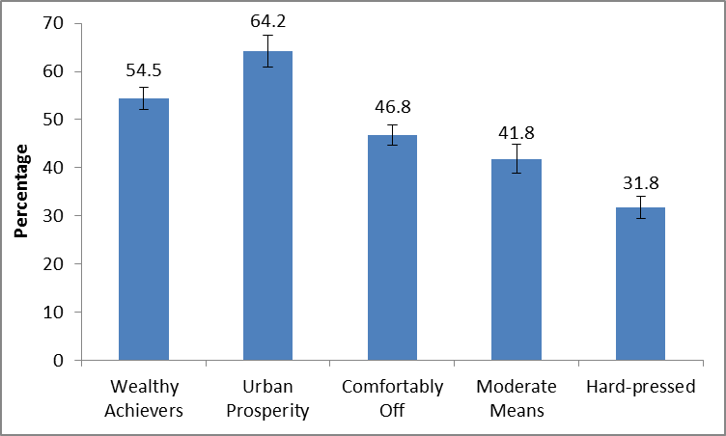
Notes
- Confidence intervals range between +/-2.1 and +/-3.3

Over half (57.2%) of adults in the upper socio-economic group visited a museum or gallery compared to 32.9 per cent in the lower group. Over half of working adults had attended (52.5%) compared to 39.6 per cent of adults not working.

Digital engagement

In October 2010 to September 2011, 25.9 per cent of adults had visited a museum or gallery website, an increase from 15.8 per cent in 2005/06.

Between 2008/09 and 2010/11 Q2, of those who had visited a museum or gallery website, there were increases in the proportions of people visiting a museum or gallery website to book tickets (from 47.5% to 54.5%) or to find out about a subject (from 46.5% to 50.9%). Meanwhile the proportion visiting to look at a collection remained steady over the last couple of years (21.5% in the latest period).

The Taking Part Survey added new questions on museum or gallery websites from July 2011. In this period, of those who had visited a museum or gallery website, 17.6 per cent of adults had taken a virtual tour of a museum or gallery and 13.5 per cent had viewed or downloaded an event or exhibition.

Further detail on this section can be found in the accompanying spreadsheets to this release available at: http://www.dcms.gov.uk/publications/8734.aspx

- Libraries

This chapter examines library participation as measured by attendance in the last 12 months, by a range of area-level and socio-demographic breakdowns. Details on the ways that people digitally engage with library services are also given.

Key findings

- In October 2010 to September 2011, 39.0 per cent of adults had used a library in the last 12 months, a significant decrease from 48.2 per cent in 2005/06, but showing no further change from 2009/10.

- Between 2005/06 and October 2010 to September 2011, the proportion of people using a public library declined in all regions.

Library attendance

In October 2010 to September 2011, 39.0 per cent of adults reported using a library service in the last 12 months, a significant decrease from 48.2 per cent in 2005/06, and no change from 2009/10 (Figure 3.1).

Figure 3.1: Library attendance by sex, 2005/06 to October 2010 - September 2011

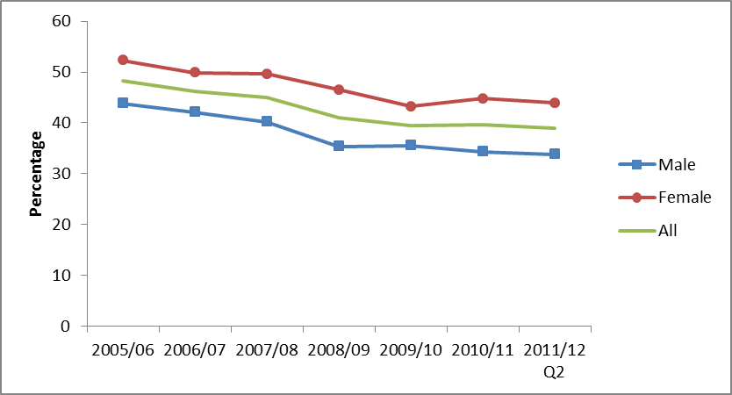
Notes
(1) Confidence intervals range between +/-0.7 and +/-2.5 from 2005/06 onwards.
There is no significant difference between library attendance in urban (39.4%) and rural areas (37.2%). Attendance levels in both areas have declined since 2005/06.

Between 2005/06 and October 2010 to September 2011, the proportion of people using a public library declined in all regions. During that time period, the decline in library usage has been across all socio-demographic groups.

In October 2010 to September 2011, the following patterns of library attendance were observed:

- Women (43.9%) have a higher rate of library attendance than men (33.8%).
- People in upper socio-economic groups (43.2%) have a higher rate of library attendance than people in lower socio-economic groups (33.1%).
- People not working (41.6%) have higher rates of library attendance than those who are working (37.1%).
- White people (37.8%) have lower rates of library attendance than black and minority ethnic (BME) groups (47.7%).

The same patterns have been consistent since 2005/06; however the library attendance rates were higher for each category in 2005/06.

Digital engagement

In October 2010 to September 2011, 16.2 per cent of adults had visited a library website in the last 12 months, a significant increase from 8.9 per cent in 2005/06. Of those who had visited a library website, 76.4 per cent had searched and viewed online information or made an enquiry. 38.2 per cent had completed a transaction, e.g. reserve or renew items or pay a fine; a significant increase from 28.1 per cent in 2006/07.

Further detail on this section can be found in the accompanying spreadsheets to this release available at: http://www.dcms.gov.uk/publications/8734.aspx

- Arts

Taking Part asks respondents whether they have participated in a given range of arts activities or attended a range of activities. These two forms of activity are combined to provide the overall measure of arts engagement. Details on the ways that people digitally engage with the arts are also given.

Key findings

- In October 2010 to September 2011, 77.3 per cent of adults had engaged in the arts in the last year.

- Arts engagement increased between 2009/10 and October 2010 to September 2011 for the most deprived decile group, from 59.9 per cent to 67.7 per cent.

- Between 2005/06 and October 2010 to September 2011 arts engagement increased for people living in urban areas, from 74.9 per cent to 76.7 per cent.

- Adults aged 65-74 and 75+ have seen a significant increase in engagement since 2005/06 (from 70.7% to 75.7% for 65-74 year olds and from 57.5% to 61.1% for age 75 and over). However, adults aged 75 and over still have significantly lower arts engagement rates than the other age groups.

Arts engagement

The latest results show 77.3 per cent of adults reported engagement in arts activities in the last 12 months, which is not a statistically significant increase from 76.3 per cent in 2005/06 (Figure 4.1).

Figure 4.1: Arts engagement, by sex, 2005/06 to October 2010 - September 2011

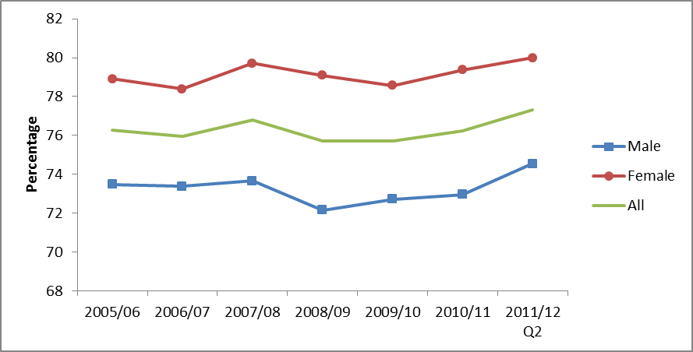Notes
(1) Confidence intervals range between +/-0.7 and +/-3.1 from 2005/06 onwards.

In October 2010 to September 2011, 62.8 per cent of adults had engaged with the arts three or more times in the last 12 months, unchanged from 2005/06. 8.2 per cent of adults had engaged once in the last 12 months, a significant increase from 7.2 per cent in 2005/06.

Arts engagement in the regions remained steady between 2005/06 and October 2010 to September 2011. However, arts engagement increased for people living in Urban areas (from 74.9% to 76.7%) during that period.

In October 2010 to September 2011, the following patterns of arts engagement were observed:

- Arts engagement tends to be higher among people who live in less deprived neighbourhoods. Since 2009/10, levels of engagement have remained level in each Index of Deprivation decile group, except for the most deprived, where engagement has increased from 59.9 per cent to 67.7 per cent.
- People aged 75 and over have significantly lower arts engagement rates (61.1%) than the other age groups. Although the 65-74 and 75+ age groups have seen a significant increase in engagement since 2005/06 (from 70.7% to 75.7% for 65-74 year olds, from 57.5% to 61.1% for age 75 and over), engagement rates for other age groups have remained steady during that period.
- Women (80.0%) had higher arts engagement rates than men (74.5%).
- Arts engagement is higher among white people (78.3%) than black and minority ethnic (BME) groups (69.8%).
- People with no long-standing illness or disability had a higher arts engagement rate (79.8%) than people with a long-standing illness or disability (71.5%).

These patterns are consistent with previous years.

Digital engagement

In October 2010 to September 2011, 39.5 per cent of adults had visited a theatre or concert website, a significant increase from 30.5 per cent in 2005/06. Of those who had visited a theatre or concert website, 64.7 per cent of people had bought tickets for an arts performance or exhibition, a significant increase from 43.2 per cent in 2006/07.

The Taking Part Survey added new questions on arts websites from July 2011. Between July 2011 and October 2011, of those who had visited an arts website, the most popular reason was to find out more about an artist, performer or event (71.0%), followed by viewing or downloading part or all of a performance or exhibition (23.6%). 8.1% of adults visited an arts website to find out how to take part or improve their creative skills.

Further detail on this section can be found in the accompanying spreadsheets to this release available at: http://www.dcms.gov.uk/publications/8734.aspx

- Archives

Archives have been routinely presented alongside data on museums and galleries in previous releases. This report presents analysis on the individual archive sector. Participation in archives is measured by attendance at an archive in the last year. Details on the ways that people digitally engage with archives are also given.

Key findings

- In the year to September 2011, the proportion of adults visiting an archive (in their own time and voluntary) in the last year remained steady at 3.7 per cent.

- Half of adults who did visit an archive did so just once in the last 12 months.

- 6.9 per cent of adults aged 65-74 visited an archive, compared to just 1.7 per cent of 16-24 year olds.

Overall participation in archives

In this latest period, 3.7 per cent of adults had visited an archive in the last year in their own time or as part of voluntary work. This is significantly lower than 2005/06 (5.9%). Including paid work visits and academic study visits, this increases to 4.7 per cent of all adults. The trend over time is shown in Figure 5.1 below.

Figure 5.1: Percentage of adults visiting an archive or records office, 2005/06 to October 2010 - September 2011

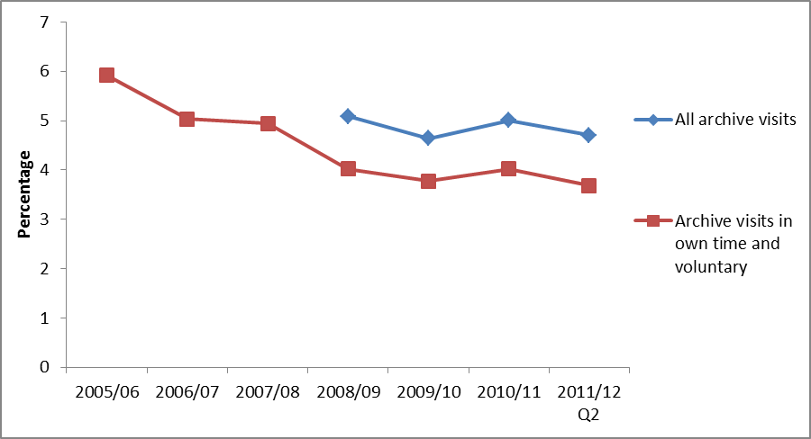
Notes
- Confidence intervals range between +/-0.3 and +/-0.8 from 2005/06 onwards.
- Some archive questions were not asked prior to the 2008/09 survey.

There is little variation between different areas or demographic groups, but adults from upper socio-economic groups had a significantly higher attendance rate (4.7%) than those in lower socio-economic groups (2.7%).

Over three quarters of all archive visits (77.1%) were in their own time, followed by 16.0 per cent visiting for paid work, and 8.2 per cent for academic study.

Digital engagement

People are more likely to visit an archive or records office online than in person. In October 2010 to September 2011, 11.2 per cent of adults had visited an archive or records office website in the last 12 months, a significant increase from 9.7 per cent in 2005/06. Of those who had visited an archive or records office website, 61.7 per cent had done so to view digitised documents; around a third of adults had searched a catalogue, and 19.6 per cent had completed a transaction.

Further detail on this section can be found in the accompanying spreadsheets to this release available at: http://www.dcms.gov.uk/publications/8734.aspx

- Sport and active recreation

This chapter examines sport and active recreation by a range of area-level and socio-demographic breakdowns. Key findings on swimming and cycling proficiency – that is the extent to which adults feel able to swim and cycle – are also provided. Details on digital engagement as measured by visiting sports websites are also given.

Key findings

- 54.0 per cent of adults had participated in active sport at least once in the last 4 weeks. 25.8 per cent had participated in 30 minutes of moderate intensity sport at least three times in the last week, with the corresponding figure of 43.0 per cent at least once in the last week.

- Since 2005/06, the proportion of 16-24 year olds participating in sport at least once in the last 4 weeks has decreased, while the proportion of people aged 75+ participating has increased.

Participation in sport or recreational physical activities

In October 2010 to September 2011, 54.0 per cent of adults had participated in active sport at least once in the last 4 weeks. This is unchanged from 2005/06 (53.7%). Over that same period, 25.8 per cent of adults had participated in moderate intensity sport for at least 30 minutes three times in the last week, an increase from 2005/06 (23.2%). 43.0 per cent had participated in moderate intensity sport for at least 30 minutes once in the last week, an increase from 2005/06 (41.2%) (Figure 6.1).

Figure 6.1: Percentage of adults who have participated in sports, 2005/06 to October 2010 - September 2011

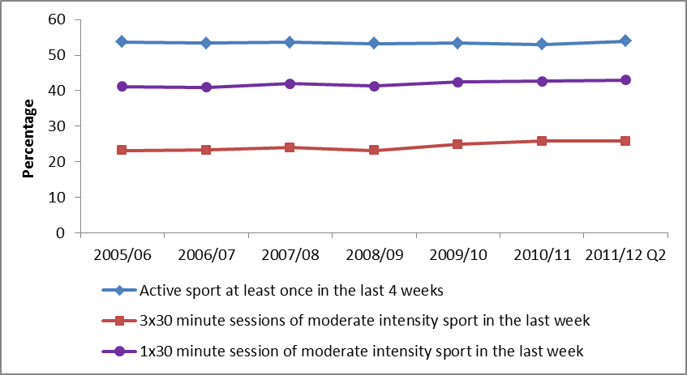
Notes
(1) Confidence intervals range between +/-0.6 and +/-1.9 from 2005/06 onwards.

When we look at the frequency of 30 minutes or more of moderate intensity sport undertaken in the last 4 weeks, during 2005/06 and October 2010 to September 2011, the percentage participating less than once a week decreased from 9.8 per cent to 8.9 per cent. At the other end, the percentages participating at least three times a week but not every day and those participating every day increased from 14.3 per cent to 15.9 per cent, and from 8.9 per cent to 9.9 per cent, respectively.

The proportion of people in ACORN classification ‘Urban Prosperity’ who have done sport once in the last 4 weeks significantly increased from 59.3 per cent in 2005/06 to 63.4 per cent in October 2010 to September 2011. In general, people who live in less deprived neighbourhoods are more likely than those who live in more deprived neighbourhoods to participate in sport. This has not changed since 2005/06.

Between 2005/06 and October 2010 to September 2011, the proportion of 16-24 year olds who had taken part in active sport at least once in the last 4 weeks decreased from 76.8 per cent to 72.1 per cent. Across the same time period, the proportion of people aged 75+ doing sport increased from 15.2 per cent to 19.9 per cent.

Rates of sports participation have remained steady across the other socio-demographic groups, apart from people not working where it increased from 38.6 per cent to 41.0 per cent during the period.

For the 1x30 and 3x30 minute moderate intensity sport in the last week measures, there have been significant increases in participation rates between 2005/06 and October 2010 to September 2011, for the 25-44 age group (from 28.6% to 32.5% for the 3x30 measure, and from 50.0% to 53.0% for the 1x30 measure,) and 45-64 age groups (from 20.1% to 23.8% for the 3x30 measure, and from 36.8% to 40.5% for the 1x30 measure). Older age groups have a lower sport participation rate (Figure 6.2).

Figure 6.2: Percentage of adults who have participated in sports by age group, October 2010 - September 2011

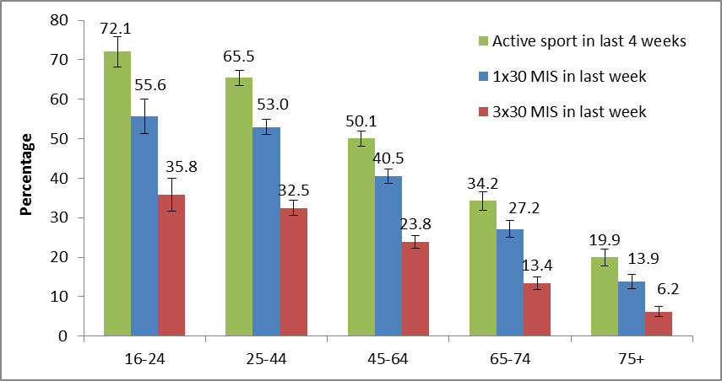
Notes
(1) Confidence intervals range between +/-1.3 and +/-4.4.
During the same period, there was also a significant increase in participation rates in the 1x30 measure for men (from 46.0% to 48.9%), and also significant increases in participation rates in the 3x30 measure for men (from 26.8% to 29.9%) and women (from 19.7% to 21.8%).

Digital engagement

Since 2005/06, the proportion of adults visiting sports websites has increased from 26.1 per cent to 37.4 per cent.

Further detail on this section can be found in the accompanying spreadsheets to this release available at: http://www.dcms.gov.uk/publications/8734.aspx

Cycling and swimming proficiency

- In October 2010 to September 2011, 81.7 per cent of adults stated that they could swim and 85.8 per cent stated that they could cycle.
- Despite swimming being among the most popular sports for women, men (86.3%) are more likely than women (77.3%) to say that they can swim. Men are also more likely to say that they can cycle (92.9% compared with 79.0%).
- White people were more likely than BME groups to say that they can swim (83.8% compared with 65.7%) and cycle (87.2% compared with 75.3%).
- Like sports participation generally, swimming and cycling proficiency is also linked with the type of area people live in, with people who live in the least deprived neighbourhoods more likely to say that they can swim and cycle.

- Big Society
Taking Part asks whether respondents have done any volunteering work in the last 12 months and whether this relates to any of the DCMS sectors. It also includes a range of questions on social capital and cohesion. Recently added questions ask about charitable donations and whether these relate to DCMS sectors.

Key findings

- In October 2010 to September 2011, the proportion of adults volunteering in the last 12 months remained at 23.8 per cent. 7.1 per cent of all adults had volunteered in any DCMS sector. Of those who volunteered, 8.8 per cent had done so in the arts sector which is a significant increase from 2005/06 (6.3 per cent).

- There was a significant increase in the proportion of black and ethnic minority (BME) groups who had volunteered in the last 12 months compared to 2005/06 (up from 19.6% to 23.5%).

- In October 2010 to September 2011 88.9 per cent of adults had donated money (including any donations into a collection box) in the last 12 months. 31.5 per cent of all adults had donated to one of the DCMS sectors.

Volunteering

In 2011/12 Q2, 23.8 per cent of adults reported that they had taken part in voluntary activities in the last 12 months. 7.1 per cent of all adults had volunteered in any DCMS sector, and Figure 7.1 shows of those who volunteered which sectors they did it in.

Figure 7.1: Volunteering by DCMS Sector (% of adults who volunteer), 2005/06 to October 2010 – Sept 2011

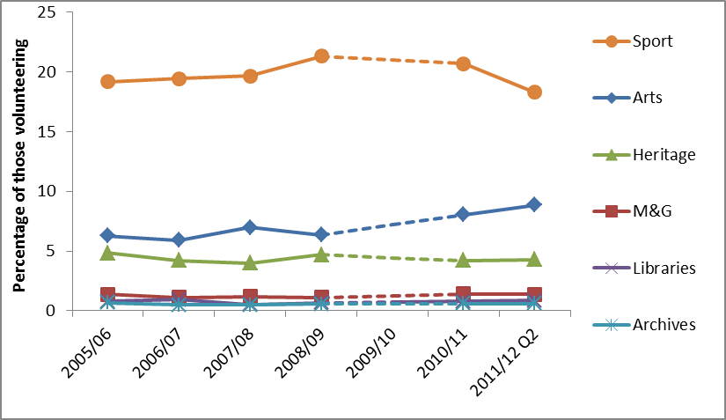
Notes
- Confidence intervals range between +/-0.2 and +/-1.8 from 2005/06 onwards
- Volunteering question was not asked in 2009/10

Adults who had participated in any DCMS sector had higher volunteering rates, than adults who had not participated, e.g. of adults who had participated in sport, 27.8 per cent of them had volunteered in sport, compared with just 7.6 per cent of those who did not play sports.

For adults who volunteered in DCMS sectors we asked them ‘During the last four weeks how much time have you spent on voluntary work?’ The arts sector had the highest average amount of time spent volunteering during the last 4 weeks (over 13 hours). On average 12 hours 11 minutes was spent in the last 4 weeks by volunteers in the heritage sector, followed by and 8 hours 50 minutes by volunteers in the sports sector.

Charitable giving

Taking Part asks whether respondents have donated money in the last 12 months and whether this was to any of the DCMS sectors.

In October 2010 to September 2011 88.9 per cent of adults had donated money (including any donations into a collection box) in the last 12 months. 31.5 per cent of all adults had donated to one of the DCMS sectors.

36.2 per cent of adults donated money less often than once a month but at least 3 or 4 times a year and 32.2 per cent donated less often than once a week but at least once a month.

Overall civic participation

Taking Part asks a series of questions on sporting and cultural facilities in the respondent’s local area.

In the year to September 2011, over three quarters of adults (76.6%) had not taken any actions to try to get something done about sporting and cultural facilities in their area. The most common action that had been taken was to contact the council, with 11.6 per cent of adults having done so. Also 4.8 per cent of adults had contacted their local councillor or MP.

43.8 per cent of adults had been involved in groups, clubs or organisations in the last 12 months, which was significantly lower (at the 90% confidence level) than in 2010/11. Of those adults, the most popular type of group was sports/exercise groups, taking part/coaching/watching (50.7% of adults who had attended a group), followed by hobbies/social clubs (34.8%).

Further detail on this section can be found in the accompanying spreadsheets to this release available at: http://www.dcms.gov.uk/publications/8734.aspx
- The 2012 Olympic and Paralympic Games

This chapter examines the extent to which people in England support the UK hosting the 2012 Olympic and Paralympic Games. It covers the reasons why people are either supportive of or against the UK hosting the 2012 Games, and provides analysis by a range of area level and socio-demographic variables. This chapter also examines for the first time how people intend to get involved in the Games.

Key findings

    - Almost two thirds (64.5%) of adults are slightly or strongly supportive of the 2012 Olympic and Paralympic Games.

    - The proportion of those strongly supportive of the Games has shown a significant decrease, falling from 48.4 per cent in 2005/06 to 39.7 per cent in 2011/12 Q2. The proportion of those who are slightly supportive has increased to 24.9 per cent from 22.5 per cent in 2005/06 whilst the proportion who are neither against nor supportive of the Games has also increased from 18.4 per cent to 24.5 per cent over the same period.

    - Between October 2010 and September 2011, 6.9 per cent of adults reported that the UK winning the bid had motivated them to do more sport or recreational physical activity, 3.8 per cent reported that they were motivated to do more cultural activities and 5.8 per cent reported that they were motivated to do more voluntary work.

    - 85.6 per cent of adults intend to follow the London 2012 Olympic or Paralympic Games; with 25.3 per cent of adults actively getting involved in the Games.

The 2012 Olympic and Paralympic Games

In 2011/12 Q2, 64.5 per cent of adults were supportive of the 2012 Games, reporting that they were slightly or strongly supportive. This is a significant decrease from 2005/06 when 71.0 per cent reported that they were supportive. The proportion of those who are strongly supportive has fallen from 48.4 per cent in 2005/06 to 39.7 per cent in the latest results. The proportion who are neither against nor supportive of the Games has increased from 18.4 per cent to 24.5 per cent over the same period with those either slightly or strongly against remaining stable at 10.3 per cent.

Those from a black and minority ethnic (BME) background were more likely to be supportive of the Games than those with a white background (77.3% and 63.4% respectively). Men were more likely to be supportive than women (67.2% and 62.8%, respectively) and those aged 25-44 years old were the most supportive group (69.3%). The least supportive group was those aged 75+ with 54.0 per cent being supportive of the Games.

London is now the region with the highest level of support (70.7 per cent) while those in the North East are least supportive (56.9%). However, the levels of support within London vary, and between July 2005 and September 2011, 74.2 per cent of respondents in Newham (a host borough) were supportive of the Games, compared to 55.7 per cent of respondents in Bexley.

Figure 8.1: Proportion of adults who are slightly or strongly supportive of the UK hosting the 2012 Olympic Games, London, July 2005 to September 2011
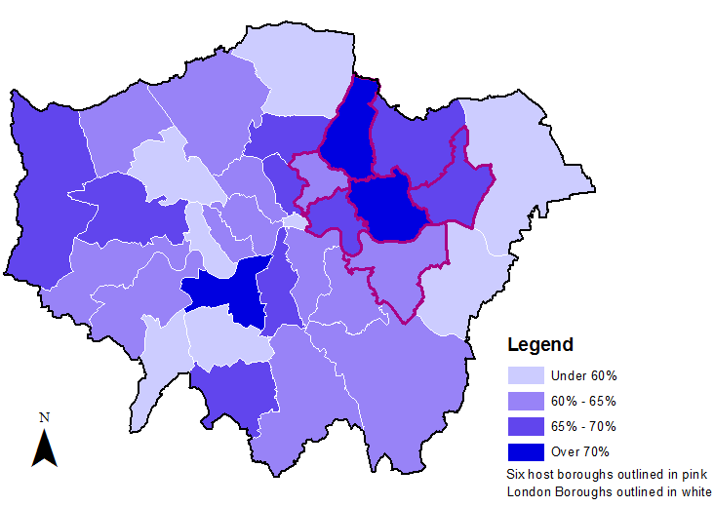
Notes
- Results for the City of London are indicative due to a small sample size.
- Sample sizes vary by London Borough (excluding City of London) from 171 to 713.

Between July 2011 and September 2011 the Taking Part Survey asked some new questions on adults’ intended involvement in the Games. 85.6 per cent of adults intend to follow the London 2012 Olympic or Paralympic Games, either by watching on TV at home (82.2%), reading about it on a newspaper online or offline (31.7%), listening to it on the radio at home (15.3%), watching or listening on the internet at home (14.7%) or watching live events on a public big screen (12.0%).

Additionally, since July 2011 we asked adults whether they intend to actively follow or get involved in the London 2012 Olympic or Paralympic Games. 25.3 per cent of adults said they did, which includes attending a free or ticketed Olympic or Paralympic event, taking part in a Games related sports or physical activity or using a new or improved sports facility linked to the Games, volunteering during the Games (e.g. as a Gamesmaker or London Ambassador), gaining Games related employment or training, taking part in a Games related cultural event or activity or taking part in a Games related community event or activity (e.g. street party or local Inspire Mark project).
Further detail on this section can be found in the accompanying spreadsheets to this release available at: http://www.dcms.gov.uk/publications/8734.aspx
Annex A: Background note

- The Taking Part Survey is commissioned by the Department for Culture, Media and Sport (DCMS) and its partner arm’s length bodies (ALBs). For 2011 to 2015 these are Arts Council England, English Heritage and Sport England.

- Taking Part is a National Statistic and as such has been produced to the high professional standards set out in the Code of Practice for Official Statistics. National Statistics undergo regular quality assurance reviews to ensure they meet customer needs and are produced free from any political interference. For more information, see http://www.statisticsauthority.gov.uk/assessment/code-of-practice/code-of-practice-for-official-statistics.pdf

- Stringent quality assurance procedures have been adopted for this statistical release. All data and analysis has been checked and verified by two different members of the team and TNS-BMRB to ensure the highest level of quality.

- The latest results presented here are based on interviews issued between October 2010 and September 2011. The total sample size for this period is 11,780.

- The survey measures participation by adults (aged 16 and over) and children (5-10 and 11-15) living in private households in England. No geographical restriction is placed on where the activity or event occurred.

- The median adult sample interview length for the 2010/11 survey was 40 minutes 42 seconds (mean 42 minutes 36 seconds). The median survey length for the 5-10 year old child interview was 14 minutes 3 seconds (mean 14 minutes 58 seconds) and for 11-15 year olds it was 24 minutes 16 seconds (mean 25 minutes 41 seconds).

- Participation in these activities must be for the purpose of recreation or leisure, including voluntary work. It excludes involvement in activities where the prime motivation is paid work or academic studies. The exceptions to this are attendance at historic environment sites which includes visits made for academic study, and sports participation which exclude volunteering, teaching, coaching and refereeing. Paid work visits and academic study visits are also included in one of the archive attendance measures.

- The range has been calculated using a 95% confidence interval. This means there is a 95% probability the true percentage lies in the range given. All estimates have been rounded to one decimal place. An overall design factor of 1.265 has been applied to the dataset for the period October 2010 to September 2011. Individual design factors have been calculated for each sector in this period, ranging from 1.224 to 1.384. Statistical significance tests have been run at the 95% level. This means the probability that any given difference happened by chance is low (1 in 20).

- All differences and changes reported are statistically significant at the 95% confidence level unless otherwise stated.

- Some figures may have been revised from previous releases, in which case the figures in this release supersede those from previous statistical releases. For more detailed information on the DCMS revisions policy and how revisions are handled for the Taking Part Survey, please see the DCMS statement of compliance on our website.

- The data are weighted to ensure the representativeness of the Taking Part sample. There are two types of weighting: i) to compensate for unequal probabilities of selection; and ii) to adjust for differential non-response. Weighting is based on mid-2009 population estimates from the Office for National Statistics.

- For more information about the Taking Part Survey, including previous publications, see http://www.culture.gov.uk/reference_library/research_and_statistics/4828.aspx

Versions of the questionnaire from all years of the survey are available, see http://www.culture.gov.uk/what_we_do/research_and_statistics/7387.aspx

- The fieldwork for the survey is being conducted by TNS-BMRB. For more information, see http://www.tns-bmrb.co.uk

- We can also provide documents to meet the specific requirements of people with disabilities. Please call 020 7211 6000 or email takingpart@culture.gsi.gov.uk

- This report has been produced by Yun Wong and Peter Antoniades. Acknowledgement goes to colleagues within the DCMS, partner ALBs and TNS-BMRB for their assistance with the production and quality assurance of this release.

- The responsible statistician for this release is Peter Antoniades. For enquiries on this release, please contact Peter Antoniades on 0207 211 6188.

- For general enquiries telephone: 0207 211 6200
Department for Culture Media and Sport
2-4 Cockspur Street
London
SW1Y 5DH
enquiries@culture.gov.uk

.

Annex B: Sector definitions

The following annex presents the various definitions for adult participation in DCMS sectors.

Libraries
The respondent is asked if they have used a public library service. If the respondent is unsure what is in scope, the interviewer has the following definition to refer to.
“Use of a public library can include:
- A visit to a public library building or mobile library to make use of library services (including to print/use electronic resources or to take part in an event such as a reading group or author visit)
- The use of on-line library resources or services remotely (i.e. used a computer outside the library to view the website, catalogue or databases)
- Access, and receipt, of the library service by email, telephone, fax or letter
- Receipt of an outreach service such as home delivery or library events outside a library building
Use of other libraries and archive services is excluded.”

Museum, gallery or archive
The respondent is asked if they have attended a museum, gallery or archive. If the respondent is unsure what is in scope, the interviewer has the following definition to refer to.
“Archives are documents that have been created by families, individuals, businesses or organisations and have been specially chosen to keep permanently. They can be written papers such as letters or diaries, maps, photographs or film or sound recordings. Archives are historical documents but do not have to be very old. Places that keep archives are usually called a record office or archive centre.
Registering a birth, death or marriage happens at a registry office, not at an archive centre/record office.”

Arts
The respondent is asked if they have participated in a given list of arts activities, or attended a given list of arts events. Eligible activities and events are as follows.
Participation:
- Dance – ballet or other dance (for fitness and not for fitness)
- Singing – live performance or rehearsal/practice (not karaoke)
- Musical instrument – live performance, rehearsal/practice or played for own pleasure
- Written music
- Theatre – live performance or rehearsal/practice (e.g. play or drama)
- Opera/musical theatre – live performance or rehearsal/practice
- Carnival (e.g. as a musician, dancer or costume maker)
- Street arts (art in everyday surroundings like parks, streets, shopping centre)
- Circus skills (not animals) – learnt or practised
- Visual art – (e.g. painting, drawing, printmaking or sculpture)
- Photography – (as an artistic activity, not family or holiday ‘snaps’)
- Film or video – making as an artistic activity (not family or holidays)
- Digital art – producing original digital artwork or animation with a computer
- Craft – any craft activity (e.g. textiles, wood, metal work, pottery, calligraphy etc)
- Creative writing – original literature (e.g. stories, poems or plays)
- Book club – being a member of one

Attendance:
- Visual art exhibition (e.g. paintings, photography or sculpture)
- Craft exhibition (not crafts market)
- Event which included video or digital art
- Event connected with books or writing
- Street arts (art in everyday surroundings like parks, streets or shopping centre)
- Public art display or installation (an art work such as sculpture that is outdoors or in a public place)
- Circus (not animals)
- Carnival
- Culturally specific festival (e.g. Mela, Baisakhi, Navratri)
- Theatre (e.g. play, drama, pantomime)
- Opera/musical theatre
- Live music performance (e.g. classical, jazz or other live music event but not karaoke)
- Live dance event (e.g. ballet, African People’s dance, South Asian, Chinese, contemporary or other live dance)

Historic environment
The respondent is asked if they have visited the following list of historic environment sites.

- A city or town with historic character
- A historic building open to the public
- A historic park, garden or landscape open to the public
- A place connected with industrial history or historic transport system
- A historic place of worship attended as a visitor
- A monument such as a castle, fort or ruin
- A site of archaeological interest
- A site connected with sports heritage

Active sport
The respondent is asked about their participation in active recreation and a range of sports. Eligible activities are as follows.

- Swimming or diving (indoors and outdoors)
- BMX, cyclo-cross, mountain biking
- Bowls (indoors and outdoor lawn bowls)
- Tenpin bowling
- Health, fitness, gym or conditioning activities
- Keepfit, aerobics, dance exercise (includes exercise bike)
- Judo
- Karate
- Taekwondo
- Other martial arts (includes self-defence, tai chi)
- Weight training (includes body building)
- Weightlifting
- Gymnastics
- Rugby League
- Rugby Union
- American football
- Football (includes 5-a-side and 6-a-side) [indoors and outdoors]
- Gaelic sport (e.g. camogie, Gaelic football, hurling, Irish handball and shinty)
- Cricket
- Hockey (excludes ice, roller and street hockey, but included in ‘other’)
- Baseball/softball
- Netball
- Tennis
- Badminton
- Squash
- Basketball
- Table tennis
- Track and field athletics
- Jogging, cross-country, road running
- Yachting or dingy sailing
- Canoeing
- Windsurfing or boardsailing
- Ice skating
- Curling
- Golf, pitch and putt, putting
- Skiing (on snow or on artificial surface; on slopes or grass)
- Horse riding
- Climbing/mountaineering (includes indoor climbing)
- Hill trekking or backpacking
- Motor sports
- Volleyball
- Orienteering
- Rounders
- Rowing
- Triathlon
- Boxing
- Waterskiing
- Lacrosse
- Fencing
- Other types of sport, e.g. rollerblading, street hockey, skateboarding, water polo, surfing, scuba diving, gliding, hang/paragliding, parachuting or parascending

Moderate intensity sport
To be counted as ‘moderate intensity’, the respondent must have participated in at least one 30-minute session (or alternatively three 30-minute sessions) in the past week of any of the sports (with the exception of bowls) listed above as well as recreational cycling or recreational walking. In addition, the effort put into the activity needs to be of moderate intensity, i.e. raises their breathing rate (or for walking it needs to be done at a brisk or fast pace).
The only exception to this is for those adults aged 65 and over, where some light activities are in also scope – indoor and outdoor bowls, yoga, Pilates, croquet and archery.

Digital Participation
Digital Participation includes visiting websites for at least one of the following reasons:

- Museum or gallery website – To look at items from a collection.
- Museum or gallery website – To find out about a particular subject.
- Museum or gallery website – To take a virtual tour of a museum or gallery
- Museum or gallery website – To view or download an event or exhibition
- Library website – To complete a transaction (e.g. reserve or renew items, pay a fine).
- Library website – To search and view online information or make an enquiry.
- Heritage website – To take a virtual tour of a historical site.
- Heritage website – To learn about history or the historic environment
- Heritage website – To discuss history or visits to the historic environment on a forum
- Arts Website – To view or download part or all of a performance or exhibition
- Arts Website – To discuss the arts or share art that others have created
- Arts Website – To upload or share art that you have created yourself
- Arts Website – To find out how to take part or improve your creative skills
- Archive or records office website – To complete a transaction.
- Archive or records office website – To view digitized documents online.
- Archive or records office website – To search a catalogue.

Volunteering
The respondent is asked about any voluntary work they have done, including:

- Raising or handling money / taking part in sponsored events
- Leading a group
- Being a member of a committee
- Organising or helping to run an activity or event
- Visiting people
- Befriending / mentoring people
- Coaching or tuition
- Giving advice/ information/ counselling
- Secretarial, administrative or clerical work
- Providing transport or driving
- Representing – e.g. addressing meetings, leading a delegation
- Campaigning – e.g. lobbying, canvassing, letter writing
- Conservation/restoration
- Officiating – e.g. judging, umpiring or refereeing
- Other practical help - e.g. helping out a school, religious group, with shopping/refreshments
- Work in a charity shop

The respondent is also asked whether this activity was connected to any of the following areas:

- Arts
- Museum or gallery
- Heritage
- Libraries
- Archives
- Sport
- Any other sector

2-4 Cockspur Street
London SW1Y 5DH
www.culture.gov.uk

Percentages will not total to 100% as some people may have visited a museum or gallery for more than one reason.
Percentages will not total to 100% as some people may have visited an archive for more than one reason.
Actions include, contact a local radio station, TV station or paper; talk to / written to a sporting or cultural facility, contact the council, contact a local councillor or MP, join a local group or attend a neighbourhood forum, attend a protest meeting or joined a campaign group, or help organise a petition.

