ANNEX 5: MARKET CONTEXT DATA

  broadband penetration vs. online advertising
  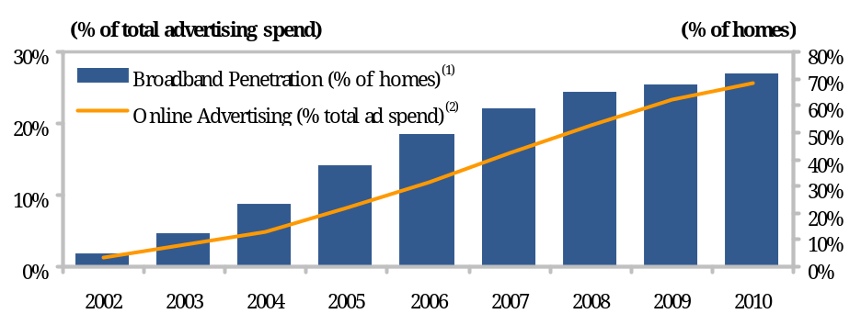
  High speed internet usage has increased dramatically since 2000…
  age and gender of the 30 most-viewed channels ⁽⁴⁾
  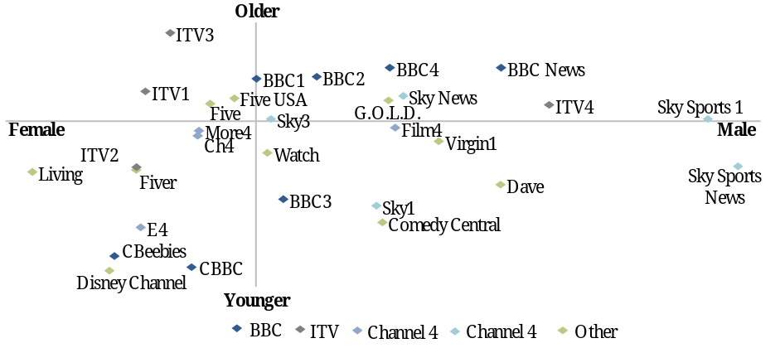
  In the meantime, to maximise advertiser ROI, brands across various forms of media including in TV have proliferated across consumer demand niches, increasing competition
  Advertising spend by media format⁽³⁾
  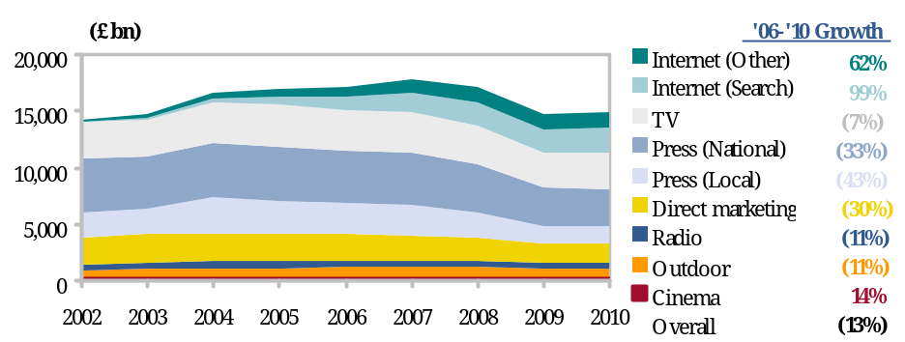
  …leading to advertising spend being directed away
  from newspapers, radio and TV
  UK media index⁽⁵⁾
  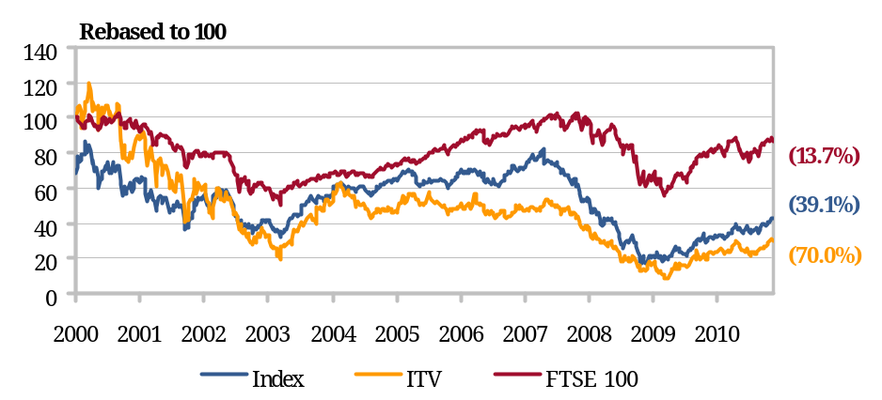
  Structural decline and increased competition has impacted the comparative performance of traditional media companies
ANNEX 5: MARKET CONTEXT DATA (cont’d)

  Audience Share Per Channel⁽¹⁾
  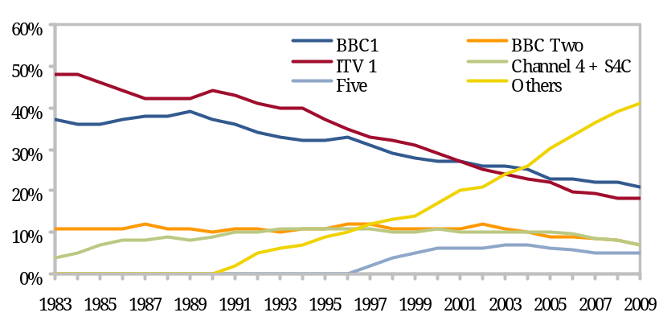
  Proliferation of channels over time has
  eroded the audience share of BBC1 and ITV1…
  Multi Channel Take Up⁽³⁾
  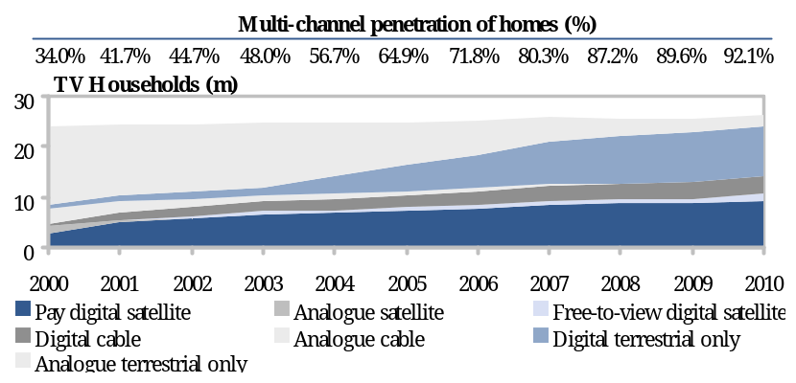
  Households have shown significant willingness to pay for new platform packages leading to a reduction in free-to-air household share…
  commercial tv market shares⁽²⁾
  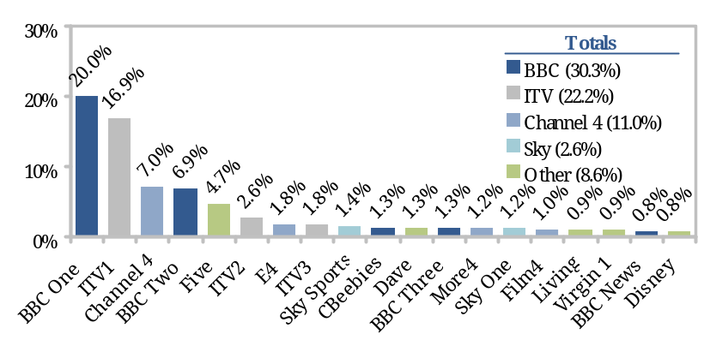
  … however, top 5 viewing shares remain concentrated with a long tail of channels with a c.1% share that typically broadcast syndicated content
  channels with a c.1% share that typically broadcast syndicated content
  split in TV Revenues Over Time⁽⁴⁾
  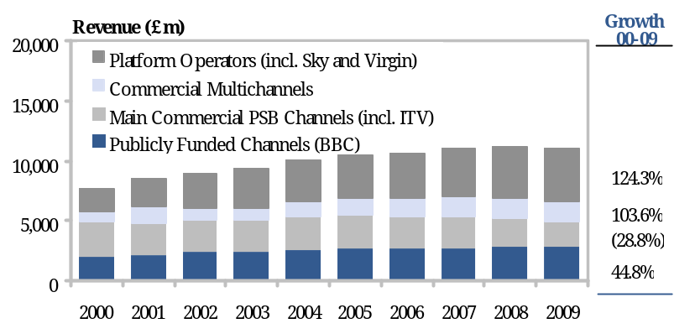
  … leading to platform operators increasing their share of industry revenues, and commercial PSB operators facing decline
ANNEX 5: MARKET CONTEXT DATA (cont’d)

  Definition of Local TV⁽¹⁾
  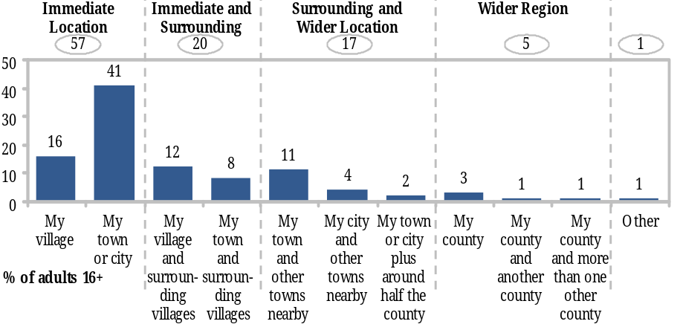
  Consumers tend to define their own village or town as being local…
  Daily media USAGE by type⁽²⁾
  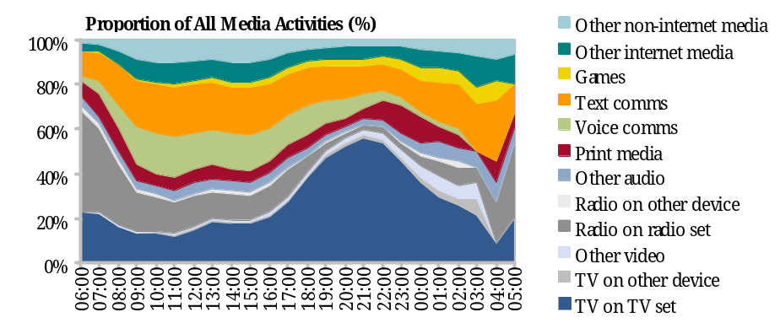
  Overall TV watching tends to peak in the evenings, with news being positioned around breakfast, lunch and early evening audiences
  Interest in Local content by genre⁽¹⁾
  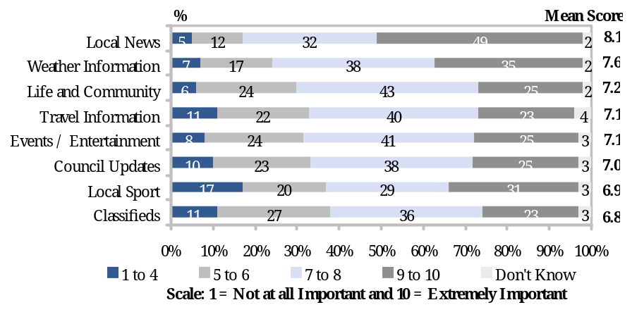
  …while they are mostly interested in local news, weather,
  life and community and traffic
  regional SHARE of viewing at time of broadcast (BARb)⁽³⁾
  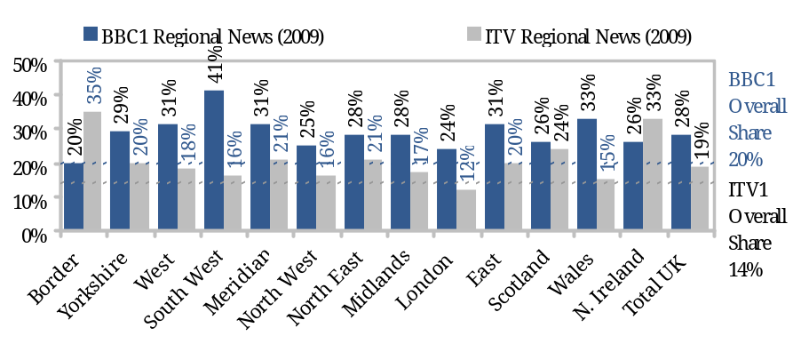
  Regional news enjoys significant audience share, however this neither proves nor disproves satisfaction with regional news or pent up demand for additional news
ANNEX 6: COMPARISON TO OTHER COUNTRIES
The US market is structurally different in its size, propensity for firms to advertise locally, low cost/high bandwidth cable distribution and network-affiliate heritage
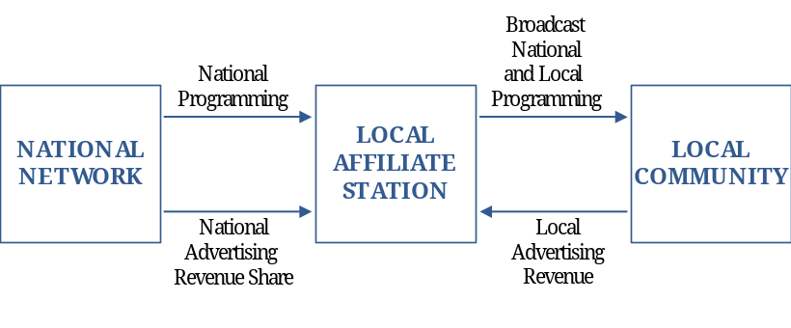
  Observations
  - Local stations have long been the cornerstone of the TV industry in the US; this is unique to the US and explained by:
  - significant distances between population centres
  - long-established network/affiliate licensing practices
  - Significantly higher TV advertising spend per capita than Europe
  - Large city stations are owned by the national networks, while smaller stations are independent, and have long-term network contracts
  - networks cite a 0.5m population conurbation as the minimum for a full service station, assuming a 7-8% audience share
  - Full service local stations are able to apply for 'must carry' obligations of cable operators, allowing the channels to be carried free of charge
  - Local advertising is a greater proportion of the whole
  ILLUSTRATIVE network affiliate model
  advertising market comparison⁽¹⁾
  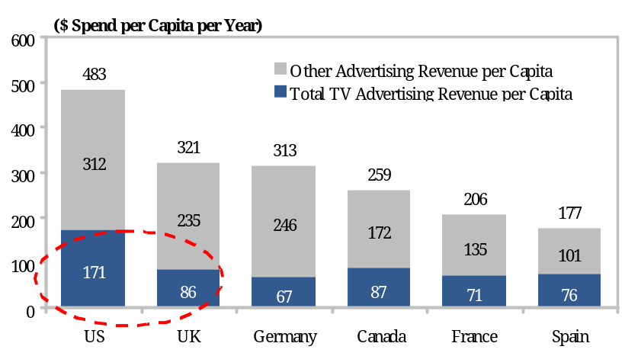
  BRoadcasters' market shares⁽²⁾
  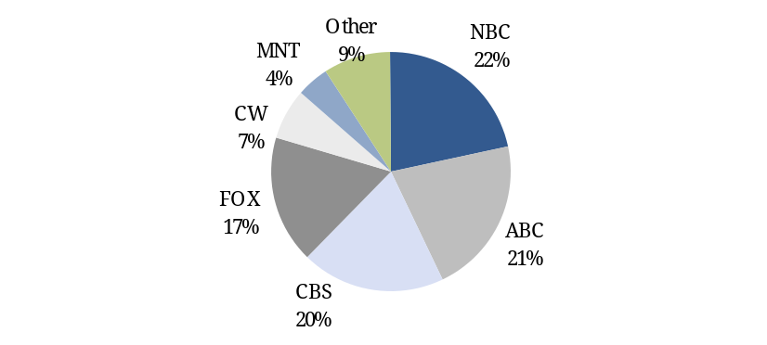
ANNEX 6: COMPARISON TO OTHER COUNTRIES
Europe and Canada are closer comparables to the UK. However, to the knowledge of the Steering Group, none of these markets have been able to provide broad local TV coverage without some kind of subsidy
Country | Model | COmmentary | subsidy detail
 | Network-affiliate model, plus subsidised community TV | - Long-term political interest in maintaining Canadian programming in both French and English given US proximity  - Most towns have one or more broadcast stations, most of which are affiliated with a national network  - Five major cities also have a city TV station  - Community channels are funded by cable providers who must provide facilities and funding (6% basic revenues) when they have at least 6,000 subscribers | - Local stations benefit from affiliate arrangements and legislation requires that cable broadcasters support community channels
 | Regional opt-out model (like UK) and numerous local cable channels | - Dominated by PSB France 3, which provides limited daily regional content and some local opt-outs  - Following a new program of licensing organised by the regulator (CSA), there has been an increase in the number of DTT channels, including some local broadcasters  - 100+ non-terrestrial local channels, usually broadcasting on cable, provide Local programming; these channels usually operate in an amateurish manner, broadcasting poor quality content often for just a few hours each day | - Regional content is subsidised through France 3  - Some regional governments provide further subsidies
 | Regional opt-out model; State subsidised local channels | - Germany benefits from significant cable penetration  - Seven regional channels (collectively Die Dritten) broadcast local opt outs (NDR Fernsehen broadcasts five, for example) through cable, satellite and IPTV. This content is sourced locally  - Most cities also have a local station broadcasting only on cable, usually subsidised by the Lander  - RTL (largest commercial broadcaster) runs local subsidiaries and broadcasts brief local content daily | - Government subsidy – the Lander subsidise most local stations
 | Regional opt-out model; government-run regional channels | - National public broadcaster Television Espanola broadcasts regional content, and ten regional governments operate their own regional channels, collaborating to buy programme rights and sell advertising. DSO will make some of these channels available outside their region  - Since 2005 around 800 licences to broadcast local DTT have been awarded | - Around 50% of local stations are funded by local governments. Almost all of the rest are supported by larger media groups
ANNEX 7: OFCOM’S INITIAL THOUGHTS ON THE INTERACTION BETWEEN A NATIONAL BACKBONE AND LOCAL SERVICES
The following is a summary of Ofcom's initial thoughts on the interaction between the national backbone and local services carried on DTT using GI
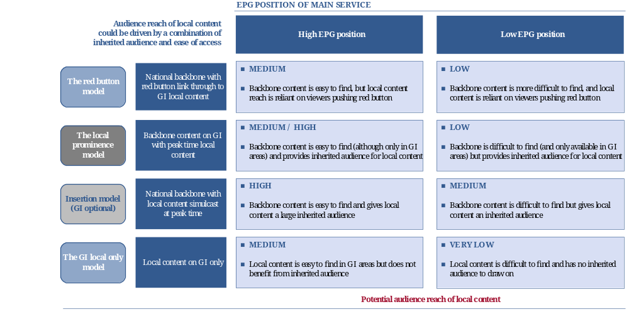
ANNEX 8: ILLUSTRATIVE CANDIDATE CONURBATIONS IDENITIFIED BY OFCOM
Top 20 conurbations by population size shown
ANNEX 9: POTENTIAL NATIONAL ADVERTISING FOR A LOCAL TV NETWORK
Potential national advertising revenue of £15m is supported by relatively conservative assumptions, particularly if national spectrum is available
inputs | GI | National Spectrum | sources
Demographics
UK Population | 58.8m | 58.8m | - UK population as per 2001 consensus (as used by Ofcom)
Local TV Addressable Audience
Audience reach in targeted conurbations (Pop) | 11.1m | 14.0m | - Top 10 conurbations have a population of 19.1m, this has been reduced by 26.8% to reflect the fact that only 73.2% of households view TV over DTT (reflecting in part penetration of satellite and cable)  - Further reductions to reflect imperfect GI coverage applied in GI scenario (based on Ofcom coverage assessment and estimated coverage adjustments of up to 50% per conurbation)
Assumed TV audience reach in rest of country | n.a | 29.1m | - In a national spectrum usage scenario, the remaining population would access national backbone programming on DTT via the prominent EPG position
Total Population Reach | 11.1m | 43.0m | - Approximate UK population able to receive local TV signal over DTT
Implied % of total population | 18.9% | 73.2%
Local TV Audience Reach
Assumed share of targeted local audiences reached | 2.0% | 2.0% | - In the targeted conurbations, this would position the local channel below ITV2 and above E4 in terms of audience share; this is reliant on a strong EPG position
Assumed audience share of population in rest of country | n.a | 0.25% | - Audience share in areas with no local services (just national backbone content) is assumed to be considerably less
Equivalent National Audience Share | 0.38% | 0.60% | - Equivalent share of all UK audiences; places local TV below the top 20 in both cases
Implied (undiscounted) revenue for Local TV | £24.6m | £38.9m | - In 2009, ITV1 revenue was approximately £65m per percentage of national audience share. ⁽¹⁾ This has been applied to estimated local TV network share.
Discount Applied to Local TV Advertising Rates | 39.1% | 61.5% | - Discount to ITV1 2009 advertising rates required to generated £15.0m in revenue for local TV network
Potential Revenue Based on Discounted Pricing | £15.0m | £15.0m
ANNEX 10: ILLUSTRATIVE SCHEMATICS OF LOCAL TV OWNERSHIP OPTIONS
 | Example of Integrated Structure

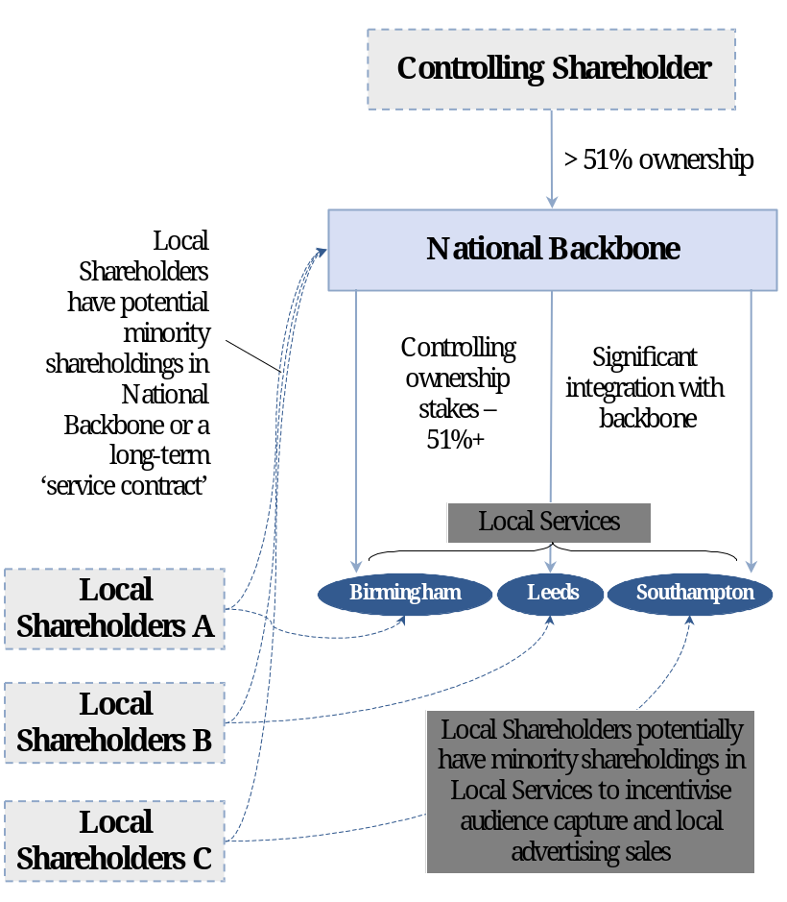
  benefits
  ✓ Allows for centralised control / co-ordination of local service content and programming
  ✓ Likely to maximise prospects of sharing / reducing costs
  ✓ Whole entity aligned to maximise commercial viability / profitability – for example clear direction with respect to national marketing and promotion, and lower risk of regional performance variations
  potential issues
  ✗ May not offer existing local media groups enough control to be "interesting"
  ✗ Branding and identity likely to be national rather than local – i.e. similar to ITV1/BBC1 models of national schedules with regional news opt-outs
  ✗ Over medium to long term, risk that network gravitates away from local content to improve profitability
Note: "Local Shareholders" refers to some combination of local media and local enterprise.
ANNEX 10: ILLUSTRATIVE SCHEMATICS OF LOCAL TV OWNERSHIP OPTIONS
 | Example of Local Service Centric Structure

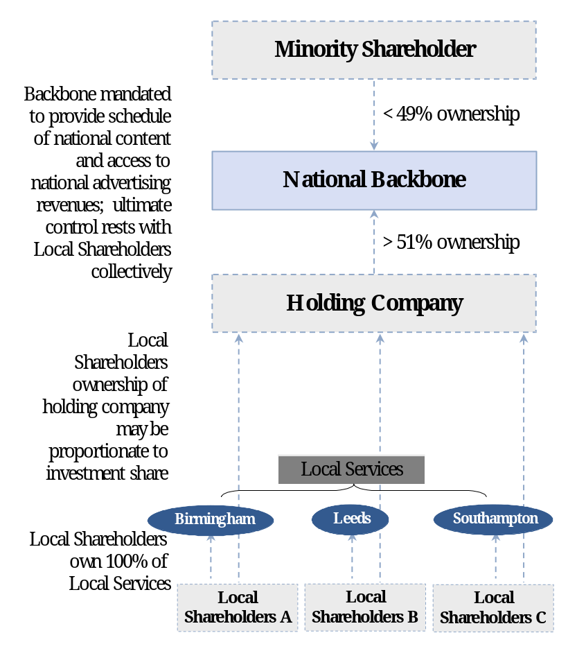
  benefits
  ✓ Provides local shareholders with full control
  ✓ Fully incentivises local media groups to generate local revenues where possible
  ✓ More likely to facilitate local services with strong local identities
  potential issues
  ✗ May give rise to coordination / control issues, e.g. coordinating local service content and quality
  ✗ May lead to interest alignment issues between different local services – e.g. how will current group be incentivised to add additional conurbations?
  ✗ May lead to lack of economic incentives for backbone operator to maximise national revenues and schedule quality
  ✗ Variability of performance / sustainability of local service groups may lead to failures
ANNEX 10: ILLUSTRATIVE SCHEMATICS OF LOCAL TV OWNERSHIP OPTIONS
 | Example of Split Ownership Structure

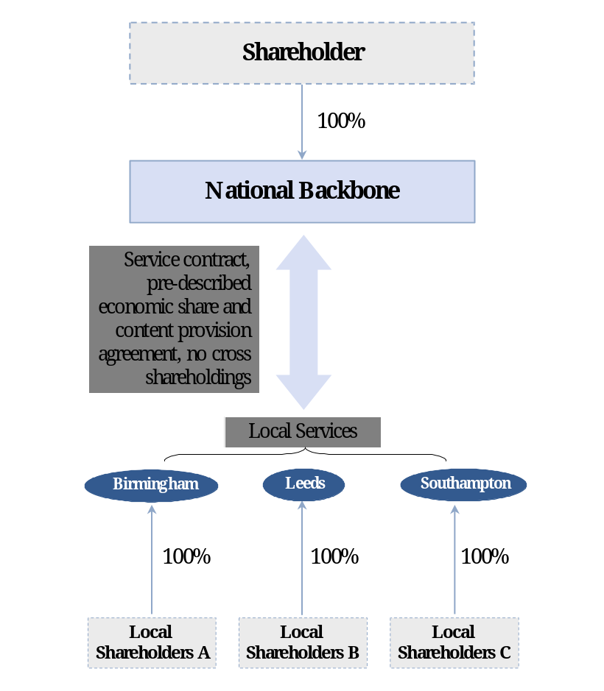
  benefits
  ✓ Aligns national backbone to maximise quality of control and advertising revenues to maximise profitability
  ✓ Gives local shareholders increased control of individual operations and incentives to sell local advertising
  ✓ More likely to allow local services to have a distinct identity
  potential issues
  ✗ Could eventually lead to divergence of interests between national backbone and local services, e.g. national backbone pulling away from local service obligations
  ✗ Could lead to variability of quality / performance between local service groups
ANNEX 10: ILLUSTRATIVE SCHEMATICS OF LOCAL TV OWNERSHIP OPTIONS
 | Example of Cross-Ownership Structure (recommended by Steering Group)

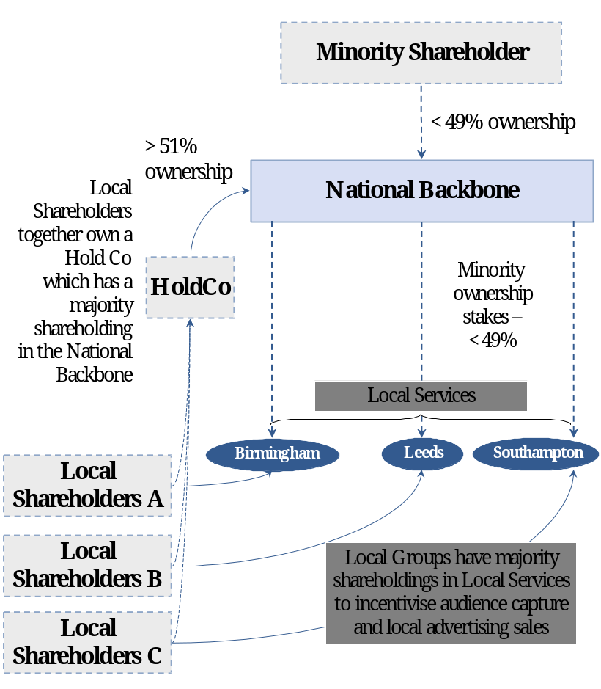
  benefits
  ✓ Provides national backbone operator with significant shareholder influence and economics, while integrating the backbone with the local services through minority equity interests
  ✓ Local Groups remain incentivised to run local services, while having significant influence over national backbone to alleviate 'national consolidation' risks
  ✓ Backbone operator retains significant economic incentive to maximise content quality and national revenues
  - If backbone is created first, this gives greater certainty to the prospective local licence holder
  potential issues
  ✗ Complexity – i.e. too many 'interests' at national backbone level?
  ✗ May not be sufficient ownership to attract a shareholder for the national backbone
  ✗ Potential governance/alignment issues
  - It might be difficult to achieve through a licensing regime alone

1 Source: Ofcom
2 Source: Enders Analysis
3 Source: Enders Analysis, Internet (Other) includes display and classified 4 Source: BARB. Channels plotted according to the percentage of all viewing coming from male and 45+ viewers compared to total TV in multichannel homes
5 Index based on share price performance weighted by company's market capitalisation. Index consists of DMGT, Independent News and Media, ITV, Johnston Press, Trinity Mirror and WPP Source: Datastream (as at 1 December, 2010)
1 Source: Ofcom / Broadcasters
2 Share of total viewing time on multi channel platforms source: BARB
3 Ofcom. Note analysis is for primary sets only. Figures include Q1 10 figures
4 Source: Ofcom / Broadcasters
Source: Ofcom, Local and Regional Media in the UK
Source: Ofcom, Communications Market Report, 2010
Source: BARB
Source: Zenith Optimedia 2010
Source: JPMorgan estimates and Lazard analysis. Represents shares of underlying station revenues at the national network level.
Source: Enders Analysis, Ofcom, Analysys Mason
Source: Ofcom
Note: Number indicates rank of conurbation population size. Geographical Interleaved spectrum has already been licensed in the case of Winter Hill and Cardiff.
Source: Ofcom. Population size is per the Office of National Statistics
ITV1 audience share: 16.9% and ITV1 advertising revenue of £1,100m in 2009 implies average revenue of £65m per 1% of population. Source Ofcom, BARB
Source: Ofcom, BARB, Company information

