
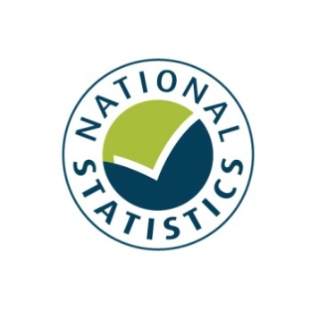

Taking Part 2011/12 Quarter 1
Statistical Release
September 2011





Our aim is to improve the quality of life for all through cultural and sporting activities, support the pursuit of excellence, and champion the tourism, creative and leisure industries.

Taking Part is a National Statistic and has been produced to the standards set out in the Code of Practice for Official Statistics

Contents

Introduction 5
Key findings 7
Chapter 1: Libraries 8
Chapter 2: Heritage 10
Chapter 3: Museums and galleries 12
Chapter 4: Arts 15
Chapter 5: Archives 17
Chapter 6: Sport and active recreation 19
Chapter 7: Volunteering 21
Chapter 8: The 2012 Olympics 23
Annex A: Background note 25
Annex B: Sector definitions 27

Introduction

This report
This report presents the latest headline results from the Taking Part survey, incorporating the first quarter of fieldwork from the seventh year of the survey and covering the twelve month period from July 2010 to June 2011. Where observations are made over time, the latest data are compared with earliest available data (typically 2005/06).

The report presents headline findings for the main culture and sport estimates along with updates on data to support the 2012 Olympic and Paralympic Games and Big Society objectives. Where we have recently extended our analysis to look at digital engagement with our sectors, this is presented alongside the relevant sector figures.

This release reports findings for adults only. The next update for child data will be presented in summer 2012. Taking Part users are encouraged to contribute their views on the content of this release and areas of interest for analysis to the Taking Part team at DCMS: TakingPart@culture.gsi.gov.uk .

The second Taking Part User Event was held on 18th August 2011 gathering together a range of users from different sectors and backgrounds. Material from this event is available on our site at: http://www.culture.gov.uk/what_we_do/research_and_statistics/7394.aspx

The Taking Part Survey
The Taking Part survey is commissioned by the Department for Culture, Media and Sport (DCMS) in partnership with a number of our arm’s length bodies. At present, these are Arts Council England, English Heritage, and Sport England.

Taking Part is a continuous face-to-face survey with adults aged 16 and over living in private households in England. It is conducted on behalf of DCMS by TNS-BMRB. The survey has run since mid-July 2005. A child interview was added to the survey in January 2006, interviewing a randomly selected child in those households containing at least one child aged 11-15. This is also a continuous face-to-face survey. In 2008/09, the child survey was broadened to include children aged 5-10. Interviews with children aged 11-15 are carried out directly, for those aged 5-10 an interview is conducted with the adult respondent.

The survey provides a wide range of data about engagement and non-engagement in culture, leisure and sport as well as more diverse measures that support a range of Government objectives. Taking Part is the key evidence source for DCMS, providing reliable national estimates of participation and supporting the Department’s aim of improving the quality of life for everyone by providing people with the chance to get involved in a variety of these opportunities. The survey also aims to support the DCMS Structural Reform Priorities and Business Plan through the provision of data for DCMS input and impact indicators and the broader information strategy. The latest DCMS indicators are available at: http://www.culture.gov.uk/about_us/8192.aspx

The Taking Part Survey contributes to the evidence base across a wide range of topics including satisfaction and enjoyment of culture and sport, social capital, volunteering and barriers to participation. It also collects an in-depth range of socio-demographic information on respondents. A wider range of measures are included in the spreadsheets accompanying this release, while analysis of 2005/06 to 2010/11 adult data can be conducted through NetQuest, our on-line analytical tool:
http://www.culture.gov.uk/what_we_do/research_and_statistics/6762.aspx

Forthcoming releases
The next release, scheduled for the end of December 2011, will present latest rolling estimates including the second quarter of the seventh year of the survey (July 2011 to September 2011).
Future releases will follow a similar schedule, being released ahead of the Quarterly Data Summaries that will be produced by all departments. Taking Part forms part of the wider DCMS data strategy as well as supporting its impact and input indicators. Details of these are available at: http://www.culture.gov.uk/about_us/8192.aspx
In addition, topic specific analysis will now be published on a quarterly basis, looking in depth at particular areas of the survey. The first of these reports will be published in mid-November. Further information on these will be made available on the Taking Part site.
If you would like further information on these releases or the Taking Part Survey, please contact the Taking Part team on TakingPart@culture.gsi.gov.uk. Additional contact details are contained within Annex A.
Key findings

Culture
- In the year to 2011/12 Q1 (July 2010 to June 2011), 70.9 per cent of adults report having visited a heritage site in the last year. 3.0 per cent of adults report visiting a heritage site at least once a week, a significant increase since 2005/06.

- Between 2005/06 and 2011/12 Q1, the proportion of people visiting a museum or gallery in the last year significantly increased (from 42.3% to 46.1%).

- In July 2010 to June 2011, 39.4 per cent of adults had used a library in the last 12 months, a significant decrease from 48.2 per cent in 2005/06, but showing no further change from 2009/10.

- In July 2010 to June 2011, 76.7 per cent of adults had engaged with the arts in the last year.

- In July 2010 to June 2011, the proportion of adults visiting an archive (in their own time and voluntary) in the last year remained steady at 3.8 per cent.

Sport
- 53.3 per cent of adults had participated in active sport at least once in the last 4 weeks while 25.2 per cent had participated in 30 minutes of moderate intensity sport at least three times in the last week.

- Since 2005/06, the proportion of 16-24 year olds participating in sport has decreased, while the proportion of people aged 75+ participating has increased.

Big Society
- In the year to 2011/12 Q1, 23.8 per cent of adults reported that they had volunteered in the last 12 months. This is unchanged from previous years.

- In July 2010 to June 2011 89.1 per cent of adults had donated money (including any donations into a collection box) in the last 12 months. 31.2 per cent of all adults had donated to one of the DCMS sectors.

2012 Olympic and Paralympic Games
- Almost two thirds (65.5%) of adults are slightly or strongly supportive of the 2012 Olympic and Paralympic Games.
.

.
- Libraries

This chapter examines library participation by a range of area-level and socio-demographic breakdowns. Details on the ways that people digitally engage with library services are also given.

Key findings

- In July 2010 to June 2011, 39.4 per cent of adults had used a library in the last 12 months, a significant decrease from 48.2 per cent in 2005/06, but showing no further change from 2009/10.

- Between 2005/06 and July 2010 to June 2011, the proportion of people using a public library declined in all regions except the North East where participation levels remained steady.

Library participation

In July 2010 to June 2011, 39.4 per cent of adults reported using a library service in the last 12 months, a significant decrease from 48.2 per cent in 2005/06, and no change from 2009/10 (Figure 1.1).

Figure 1.1: Library participation by sex, 2005/06 to July 2010 - June 2011

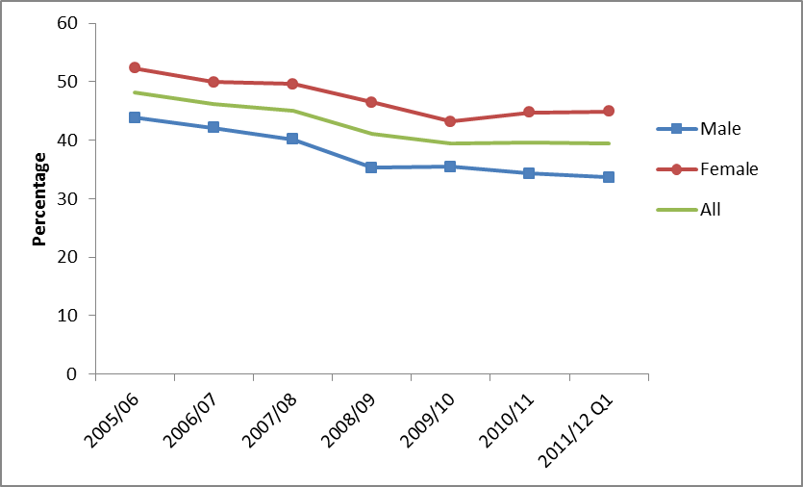
Notes
(1) Confidence intervals range between +/-0.7 and +/-2.5
There is no significant difference between library participation in urban (39.9%) and rural areas (37.4%). Participation levels in both areas have declined since 2005/06.

Between 2005/06 and July 2010 to June 2011, the proportion of people using a public library declined in all regions with the exception of the North East. During that time period, the decline in library usage has been consistent across all socio-demographic groups.

In July 2010 to June 2011, the following patterns of library attendance were observed:

- Women (44.9%) have a higher rate of library participation than men (33.7%).
- People in upper socio-economic groups (43.7%) have a higher rate of library participation than people in lower socio-economic groups (33.4%).
- People not working (42.8%) have higher rates of library participation than those who are working (37.1%).
- White people (38.1%) have lower rates of library participation than Black or minority ethnic (BME) groups (49.3%).

The same patterns were observed in 2005/06, however the library participation rates were higher for each category in that year.

Digital engagement

In July 2010 to June 2011, 16.5 per cent of adults had visited a library website in the last 12 months, a significant increase from 8.9 per cent in 2005/06. Of those who had visited a library website, 76.6 per cent had searched and viewed online information or made an enquiry. 38.9 per cent had completed a transaction, e.g. reserve or renew items, pay a fine.

Further detail on this section can be found in the accompanying spreadsheets to this release available at: http://www.dcms.gov.uk/publications/8462.aspx

- Heritage

The survey reports whether adults have visited a heritage site in the 12 months prior to interview and the frequency with which they attend these types of sites.

Key findings

- In July 2010 to June 2011, 70.9 per cent of adults report having visited a heritage site in the last year. 3.0 per cent of adults report visiting a heritage site at least once a week, a significant increase since 2005/06.

- There has been a significant increase in the proportion of men who have visited a heritage site, 72.0 per cent in July 2010 to June 2011, compared to 70.0 per cent in 2005/06.

Heritage participation

The latest results show 70.9 per cent of adults reported visiting a heritage site in the last 12 months. This compares with a figure of 70.7 per cent in the previous Taking Part release (June 2011) and 69.9 per cent in 2005/06. There has been a significant increase in the proportion of those visiting a heritage site at least once a week, 3.0 per cent in the latest results compared to 2.4 per cent in 2005/06. Figure 2.1 shows the proportion of adults participating in heritage over time.

Figure 2.1: Heritage participation, 2005/06 to July 2010 - June 2011

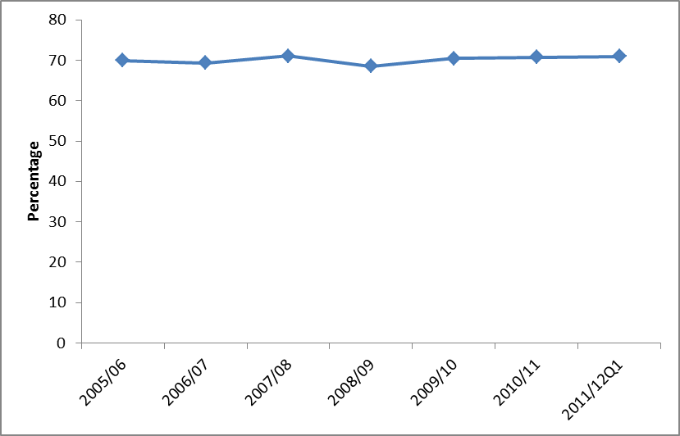
Notes
(1) Confidence intervals range between +/-0.7 and +/-2.4

Digital engagement

Since 2005/06, the proportion of people visiting heritage websites increased from 18.3 per cent to 27.5 per cent.

Between 2005/06 and July 2010 to June 2011, the proportion of people who visited a heritage website to take a virtual tour of a heritage site remained steady (27.9% of people had done this in July 2010 to June 2011).

Further detail on this section can be found in the accompanying spreadsheets to this release available at: http://www.dcms.gov.uk/publications/8462.aspx

- Museums and galleries

Museums and galleries have been routinely presented alongside data on archives in previous releases. This report presents museums and galleries separately.

Key findings

- Between 2005/06 and 2011/12 Q1, the proportion of people visiting a museum or gallery in the last year significantly increased (from 42.3% to 46.1%).

- 27.6 per cent of adults visited 1-2 times a year, 14.5 per cent did so 3-4 times a year, 3.3 per cent at least once a month and half a per cent went at least once a week.

- 51.2 per cent of adults aged 25-44 visited a museum or gallery in the last year, compared to just 27.4 per cent of 75+ year olds.

Overall participation in museums and galleries

In July 2010 to June 2011, 46.1 per cent of adults visited a museum or gallery an increase from 2005/06 (42.3%) but the level has been steady since 2009/10 (Figure 3.1).

Figure 3.1: Proportion who have visited a museum or gallery in the last year, 2005/06 to July 2010 - June 2011

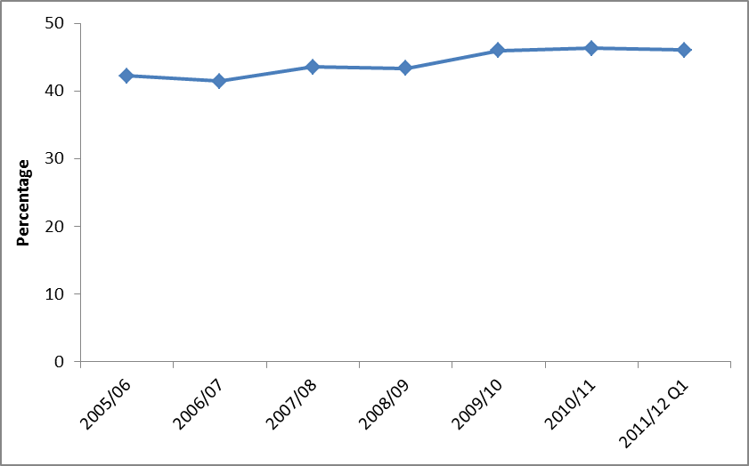
Notes
- Confidence intervals range between +/-0.7 and +/-1.9

The vast majority of visits were done in their own free time (97.4%), with a small percentage attending for paid work and for academic study (2.6% and 2.5% respectively).

While people who live in rural areas are just as likely as people in urban areas to have visited a museum or gallery in the last year, there are variations by region.

In 2011/12 Q1, Londoners (53.0%) had the highest levels of participation, while those in the East Midlands (39.6%) had the lowest levels of participation. Since 2005/06, the proportion of people visiting museums or galleries increased in the North West (40.4% to 48.5%), Yorkshire and the Humber (38.8% to 45.5%), the West Midlands (35.3% to 40.9%).

People in the higher ACORN groups such as Wealthy Achievers (52.3%) and Urban Prosperity (60.6%) had higher participation rates than the Hard-pressed (31.6%) (Figure 3.2).

Figure 3.2: Proportion who have visited a museum or gallery in the last year, July 2010 - June 2011, by ACORN group

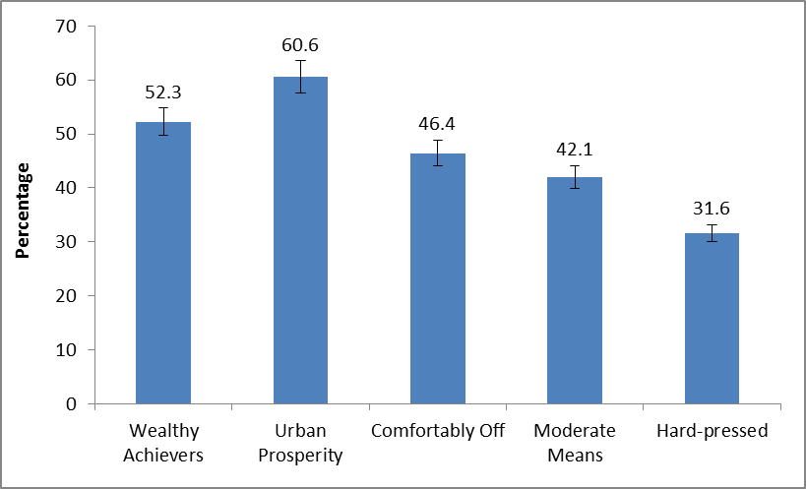
Notes
- Confidence intervals range between +/-2.0 and +/-3.2

Over half (56.1%) of adults in the upper socio-economic group visited a museum or gallery compared to 31.7 per cent in the lower group. Over half of working adults had attended (51.0%) compared to 39.2 per cent of adults not working.

Digital engagement

In July 2010 to June 2011, 25.6 per cent of adults had visited a museum or gallery website, an increase from 15.8 per cent in 2005/06.

Between 2008/09 and July 2010 to June 2011, there were increases in the proportions of people visiting a museum or gallery website to book tickets (from 47.5% to 53.4%) or to find out about a subject (from 46.5% to 50.8%). Meanwhile the proportion visiting to look at a collection remained steady (21.0% in July 2010 to June 2011).

Further detail on this section can be found in the accompanying spreadsheets to this release available at: http://www.dcms.gov.uk/publications/8462.aspx

- Arts

Taking Part asks respondents whether they have participated in a given range of arts activities or attended a range of activities. These two forms of activity are combined to provide the overall measure of arts participation.

Key findings

- In July 2010 to June 2011, 76.7 per cent of adults had engaged with the arts in the last year.

- Yorkshire and Humberside is the only region where there has been a significant increase in arts engagement between 2005/06 (71.8%) and July 2010 to June 2011 (75.5%). Rates in other regions remained steady.

Arts participation

The latest results show 76.7 per cent of adults reported participation in arts activities in the last 12 months, which is not a statistically significant increase from 76.3 per cent in 2005/06 (Figure 4.1).

Figure 4.1: Arts participation, by sex, 2005/06 to July 2010 - June 2011

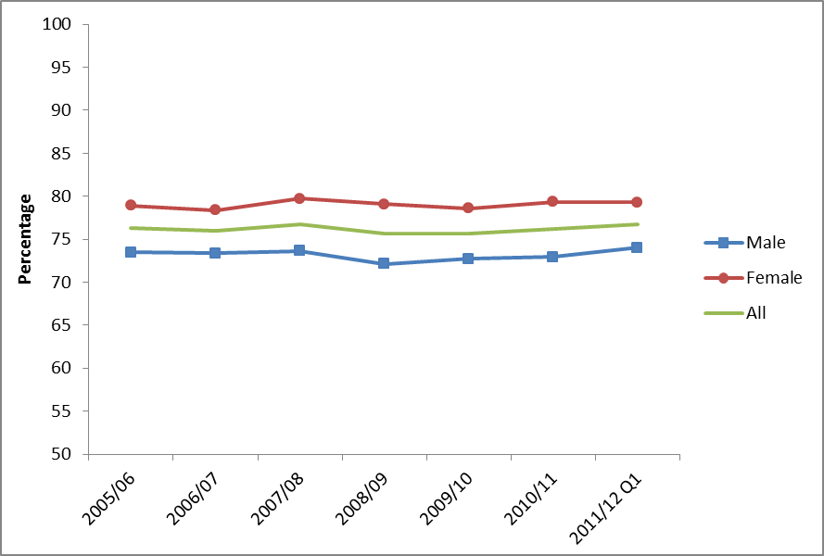
Notes
(1) Confidence intervals range between +/-0.7 and +/-3.1

In July 2010 to June 2011, 62.1 per cent of adults had engaged with the arts three or more times in the last 12 months, unchanged from 2005/06.

Yorkshire and Humberside is the only region where there has been a significant increase in arts engagement between 2005/06 (71.8%) and July 2010 to June 2011 (75.5%). Rates in other regions remained steady.

Between 2005/06 and July 2010 to June 2011, arts engagement increased among those aged 65-74 (from 70.7% to 75.2%) and 75 and over (57.7% to 61.1%).

In July 2010 to June 2011, the following patterns of arts engagement were observed:

- Arts engagement tends to be higher among people who live in less deprived neighbourhoods.
- There is some regional variation in arts engagement. For example, arts engagement in the South East (82.6%) is significantly higher than that in the North East (70.8%).
- People in rural areas (79.5%) have higher rates of arts engagement than people in urban areas (76.1%).
- People aged 75 and over have significantly lower arts engagement rates (61.1%) than the other age groups.
- Women (79.3%) had higher arts engagement rates than men (74.0%).
- Arts engagement is higher among white people (77.9%) than BME groups (67.9%).
- People with no long-standing illness or disability had a higher arts engagement rate (79.0%) than people with a long-standing illness or disability (71.2%).

These patterns are consistent with previous years.

Digital engagement

In July 2010 to June 2011, 42.7 per cent of adults had visited a theatre or concert website, a significant increase from 30.5 per cent in 2005/06. Of those who had visited a theatre or concert website, the top three reasons were: buying tickets for an arts performance or exhibition (67.8%), looking up information about arts events (63.1%) and downloading music (11.3%).

Further detail on this section can be found in the accompanying spreadsheets to this release available at: http://www.dcms.gov.uk/publications/8462.aspx

- Archives

Archives have been routinely presented alongside data on museums and galleries in previous releases. This report presents analysis on the individual archive sector.

Key findings

- In July 2010 to June 2011, 3.8% of adults had visited an archive (in their own time and voluntary) in the last year, with the proportion remaining steady since 2008/09.

- Nearly half of adults who did visit an archive did so just once in the last 12 months.

- 7.9 per cent of adults aged 65-74 visited an archive, compared to just 1.6 per cent of 16-24 year olds.

Overall participation in archives

In this latest period, 3.8 per cent of adults had visited an archive in the last year in their own time or as part of voluntary work. Including paid work visits and academic study visits, this increases to 4.8 per cent of all adults. The trend over time is shown in Figure 5.1 below.

Figure 5.1: Percentage of adults visiting an archive or records office, 2005/06 to July 2010 - June 2011

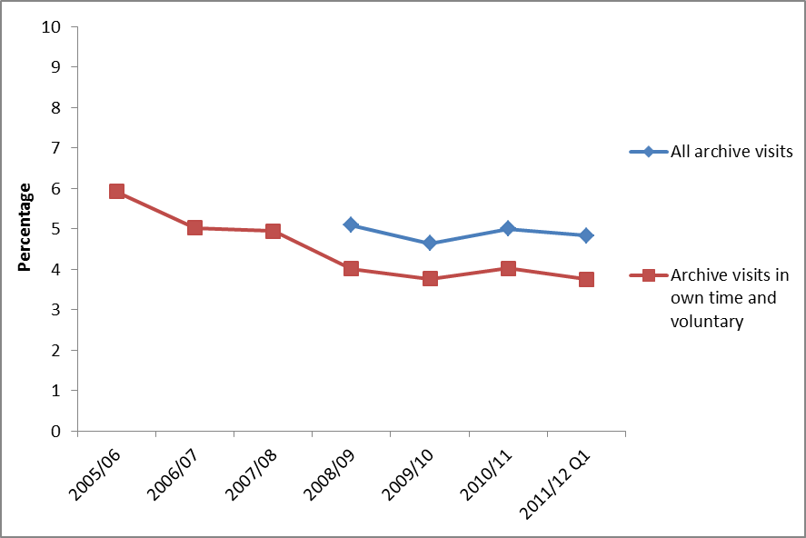
Notes
- Confidence intervals range between +/-0.3 and +/-0.8
- Some archive questions were not asked prior to the 2008/09 survey.

There is little variation between different areas or demographic groups, but adults from upper socio-economic groups had a significantly higher attendance rate than those in lower socio-economic groups.

Over three quarters of all archive visits (76.7%) were in their own time, followed by 17.4 per cent visiting for paid work, and 7.9 per cent for academic study.

Digital engagement

People are more likely to visit an archive or records office online than in person. In July 2010 to June 2011, 11.2 per cent of adults had visited an archive or records office website in the last 12 months, a significant increase from 9.7 per cent in 2005/06. Of those who had visited an archive or records office website, 63.2 per cent had done so to view digitised documents, 30.4 per cent had searched a catalogue while 19.8 per cent had completed a transaction.

Further detail on this section can be found in the accompanying spreadsheets to this release available at: http://www.dcms.gov.uk/publications/8462.aspx

- Sport and active recreation

This chapter examines sport and active recreation by a range of area-level and socio-demographic breakdowns. Key findings on swimming and cycling proficiency – that is the extent to which adults feel able to swim and cycle – are also provided.

Key findings

- 53.3 per cent of adults had participated in active sport at least once in the last 4 weeks while 25.2 per cent had participated in 30 minutes of moderate intensity sport at least three times in the last week.

- Since 2005/06, the proportion of 16-24 year olds participating in sport has decreased, while the proportion of people aged 75+ participating has increased.

Participation in sport or recreational physical activities

In July 2010 to June 2011, 53.3 per cent of adults had participated in active sport at least once in the last 4 weeks. This is unchanged from 2005/06 (53.7%). Over that same period, 25.2 per cent of adults had participated in moderate intensity sport for at least 30 minutes three times in the last week, an increase from 2005/06 (23.3%) (Figure 6.1).

Figure 6.1: Percentage of adults who have participated in sports at least once in the last 4 weeks and at least 3x30 minute sessions of moderate intensity in the last week, 2005/06 to July 2010 - June 2011

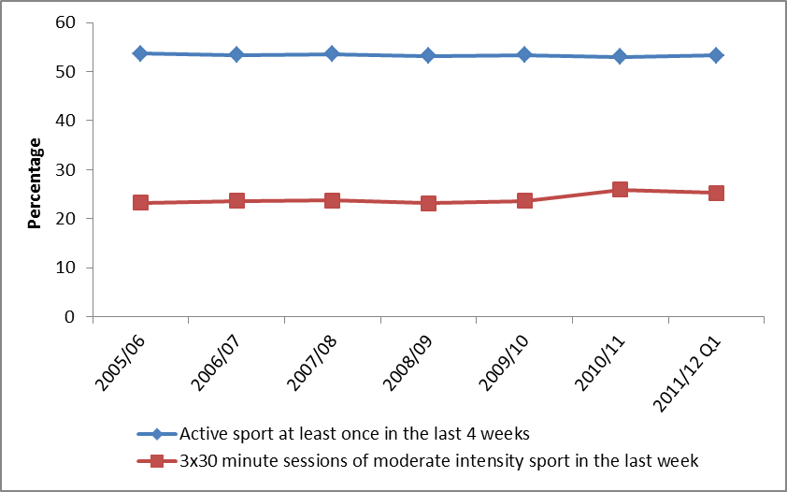
Notes (1) Confidence intervals range between +/-0.7 and +/-1.9.

In general, people who live in less deprived neighbourhoods are more likely than those who live in more deprived neighbourhoods to participate in sport. This has not changed since 2005/06.

Between 2005/06 and July 2010 to June 2011, the proportion of 16-24 year olds who had taken part in active sport at least once in the last 4 weeks decreased from 76.8 per cent to 71.9 per cent. Across the same time period, the proportion of people aged 75+ doing sport increased from 15.2 per cent to 18.8 per cent.

Rates of sports participation have remained steady across the other socio-demographic groups.

Since 2005/06, the proportion of adults visiting sports websites has increased from 26.1 per cent to 36.7 per cent.

Further detail on this section can be found in the accompanying spreadsheets to this release available at: http://www.dcms.gov.uk/publications/8462.aspx

Cycling and swimming proficiency

- In July 2010 to June 2011, 80.7 per cent of adults stated that they could swim and 85.7 per cent stated that they could cycle.
- Despite swimming being among the most popular sports for women, men (85.5%) are more likely than women (77.4%) to say that they can swim. Men are also more likely to say that they can cycle (92.7% compared with 78.9%).
- White people were more likely than BME groups to say that they can swim (83.6% compared with 64.6%) and cycle (86.9% compared with 76.4%).
- Like sports participation generally, swimming and cycling proficiency is also linked with the type of area people live in, with people who live in the least deprived neighbourhoods more likely to say that they can swim and cycle.
- Volunteering

Taking Part asks whether respondents have done any volunteering work in the last 12 months and whether this relates to any of the DCMS sectors. Recently added questions ask about charitable donations and whether these relate to DCMS sectors.

Key findings

- In the year to 2011/12 Q1, 23.8 per cent of adults reported that they had volunteered in the last 12 months. This is unchanged from previous years.

- Between 2005/06 and 2011/12 Q1, there was a significant increase in the proportion of people volunteering within the arts sector.

- In July 2010 to June 2011 89.1 per cent of adults had donated money (including any donations into a collection box) in the last 12 months. 31.2 per cent of all adults had donated to at least one of the DCMS sectors.

Volunteering

In 2011/12 Q1, 23.8 per cent of adults reported that they had taken part in voluntary activities in the last 12 months, unchanged from 2005/06 when 23.8 per cent also reported having done this. Within the DCMS sectors, there was a significant increase in the proportion of people volunteering within the arts sector, rising to 8.3 per cent in 2011/12 Q1.

Figure 7.1: Volunteering in DCMS sectors, 2005/06 to July 2010 – June 2011

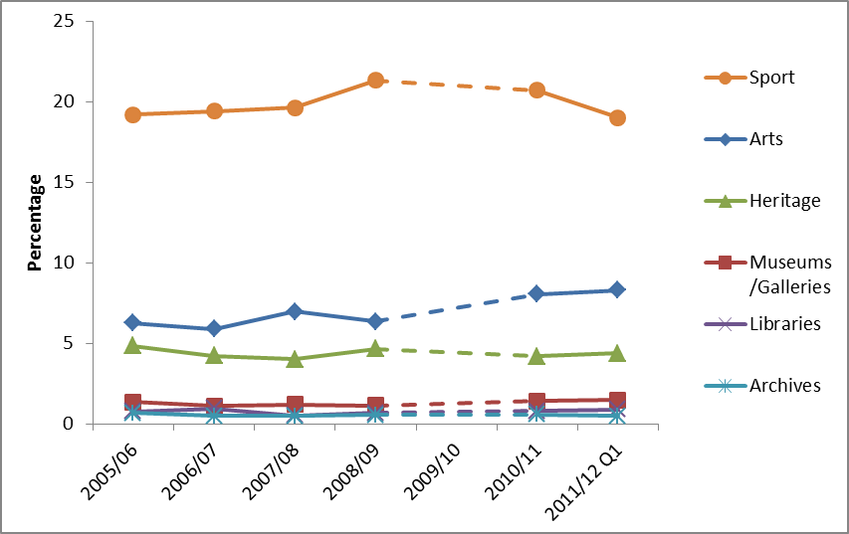
Notes
- Confidence intervals range between +/-0.3 and +/-2.0.

Charitable giving

Taking Part asks whether respondents have donated money in the last 12 months and whether this was to any of the DCMS sectors.

In July 2010 to June 2011 89.1 per cent of adults had donated money (including any donations into a collection box) in the last 12 months. 31.2 per cent of all adults had donated to at least one of the DCMS sectors.

The highest frequency of charitable giving was less often than once a month but at least 3 or 4 times a year (34.7%), and 31.6 per cent donated less often than once a week but at least once a month.

Further detail on this section can be found in the accompanying spreadsheets to this release available at: http://www.dcms.gov.uk/publications/8462.aspx

- The 2012 Olympic and Paralympic Games

This chapter examines the extent to which people in England support the UK hosting the 2012 Olympic and Paralympic Games. It covers the reasons why people are either supportive of or against the UK hosting the 2012 Games, and provides analysis by a range of area level and socio-demographic variables.

Key findings

    - Almost two thirds (65.5%) of adults are slightly or strongly supportive of the 2012 Olympic Games compared to 71.0 per cent in 2005/06.

    - The proportion of those strongly supportive of the 2012 Olympic and Paralympic Games has shown a significant decrease, falling from 48.4 per cent in 2005/06 to 40.8 per cent in 2011/12 Q1. The proportion of those who are slightly supportive has increased to 24.7 per cent from 22.5 per cent in 2005/06.

    - In 2011/12 Q1, 6.9 per cent of adults reported that the UK winning the bid had motivated them to do more sport or recreational physical activity, 3.9 per cent reported that they were motivated to do more cultural activities and 5.9 per cent reported that they were motivated to do more voluntary work.

The 2012 Olympic and Paralympic Games

In 2011/12 Q1, 65.5 per cent of adults were supportive of the 2012 Games, reporting that they were slightly or strongly supportive. This is a significant decrease from 2005/06 when 71.0 per cent reported that they were supportive. The proportion of those who are strongly supportive has fallen from 48.4 per cent in 2005/06 to 40.8 per cent in the latest results.

Those from a BME background were more likely to be supportive of the Games than those with a white background, 77.4 per cent and 64.5 per cent respectively. Men were more likely to be supportive than women (68.4% and 63.5%) and those aged 25-44 years old were the most supportive group (70.0%). The least supportive group was those aged 75+ with 55.0 per cent being supportive of the Games.

The East of England is the region with the highest level of support (71.2 per cent) while those in the East Midlands are least supportive (60.1%). In London, 70.9 per cent were supportive of the Games.

Further detail on this section can be found in the accompanying spreadsheets to this release available at: http://www.dcms.gov.uk/publications/8462.aspx

Annex A: Background note

- The Taking Part survey is commissioned by the Department for Culture, Media and Sport (DCMS) and its partner arm’s length bodies (ALBs). For 2011 to 2015 these are Arts Council England, English Heritage, and Sport England.

- Taking Part is a National Statistic and as such has been produced to the high professional standards set out in the Code of Practice for Official Statistics. National Statistics undergo regular quality assurance reviews to ensure they meet customer needs and are produced free from any political interference. For more information, see http://www.statisticsauthority.gov.uk/assessment/code-of-practice/code-of-practice-for-official-statistics.pdf

- Stringent quality assurance procedures have been adopted for this statistical release. All data and analysis has been checked and verified by at least two different members of the team to ensure the highest level of quality.

- The latest results presented here are based on interviews issued between July 2010 and June 2011. The total sample size for this period is 12,977.

- The survey measures participation by adults (aged 16 and over) and children (5-10 and 11-15) living in private households in England. No geographical restriction is placed on where the activity or event occurred.

- The median adult sample interview length for the 2010/11 survey was 40 minutes 42 seconds (mean 42 minutes 36 seconds). The median survey length for the 5-10 year old child interview was 14 minutes 3 seconds (mean 14 minutes 58 seconds) and for 11-15 year olds it was 24 minutes 16 seconds (mean 25 minutes 41 seconds).

- Participation in these activities must be for the purpose of recreation or leisure, including voluntary work. It excludes involvement in activities where the prime motivation is paid work or academic studies. The exceptions to this are attendance at historic environment sites which includes visits made for academic study, and sports participation which exclude volunteering, teaching, coaching and refereeing.

- The range has been calculated using a 95% confidence interval. This means there is a 95% probability the true percentage lies in the range given. All estimates have been rounded to one decimal place. An overall design factor of 1.260 has been applied to the dataset for the period July 2010 to June 2011. Individual design factors have been calculated for each sector in this period, ranging from 1.235 to 1.351. Statistical significance tests have been run at the 95% level. This means the probability that any given difference happened by chance is low (1 in 20).

- All differences and changes reported are statistically significant at the 95% confidence level unless otherwise stated.

- Some figures may have been revised from previous releases, in which case the figures in this release supersede those from previous statistical releases. For more detailed information on the DCMS revisions policy and how revisions are handled for the Taking Part survey, please see the DCMS statement of compliance on our website.

- The data are weighted to ensure the representativeness of the Taking Part sample. There are two types of weighting: i) to compensate for unequal probabilities of selection; and ii) to adjust for differential non-response. Weighting is based on mid-2009 population estimates from the Office for National Statistics.

- For more information about the Taking Part survey, including previous publications, see http://www.culture.gov.uk/reference_library/research_and_statistics/4828.aspx

Versions of the questionnaire from all years of the survey are available, see http://www.culture.gov.uk/what_we_do/research_and_statistics/7387.aspx

- The fieldwork for the survey is being conducted by TNS-BMRB. For more information, see http://www.tns-bmrb.co.uk

- We can also provide documents to meet the specific requirements of people with disabilities. Please call 020 7211 6000 or email takingpart@culture.gsi.gov.uk

- This report has been produced by Reannan Rottier, Yun Wong, Peter Antoniades and Neil Wilson. Acknowledgement goes to colleagues within the DCMS, partner ALBs and TNS-BMRB for their assistance with the production and quality assurance of this release.

- The responsible statistician for this release is Neil Wilson. For enquiries on this release, please contact Peter Antoniades on 0207 211 6188.

- For general enquiries telephone: 0207 211 6200
Department for Culture Media and Sport
2-4 Cockspur Street
London
SW1Y 5DH
enquiries@culture.gov.uk

.

Annex B: Sector definitions

The following annex presents the various definitions for adult participation in DCMS sectors.

Libraries
The respondent is asked if they have used a public library service. If the respondent is unsure what is in scope, the interviewer has the following definition to refer to.
“Use of a public library can include:
- A visit to a public library building or mobile library to make use of library services (including to print/use electronic resources or to take part in an event such as a reading group or author visit)
- The use of on-line library resources or services remotely (i.e. used a computer outside the library to view the website, catalogue or databases)
- Access, and receipt, of the library service by email, telephone, fax or letter
- Receipt of an outreach service such as home delivery or library events outside a library building
Use of other libraries and archive services is excluded.”

Museum, gallery or archive
The respondent is asked if they have attended a museum, gallery or archive. If the respondent is unsure what is in scope, the interviewer has the following definition to refer to.
“Archives are documents that have been created by families, individuals, businesses or organisations and have been specially chosen to keep permanently. They can be written papers such as letters or diaries, maps, photographs or film or sound recordings. Archives are historical documents but do not have to be very old. Places that keep archives are usually called a record office or archive centre.
Registering a birth, death or marriage happens at a registry office, not at an archive centre/record office.”

Arts
The respondent is asked if they have participated in a given list of arts activities, or attended a given list of arts events. Eligible activities and events are as follows.
Participation:
- Dance – ballet or other dance (for fitness and not for fitness)
- Singing – live performance or rehearsal/practice (not karaoke)
- Musical instrument – live performance, rehearsal/practice or played for own pleasure
- Written music
- Theatre – live performance or rehearsal/practice (e.g. play or drama)
- Opera/musical theatre – live performance or rehearsal/practice
- Carnival (e.g. as a musician, dancer or costume maker)
- Street arts (art in everyday surroundings like parks, streets, shopping centre)
- Circus skills (not animals) – learnt or practised
- Visual art – (e.g. painting, drawing, printmaking or sculpture)
- Photography – (as an artistic activity, not family or holiday ‘snaps’)
- Film or video – making as an artistic activity (not family or holidays)
- Digital art – producing original digital artwork or animation with a computer
- Craft – any craft activity (e.g. textiles, wood, metal work, pottery, calligraphy etc)
- Creative writing – original literature (e.g. stories, poems or plays)
- Book club – being a member of one

Attendance:
- Visual art exhibition (e.g. paintings, photography or sculpture)
- Craft exhibition (not crafts market)
- Event which included video or digital art
- Event connected with books or writing
- Street arts (art in everyday surroundings like parks, streets or shopping centre)
- Public art display or installation (an art work such as sculpture that is outdoors or in a public place)
- Circus (not animals)
- Carnival
- Culturally specific festival (e.g. Mela, Baisakhi, Navratri)
- Theatre (e.g. play, drama, pantomime)
- Opera/musical theatre
- Live music performance (e.g. classical, jazz or other live music event but not karaoke)
- Live dance event (e.g. ballet, African People’s dance, South Asian, Chinese, contemporary or other live dance)

Historic environment
The respondent is asked if they have visited the following list of historic environment sites.

- A city or town with historic character
- A historic building open to the public
- A historic park, garden or landscape open to the public
- A place connected with industrial history or historic transport system
- A historic place of worship attended as a visitor
- A monument such as a castle, fort or ruin
- A site of archaeological interest
- A site connected with sports heritage

Active sport
The respondent is asked about their participation in active recreation and a range of sports. Eligible activities are as follows.

- Recreational walking
- Recreational cycling
- Swimming or diving (indoors and outdoors)
- BMX, cyclo-cross, mountain biking
- Bowls (indoors and outdoor lawn bowls)
- Tenpin bowling
- Health, fitness, gym or conditioning activities
- Keepfit, aerobics, dance exercise (includes exercise bike)
- Judo
- Karate
- Taekwondo
- Other martial arts (includes self-defence, tai chi)
- Weight training (includes body building)
- Weightlifting
- Gymnastics
- Rugby League
- Rugby Union
- American football
- Football (includes 5-a-side and 6-a-side) [indoors and outdoors]
- Gaelic sport (e.g. camogie, Gaelic football, hurling, Irish handball and shinty)
- Cricket
- Hockey (excludes ice, roller and street hockey, but included in ‘other’)
- Baseball/softball
- Netball
- Tennis
- Badminton
- Squash
- Basketball
- Table tennis
- Track and field athletics
- Jogging, cross-country, road running
- Yachting or dingy sailing
- Canoeing
- Windsurfing or boardsailing
- Ice skating
- Curling
- Golf, pitch and putt, putting
- Skiing (on snow or on artificial surface; on slopes or grass)
- Horse riding
- Climbing/mountaineering (includes indoor climbing)
- Hill trekking or backpacking
- Motor sports
- Volleyball
- Orienteering
- Rounders
- Rowing
- Triathlon
- Boxing
- Waterskiing
- Lacrosse
- Fencing
- Other types of sport, e.g. rollerblading, street hockey, skateboarding, water polo, surfing, scuba diving, gliding, hang/paragliding, parachuting or parascending

Moderate intensity sport
To be counted as ‘moderate intensity’, the respondent must have participated in at least one 30-minute session of any of the sports (with the exception of bowls) listed above on at least three separate days in the past week. In addition, the effort put into the activity needs to be of moderate intensity, i.e. raises their breathing rate (or for walking it needs to be done at a brisk or fast pace).

The only exception to this is for those adults aged 65 and over, where some light activities are in also scope – indoor and outdoor bowls, yoga, Pilates, croquet and archery.

Digital Participation
Digital Participation includes visiting websites for at least one of the following reasons:

- Museum or gallery website – To look at items from a collection.
- Museum or gallery website – To find out about a particular subject.
- Library website – To complete a transaction (e.g. reserve or renew items, pay a fine).
- Library website – To search and view online information or make an enquiry.
- Heritage website – To take a virtual tour of a historical site.
- Theatre or concert website – To download music.
- Theatre or concert website – To view or download an arts performance or exhibition.
- Theatre or concert website – To discuss the arts or share artworks.
- Archive or records office website – To complete a transaction.
- Archive or records office website – To view digitized documents online.
- Archive or records office website – To search a catalogue.

Volunteering
The respondent is asked about any voluntary work they have done, including:

- Raising or handling money / taking part in sponsored events
- Leading a group
- Being a member of a committee
- Organising or helping to run an activity or event
- Visiting people
- Befriending / mentoring people
- Coaching or tuition
- Giving advice/ information/ counselling
- Secretarial, administrative or clerical work
- Providing transport or driving
- Representing – e.g. addressing meetings, leading a delegation
- Campaigning – e.g. lobbying, canvassing, letter writing
- Conservation/restoration
- Officiating – e.g. judging, umpiring or refereeing
- Other practical help - e.g. helping out a school, religious group, with shopping/refreshments

The respondent is also asked whether this activity was connected to any of the following areas:

- Arts
- Museum or gallery
- Heritage
- Libraries
- Archives
- Sport
- Any other sector

2-4 Cockspur Street
London SW1Y 5DH
www.culture.gov.uk

