
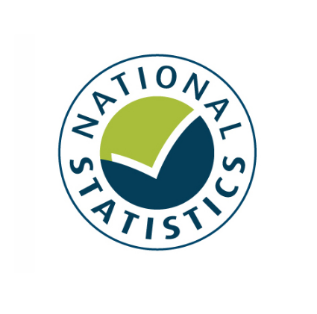

DCMS Statistical Bulletin
Alcohol, Entertainment and Late Night Refreshment Licensing
England and Wales, April 2008 – March 2009

Peter Antoniades and Victoria Thompson
DCMS Evidence & Analysis Unit
22nd October 2009

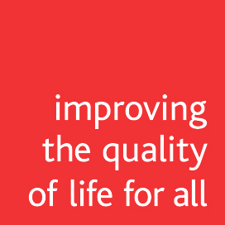

Our aim is to improve the quality of life for all through cultural and sporting activities, support the pursuit of excellence, and champion the tourism, creative and leisure industries.

Contents
Page
Background | 5
Alcohol, Entertainment and Late Night Refreshment Licensing Statistical Bulletin History | 5
Information On This Year’s Collection | 6
Changes from the 2008 collection | 6
Data reported in this bulletin | 6
Reporting Methodology | 6
Data Quality | 7
Executive Summary | 8
Headline Annual Comparisons | 10
Headline Time Series | 12
Annual Time Series Charts | 13
COMMENTARY PART 1 – LICENSED PREMISES AT 31st MARCH 2009 | 14
Premises Licences | 14
Club Premises Certificates | 15
Personal Licences | 15
Alcohol Permissions | 16
Regulated Entertainment and Late Night Refreshment | 17
24-Hour Alcohol Licences | 18
Cumulative Impact areas | 20
COMMENTARY PART 2 – LICENCE ACTIVITY IN 2008/09 | 21
Premises Licences Activity | 21
Club Premises Certificates Activity | 22
Personal Licences Activity | 23
Completed Reviews | 24
Expedited Reviews | 26
Hearings, Appeals and Judicial Reviews | 26
Temporary Event Notices | 27
Licensing Collection Methodology | 36
Data amendments | 37
Modelling to National Totals | 37
National Statistics | 38
Glossary | 39
Annex A: History of the Collection | 46
Changes from the 2007 collection | 46
Changes from the liquor licensing collection | 46
Annex B: Background and Summary of Changes in the Licensing Law | 47
Annex C: Questionnaire with Response Rates | 48
Annex D: Maps Showing 24 Hour Alcohol Licences by Premises Type | 53
Further Information | 54
FIGURES Page
1 | Premises licences and club premises certificates by activity authorised | 8
2 | Premises licences, club premises certificates and temporary event notices | 9
A | Premises licences by alcohol permissions 2007,2008,2009 | 13
B | Premises licences and club certificates by authorised regulated entertainment 2007,2008,2009 | 13
C | Premises licences by alcohol permissions 2007,2008,2009 | 13
3 | Premises licences by fee band | 14
4 | Club premises certificates by fee band | 15
5 | Premises licences and club premises certificates by alcohol permissions | 16
6 | Premises licences and club premises by authorised regulated entertainment | 17
7 | Premises with 24-hour alcohol licences | 18
8 | 24-hour alcohol licences as a proportion of licences permitted to sell alcohol by LA | 19
9 | Number of cumulative impact areas per licensing authority | 20
10 | Premises licence activity by outcome | 21
11 | Club premises certificate activity by outcome | 22
12 | Completed reviews instigated by responsible authority | 24
13 | Actions taken following completed reviews | 25
D | Map showing the proportion of 24-hour alcohol licences excluding hotels by LA | 53
E | Map showing the proportion of hotels with 24-hour alcohol licences by LA | 53

TABLES Page
A | Modelled Estimates for Key Statistics, March 2009 and Estimated Change |  | 11
B | Modelled Estimates for Key Statistics, March 2007, March 2008, March 2009 |  | 12
1 | Number of Premises Licences, Club Premises Certificates and Personal Licences by Fee Band, England and Wales, 31st March 2009 |  | 28
2 | Number of Premises Licences and Club Premises Certificates by licensable activity - England and Wales, 31st March 2009 |  | 29
3 | Number of Premises Licences and Club Premises Certificates by regulated entertainment type - England and Wales, 31st March 2009 |  | 30
4 | Number of Premises Licences with 24 hour alcohol provisions by premises type - England and Wales, 31st March 2009 |  | 31
5 | Number of Cumulative Impact Areas - England and Wales, 31st March 2009 |  | 31
6 | Licence Activity by outcome for England and Wales in 2008/09 |  | 32
7 | Number of police objections to Personal Licences, and committee hearings - England and Wales in 2008/09 |  | 33
8a | Number of completed reviews by type of licence – England and Wales in 2008/09 |  | 33
8b | Reason for completed review - England and Wales in 2008/09 |  | 33
8c | Number of completed reviews instigated by each Responsible Authority - England and Wales in 2008/09 |  | 33
9 | Action taken following completed reviews - England and Wales in 2008/09 |  | 34
10 | Number of Expedited review applications, applications withdrawn and interim steps taken - England and Wales in 2008/09 |  | 34
11 | Number licences surrendered, lapsed, suspended, revoked, forfeited or withdrawn by licence type, England and Wales in 2008/09 |  | 34
12 | Number of appeals and judicial reviews for- England and Wales in 2008/09 |  | 35
13 | Number of Temporary Event Notices - England and Wales in 2008/09 |  | 35
 | Key Findings by Local Authority Area in 2008/09 | ONLINE ONLY, link on page 35
Background
The Secretary of State for Culture, Media and Sport has policy responsibility in Government for licensing law relating to the sale of alcohol, the provision of regulated entertainment and the provision of late night refreshment in England and Wales under the Licensing Act 2003 (the 2003 Act). The 2003 Act combined six regulatory regimes into one system to be run by a single Licensing Authority (LA) in each area (mainly local authorities). This meant transferring responsibility for alcohol licensing from the Courts to local authorities in order to establish a more democratically accountable system which gives local communities a greater say in the decisions that affect them. The 2003 Act put four licensing objectives at the centre of licensing decisions: public safety, the prevention of crime and disorder, the prevention of public nuisance, and the protection of children from harm. The new system aimed to balance greater freedom and flexibility for licensed sectors with tough measures to control problem premises. The Act came into force on 24th November 2005.

Alcohol, Entertainment and Late Night Refreshment Licensing Statistical Bulletin History

In November 2007, DCMS released the first year of Alcohol, Entertainment and Late Night Refreshment statistics 2006/07, following the implementation on the Licensing Act 2003. Overall 87% of Licensing Authorities responded to the 2006/07 licensing collection.
On 30th October 2008, DCMS released the second year’s collection of statistics. Overall 97% of Licensing Authorities responded to the Alcohol, Entertainment and Late Night Refreshment statistics 2007/08 bulletin.
The 2008/09 collection is the third year these statistics have been collected, and the first time the overall collection has received a full 100% response rate from Licensing Authorities in England and Wales. (See page 46 for full history of the collection)
Information on this year’s collection
The main purpose of this collection is to monitor the impact of the Licensing Act. It provides information to help Licensing Authorities benchmark their position and provide understanding in the context of the national picture. The information collected asks for most of the regularly requested information about licensed premises, and will continue to inform our ongoing monitoring of the licensing regime.

These data have been collected from a census of Licensing Authorities that completed a statistical return. This collection is in line with the first Licensing Act 2003 data collection, which was conducted in 2007. The data are consistent with the previous two collections in 2007 and 2008, but with some new questions to reflect additional changes to the licensing regime. Coverage includes licences for the sale of alcohol, regulated entertainment or provision of late night hot food and drink.

This collection is not a collection on the number of public houses, as the Act does not legally define these. Due to difficulties in classification Licensing Authorities do not collect details of whether a premises is a pub, bar, club, store etc. The Act defines activities not premises types.

A full version of the questionnaire and the individual response rates for each question are on page 49. Comparisons of headline national totals have again been made for key statistics against previous years’ modelled estimates. These are provided on pages 11 -13 in tables A and B.

A full glossary explaining all terms used in this statistical bulletin can be found on page 39.

Changes from the 2008 collection
There are some minor changes since last year’s collection, which include the following:
- An additional “Local Residents” category was included for the question on number of completed reviews instigated by each of the responsible authorities (previously this would have been within the “Other responsible authorities or Interested Parties” category).
- The overall response rate increased to 100% for some questions, receiving at least a partial return from all 377 Licensing Authorities in England and Wales. The response rate differed for each question (please see questionnaire with individual response rates on page 36 for full details).

Data reported in this bulletin
The main data presented in this bulletin are based on the actual returns submitted by LAs. However, in order to provide an accurate comparison with 2007 and 2008, modelled estimates are used in the section 'Headline annual comparisons' to control for individual questions where there was a non-response in one or more of the three years.

Reporting methodology
Within the commentary figures have been rounded to two significant figures, i.e. if greater than 1,000, figures have been rounded to the nearest hundred; between 1,000 and 100, figures have been rounded to the nearest ten; all figures below 100 have not been rounded and are shown in full. The figures in all supporting tables, both within this bulletin and online, have not been rounded (Except Table A and Table B, which has been rounded to the nearest hundred).

Some percentages in the tables and figures may not add up to 100% due to rounding.

Also within the commentary, percentage splits correspond to the percentage of valid responses, i.e. the split shown adds up to 100% but excludes unknown values. Therefore these splits should not be used to scale up to a total. The tables at the back of this bulletin report total and sub-total percentages including and excluding unknowns.

Data quality
The questionnaire was sent out to 378 Licensing Authorities, however two Licensing Authorities submitted a joint response, therefore the total number of Licensing Authorities in the collection has reduced by one. In total we received 377 completed returns out of a possible 377, and every effort has been made to ensure that the data reported in this bulletin is as robust as possible. Only minor changes were made from the last collection, and LAs were asked to inform us of any difficulties in providing the new information required, such as the local government reorganisation that created nine unitary authorities in England from 1 April 2009. LAs were asked to provide information as of 31st March 2009 and the preceding 12 months under the Licensing Authority boundaries which were in place in that period, and not the newly formed Unitary Authority boundaries.

As this is the third year of this collection, the data quality has generally improved as Licensing Authorities have had time to develop their licensing software systems to record the information we require in an accurate way, and they have had experience of completing this exercise before. Work with licensing software providers is continuing to help minimise the burden on LAs, and make the statistics required easier to extract from their systems. Data quality is expected to continue improving in future collections.

Further explanation of licensing collection methodology can be found on page 36.

Executive Summary
The following results are based only on the completed returns received and therefore in some questions will be an underestimate of the full picture in England and Wales.
Returns from 100% of LAs were received in total, but the response rate differed for each question.

- 215,100 licences and certificates were in force in England and Wales on 31st March 2009. 197,900 were premises licences and 17,300 were club premises certificates. There were also 391,600 personal licences. [Based on 100% of all LAs]

- 171,800 licences and certificates in force were authorised to sell alcohol, and 31,300 were not permitted to sell alcohol. 44,400 premises licences were authorised for off-sale of alcohol only. 39,500 licences authorised on-sale of alcohol only, of which 7,700 were club premises certificates, and an additional 82,700 allowed both on and off sales, of which 8,100 were club premises certificates. [approx. 93% response rate]

- Just over 73,800 premises were licensed for late night refreshment. [90% response]

- 105,800 premises licences and 12,000 club premises certificates were authorised for any form of entertainment. Over 435,000 regulated entertainment activities were authorised; the most common types of which were playing recorded music and staging live music. [This is based on 89% and around 75% of all LAs respectively]

- There were 7,200 premises with 24-hour licences of which 4,100 were hotel bars, 1,500 supermarkets and stores, 850 pubs, bars and nightclubs, and 680 other premises types. [96% response]

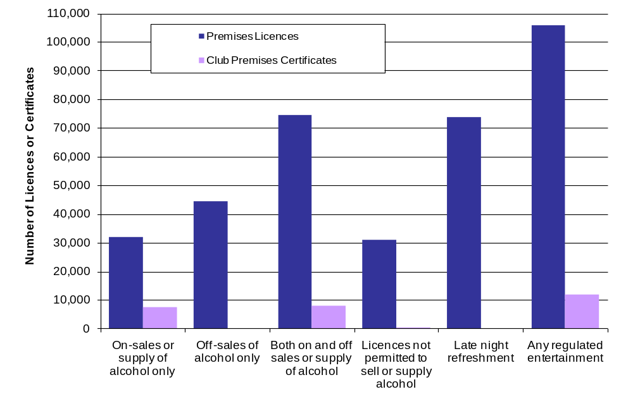FIGURE 1: PREMISES LICENCES AND CLUB PREMISES CERTIFICATES BY ACTIVITY AUTHORISED, ENGLAND AND WALES, 31st MARCH 2009

- There were 10,600 new applications for premises licences. 97% of all decided outcomes resulted in the licence being granted. New premises licences granted in the year to 31 March 2009 made up 5% of the total number of premises licences. [around 98% response rate]

- 210 applications were made for club premises certificates, with just 4 refused. There were also over 46,600 applications made for new personal licences with less than 1% refused. [approx. 98% response]

- Over 1,100 reviews were completed in this reporting period, 9 in 10 were premises licences following an application for a review. Over half the reviews were instigated by the Police, and the main reason for completed review was ‘Crime and Disorder’. Data collected for the first time reported that Local Residents were responsible for instigating 10% of all completed reviews. [This is based on 100% and around 99% of all LAs respectively]

- Following a completed review, in 190 cases the operating hours for the licence was modified and 740 reviews resulted in other conditions being added or modified. Additionally, 170 licences or certificates were suspended and 150 premises licences were revoked or club premises certificates withdrawn. [100% response]

- 4,600 premises licences and club premises certificate applications, and 260 personal licence applications went to a committee hearing in 2008/09. [approx. 99% response]

- There were 123,400 Temporary Event Notices in the year to March 2009. [100% response]

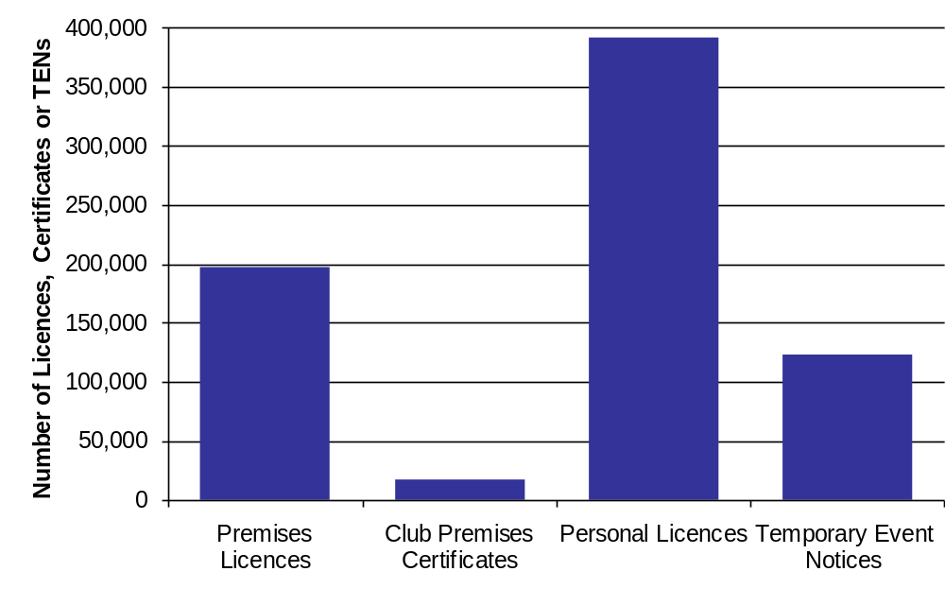
FIGURE 2: PREMISES LICENCES, CLUB PREMISES CERTIFICATES AND TEMPORARY EVENT NOTICES, ENGLAND AND WALES, 2008/09
Headline Annual Comparisons

As this is the third year of this statistical bulletin we are able to make some comparisons of key statistics between collections. However, as the number of Licensing Authorities answering each question was different between years (see Annex A), we needed to model the data to allow for meaningful and accurate comparisons.

2009 and previous year’s figures have been scaled up for some of the key questions so that they represent the estimated total figures for England and Wales (please see “licensing collection methodology – modelling to national totals” on page 37 for full details).

Comparisons between 31st March 2008 and 31st March 2009 for England and Wales have been estimated, and are as follows (rounded to the nearest hundred):

- The total number of premises licences in England and Wales (scaled up to 100%, i.e. all Licensing Authorities) was 195,900 on 31st March 2008 and 197,900 on 31st March 2009. Therefore there was an estimated 1% increase in the number of premises licences but over 100 Licensing Authorities recorded a decrease over the 12 month period.

- The total number of club premises certificates in England and Wales was 17,600 in 2008 and 17,300 in 2009. Therefore there was an estimated 2% decrease in the total number of club premises certificates over the 12 month period (with over 300 certificates being surrendered).

- There were 391,600 personal licences in force on 31st March 2009. This means an estimated 13% increase in the total number of personal licences compared to 12 months ago.

- The total number of premises licences with ‘on-sales of alcohol only’ was 35,000 in 2008 and 34,700 in 2009, a decrease of around 1%.

- The number of ‘off-sales alcohol only’ premises licences was 46,500 in 2008 and 47,600 in 2009 (around a 2% increase). The number of premises licences with ‘both on and off sales was relatively constant between 2008 (82,100) and 2009 (81,800) with a decrease of less than half a percent.

- The total number of ‘on-sales alcohol only’ club premises certificates in 2008 was 8,000. This increased by around 2% to 8,100 in 2009. There was also an estimated 6% decrease over the same 12 month period for club premises certificates with ‘both on and off-sales of alcohol only’ from 9,200 in 2008 to 8,700 in 2009.

- The total number of licences permitting late night refreshment increased by nearly 4,000 to 81,100 in 2009, an approximate 5% increase over the year.

- The estimated total number of premises licences permitted for any regulated entertainment was 113,500 in 2008 and around 117,800 in 2009 (an approximate 4% increase). The number of club premises certificates with provisions for any regulated entertainment fell slightly to 13,400 in 2009 (around 1% decrease), in line with the decrease in club premises certificates over the 12 month period.

- The estimated total premises licences with live music provisions was 79,800 in 2008 and 83,600 in 2009 (an estimated 5% increase). The total club premises certificates with provisions for live music was 10,700 in 2009 (an estimated increase of just under 1% on 2008). Overall the estimated total number of live music licences or certificates was 94,400 as at March 31st 2009 (estimated 4% annual increase).

- The number of premises with 24-hour alcohol licences in England and Wales was 7,100 in 2008 and 7,400 in 2009. This represents an increase of around 4%, and was driven by an estimated 17% increase in Supermarkets and Stores with 24 hour alcohol provisions (around 200 more), and an estimated 19% increase in pubs, bars and nightclubs with 24 hour alcohol provisions (around 100 more). Hotels – the main premises types that have 24 hour licences to sell or supply alcohol – saw an estimated 3% decrease to 4,200 over the past year.

- The number of completed reviews had increased by around 100 to 1,125 in the 12 Month period from 1st April 2007 – 31st March 2008. Some of this is due to expedited review powers being available for the whole of this 12 month period.

- The number of Temporary Event Notices increased by 3% from 119,400 in the 12 month period up to 31st March 2008 to 123,400 this year. Since 1st April 2006 in total over 360,000 TENs have been used to premises choosing to carry out licensable activity on unlicensed premises (or operate outside the terms of their existing licence) in England and Wales.

- The increase in number of TENs as well as an increase in premises licence with any regulated entertainment could be in response to the recession, as businesses choose to diversify what they offer to attract customers. The recession may also be a reason for an increase in number of premises licences surrendered and lapsed and a decrease in number of new applications for licences compared to 2007/08.

Table A: Modelled Estimates for Key Statistics, March 2009 and Estimated Change*
 | 31st March 2009 | Change Since 31st March 2008 | Estimated Percentage Change
Premises Licences | 197,861 | +2,000 | 1%
Club Premises Certificates | 17,259 | -300 | -2%
Personal Licences | 391,637 | +44,000 | 13%
Premises Licences On-sales of alcohol only | 34,700 | -300 | -1%
Premises Licences Off-sales or supply of alcohol only | 47,600 | +1,000 | 2%
Premises Licences Both on and off sales or supply of alcohol | 81,800 | -300 | 0%
Club Premises Certificates On-sales of alcohol only | 8,100 | +200 | 2%
Club Premises Certificates Both on and off sales or supply of alcohol | 8,700 | -500 | -6%
Late Night Refreshment | 81,100 | +4,000 | 5%
Premises Licences with any regulated entertainment | 117,800 | +4,300 | 4%
Premises Licences with live music provisions | 83,600 | +3,800 | 5%
Premises Licences with recorded music provisions | 102,800 | +3,900 | 4%
Club Premises Certificates with any regulated entertainment | 13,400 | -100 | -1%
Club Premises Certificates with live music provisions | 10,700 | +100 | 1%
Club Premises Certificates with recorded music provisions | 11,900 | +100 | 1%
Premises with 24 hour alcohol licences | 7,400 | +300 | 4%
of which: Pubs, Bars and Nightclubs | 900 | +100 | 19%
Supermarkets and Stores | 1,600 | +200 | 17%
Hotel Bars | 4,200 | -100 | -3%
Other premises type | 700 | 0 | 6%
Total number of completed reviews | 1,125 | +100 | 10%
Valid Temporary Event Notices given to Licensing Authority | 123,419 | +4,000 | 3%

*Figures in Table A have been rounded to the nearest hundred, unless we received a 100% response, in which case modelling was unnecessary and figures are shown unrounded.
Headline Annual Time Series

The model has been reapplied to 2008 and 2007 figures. This has been done for two reasons. Firstly, extra (and in some cases more accurate) information is available for some Local Authorities, which answered one of these questions for the first time in 2009. Secondly, a few Local Authorities flagged up that there were some errors in previous year’s returns. In these cases, modelled estimates replaced previously stated inaccurate figures. The model therefore recalculates modelled estimates in 2007 and 2008 based on new information provided in 2009. (Please see “licensing survey methodology – modelling to national totals” on page 37 for full details.)

Table B: Modelled Estimates for Key Statistics, March 2007, March 2008, March 2009*

 | 31st March 2007 | 31st March 2008 | 31st March 2009
Premises Licences | 185,900 | 195,900 | 197,861
Club Premises Certificates | 17,600 | 17,600 | 17,259
Personal Licences | 292,900 | 347,700 | 391,637
Premises Licences On-sales of alcohol only | 33,000 | 35,000 | 34,700
Premises Licences Off-sales or supply of alcohol only | 44,400 | 46,500 | 47,600
Premises Licences Both on and off sales or supply of alcohol | 79,200 | 82,100 | 81,800
Club Premises Certificates On-sales of alcohol only | 7,400 | 8,000 | 8,100
Club Premises Certificates Both on and off sales or supply of alcohol | 10,100 | 9,200 | 8,700
Late Night Refreshment | 68,600 | 77,100 | 81,100
Premises Licences with any regulated entertainment | 108,900 | 113,500 | 117,800
Premises Licences with live music provisions | 75,200 | 79,800 | 83,600
Premises Licences with recorded music provisions | 94,400 | 98,900 | 102,800
Club Premises Certificates with any regulated entertainment | 13,400 | 13,500 | 13,400
Club Premises Certificates with live music provisions | 10,900 | 10,700 | 10,700
Club Premises Certificates with recorded music provisions | 11,600 | 11,700 | 11,900
Premises with 24 hour alcohol licences | 6,000 | 7,100 | 7,400
of which: Pubs, Bars and Nightclubs | 600 | 700 | 900
Supermarkets and Stores | 1,100 | 1,400 | 1,600
Hotel Bars | 3,700 | 4,300 | 4,200
Other premises type | 500 | 700 | 700
Total number of completed reviews | 800 | 1,000 | 1,125
Valid Temporary Event Notices given to Licensing Authority | 118,200 | 119,400 | 123,419

*Figures in Table B have been rounded to the nearest hundred, unless we received a 100% response, in which case modelling was unnecessary and figures are shown unrounded. Differences between 2008 and 2009 as shown on Table A may not match figures in Table B due to rounding.

Annual Time Series Charts
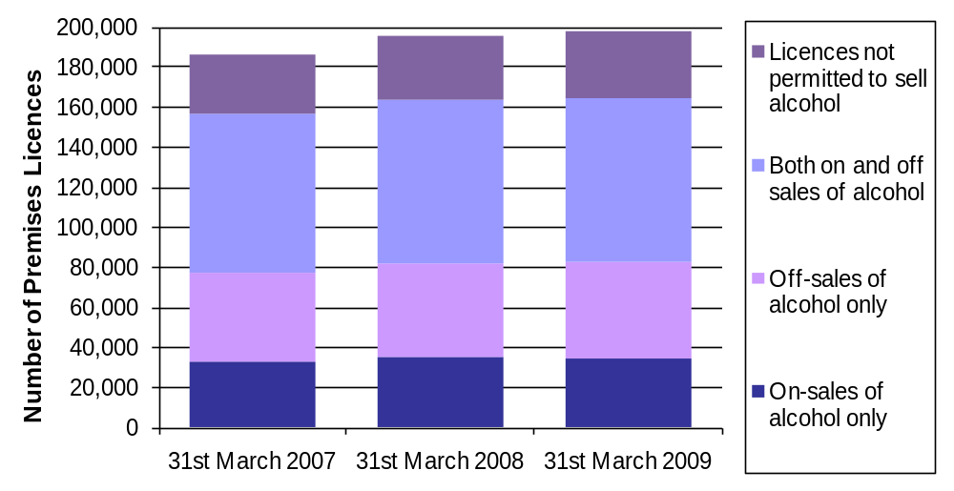
FIGURE A: PREMISES LICENCES BY ALCOHOL PERMISSIONS, ENGLAND & WALES, 2007, 2008, 2009

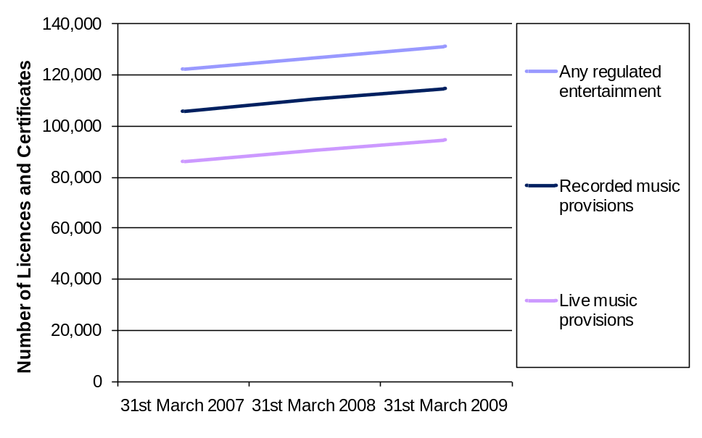
FIGURE B: LICENCES AND CERTIFICATES WITH REGULATED ENTERTAINMENT TYPES, ENGLAND AND WALES, 2007, 2008, 2009

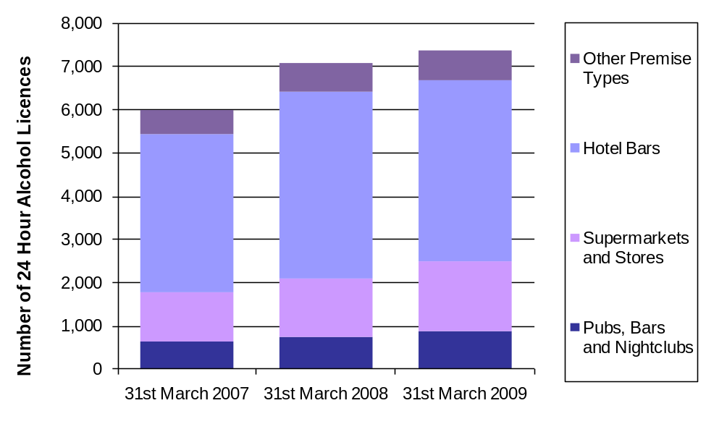
FIGURE C: 24 HOUR ALCOHOL LICENCES, ENGLAND AND WALES, 2007, 2008, 2009

Commentary – Part 1
Premises Licences
100% of LAs submitted a figure for premises licences. 87% provided a split by fee band,
96% provided a number with no fee applicable.
A premises licence can be used for the sale or supply of alcohol, the provision of regulated entertainment or the provision of late night refreshment or any combination of these activities, under the Licensing Act 2003.

- On 31 March 2009 there were 197,900 premises licences in force in England and Wales.

Each premises licence has a fee band which is based on its non-domestic rateable value. The fee bands give a broad indication of the size of the premises, the scale of the business, turnover etc. The number of premises licences split by premises fee band were 41,100 in Band A); 91,600 in Band B; 21,300 in Band C; 4,700 in Band D (no multiplier); 610 in Band D (with multiplier); 11,400 in Band E [no multiplier) and 710 in Band E (with multiplier). These totals include some of the 12,400 premises licences that didn't attract a fee but still had a fee band based on the non-domestic rateable value, where the fee band was known. The fee band was unknown for 26,300 premises licences.

Over 30% of all Band D (with multiplier) premises licences and 27% of Band E (with multiplier) are in London.

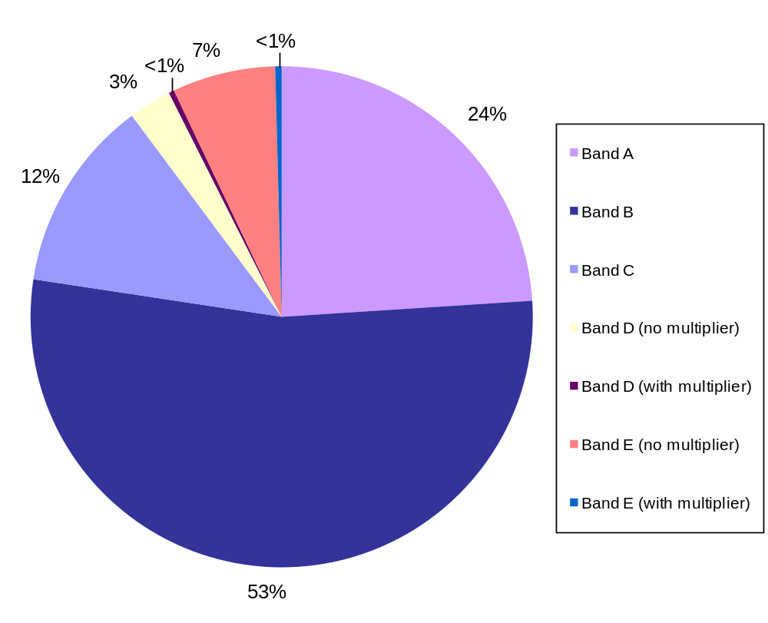

FIGURE 3: PREMISES LICENCES BY FEE BAND, ENGLAND AND WALES, 31 MARCH 2009
(Percentages in figure 3 do not add up to 100% due to rounding.)

Club Premises Certificates
100% of LAs submitted a figure for club premises certificates. 87% provided a split by fee band,
and 95% provided a number with no fee applicable.
The Licensing Act 2003 recognises that non-profit making members clubs give rise to different issues for licensing law than commercially run premises selling direct to the public. These qualifying clubs (such as the Royal British Legion, working men's clubs, cricket clubs, rugby clubs) are generally organisations where members join together for a particular social, sporting or political purpose and then the club purchases alcohol in bulk for its members.

- On 31 March 2009 there were 17,300 club premises certificates in force in England and Wales.

The split of these club premises certificates by their fee band (based on its non-domestic rateable value) are as follows: 4,600 were in Band A; 9,200 in Band B; 830 in Band C; 110 in Band D; and 230 in Band E. These totals include some of the 140 club premises certificates that didn't attract a fee, but still had a band, where known. The fee band was unknown for 2,300 club premises certificates. Over a third of all Band D and E club premises certificates are in the South East.

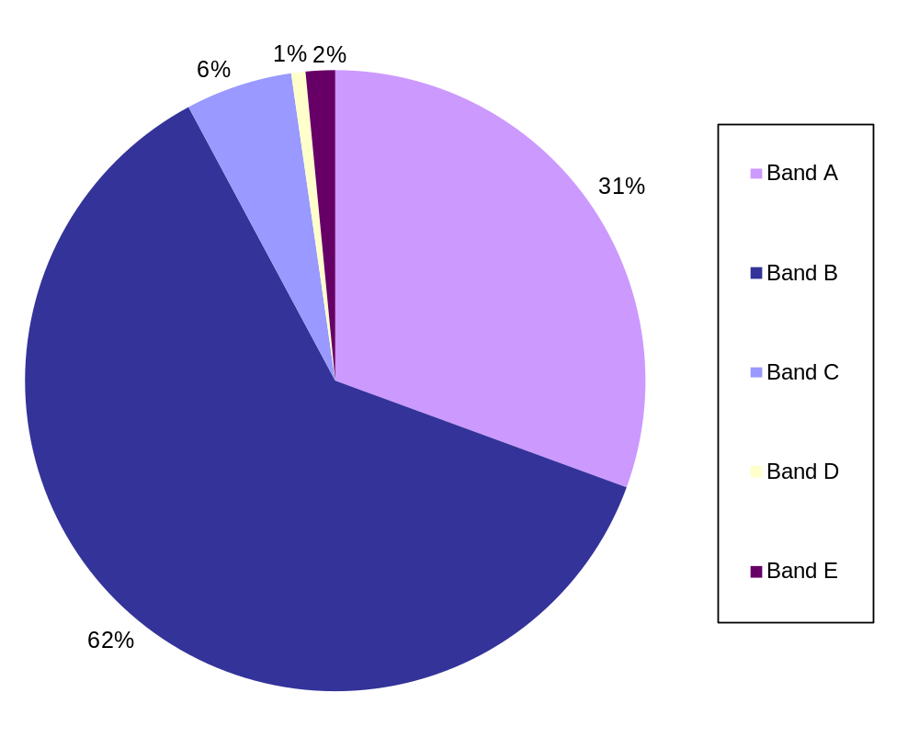
FIGURE 4: CLUB PREMISES CERTIFICATES BY FEE BAND, ENGLAND AND WALES, 31 MARCH 2009
(Percentages in figure 4 do not add up to 100% due to rounding.)

Personal Licences
100% of LAs submitted a figure for personal licences.
The personal licence is separate from the licence which authorises the premises to be used for the supply of alcohol.
- In the year ending March 2009 there were 391,600 personal licence holders.

Alcohol Permissions
93% of LAs provided information on alcohol permissions for premise licences,
and 94% for club premises certificates.
A premises licence can be used for the sale by retail of alcohol and the supply of alcohol (by clubs) for consumption on the premises, off the premises, or both on and off the premises.

- Around 8 in 10 premises licences have authorisation to sell alcohol. On 31st March 2009 there were 31,900 premises licences with on-sales only alcohol licences and 44,400 with off sales only alcohol licences. 74,600 licences had both on and off sales of alcohol licences in force, and a further 5,000 had permissions to sell or supply alcohol but did not specify in what capacity. 30,900 premises licences were not permitted for the sale or supply of alcohol, and alcohol permissions were unknown in 11,000 premises licences.

- More than nine in ten club premises certificates had a permission to supply alcohol. 7,700 club premises certificates authorised on-sale or supply only alcohol licences, 8,100 were authorised for both off and on sales or supply of alcohol and a further 170 had permissions to sell alcohol but did not specify in what capacity. 380 club premises certificates were not permitted for the sale or supply of alcohol. Alcohol permissions were unknown in 1,000 club premises certificates.

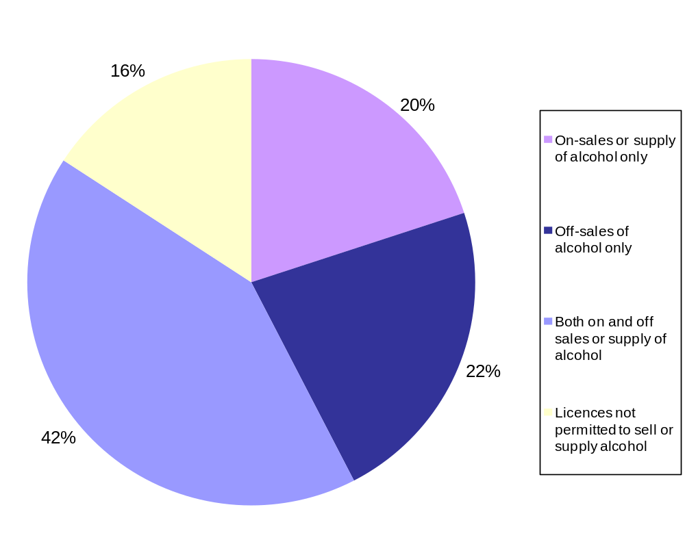
FIGURE 5: PREMISES LICENCES AND CLUB PREMISES CERTIFICATES COMBINED BY ALCOHOL PERMISSIONS, ENGLAND AND WALES, 31 MARCH 2009
(NB, off-sales of alcohol only is only for premises licences.)

Regulated Entertainment and Late Night Refreshment
89% of LAs submitted a total for regulated entertainment, with around just 75% of LAs providing a split by licensable activity. 90% of LAs provided a total for late night refreshment.
The provision of regulated entertainment covers the provision of entertainment (plays, films, indoor sporting events, boxing or wrestling, live music, recorded music and dance) as well as the provision of entertainment facilities (facilities provided for enabling people to take part in making music, dancing and similar activities). Entertainment is “regulated entertainment” when it takes place in the presence of a public audience or members and guests of a qualifying club, whether a charge is made or not. Entertainment which takes place in the presence of a private audience is only regulated entertainment when a charge is made with a view to making a profit.

- 105,800 premises licences and 12,000 club premises certificates in force were licensed for some type of regulated entertainment.

- The most popular forms of entertainment for premises licences were recorded music (78,100), live music (63,400), facilities for dancing (44,500) and facilities for making music (39,600).

- For club premises certificates, the most popular forms were recorded music (9,000 club certificates), live music (8,100), facilities for dancing (6,800), facilities for making music (4,400) and indoor sporting events (4,300).

- On 31 March 2009, around 435,000 licensable activities were authorised with a premises licence or club premises certificate.

Late night refreshment is the provision of hot food or drink to the public, for consumption on or off the premises, between 11pm and 5am or the supply of hot food or hot drink to any persons between those hours on or from premises to which the public has access.

- 73,800 premises licences (over a third of all premises licences in force) had late night refreshment activity authorised. 18% of these were in Greater London Authorities and 20% were in other metropolitan districts.
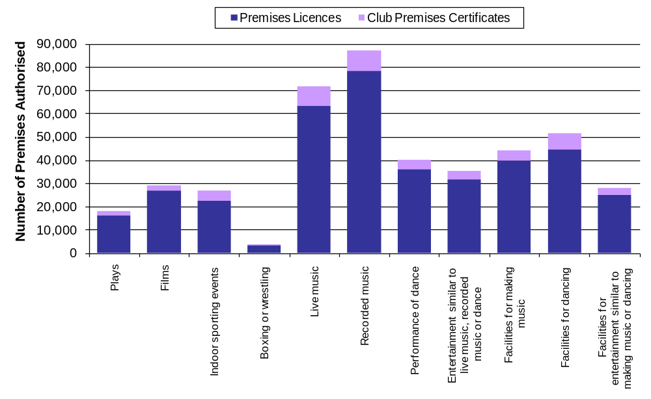
FIGURE 6: PREMISES LICENCES AND CLUB PREMISES CERTIFICATES BY AUTHORISED REGULATED ENTERTAINMENT, ENGLAND AND WALES, 31 MARCH 2009
24-Hour Alcohol Licences
96% of LAs submitted a total for 24-hour alcohol licences, see page 49 for more details
There were approximately 7,200 premises licensed for the sale or supply of alcohol for 24 hours in their standard timings, on 31 March 2009. This is 4% of all premises licences and club premises certificates authorised to sell alcohol. The possession of a 24 hour licence does not necessarily mean that the premises will choose to open for 24 hours. Prior to the 2003 Act, hotels were authorised to sell alcohol to residents and their private guests only, outside of permitted licensing hours and were able to apply to keep this provision under ‘grandfather rights’.

The results by Government Office Region showed that the South West had 23% of all 24-hour alcohol licences in England and Wales. The North West had 19%, South East had 14%, and London had 11% and the East of England had 10%. The other regions and Wales had less than 7% of the total in their area.

- Around six in ten of all 24 hour alcohol licences were in hotel bars (4,100), of which around 86% were open to guests only and the remaining 14% open to guests and public. Over half of all hotel bars with a 24 hour licence were in the North West or the South West, with over 90% of these open to guests only. A large number of hotels are located in leisure resort areas and therefore these areas would also have a large proportion of hotel bars with 24 hour alcohol licences for guests.

- 1,500 Supermarkets and Stores had 24-hour alcohol licences, of which 56% were large supermarkets and the remaining 44% were other convenience stores. Nearly half of all ‘other’ convenience stores with 24 hour licences were in London (330 premises licences).

- 37% of all Licensing Authorities had at least one Pub, Bar or Nightclub with a 24-hour alcohol licence (850 such premises in total). 270 of these licences (nearly one third) were in the South West, with only 18 in the North East.

- 680 other premises types were licensed for the sale or supply of alcohol for 24 hours. This category included casinos, warehouses, village halls, cafés and restaurants, cinemas, holiday camps, and private member clubs as well as various other premises types.
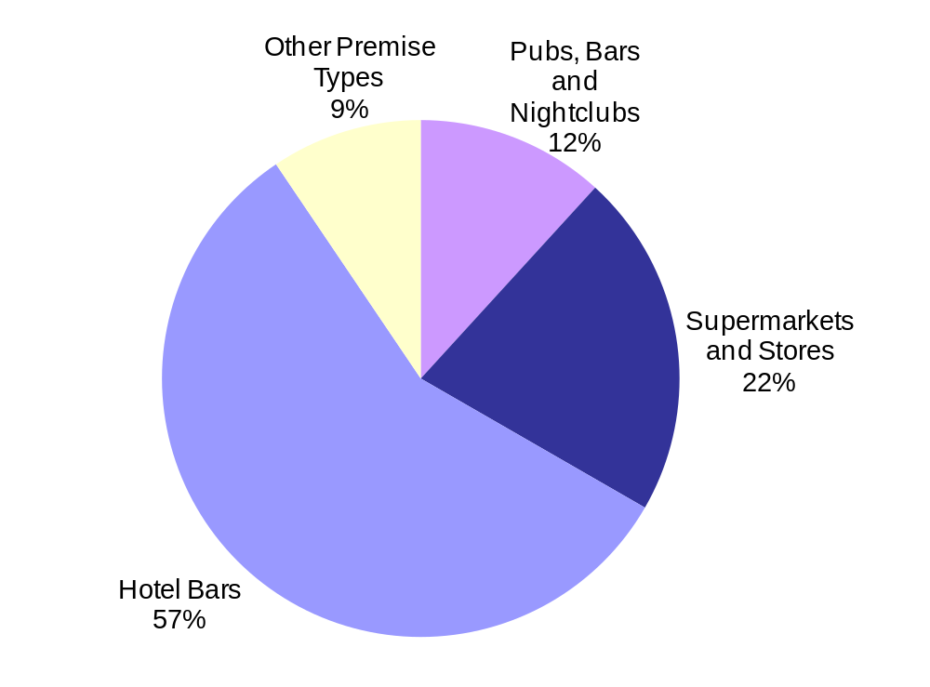
FIGURE 7: PREMISES WITH 24-HOUR ALCOHOL LICENCES BY PREMISES TYPE, ENGLAND AND WALES, 31 MARCH 2009

- Figure 8 shows licences permitted for the sale or supply of alcohol for 24 hours in their standard timings as a proportion of the total number of alcohol licences (and certificates) in force per authority area. It shows that the majority of LAs with 8% or more of their licences with 24 hour timings are coastal LAs. Many of these are leisure resort areas and will have a larger number of hotels (please see Annex D on page 53 for maps showing 24 hour alcohol licences by premises type).

- The map also shows that most LAs have less than 4% of their licences permitted to sell alcohol for 24 hours.

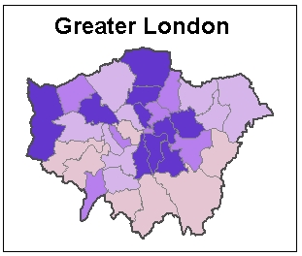
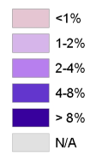
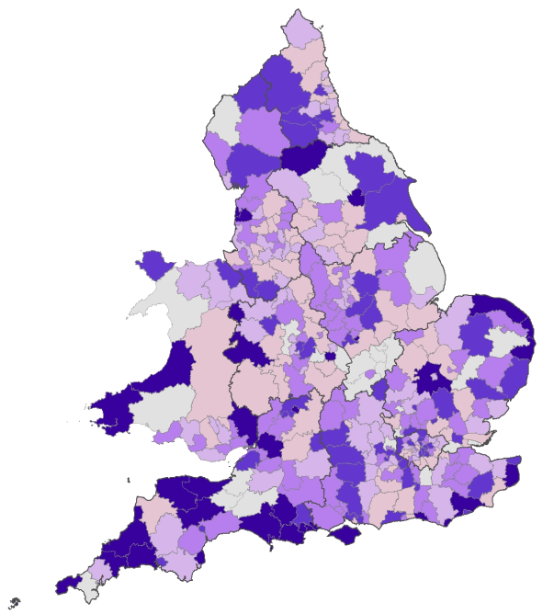

FIGURE 8: TOTAL 24-HOUR ALCOHOL LICENCES AS A PROPORTION OF LICENCES PERMITTED TO SELL OR SUPPLY ALCOHOL BY LOCAL AUTHORITY (GREATER LONDON ENLARGED – Not to Scale)

Cumulative Impact Areas
100% of LAs submitted a figure for cumulative impact areas
A cumulative impact area is an area that the Local Authority has identified in their licensing policy statement where there is a saturation of licensed premises and the 'cumulative impact' of any additional licensed premises could affect the licensing objectives.

- As on 31st March 2009 there were 129 cumulative impact areas of which 21% were in Greater London Authorities and 18% in other metropolitan districts.

- 80 Licensing Authorities had at least one cumulative impact area, including 27 Local Authority areas which had two or more cumulative impact areas.

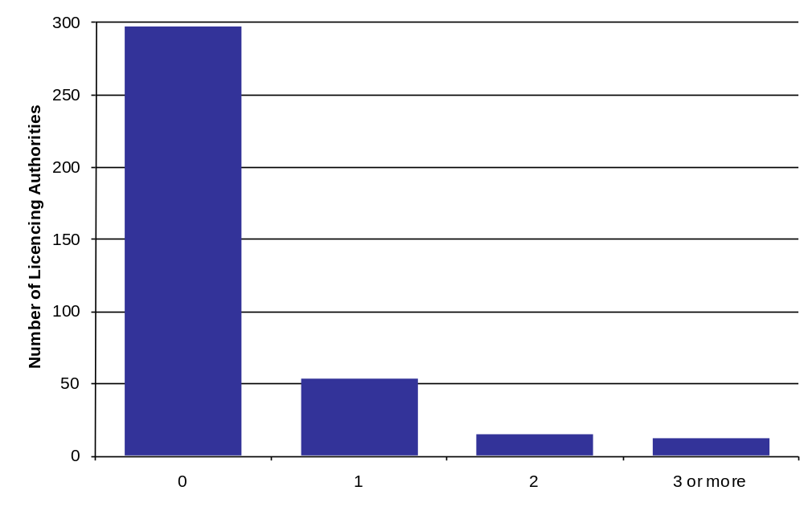

FIGURE 9: NUMBER OF CUMULATIVE IMPACT AREAS PER LICENSING AUTHORITY, ENGLAND AND WALES, 31ST MARCH 2009
Part 2 – Licence Activity in 2008/09

Premises Licences
99% of LAs reported a total for premises licence applications, see page 50 for more details
2008/09 was the third full financial year where the new Licensing Act was in effect. In this period there were 10,600 new premises licences applied for, of which 10,000 were granted (97% of all decided outcomes) and 280 were refused. Newly granted premises licences accounted for around 5% of the total number of premises licences in force on 31st March 2009.
There were 7,500 applications made to change the terms of a licence, for example the opening hours, the licensable activities or the conditions. 7,000 of these variations were granted (97%), with 210 refused (3%). There were 42,800 requests to specify a different individual as the designated premises supervisor and 42,200 were granted with 110 refused (less than 1%).
Provisional statements are applications where the premises are being constructed, extended or altered for use for licensable activities. 27 were applied for in 2008/09, 25 were granted, and 0 were refused.
Other findings for premises licences in the year to 31st March 2009 were:

- 16,200 applications were made for transfers of premises licences. 15,900 were granted in this period and 120 were refused (1%).

- 4,500 premises licences were surrendered, whilst 590 lapsed due to the death, incapacity, insolvency etc. of the licence holder. The number of surrendered and lapsed premises licences was higher than in previous years and may be as a result of the recession.

- 12 were suspended by a court for the sale or supply of alcohol, following an offence of persistently selling to underage children; and 54 premises licences were prohibited from selling alcohol for 48 hours following a closure notice.
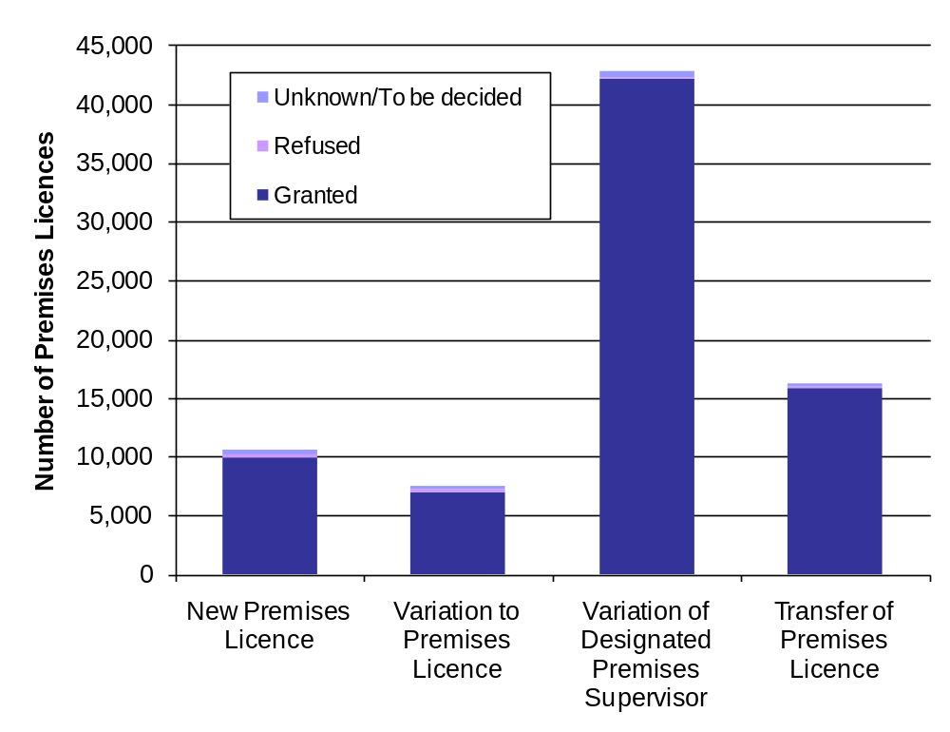

FIGURE 10: PREMISES LICENCE ACTIVITY, BY OUTCOME, ENGLAND AND WALES 2008/09
Club Premises Certificates
99% of LAs submitted a total for club premises certificate applications, see page 50 for more details
During the twelve months ending 31 March 2009 there were 210 new applications for club premises certificates. 200 were granted (98% of all decided outcomes) and 4 were refused. The newly granted club premises certificates accounted for just 1% of the total number of club premises certificates in force on 31st March 2009.

Other findings for club premises certificates in the year to 31st March 2009 were:

- 320 variations to club premises certificates were applied for. Variations include changing the activities of the qualifying club, or the conditions of the certificate. 310 were granted (99%) in this reporting period and 4 were refused.

- 320 club premises certificates were surrendered; 8 lapsed as they were only in effect for a limited period which has since expired. 19 were withdrawn where the club was no longer a qualifying club.

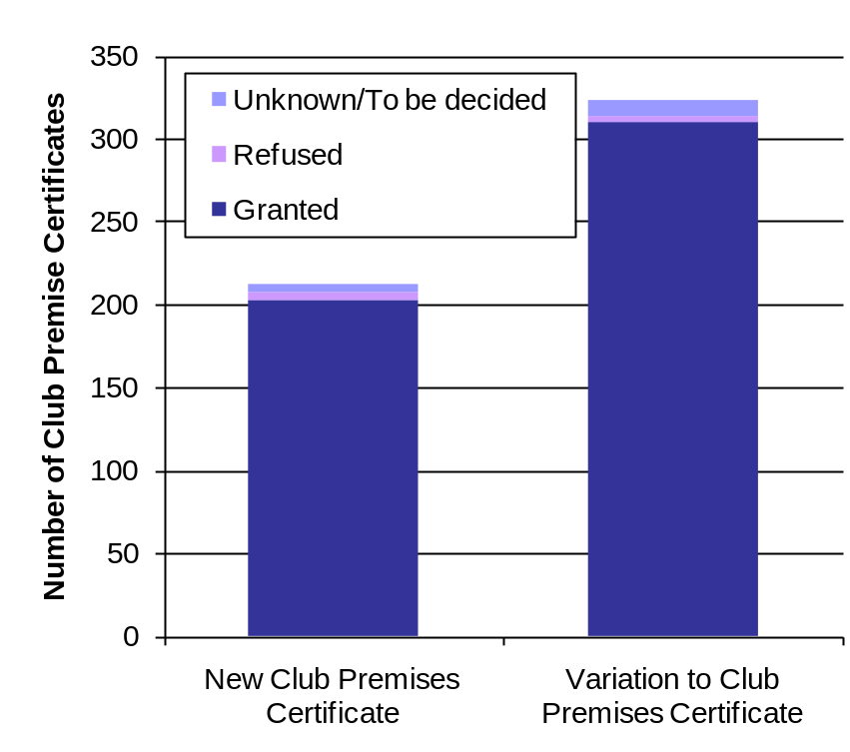

FIGURE 11: CLUB PREMISES CERTIFICATE ACTIVITY, BY OUTCOME, ENGLAND AND WALES 2008/09

Personal Licences
99% of LAs submitted a total for personal licence applications, see page 50 for more details
A personal licence authorises an individual to supply or authorise the supply of alcohol in accordance with a premises licence under the Licensing Act 2003.

- In the year ending 31st March 2009, 46,600 new personal licences were applied for, of which 45,700 were granted (99% of decided outcomes) and 270 were refused.

- The new personal licences granted account for nearly 12% of the total number of personal licences in force on 31st March 2008.

The Act provides the police and licensing authorities with powers to deal with errant personal licence holders. In the year ending March 2009 there were 250 police objections to personal Licence applications.

Other findings for personal licences in the year to 31st March 2009 were:

- 320 personal licences were surrendered; 9 were revoked; 6 were forfeited; and 18 were suspended by a court.

- There were 260 committee hearings following a personal licence application.

Completed Reviews
100% Licensing Authorities responded to number of completed reviews, more than 95% provided a reason for the completed review, and 95% reported who instigated the review.
There have been over 1,100 completed reviews in 2008/09. 1,000 were for premises licences following an application for a review, 75 were for premises licences following an application by police for expedited review and 26 were premises licences following closure orders under section 161 of the 2003 Licensing Act. This was the first full year the expedited review powers were in force. 22 completed reviews were for club premises certificates following an application for a review.

The main reason for completed reviews (as reported by the licensing objectives and the stated grounds of the review) was crime & disorder (730 reviews), this was followed by protection of children (500 reviews), public nuisance (470 reviews), and the least common reason was public safety (210 reviews).

The police were the main responsible authority for instigating the review, (610 reviews, 54%). 230 reviews were instigated by Trading Standards Officers (20%), Environmental Health Officers instigated 150 reviews (13%), Local Residents instigated 110 reviews (10%) and Other Responsible Authorities or Interested Parties instigated 24 reviews (2%). These totals include 11 cases where more than one authority instigated the review. Other Responsible Authorities or Interested Parties included the Fire and Rescue Authorities, planning authorities and Local Safeguarding Children Board. In 20 reviews the instigating authority/party was unknown.

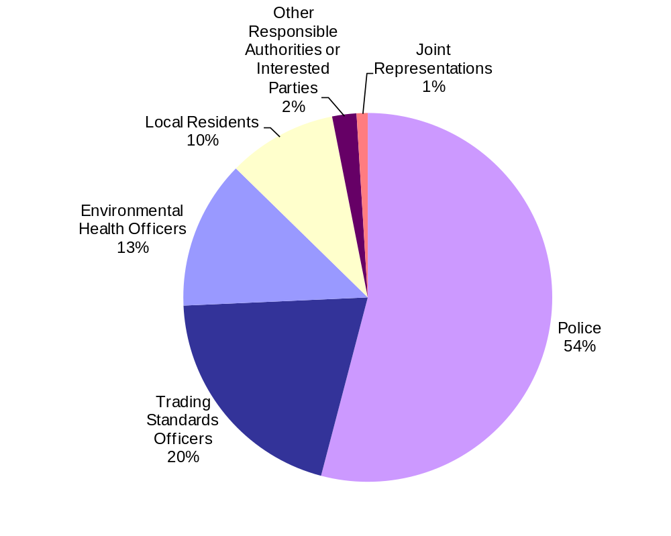

FIGURE 12: COMPLETED REVIEWS INSTIGATED BY RESPONSIBLE AUTHORITY, ENGLAND AND WALES 2008/09

- Following a completed review, 170 licences or certificates were suspended and 150 premises licences were revoked or club premises certificates withdrawn.
- Around 190 cases resulted in a licence modifying their operating hours and in 740 cases other conditions were added or modified following a completed review.
- In over 120 cases the licensable activity was partially restricted, and in over 110 premises licences reviews, the designated premises supervisor was removed. Following just 4% of completed cases no action was taken following a review (50 reviews).

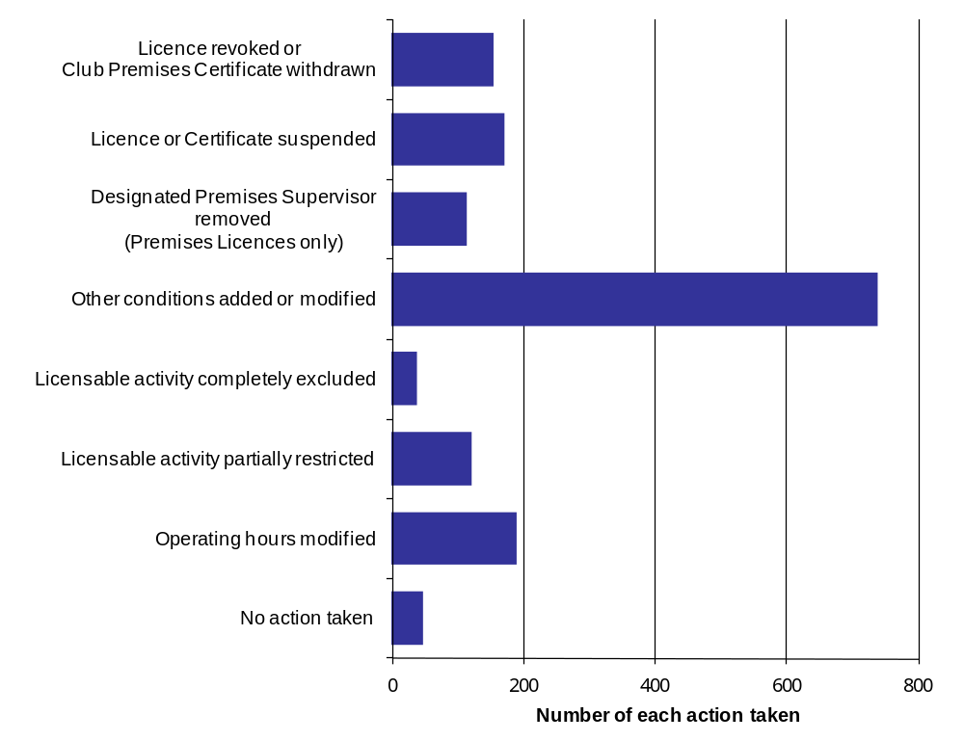

FIGURE 13: ACTIONS TAKEN FOLLOWING COMPLETED REVIEWS, ENGLAND AND WALES 2008/09

Expedited Reviews
100% of LAs responded to the questions on expedited reviews and actions taken.

Expedited review powers came into force from 1st October 2007, so this is the first full year expedited review powers were available. The new powers apply only where a premises licence authorises the sale of alcohol. They do not apply in respect of other premises licences, nor to those operating under a club premises certificate. The purpose of the powers is to complement existing procedures in the Licensing Act 2003 for tackling crime and disorder associated with licensed premises. The powers allow the police to trigger a fast track process to review a premises licence where the police consider that the premises are associated with serious crime or serious disorder (or both); and the licensing authority to respond by taking interim steps quickly, where appropriate, pending a full review.

- Between 1st April 2008 and 31st March 2009 there were 75 applications by the chief officer of police for an expedited/summary review of a premises licence because of serious crime and/or serious disorder under S.53A of the 2003 Act. None of these applications were withdrawn or removed.
- All 75 cases resulted in a completed review of the premises licence (following an application by police for an expedited/summary review under S.53A of the 2003 Act).
- In 69 expedited reviews, interim steps were taken following the successful application for the review. Interim steps are temporary measures which have to be taken within 48 hours of the expedited review being accepted under one specific review power. These measures then fall (unless they are reimposed at the review hearing). In 6 cases no interim steps were taken.
- In 48 cases the interim step was to suspend the premises licence. In 19 cases the interim step was to modify the operating hours, and other conditions were added or modified in 29 cases. The other interim steps were licensable activity partially restricted in 10 cases, licensable activity was completely excluded in 2 cases and in 10 cases the Designated Premises Supervisor was removed.
- 26 expedited reviews (over a third) were in London and 19 (a fifth) were in the North West.

Hearings, Appeals and Judicial Reviews
Around 99% of LAs responded to number of applications that went to a hearing, 98% responded to number of appeals completed and 100% of LAs recorded the number of completed judicial reviews.

In the year ending 31st March 2009 there were over 4,600 premises licence or club premises certificate applications that went to a committee hearing. These include applications that went to a hearing for a premises licence, provisional statements, club premises certificates or to vary a licence.

Over the same 12 month period there were 170 completed appeals against the application decision (where the Magistrates Court notified parties of its decision in the time period specified). There were also 140 completed appeals against the licence review decision.

- There were 3 completed judicial reviews in the higher courts between 1st April 2008 and 31st March 2009. The licensing authorities which had a completed judicial review were Bassetlaw, Bristol and Swindon.
Temporary Event Notices
100% of LAs submitted a total for Temporary Event Notices, see page 52 for more details
Temporary Event Notices (TENs) have replaced the temporary permissions that were available under the old regimes such as occasional permissions, occasional licences, special hours’ certificates, or temporary public entertainment licences. They are a light touch permission that allows licensable activities to be undertaken which last no more than 96 hours and must involve no more than 499 people. There are also restrictions on the number of TENs an individual can give in a year and the number of events that can be held under a TEN each year on an individual premise.

- There were over 123,400 TENs used in year to March 2009. The South East region had the highest proportion of TENs in England and Wales (20%), followed by the South West (15%) and London (14%).

- Over 1,100 TENs were withdrawn and 400 were received following modification with police consent.

- Further to this, 200 counter notices were given by the licensing authority following police objection and nearly 240 counter notices were given where limits were exceeded.

- Nearly 230 TENs resulted in a committee hearing.
Tables
Table 1: Number of Premises Licences, Club Premises Certificates and Personal Licences by Fee Band – England and Wales, 31st March 2009
 | Total | Percentage valid* | Total percentage (including unknown)*
Premises Licences | 197,861 |  | 100%
Band A | 41,131 | 24% | 21%
Band B | 91,637 | 53% | 46%
Band C | 21,335 | 12% | 11%
Band D (no multiplier) | 4,732 | 3% | 2%
Band D (with multiplier) | 607 | 0% | 0%
Band E (no multiplier) | 11,395 | 7% | 6%
Band E (with multiplier) | 714 | 0% | 0%
Band unknown | 26,310 |  | 13%
Number with no fee applicable | 12,403 |  | 6%
Club Premises Certificates | 17,259 |  | 100%
Band A | 4,579 | 31% | 27%
Band B | 9,221 | 62% | 53%
Band C | 834 | 6% | 5%
Band D | 111 | 1% | 1%
Band E | 229 | 2% | 1%
Band unknown | 2,285 |  | 13%
Number with no fee applicable | 140 |  | 1%
Personal Licences | 391,637 |  | 100%

*The percentages in the table may not add up to 100% due to rounding.
Table 2: Number of Premises Licences and Club Premises Certificates by licensable activity - England and Wales, 31st March 2009
 | Total | Percentage valid | Total percentage (including unknown)*
Premises Licences | 197,861 |  | 100%
Premises Licences Selling Alcohol | 155,895 | 83% | 79%
On-sales or supply of alcohol only | 31,873 | 17% | 16%
Off-sales of alcohol only | 44,432 | 24% | 22%
Both on and off sales or supply of alcohol | 74,629 | 40% | 38%
On/off/both sales unspecified | 4,961 | 3% | 3%
Licences not permitted to sell or supply alcohol | 30,919 | 17% | 16%
Alcohol Permissions Unknown | 11,047 |  | 6%
Late Night Refreshment | 73,817 |  | 37%
Club Premises Certificates | 17,259 |  | 100%
Club Premises Certificates Selling Alcohol | 15,882 | 98% | 92%
On-sales or supply of alcohol only | 7,655 | 47% | 44%
Both on and off sales or supply of alcohol | 8,059 | 50% | 47%
On/both sales unspecified | 168 | 1% | 1%
Licences not permitted to sell or supply alcohol | 377 | 2% | 2%
Alcohol Permissions Unknown | 1,000 |  | 6%

*The percentages in the table may not add up to 100% due to rounding.
Table 3: Number of Premises Licences and Club Premises Certificates by regulated entertainment type - England and Wales, 31st March 2009
 | Total | Percentage of entertainment licences | Percentage of all licences
Premises Licences | 197,861 |  | 100%
Premises Licences with any regulated entertainment | 105,768 | 100% | 53%
Plays | 16,364 | 15% | 8%
Films | 26,740 | 25% | 14%
Indoor sporting events | 22,457 | 21% | 11%
Boxing or wrestling | 3,307 | 3% | 2%
Live music | 63,388 | 60% | 32%
Recorded music | 78,106 | 74% | 39%
Performance of dance | 36,070 | 34% | 18%
Entertainment similar to live music, recorded music or dance | 31,807 | 30% | 16%
Facilities for making music | 39,607 | 37% | 20%
Facilities for dancing | 44,538 | 42% | 23%
Facilities for entertainment similar to making music or dancing | 25,050 | 24% | 13%
Club Premises Certificates | 17,259 |  | 100%
Club Premises Certificates with any regulated entertainment | 11,979 | 100% | 69%
Plays | 1,714 | 14% | 10%
Films | 2,441 | 20% | 14%
Indoor sporting events | 4,283 | 36% | 25%
Boxing or wrestling | 446 | 4% | 3%
Live music | 8,131 | 68% | 47%
Recorded music | 9,014 | 75% | 52%
Performance of dance | 4,047 | 34% | 23%
Entertainment similar to live music, recorded music or dance | 3,372 | 28% | 20%
Facilities for making music | 4,434 | 37% | 26%
Facilities for dancing | 6,839 | 57% | 40%
Facilities for entertainment similar to making music or dancing | 2,864 | 24% | 17%

Note: Multiple activities can apply to a particular premise.
Table 4: Number of Premises Licences with 24 hour alcohol provisions by premises type - England and Wales, 31st March 2009
 | Total | Percentage valid | Total percentage (including unknown)
Premises with 24 hour alcohol licences | 7,178 | 100% | 100%
Pubs, Bars and Nightclubs | 845 | 12% | 12%
Supermarkets and Stores | 1,547 | 22%
Large supermarkets | 861 |  | 12%
Other convenience stores | 675 |  | 9%
Unknown | 11 |  | 0%
Hotel Bars | 4,108 | 57%
Open 24 hours to guests and public | 577 |  | 8%
Open 24 hours to guests only | 3,497 |  | 49%
Unknown | 34 |  | 0%
Other premises type | 678 | 9% | 9%

*The percentages in the table do not add up to 100% due to rounding.

Table 5: Number of Cumulative Impact Areas - England and Wales, 31st March 2009
 | Total
Number of Cumulative Impact Areas | 129

Table 6 – Licence Activity by outcome for England and Wales in 2008/09

 |  |  |  |  | Percentage valid where decision known |  | Percentage totals including unknowns*
 | Applied | Granted | Refused | Unknown / To Be Decided | Granted | Refused | Granted | Refused | Unknown / To Be Decided
New Premises Licence | 10,587 | 9,962 | 275 | 350 | 97% | 3% | 94% | 3% | 3%
Variation to Premises Licence | 7,473 | 7,004 | 208 | 261 | 97% | 3% | 94% | 3% | 3%
Variation of Designated Premises Supervisor | 42,792 | 42,173 | 107 | 512 | 100% | 0% | 99% | 0% | 1%
New Club Premises Certificate | 213 | 203 | 4 | 6 | 98% | 2% | 95% | 2% | 3%
Variation to Club Premises Certificate | 324 | 310 | 4 | 10 | 99% | 1% | 96% | 1% | 3%
New Personal Licence | 46,645 | 45,695 | 269 | 681 | 99% | 1% | 98% | 1% | 1%
Provisional Statement | 27 | 25 | 0 | 2 | 100% | 0% | 93% | 0% | 7%
Transfer of Premises Licence | 16,248 | 15,898 | 123 | 227 | 99% | 1% | 98% | 1% | 1%

*The percentages in the table may not add up to 100% due to rounding.

Table 7: Number of police objections to Personal Licences, and committee hearings - England and Wales in 2008/09
 | Total
Number of police objections to Personal Licence applications | 252
Number of applications that went to a committee hearing
Premises Licence/Club Premises Certificate applications | 4,637
Personal Licence applications | 264

Table 8a: Number of completed reviews by type of licence - England and Wales in 2008/09

 | Total | Percentage
Completed reviews | 1,125 | 100%
Premises Licences (following application) | 1,002 | 89%
Premises Licences (following application by police for expedited review) | 75 | 7%
Premises Licences (following closure orders under S.161 of Act) | 26 | 2%
Club Premises Certificates - following application | 22 | 2%

Table 8b: Reason for completed review - England and Wales in 2008/9
 | Total | Percentage
Crime & Disorder | 726 | 65%
Protection of Children | 502 | 45%
Public Nuisance | 470 | 42%
Public Safety | 212 | 19%

Note: more than one reason may apply to each review, so the percentages will not add to 100%

Table 8c - Number of completed reviews instigated by each Responsible Authority - England and Wales in 2008/09
 | Total | Percentage valid | Total percentage (including unknown)*
Police | 610 | 55% | 54%
Trading Standards Officers | 228 | 20% | 20%
Environmental Health Officers | 147 | 13% | 13%
Local Residents | 108 | 10% | 10%
Other Responsible Authorities or Interested Parties | 24 | 2% | 2%
Unknown | 20 |  | 2%

*The percentages in the table do not add up to due to rounding and in 11 cases more than one responsible authority instigated the review.

Table 9: Action taken following completed reviews - England and Wales in 2008/09
 | Total | Percentage
Completed reviews | 1,125 | 100%
No action taken | 48 | 4%
Operating hours modified | 190 | 17%
Licensable activity partially restricted | 121 | 11%
Licensable activity completely excluded | 38 | 3%
Other conditions added or modified | 738 | 66%
Designated Premises Supervisor removed (Premises Licences only) | 113 | 10%
Licence or Certificate suspended | 171 | 15%
Licence revoked or Club Premises Certificate withdrawn | 154 | 14%

Note: more than one action may apply to each completed review, so the percentages will not add to 100%

Table 10: Number of Expedited review applications, applications withdrawn and interim steps taken - England and Wales in 2008/09
 | Total | Percentage of expedited reviews where interim steps taken | Percentage of expedited reviews
Total number of applications for expedited reviews | 75 |  | 100%
Number of expedited review applications withdrawn or rejected | 0 |  | 0%
Number of cases where no interim steps were taken | 6 |  | 8%
Number of cases where interim steps were taken | 69 |  | 92%
Operating hours modified | 19 | 28%
Licensable activity partially restricted | 10 | 14%
Licensable activity completely excluded | 2 | 3%
Other conditions added or modified | 29 | 42%
Designated Premises Supervisor removed | 10 | 14%
Licence suspended | 48 | 70%

Note: more than one interim step may apply per review, so the percentages will not add to 100%

Table 11: Number licences surrendered, lapsed, suspended, revoked, forfeited or withdrawn by licence type, 2008/09
 | Surrendered | Lapsed | Suspended by a court | Closure notice
Premises Licences | 4,527 | 591 | 12 | 54
 | Surrendered | Lapsed | Withdrawn
Club Premises Certificates | 317 | 8 | 19
 | Surrendered | Revoked | Forfeited | Suspended by a court
Personal Licences | 317 | 9 | 6 | 18

Table 12: Number of appeals and judicial reviews for- England and Wales in 2008/09
 | Total
Number of appeals against application decision | 168
Number of appeal against licence review decision | 141
Number of judicial reviews completed | 3

Table 13: Number of Temporary Event Notices - England and Wales in 2008/09
 | Total
Valid Temporary Event Notices given to Licensing Authority | 123,419
Temporary Event Notices withdrawn | 1,122
Temporary Event Notices received following modification with police consent | 399
Counter Notices given following police objection | 197
Temporary Event Notices that resulted in a committee hearing | 225
Counter Notices given where limits exceeded | 237

Table Breakdowns for each question by Local Licensing Authority Area in 2008/09
Information at Licensing Authority level is available in Excel format - online only.
http://www.culture.gov.uk/reference_library/publications/5571.aspx

Licensing Collection Methodology

- Overall there was a 100% response rate to the MS Excel questionnaire that was sent by e-mail to each Licensing Authority (LA) in England and Wales. However the response rate differed for each question asked, so only partial returns were received for some sections.
- Authorities were initially given over 3 months to submit their completed questionnaire, though late returns were accepted.
- Each submitted data response was checked and validated.
- All Licensing Authorities in England and Wales submitted a return, receiving over 220 fully completed returns.
- Conwy Licensing Authority and Denbighshire Licensing Authority submitted a joint response as they had done in 2007/08; therefore the total number of Licensing Authorities in the collection was again 377.
- The questionnaire was structured in 2 parts – one asking for information of the number of licences in force on 31st March 2009 and the other asking for detail of associated activity over the 12 months to this date.
- Licensing Authorities were informed that if the rateable value fee band has not yet been set (a requirement before a licence can be granted), then these should be recorded as fee band A. LAs were informed that premises licences that don’t attract a fee would still have a fee band (based on the non-domestic rateable value of the premises), in some cases in previous years these were recorded in the “Fee Band Unknown” category.
- The questionnaire sent to each licensing authority is shown in Annex C (without the extensive instructions that were provided). It was requested that all white cells should be completed, and as many yellow cells as possible. The questionnaire stated that all values entered should be numerical, and to use 0 where the answer is 'none'. Any cells that were left blank were assumed to be unknown, and are treated as a non-response to that part of the question.
- Clear and easy-to-use guidance was included with the electronic form and further automatic validation checks were built in, along with an error summary sheet which highlighted any errors or missing values throughout the questionnaire.
- As some categories were optional, they were not completed for all licensing authorities. There was a lower response rates for type of licensable activity authorised in question 2b. This was an optional part of the question and only around three quarters of all LAs were able to provide an accurate breakdown of this category.
- In some cases the data returned were not consistent, for example, sometimes the totals did not match the sum of the different types of licences. These errors were followed up with the Licensing Authority and amendments to the figures were made.
- The quality of the data varied noticeably from question to question and there were some inconsistencies between Licensing Authority returns, such as reporting the number of premises licences with only late night refreshment rather than any with late night refreshment provisions. A number of errors were flagged up in further validity checks and each LA was contacted where necessary in an attempt to rectify these.
- A number of LAs informed us of inaccuracies with figures submitted in last year’s collection. Some of the reasons stated were miscoding of categories, the way in which the data was recorded on their systems, human error, double counting some licences where there had been variations, lack of experience answering the statistical return.
- A common reason for poor quality returns was the diversity of computer systems in place within the Licensing Authorities. Some of these systems were not set up to easily allow responses to some of the questions asked. In these cases, in order to provide answers it would have required a large amount of time and effort to find out the information manually and in many cases was not possible at all.
- In a few instances Licensing Authorities were only able to provide estimates, or could not provide figures for the period requested. These comments and caveats provided from individual LAs have been published as notes alongside the full online tables.
- Figures in the main commentary of this bulletin are aggregates of those reported by Licensing Authorities for this exercise. Only the section on “Headline Annual Comparisons” reports scaled up modelled figures to the complete total in England and Wales.

Data amendments
- DCMS ran a number of data quality checks on each return received. The questionnaire had an increased number of automatic error checks compared with previous collections, including a summary sheet that flagged up the reason for each error. Where an error was found and had not been corrected, the LA was contacted in an attempt to amend the incorrect figures. Error checks included:
- The “any regulated entertainment” total was no higher than the total number of licences that the authority had in force, and no lower than the highest entertainment type category.
- Sub-category splits equalled the totals, e.g. the sum of premises licences with alcohol provisions and non-alcohol provisions equalled the total number of premises licences in force.
- The total number of applications for expedited reviews, excluding any withdrawn applications, equalled the total number of completed reviews following application by police for expedited review.
In cases where the LA was unable to make corrections or could not be contacted, assumptions were made in order to amend the figures as necessary.
- In some questions where there were blank cells which were obviously zero (i.e. a split was provided to an aggregate total, but some parts were left blank) then they were edited to “0”.
- In question 9, amendments were made to the number of “no action taken” following completed reviews where it was evident that actions had not been taken.
- All amendments are highlighted in the online tables by individual Licensing Authority.
- The 2009 exercise highlighted some errors and anomalies in a small number of previous years’ returns but no amendments are being made to previously published figures, apart from the remodelled estimates reported on pages 10 -12. The modelling methodology takes into account LAs that informed us of some errors in their 2008 return and their 2007 return. In these cases, modelled estimates replaced previously stated incorrect figures.

Modelling to National Totals
- In the 2007 Alcohol, Entertainment and Late Night Refreshment statistics, a full response was not received from some Licensing Authorities, with 51 Licensing Authorities not responding at all to the data request. In 2008 the response rate for each question was higher, with only 10 Licensing Authorities not responding at all. In 2009 all Licensing Authorities in England and Wales submitted a response and the response rate was even higher than previous years for each question. In order to make meaningful comparisons between years, figures were scaled up to national totals for England and Wales, therefore accounting for the different levels of response.

The modelling process was discussed with external experts and is summarized below:
- Licensing Authorities informed us that 2009 figures were more accurate, so the model uses 2009 figures wherever possible, and then figures from 2008 or 2007.
- The average percentage change was calculated ( by using data from LAs that had submitted data in both years for the particular question) for each LA type between those licensing authorities that had responded in both 2009 and 2008; 2009 and 2007; and 2008 and 2007
- For each individual LA, missing figures (unknowns) were imputed using the following criteria:
- Imputed figures for 2009:
  - If a response had been provided in 2008, then the percentage change between 2008 and 2009 for the corresponding licensing authority type was applied to the 2008 figure to give an estimate for 2009.
  - If a response had been provided in 2007, and not 2008, then the percentage change between 2007 and 2009 for the corresponding LA type was applied to the 2007 figure to give an estimate for 2009.
  - If there was no response in any year, then the average for that LA type was calculated for 2009 and used as the estimate.
- Imputed figures for 2008:
  - If a response had been provided in 2009 then the percentage change between 2009 and 2008 for the corresponding licensing authority type was applied to the 2009 figure to give an estimate for 2008.
  - If a response had been provided in 2007, and not 2009, then the percentage change between 2007 and 2008 for the corresponding LA type was applied to the 2007 figure to give an estimate for 2008.
  - If there was no response in any year, then the average for that LA type was calculated for 2009 and then the percentage change between 2009 and 2008 or 2007 applied to calculate the estimate.
- Imputed figures for 2007:
  - If a response had been provided in 2009, then the percentage change between 2009 and 2007 for the corresponding licensing authority type was applied to the 2009 figure to give an estimate for 2007.
  - If a response had been provided in 2008, and not 2009, then the percentage change between 2008 and 2007 for the corresponding LA type was applied to the 2008 figure to give an estimate for 2007.
  - If there was no response in any year, then the average for that LA type was calculated for 2009 and then the percentage change between 2009 and 2007 applied to calculate the estimate.
This produced an estimate for each missing figure, with all the figures then aggregated to provide an estimated total for England and Wales for the key headline statistics.
I was reported by LAs that some 2008 figures and some 2007 figures were incorrect. These have been treated as unknowns for the modelling work, i.e. these inaccurate figures have been “blanked” and replaced by a modelled figure instead of the number they had submitted.

The modelled estimates are used for comparison of key statistics between 2008 and 2009, shown on pages 10-11 (Table A), as well as for briefing purposes. Remodelled national totals for 2007 and 2008 are shown in Table B (page 12). Imputed figures for individual LAs were only used to calculate the aggregated national totals, and will not be published separately.

National Statistics
- Alcohol, Entertainment and Late Night Refreshment Licensing statistics are classed as National Statistics. As such, every effort is made to ensure that they conform to standards of high quality, as well as relevance and integrity. For more information on National Statistics, see:

http://www.statisticsauthority.gov.uk/about-the-authority/uk-statistical-system/history/key-historical-documents/framework-for-national-statistics.pdf

Glossary
This glossary has been put together for the purposes of this report and largely replicates the definitions/instructions that accompanied the questionnaire when it was sent to Licensing Authorities. The terms appear roughly in the order they appeared within the questionnaire.

Licensing Authority Area | The geographical area where an authority exercises its functions under the Licensing Act 2003. The Licensing Authority is responsible for the licensing of alcohol, regulated entertainment and late night refreshment.
Government Office Region (GOR) | There are nine geographical Government Office Region areas in England: North East, North West, Yorkshire and The Humber, East Midlands, West Midlands, East of England, South East, London, and the South West.
Premises Licence | Authorising a premises to be used for the sale or supply of alcohol, the provision of regulated entertainment or the provision of late night refreshment, under the Licensing Act 2003. This includes time limited premises licences.
Club Premises Certificate | Authorising a ‘qualifying club’ to carry on ‘qualifying club activities’ under the Licensing Act 2003. This includes time limited certificates.  A number of criteria must be met to be considered a qualifying club. These are:  - That under the rules of the club, persons may not be admitted to membership or be admitted as candidates for membership, to any of the privileges of membership without an interval of at least two days between their nomination for membership and their admission  - That the club is established and conducted in good faith as a club  - That the club has at least 25 members  - That alcohol is not supplied to members on the premises otherwise than by or on behalf of the club
Personal Licence | Authorising an individual to supply or authorise the supply of alcohol in accordance with a premises licence or temporary event notice under the Licensing Act 2003. The annual fee for a personal licence is £37.
Fee Bands  (application fee) | A premises will fall into a band based on its non-domestic rateable value. All premises licences and club premises certificates will have a fee band, regardless to whether they pay a fee or not. The application fees associated with each band for a new licence or certificate are as follows: Band A (£100); Band B (£190); Band C (£315); Band D [no multiplier] (£450); Band D with multiplier (£900); Band E [no multiplier] (£635); Band E with multiplier (£1,905). The renewal fees associated with each fee are as follows: Band A (£70); Band B (£180); Band C (£295); Band D [no multiplier] (£320); Band D with multiplier (£640); Band E [no multiplier] (£350); Band E with multiplier (£1,050).
Multiplier | Multipliers are applied to premises used exclusively or primarily for the supply of alcohol for consumption on the premises under the authorisation of a premises licence (Bands D & E only).
No Fee Applicable | The number of premises included in the above bands that did not pay a fee for their licence. This fee exemption is set out in Regulation 9 of the Licensing Act 2003 (Fees) Regulations 2005. It includes applications for the grant or variation of a premises licence or club premises certificate made by a school or college, church hall or other similar building, village hall, parish hall or community hall or other similar building; and which relates to regulated entertainment only. If the rateable value fee band has not yet been set (which should not be the case, as this is required before a licence can be granted), Licensing authorities were asked to record these as fee band A.
Licensed to sell or supply alcohol (On-sales only) | The sale by retail of alcohol and the supply of alcohol (by clubs) for consumption on the premises.
Licensed to sell or supply alcohol (Off-sales only) | The sale by retail of alcohol for consumption off the premises.
Both on and off sales or supply of alcohol | The sale by retail of alcohol for consumption both on and off the premises only. This category should not include premises licensed for on sales only, or off sales only of alcohol.
Licences not permitted to sell or supply alcohol | Premises licences or club premises certificates not permitted to sell or supply alcohol.
Late Night Refreshment | The provision of hot food or drink to the public, for consumption on or off the premises, between 11pm and 5am or the supply of hot food or hot drink to any persons between those hours on or from premises to which the public has access.
Regulated Entertainment | This includes a total number of licences and certificates providing any form of regulated entertainment. The provision of entertainment includes the following plays, films, indoor sporting events, boxing or wrestling, live music, recorded music, dance, something similar to live or recorded music or dance as well as the provision of entertainment facilities (facilities for making music or dancing, or similar).
24 Hour Licence | Premises that are licensed for the sale or supply of alcohol for 24 hours in their standard timings. This includes premises that have 24 hour licences for specific days of the week in their standard timings (e.g. Fridays/Saturdays only), but doesn’t include premises that only have 24-hour licences as a 'seasonal variation' or 'non-standard timing' (e.g. a supermarket that has a 24-hour licence at Christmas only, or a pub with special New Year hours).
Pubs, Bars and Nightclubs | Pubs, Bars and Nightclubs permitted to sell or supply alcohol for 24 hours in their standard timings. Does not include hotel bars (separate category).
Large Supermarkets | Supermarkets to which Sunday trading restrictions apply.
Other Convenience Stores | Other stores not classed as large supermarkets, permitted to sell or supply alcohol for 24 hours in their standard timings. This includes petrol stations.
Hotel Bars | The total number of hotel bars with a 24-hour licence and, including a breakdown of this number into those hotel bars that are open to both guests and public and those which are open to guests only. For further explanation see 'Frequently Asked Questions'.
Other Premises Types | The total number of other premises types with a 24-hour licence which have not been recorded in another category (e.g. sports clubs, village halls, beach huts etc.).
Cumulative Impact Area | Area that the Local Authority has identified in their licensing policy statement where there is a saturation of licensed premises and the 'cumulative impact' of any additional licensed premises could affect the licensing objectives. Further information on cumulative impact areas is available in Sections 13.24 - 13.39 of the Revised Guidance to Licensing Authorities on the DCMS website (www.culture.gov.uk).
Time Period | This report’s time period relates to the licence activity over a 12 month period between 1st April 2008 and 31st March 2009.
Applications Made | Correctly and properly made applications received by the Licensing Authority in the time period specified. Excludes applications that were rejected because of mistakes in the form and/or failure to advertise properly.
Granted | Licences, Certificates and Statements granted in the time period specified - i.e. licences which were applied for before 1st April 2008 but granted within the 12 months specified, excluding licences applied for before 31st March 2009 but granted later. This ignores any pending appeals.
Refused | Licences, Certificates and Statements refused in the time period specified - i.e. licences which were applied for before 1st April 2008 but refused within the 12 months specified, excluding licences applied for before 31st March 2009 but refused later. This ignores any pending appeals.
Variation to Premises Licence | Applications made under Section 34 of the Act to change the terms of a licence, for example the opening hours, the licensable activities or the conditions.
Variation of Designated Premises Supervisor (DPS) | Applications made under Section 37 of the Act from a Premises Licence holder to vary a premises licence to specify a different individual as the ‘designated premises supervisor'.
Variation to Club Premises Certificate | Applications made under Section 84 of the Act to change the terms of a club premises certificate, for example the qualifying club activities or the conditions. The fee for a variation of DPS is £23.
Provisional Statements | Applications made under Section 29 of the Act where the premises is being constructed, extended or altered for use for licensable activities. The fee for a provisional statement is £315.
Transfer of Premises Licence | Applications made under Section 42 of the Act to obtain the consent of the existing premises licence holder to transfer a licence. The fee for a transfer of licence is £23.
Police Objections to Personal Licence applications | This includes an objection notice under Sections 120(5) and 124(3) of the Licensing Act 2003 (following convictions for relevant and foreign offences). Data in this report does not include objection notices that were subsequently withdrawn.
Applications that went to a committee hearing | The number of applications that resulted in a hearing, rather than the number of committee hearings held.
Personal Licence applications that went to a hearing | Applications that went to a hearing for:  [i] Determining applications for the grant of a personal licence - S.120(7)(a);  [ii] Determining applications for the renewal of a personal licence - S.121(6)(a);  [iii] Convictions coming to light after grant or renewal of a personal licence - S.124(4)(a).
Premises Licence and Club Premises Certificate applications that went to a hearing | Applications that went to a hearing for:  [i] Determining applications for a premises licence - S.18(3)(a);  [ii] Determining applications for provisional statements - S.31(3)(a);  [iii] Determining applications to vary a premises licence - S.35(3)(a);  [iv] Determining applications for club premises certificates - S.72(3)(a);  [v] Determining applications to vary club premises certificates - S.85(3).  Excludes applications for a change to DPS, transfer of premises licence, review, or cancellation of interim authority notices following police objections that went to a hearing.
Total completed reviews | Only includes reviews that have been completed - i.e. where the Licensing Authority notified parties of its decision in the time period specified. Excludes applications for a review that were withdrawn or reviews that were mediated and therefore did not go to a hearing.
Review of Premises Licence (following application) | Total completed reviews of premises licences - following an application for the review under Section 51 of the Licensing Act 2003.
Review of Premises Licence (following application by police) | Total completed reviews of premises licences - following an application for an expedited/summary review under S.53A of the 2003 Act.
Review of Premises Licence (following closure order) | Total completed reviews of premises licences under Section 167 of the Licensing Act 2003 - following a closure order under Section 161 of the Licensing Act 2003 for disorder or public nuisance.
Review of Club Premises Certificate | Total completed reviews of club premises certificates - following an application for the review under Section 87 of the Licensing Act 2003.
Reason for completed review | The number of completed reviews resulted from concerns about each licensing objective. As a review can result from concerns about one of more of the licensing objectives, this includes all the reason(s) for each review.
Crime & Disorder; Protection of Children; Public Nuisance; Public Safety | The reasons for completed review are the licensing objectives, and the stated grounds of the review.
Number of completed reviews instigated by Police, Trading Standards, EHOs, Local Residents and other Responsible Authorities or Interested Parties | The break down of total completed reviews by the responsible authority (or interested parties) which initiated the review. Includes expedited reviews sought under S.53A of the 2003 Act (which will always be instigated by the police) and reviews following closure under S.161 of the 2003 Act (again, these would be instigated by the police).
Actions Taken | The actions taken following each completed review, including completed expedited reviews. This records the resulting action, or actions, taken for each completed review of a licence. There should be at least one action associated with each review, as well as multiple actions.
Operating hours modified | For example, where the opening hours are reduced, or, where a pub has its hours for alcohol sales reduced, and this effectively reduces its operating hours.
Licensable activity partially restricted | For example, where regulated entertainment is restricted to shorter hours, or to particular days of the week.
Licensable activity completely excluded | For example, where authorisation for the sale of alcohol is completely removed from a licence.
Other conditions added or modified | For example, conditions relating to CCTV; sound proofing; door security etc.
Club Certificate withdrawn | Where a Club Premises Certificate is withdrawn under Section 88 of the Licensing Act 2003.
Total number of applications for expedited reviews | This relates to premises licences only. This is the number of applications by the chief officer of police for an expedited/summary review of a premises licence because of serious crime and/or serious disorder under S.53A of the 2003 Act. It may differ from information on the number of completed reviews by type of licence, as it seeks the number of applications under the new power, rather than completed reviews as a result.
Number of expedited review applications withdrawn or rejected | Record how often an expedited/summary review application has been rejected or withdrawn.
Number of cases where interim steps were taken | The number of cases where interim steps were taken following the successful application for an expedited review. Interim steps are temporary measures which have to be taken within 48hours of the expedited review being accepted under one specific review power. These measures then fall (unless they are reimposed at the review hearing).
Number of cases where interim steps were not taken | The number of cases where no interim steps were taken following the successful application for an expedited review
Operating hours modified | For example, where the opening hours are reduced, or, where a pub has its hours for alcohol sales reduced, and this effectively reduces its operating hours.
Licensable activity partially restricted | For example, where regulated entertainment is temporarily restricted to shorter hours, or to particular days of the week.
Licensable activity completely excluded | For example, where authorisation for the sale of alcohol is temporarily removed from a licence.
Other conditions added or modified | For example, conditions relating to door security etc.
Designated Premises Supervisor removed | Where the DPS has been removed pending the outcome of the review hearing.
Licence suspended | Licence suspended pending the outcome of the review hearing.
Number of licences surrendered, lapsed, revoked, forfeited, suspended or withdrawn | This does not include licence and certificate suspensions following licence reviews. Similarly, licence suspensions following interim steps following serious crime and/or disorder are not recorded here.
Surrendered (Premises Licence) | Where a Premises Licence is surrendered under Section 28 of the Licensing Act 2003.
Surrendered (Club Certificate) | Where a club premises certificate is surrendered under Section 81(3) of the Licensing Act 2003.
Surrendered (Personal Licence) | Where a personal licence is surrendered under Section 116 of the Licensing Act 2003.
Lapsed (Premises Licence) | Where a premises licence has lapsed due to the death, incapacity, insolvency etc. of the licence holder, as set out under Section 27 of the Licensing Act 2003. Excludes instances where a Premises Licence was in effect for a limited period, but the period has since expired (e.g. one-off events).
Lapsed (Club Certificate) | Where a club premises certificates has lapsed because it had effect for a limited period, but that period has since expired.
Revoked (Personal Licence) | Where a Personal Licence is revoked under Section 124 of the Licensing Act 2003.
Forfeited (Personal Licence) | Where a Premises Licence has been forfeited following a court order under Section 129 of the Licensing Act 2003 in the time period specified (and where that order has not been suspended, pending an appeal under Sections 129(4) or 130 of the Licensing Act 2003).
Closure Notice (Premises Licence) | Where a premises is prohibited from selling alcohol for 48 hours following a closure notice under S.169A.
Suspended by a Court  (Premises Licence) | Where a Premises Licence is suspended by a court, under Section 147B(1) of the Licensing Act 2003 (as amended by the Violent Crime Reduction Act 2006) for the sale or supply of alcohol, following an offence of persistently selling to underage children.
Suspended by a Court  (Personal Licence) | Where a Personal Licence is suspended following a court order under Section 129 of the Licensing Act 2003 in the time period specified (and where that order has not been suspended, pending an appeal under Sections 129(4) or 130 of the Licensing Act 2003).
Withdrawn (Club Certificate) | Where a club premises certificate is withdrawn under Section 90 of the Licensing Act 2003.
Appeals | Appeals where the Magistrates Court notified parties of its decision in the time period specified. This includes the number of appeals against application decision and separately appeals against the licence review decision.
Judicial Reviews | Reviews where the High Court notified parties of its decision in the time period specified.
Valid Temporary Event Notices given | A notice under Section 100 of the Licensing Act, used to authorise certain relatively small-scale events involving licensable activities, subject to certain criteria and limits. Includes only notices that have been correctly and properly given in the time period specified - i.e. exclude notices that were sent back because of mistakes on the form. This also includes notices that were subsequently withdrawn. The fee for a TEN is £21.
TENs withdrawn | Temporary Event Notices withdrawn before the event under Section 103 of the Licensing Act 2003.
TENs received following modification with police consent | Temporary Event Notices received under Section 106 of the Licensing Act 2003 following modification of a Temporary Event Notice with police consent.
Counter Notices following police objection | Counter Notices given under Section 105 of the Licensing Act 2003 following police objection.
TENs resulting in a committee hearing | Number of Temporary Event Notices where there has been a counter notice following police objection - that resulted in a committee hearing - Section 105(2)(a).
Counter Notices where limits exceeded | Counter Notices given where limits relating to Temporary Event Notices are exceeded (e.g. limit of 12 Temporary Event Notices per premises per year).

Annex A: History of the collection
Liquor Licensing Statistics
‘Liquor Licensing in Great Britain’ was a statutory triennial publication which contained statistics on the number of applications for liquor licences and the number of licences in force under the 1964 Licensing Act (repealed by the Licensing Act 2003). These statistics were previously produced by the Home Office but DCMS inherited responsibility for presenting them to Parliament, as part of the responsibility for alcohol and entertainment legislation, in 2001. In October 2004, the “Liquor Licensing in England and Wales, July 2003 – June 2004” was published. In previous bulletins liquor licensing statistics were compiled from returns submitted by Clerks to Justices in England and Wales, and had a reporting period of 1st July to 30th June. Due to changes in the Licensing law, they are now collected directly from all Licensing Authorities in England and Wales, with a reporting period of 1st April to 31st March in line with the financial year.

‘Anniversary’ Statistics
In October 2006 DCMS released a summary of licensing key facts, approximately one year on from the implementation of the new Licensing Act. Following a small-scale data collection exercise, results based on the returns received from 28% of authorities were released as a fact sheet - as “interim estimates only”. Feedback from this questionnaire was used to design and develop the questionnaire used in this National Statistic data collection.

Changes from the 2007 collection
There are some changes since the 2007 collection (but in line with the 2008 collection), including:
- An addition to the question on alcohol provisions, asking specifically for licences not permitted to sell or supply alcohol.
- For completed reviews, the questionnaire included reviews for premises licences following application by police for expedited/summary review under S.53A of the 2003 Act.
- 2008 was the first time the reason for completed review was collected and which responsible authorities instigated the completed review.
- In accordance to new powers that came into force from 1st October 2007 (Licensing Act 2003, S.53A), since 2008 the number of applications by the chief officer of police for an expedited/summary review of a premises licence because of serious crime and/or serious disorder are collected. Also collected are the interim steps taken following the successful application for an expedited review.
- There is a change to the question on suspended premises licences. Prior to 6 April 2007 these were suspended premises licences following a review, whereas now they are premises licence suspended by a court, under Section 147B(1) of the Licensing Act 2003.
- Closure notices for premises licences (prohibited from selling alcohol for 48 hours following a closure notice under S.169A) were collected for the first time in 2008 and continued in 2009.

Changes to the Liquor Licensing collection
It is not possible to make comparisons to previous “Liquor Licensing” series due to changes in collection methods and coverage of different statistics to previous reports. The major changes since the Liquor Licensing collection include:
- Much information collected in this report, had not been collected prior to 2006/07, including the split of licences by fee band.
- A number of new sectors are now covered by premises licences such as takeaways (outside London), boats and circuses.
- A change in reporting period from 1st July - 30th June to 1st April – 31st March in line with the financial year.
- The overall response rate in the Liquor Licensing collection was over 99%, through a different collection process. However this collection is the first central collection of entertainment licensing statistics.

Annex B: Background and Summary of Changes in the Licensing Law
The Licensing Act 2003 changed the way alcohol and entertainment licensing is administered in England and Wales when it came into effect in 24th November 2005. The Act represents the biggest reform in alcohol, entertainment and late night refreshment licensing for over 40 years At the time it was estimated that the reforms would impact on around 200,000 businesses, non-profit making clubs, charities, community and voluntary groups, and almost the entire population of England and Wales who live near, or visit, licensed premises. The Act established a single integrated scheme for licensing premises, which is used for the supply of alcohol, to provide regulated entertainment or to provide late night refreshment. Authorisation to carry on some or all of these licensable activities is now contained in a single licence – the premises licence or the club premises certificate.

This regime aims to provide a balanced package of freedoms and safeguards. It has an important role in the prevention of crime and disorder and public nuisance perpetrated by a minority, and gives the responsible majority more freedom and choice about how they spend their leisure time. The Act also provides certain rights of appeal to the magistrates' court for those who feel aggrieved by decisions made by licensing authorities.

Key measures contained in the Act include:
- Flexible opening hours for premises, with the potential for up to 24 hour opening, seven days a week, subject to consideration of the impact on local residents, businesses and the expert opinion of a range of authorities in relation to the licensing objectives. This will help to minimise public disorder resulting from fixed closing times.
- A single premises licence which can authorise premises to supply alcohol, to provide regulated entertainment and to provide refreshment late at night. This brings together six previous licensing regimes, thereby cutting down on red tape.
- A new system of personal licences relating to the supply of alcohol which enables holders to move more freely between premises where a premises licence is in force.
- Premises licences are issued by licensing authorities (usually local authorities) after scrutiny of all applications by the police and other responsible authorities. Those living in, and businesses operating in, the vicinity of the premises can also make representations about applications.
- Personal licences are issued by licensing authorities after scrutiny of applications by the police where the applicant has been convicted of certain offences.

The explanations of the main features of the licensing regime in this document are provided as an information guide only. They are not a full and authoritative statement of the law and do not constitute professional or legal advice. Any statements in this report do not replace, extend, amend or alter in any way the statutory provisions of the Licensing Act 2003 or any subordinate legislation made under it or statutory guidance issued in relation to it.

Annex C: Questionnaire with Response Rates, England and Wales 2008/09

Q1a | Number of Premises Licences and Club Premises Certificates by fee
 | band (please include premises with no fee applicable here)
 |  | Premises Licences | Club Premises Certificates | Personal Licences
 | Total | 100% | 100% | 100%
 | of which:
 | Band A | 87% | 87%
 | Band B | 87% | 87%
 | Band C | 87% | 87%
 | Band D (no multiplier) | 87% | 88%
 | Band D (with multiplier) | 88%
 | Band E (no multiplier) | 87% | 88%
 | Band E (with multiplier) | 88%
 | Band Unknown | N/A | N/A
Q1b | Number of Premises Licences and Club Premises Certificates with no fee
 | applicable
 |  | Premises Licences | Club Premises Certificates
 | Total with no fee applicable | 96% | 95%
Q2a | Number of Premises Licences and Club Premises Certificates
 | permitted to sell or supply alcohol
 |  | Premises Licences | Club Premises Certificates
 | Total (taken from Q1a above)
 | Licensed to sell or supply alcohol (On-sales only) | 92% | 94%
 | Licensed to sell or supply alcohol (Off-sales only) | 93%
 | Both on and off sales or supply of alcohol | 92% | 94%
 | Licences not permitted to sell or supply alcohol | 93% | 94%
 | Unknown | N/A | N/A
Q2b | Number of Premises Licences and Club Premises Certificates by
 | licensable activity authorised
 |  | Premises Licences | Club Premises Certificates
 | Late night refreshment | 90%
 | Any regulated entertainment | 89% | 89%
 | of which:
 | (a) Plays | 75% | 75%
 | (b) Films | 75% | 75%
 | (c) Indoor sporting events | 75% | 75%
 | (d) Boxing or wrestling | 75% | 75%
 | (e) Live music | 75% | 75%
 | (f) Recorded music | 75% | 75%
 | (g) Performance of dance | 75% | 75%
 | (h) Entertainment similar to live music, recorded music or dance | 74% | 74%
 | (i) Facilities for making music | 75% | 74%
 | (j) Facilities for dancing | 75% | 74%
 | (k) Facilities for entertainment similar to making music or dancing | 74% | 74%
Q3 | Number of premises with 24-hour alcohol licences by premises type
 |  | Premises with 24-hour licences
 | Total | 96%
 | of which, premises in:
 | Pubs, Bars and Nightclubs | 96%
 | Supermarkets and Stores | 96%
 | of which:
 | Large supermarkets | 95%
 | Other convenience stores | 95%
 | Hotel Bars | 96%
 | of which:
 | Open 24 hours to guests and public | 95%
 | Open 24 hours to guests only | 95%
 | Other Premises Types | 96%
Q4 | Number of Cumulative Impact Areas
 | Total | 100%
Questions 5-7 relate to the licence application activity over the 12 month period.
Q5 | Number of licences applied for, granted and refused by type of licence
 |  | Applications made | Granted | Refused
 | New Premises Licence | 99% | 98% | 98%
 | Variation to Premises Licence | 98% | 97% | 96%
 | Variation of Designated Premises Supervisor | 96% | 95% | 95%
 | New Club Premises Certificate | 99% | 98% | 98%
 | Variation to Club Premises Certificate | 99% | 97% | 97%
 | New Personal Licence | 99% | 98% | 98%
 | Provisional Statement | 99% | 99% | 99%
 | Transfer of Premises Licence | 97% | 95% | 95%
Q6 | Number of police objections to Personal Licence applications
 | Total | 99%
Q7 | Number of applications that went to a committee hearing
 | Premises Licence/Club Premises Certificate applications | 99%
 | Personal Licence applications | 99%
Q8a | Number of completed reviews by type of licence
 | (Note: also include any completed expedited reviews here)
 | Total completed reviews |  | 100%
 | of which reviews of:
 | Premises Licences (following application) |  | 100%
 | Premises Licences (following application by police for expedited review) |  | 100%
 | Premises Licences (following closure orders under S.161 of Act) |  | 100%
 | Club Premises Certificates (following application) |  | 100%
Q8b | Reason for completed review
 | (Note: more than one reason may apply to each review)
 | Crime & Disorder |  | 99%
 | Protection of Children |  | 99%
 | Public Nuisance |  | 99%
 | Public Safety |  | 99%
Q8c | Number of completed reviews instigated by each of the
 | following Responsible Authorities
 | Police |  | 99%
 | Trading Standards Officers |  | 99%
 | Environmental Health Officers |  | 99%
 | Local Residents |  | 99%
 | Other Responsible Authorities or Interested Parties  (Please state in comments box below) |  | 99%
Q9 | Action taken following completed reviews
 | (Note: more than one action may apply to each completed review)
 | Total completed reviews (taken from Q8a above) |  | 100%
 | No action taken |  | 100%
 | Operating hours modified |  | 100%
 | Licensable activity partially restricted |  | 100%
 | Licensable activity completely excluded |  | 100%
 | Other conditions added or modified |  | 100%
 | Designated Premises Supervisor removed (Premises Licences only) |  | 100%
 | Licence or Certificate suspended |  | 100%
 | Licence revoked or Club Premises Certificate withdrawn |  | 100%
Q10 | Number of Expedited review applications
 | (Note: more than one interim step may apply per review)
 | Total number of applications for expedited reviews |  | 100%
 | Number of expedited review applications withdrawn or rejected |  | 100%
 | Number of cases where no interim steps were taken |  | 100%
 | Number of cases where interim steps were taken |  | 100%
 | of which:
 | Operating hours modified |  | 100%
 | Licensable activity partially restricted |  | 100%
 | Licensable activity completely excluded |  | 100%
 | Other conditions added or modified |  | 100%
 | Designated Premises Supervisor removed |  | 100%
 | Licence suspended |  | 100%
Q11 | Number of licences surrendered, lapsed, revoked, forfeited, suspended or
 | withdrawn
 |  | Premises Licences | Club Premises Certificates | Personal Licences
 | Surrendered | 99% | 99% | 98%
 | Lapsed | 97% | 98%
 | Revoked |  |  | 98%
 | Forfeited |  |  | 98%
 | Suspended by a court | 98% |  | 97%
 | Closure notice | 97%
 | Withdrawn (section 90) |  | 98%
Q12 | Number of appeals completed
 | Appeal against application decision | 98%
 | Appeal against licence review decision | 98%
Q13 | Number of judicial reviews completed
 | Total | 100%
Q14 | Number of Temporary Event Notices
 | Valid Temporary Event Notices given to Licensing Authority |  |  | 100%
 | Temporary Event Notices withdrawn |  |  | 99%
 | Temporary Event Notices received following modification with police consent |  |  | 97%
 | Counter Notices given following police objection |  |  | 98%
 | Temporary Event Notices that resulted in a committee hearing |  |  | 98%
 | Counter Notices given where limits exceeded |  |  | 98%

Annex D: Maps Showing 24 Hour Alcohol Licences by Premises Type
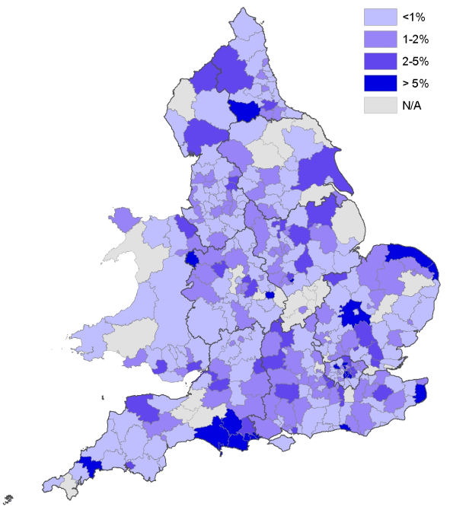

FIGURE D: TOTAL 24-HOUR ALCOHOL LICENCES (EXCLUDING HOTELS) AS A PROPORTION OF LICENCES AND CERTIFICATES PERMITTED TO SELL OR SUPPLY ALCOHOL BY LOCAL AUTHORITY

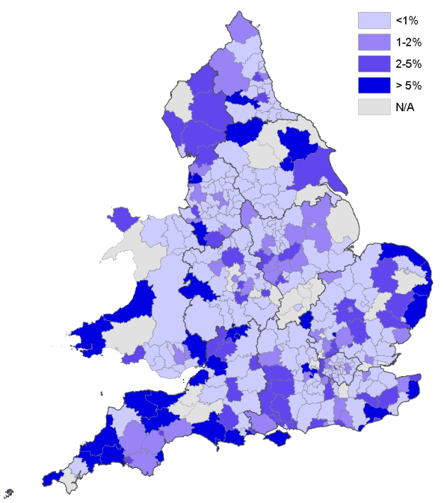
FIGURE E: HOTELS WITH 24-HOUR ALCOHOL LICENCES AS A PROPORTION OF LICENCES AND CERTIFICATES PERMITTED TO SELL OR SUPPLY ALCOHOL BY LOCAL AUTHORITY
FURTHER INFORMATION

The Alcohol, Entertainment and Late Night Refreshment Licensing 2006/07 Bulletin and online tables, as well as the 2007/08 Bulletin and online tables can be downloaded in electronic format free of charge from:
http://www.culture.gov.uk/reference_library/research_and_statistics/4865.aspx

The Department inherited responsibility for these statistics, as part of the transition of responsibility for alcohol and entertainment legislation, in 2001. The web address above also has a link to the previous Liquor Licensing bulletin provided by DCMS (October 2004).

This bulletin was prepared by the Evidence & Analysis Unit in the Department for Culture, Media and Sport. If you have any enquiries about figures in this bulletin then please contact us:

Evidence & Analysis Unit
Department for Culture, Media and Sport
2-4 Cockspur Street,
London SW1Y 5DH

Email: licensing.statistics@culture.gsi.gov.uk

Press enquiries should be made to DCMS Press Office on 020 7211 6263.


2-4 Cockspur Street
London SW1Y 5DH
www.culture.gov.uk

Conwy Licensing Authority and Denbighshire Licensing Authority
ONS Guidance on Local Government changes http://www.statistics.gov.uk/geography/admin_areas.asp
Around 3,100 of which are available 24 hours to residents and their private guests only. Prior to the 2003 Act, hotels were similarly authorised to sell alcohol outside of permitted licensing hours and were able to apply to keep this provision under ‘grandfather rights’.
A premises licence can authorise any, a combination, or all of i) the sale or supply of alcohol ii) late night refreshment iii) any regulated entertainment. A club premises certificate can authorise either i) or iii) or both.
NB, 2007 and 2008 modelled estimates will not be remodelled in future releases.
Licensing Authorities were asked to record the rateable value for premises licences not yet set, as fee band A.
See Glossary for definition of the Band D and E multiplier.
Some clubs have a premises licence instead of a club premises certificate (therefore are included in the previous section). A small number may have both (therefore are included in both sections).
Licensing Authorities were asked to record the rateable value for certificates not yet set, as fee band A.
For 5% of premises licences the alcohol permissions were unknown.
For 6% of Club Premises Certificates the alcohol permissions were unknown.
Some licences granted would have been from applications prior to 1 April 2008, and some applications applied for may not be granted until after the reporting period, which explains why the number granted and refused does not match the total number applied for. This also affects the percentage granted/refused.
Some certificates granted would have been from applications prior to 1 April 2008, and some applications applied for may not be granted until after the reporting period, which explains why the number granted and refused does not match the total number applied for. This also affects the percentage granted/refused.
If the police make no objections within a 14 day period, the licence must be granted.
Note: more than one reason may apply to each review
But exclude applications for a change to DPS, transfer of premises licence, review, or cancellation of interim authority notices following police objections that went to a hearing.
The provision of regulated entertainment covers the provision of entertainment (plays, films, indoor sporting events, boxing or wrestling, live music, recorded music and dance) as well as the provision of entertainment facilities (facilities provided for enabling people to take part in making music, dancing and similar activities). Entertainment is “regulated entertainment” when it takes place in the presence of a public audience or members and guests of a qualifying club, whether a charge is made or not. Entertainment which takes place in the presence of a private audience is only regulated entertainment when a charge is made with a view to making a profit. The performance of live music and incidental playing of recorded music is not regarded as regulated entertainment under the 2003 Act where they are incidental to another activity which is not itself regulated entertainment. The spontaneous performance of music, singing or dancing does not amount to the provision of regulated entertainment and is not a licensable activity. There are also some exemptions for activities in certain premises, such as Churches.
There are five main LA types which share similar characteristics such as size and therefore they hold similar licensing statistics. There are 47 Unitary Authority; 36 Metropolitan Districts; 238 District Authorities; 21 Welsh Unitary Authorities (as Conwy and Denbighshire submitted a joint response); 33 London Boroughs and 2 Unspecified (Inner Temple and Middle Temple within Greater London).
The extrapolated 2008 and 2007 national totals reported in this bulletin are different to the published modelled figures reported in the 2008 licensing bulletin. This is because of figures being remodelled based on more available data (outlined above) and in many cases better available data, with amendments to some previously reported figures by individual LAs where they have informed us of errors.
http://www.culture.gov.uk/what_we_do/alcohol_and_entertainment/4052.aspx
http://www.culture.gov.uk/what_we_do/alcohol_and_entertainment/4060.aspx
http://www.culture.gov.uk/reference_library/research_and_statistics/4865.aspx
The map shows that coastal LAs have a higher amount of hotels with 24 hour alcohol licences as a proportion of all their licence and certificates selling alcohol. More of these are leisure resort areas with a higher number of hotels compared to other LAs.

