Annex C: Outline logic model and guidance for completion
Your bid should be based on assumptions about how certain activities will produce specific outputs, which in turn will have a wider set of outcomes. To produce clear and measurable impacts and resident benefits, it is crucial to capture neatly and explicitly the logical pathway your project will follow to achieve success. This means showing the links between the resources you will use and a range of specific activities, each of which is designed to produce outputs that contribute to your intended outcomes, impacts and resident benefit. See Section D in the prospectus for more information on evaluation and its benefit.
To produce the clearest possible account of the logic of your proposal, you should complete an outline in the format provided below and attach it to your submitted proposal. If successful, a fully completed version will need to be submitted alongside the Impact Summary template six months after a project’s completion. For the purposes of applying for funding however, you need only submit a draft version and are free to use your own format if it captures the same content.

Proposed format for capturing project logic:
Using these resources and activities…

…to deliver these outputs…

…with these outcomes and impacts…

…and resident benefit:

Resource/input | Output / Activity | Baseline output level (if known) | Target output level | Actual Outputs (to be completed at close of project) | Intended Outcome | Intended Broader Impact | INTENDED RESIDENT BENEFIT

Example of format to be submitted in support of bids
Information submitted at the bidding stage is not expected to be complete. The project logic model will be in draft form, as you may not have all the baseline data at the time of bidding, and actual outputs will not be known until after implementation. However, it should demonstrate as far as possible the intended pathways to benefit the wider local community. The example below captures what an outline template might look like at the bidding stage:
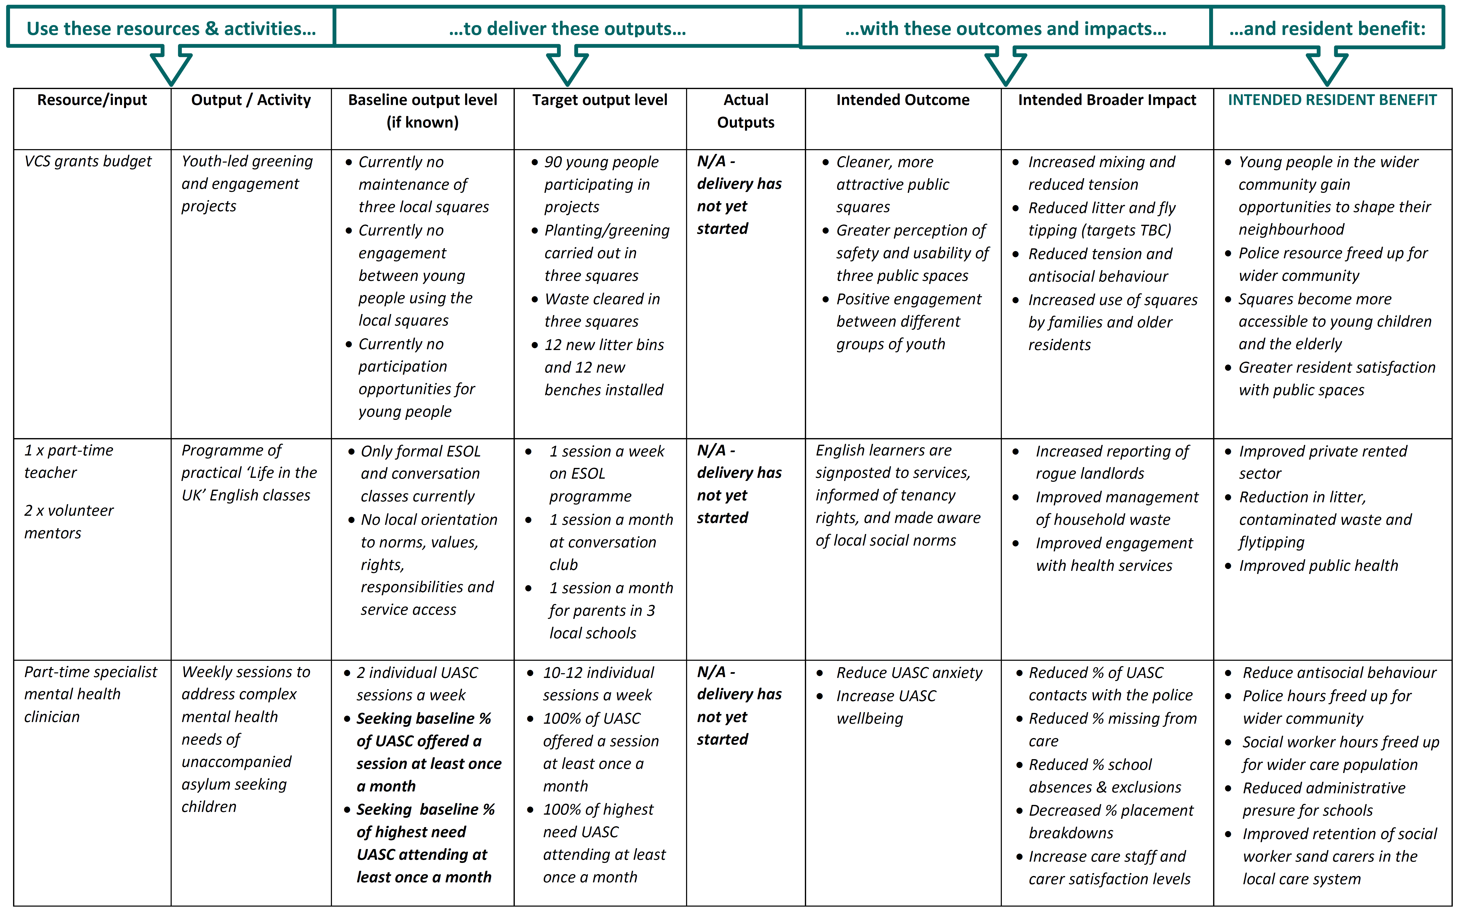
To ensure a robust statement on how success will be measured, you should also submit a tabular summary of project activities, their direct outcomes and broader impacts, and plans to measure success (example below). This will be particularly helpful where local authorities plan to measure both outcomes and broader impacts to strengthen their evidence of resident benefit.
The proposed table below, or a customised format with the same content, should be completed as far as possible for each activity and submitted alongside the logic model above with your application.
Proposed format for capturing success measures:

Activity | Outcome/Broader Impact | Indicator/Measure of Success | Pre-CMF Level (Baseline) | Post-CMF Level
Describe activity | DIRECT OUTCOMES
Describe activity | BROADER/RESIDENT IMPACT

Example of format used to support a bid:
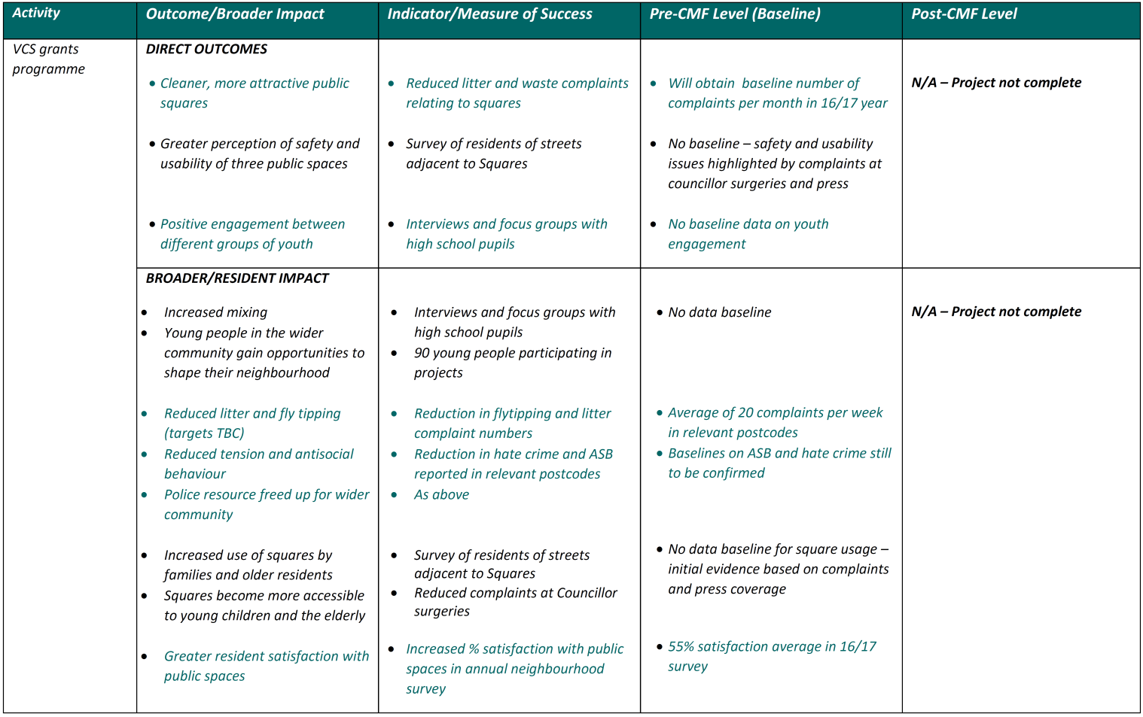
The outline of success measures will be in draft form at this stage, but will indicate how you plan to measure success, and what baseline data you plan to use (if any).

