Care and Support Specialised Housing Fund (CASSH): Supplementary information for Continuous Market Engagement (CME)

- Introduction

- This document provides updated information for bidders submitting proposals through the Care and Support Specialised Housing (CASSH) Continuous Market Engagement (CME) process. It should be read in conjunction with the bidding Prospectus for CASSH phase two which sets out full details of the fund. The requirements set out in the Prospectus remain current except where explicitly amended.

- CME bidding for up to £125m funding under CASSH Phase two was opened on Friday 8th June 2018, extending the fund by a further three years up to 31st March 2021. Funding remains available to develop specialist affordable housing schemes for older people and adults with disabilities or mental health problems as per the original intentions of the programme.

- We are not setting a closing date for applications at this time and will assess and agree bids on an on-going basis throughout the programme period. All bids for Care and Support CME must be for firm named schemes, rather than indicative proposals and must be able to achieve practical completion by 31 March 2021.

- This is a continuation of the existing CASSH fund and the funding requirements from the original bid rounds remain unchanged except for the additional priorities around housing for adults with mental health problems and affordable housing provided as part of mixed tenure sites alongside private market housing brought in under Phase two which no longer apply.

- Bid Submission

- Bids for Care and Support CME must be submitted using Homes England’s Investment Management System (IMS) using the existing Care and Support Offer type. Organisations that already have an existing Care and Support offer under Phase one or two are able to create new offer lines within their existing offer to submit their CME bids. Organisations that are new to bidding for Care and Support funding will need to submit a new offer and offer lines in the system.

- In addition to the information required in the initial bid round, bidders should identify there bids as CME by selecting ‘Continuous Market Engagement’ in the Offer Line Source drop-down field on the Offer Line Products tab.

- For substitutions for existing CASSH Offer Line, bidders should select the ‘Substitution’ option in the Offer Line Source field.
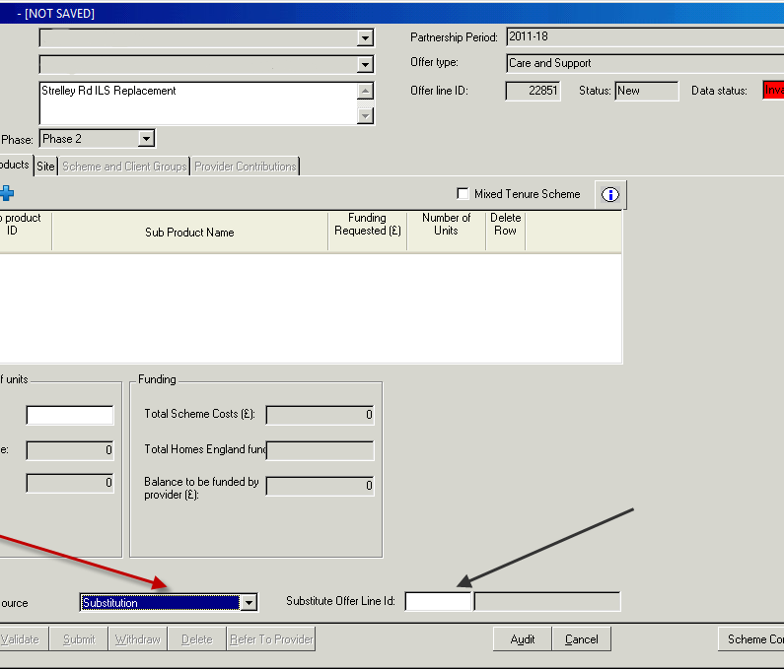

- Guidance on submitting a Care & Support bid through IMS is available on GOV.UK.

Submission of supporting statements
- For the original CASSH bid rounds supporting statements for bids were captured through offline submissions via email. It is now possible for bidders to capture this information for new CASSH CME bids online through IMS.

- The information required for each supporting statement is listed in Annex 1 of this document. It is expected that supporting statements will be unique to each scheme. Providers with existing CASSH allocations are not required to submit new statements for existing allocations.

- Assessment
- Homes England will assess each scheme proposal from a provider independently. Each scheme should therefore be able to stand alone, with no cross subsidy or interdependence with other schemes submitted by a provider, including where schemes are on the same site.

- Bid assessment will use the same quantitative and qualitative metrics set out in the Prospectus, which emphasise value for money, deliverability and strategic fit with the aims of the fund.

- Changes to payment tranches
- Grant payments under CASSH will be made on a scheme-by- scheme basis, with funding paid out in stages after specified milestones have been achieved. In order to support the delivery of new schemes, successful bidders may now also receive a proportion of the grant at the site acquisition stage of a scheme. To be able to claim an Acquisition tranche of grant the provider must have an unconditional secure legal interest in the land (freehold or long leasehold) ad must have paid of at least as much on acquisition and development of the scheme as the amount of grant being claimed.

- For Registered Providers of social housing, funding will be paid 40% at site acquisition; 35% at start on site; and 25% upon practical completion. Where no acquisition tranche is being claimed the milestones are 75%-25% as per the current programme. Providers with an existing CASSH allocation under the previous bid rounds may also claim an acquisition tranche where applicable. Such providers will be required to sign a deed of variance to their existing CASSH contract to cover this change.

- For unregistered bodies the organisation may choose between (i) receiving 100% of the funding at practical completion of the scheme or (ii) offering one of the forms of security accepted by Homes England, which include a Fixed Charge over land, a Guarantee or a Performance Bond in order to receive funding as per the milestones set out for Registered Providers above. Acceptance would be subject to Homes England’s satisfaction with the security being offered and the organisation’s individual circumstances

- Updated Contacts
- If bidders have any questions about the programme or how to bid, they are advised to email the HCA at Enquiries.CSDH@homesengland.gov.uk. Bidders should note that where questions raised may be of general applicability to all prospective bidders, these and our response may be published on GOV.UK.

- To discuss particular scheme proposals, bidders are invited to contact Homes England’s area investment teams. Details of area leads for this programme are as follows:

Homes England Operating Area | Operating Area lead contact name | Email Address | Telephone
Midlands | Angharad Bullward | Angharad.Bullward@homesengland.gov.uk | 01212349925
North East, Yorkshire and the Humber | Karen Anderson | Karen.Anderson@homesengland.gov.uk | 01914977642
North West | Susan Mackie | Susan.Mackie@homesengland.gov.uk | 01612006151
South East | Becky Ashley | Becky.Ashley@homesengland.gov.uk | 01223374001
South West | Lisa Clayton | Lisa.Clayton@homesengland.gov.uk | 01179377211

Annex 1

Supporting statement outline

- Innovation and sustainability

Q1 - Scheme outline: Please provide an outline of the scheme proposal, including where appropriate, information on:

- The level and type of care and/or support provided and any planned or existing links with local services and amenities.
- Any innovation in the use of communal/shared space which enhances recovery and well-being outcomes for the targeted client group and helps integration with the wider local community;
- How the scheme will be integrated with local health and social care and community service provision;
- Details of partnerships with NHS providers and commissioners and how they will help to ensure resources will be utilised effectively and reduce the burden on health and care budgets.

Q2 - Revenue funding: Please provide details of the expected revenue funding for the scheme, where required, or alternative mechanisms to ensure the scheme is managed effectively. Including details of agreed funding where available.

Q3 – Future flexibility/exit strategy: Please provide a description of how the design of the scheme will be resilient to the future needs of the client group (e.g. in terms of flexibility of use, robustness and environmental performance) including an exit strategy if local needs change, without requiring further government investment.

- Fit with local strategic priorities:

Q1 - Please provide details of how the proposal fits with the priorities outlined in the relevant local authority’s strategic needs statements or other evidence to show fit with local housing, health and wellbeing needs and strategic priorities.

- Design statement

Q1 - Please provide a description of the proposed design to show how the scheme will help residents to achieve optimal quality of life within their homes, including consideration of their future needs.

Where relevant, this statement should demonstrate where the scheme is meeting current good practice, for example by including a response to the 10 HAPPI design principles, which may apply to all client groups including people with disabilities or mental health problems, and/or provide examples of innovative design elements that will enable the owner or tenant to live independently, with support where necessary, for as long as they wish to.

(Site and floor plans, where appropriate, should be e-mailed to Bids.CSDH@homesengland.gov.uk)

- Employment and Skills

Q1 - Please provide a description of how the proposed scheme will support employment and skills opportunities in the local area.

