This good practice example has been withdrawn as it is older than 3 years and may no longer reflect current policy.
Using the power of football to involve, educate and inspire young people and their families: Foundation of Light

Region: North East and Humber
Remit: Further education and skills

Provider background
Foundation of Light, established in 2001, is the registered charity of Sunderland Associated Football Club. It runs programmes across Sunderland, Durham and South Tyneside working with a range of schools and academies.

Brief description
This Ofsted good practice example shows how using children’s and parents and carers’ love of football can encourage and help them to rapidly develop their English, mathematics and parenting skills and become fitter, healthier families. Children and carers participate in a range of structured activities, both individually and as families, that help them understand each other and improve a variety of skills and attitudes.

The good practice in detail
Foundation trainers, who are qualified coaches/fitness professionals as well as trained teachers, visit school assemblies across the region to talk to children about the programmes they are running. They use the football club logo and marketing materials to get children interested and wanting to be part of the programmes. The children then encourage their parents and carers to take part.
The courses are 10 to 12 weeks long and range from one hour to two and a half hours a week. During the first half of a course, the trainer works only with parents and carers, helping them to develop their skills in working with their children. In the second half, the trainers work initially with the children and then with the whole family. Although the courses are all marketed with a football theme, their aims are very definitely educational for the children and their carers. Parenting, communication and English and mathematics skills are built into each session. Trainers use the footballing theme throughout - for example jokingly dishing out yellow cards to participants for lateness.
The club gives out match tickets to families who attend the whole course and hold certificate presentations in the Stadium of Light. Families thoroughly enjoy the courses and most progress to other courses as a result. The evaluation form is designed not just to assess participants’ views, but also to promote further courses.

Children as recruiters
Children are generally enthused by football – and particularly by the football club of their own town. 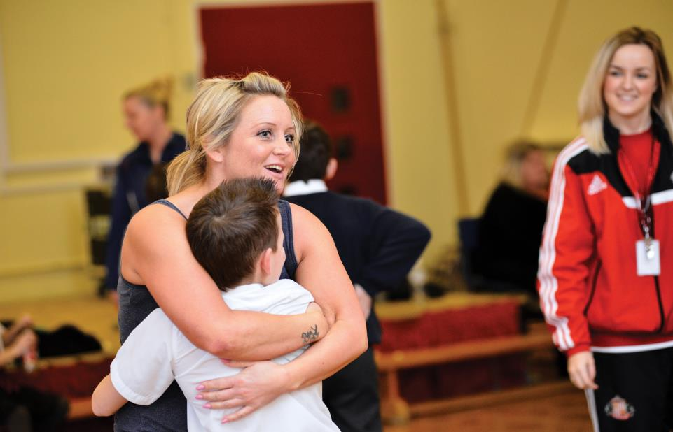
A few weeks before a course, staff visit schools and talk to the children about what they could be doing with their parents, grandparents and carers. They get the children really excited about taking part. The children, in turn, motivate their carers to come along. As a result, the Foundation has no problem in recruiting parents and carers to the programmes or in keeping families on the course. In fact, almost all families complete the course once recruited.

The football club brand
Parents, carers and children respond very positively to the Sunderland football club brand. Matthew Hill, Director of Families and Adults, explains:
‘We use Sunderland’s badge and marketing as much as possible, as we find this is very attractive to both kids and parents. Pretty much all of our paperwork has the Sunderland football logo and branding so that families can feel part of the club.
We are lucky in that the football club gives free match tickets to participating families as an incentive to stay on course. We also have events at the Stadium of Light for all families, where they are presented with in-house certificates in the professional environment of the modern football stadium. They are all really proud of their achievements. Most of them go on to other courses or provision as a direct result.’
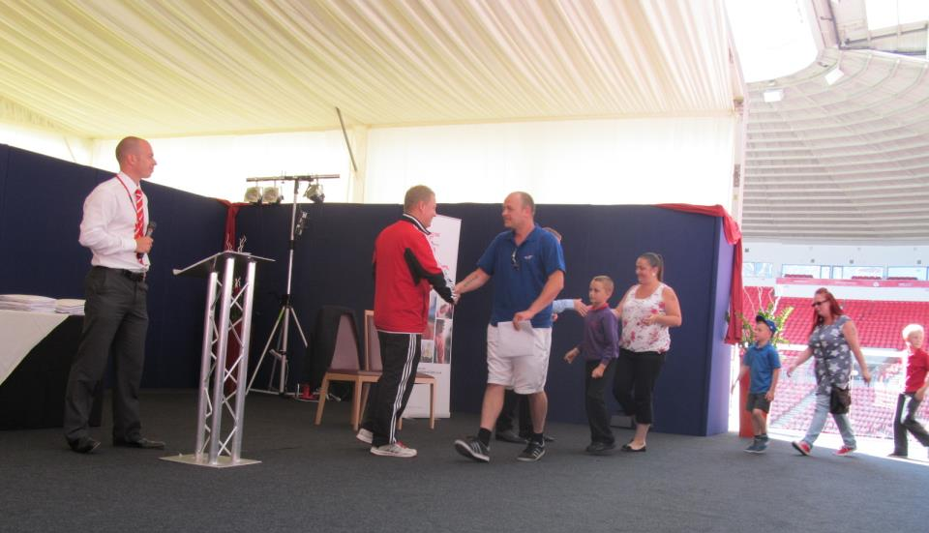
Asked if it was the brand itself that was the main attraction, he replied:
‘There’s no doubt that the city’s football club gives a great deal of “kudos” but football itself is a great draw – kids and parents really respond to football generally – those people who aren’t naturally academic particularly respond to it. And in any case, all football clubs across the country have a commitment to working with their local communities, so there should be some way of getting a similar connection wherever you are. But you know, once people are on courses, it’s the quality of what’s going on that’s the real issue – and that’s where you need to concentrate your efforts if you want to deliver something similar.’

What families say
The programmes reach over 2,000 families each year. Both the children and their parents and carers are enthusiastic about the courses and what they achieve. One parent explains:
‘My little boy has Asperger’s. Through the course, I now understand open and closed questions and their effect. I use closed questions with my lad now much more often as I now understand what he is feeling and that these types of questions make him feel better and safer. But actually, in the same group, another parent is using open questions with her boy more – and he has Asperger’s too! So we get to not only explore the similarities in our lads but also the differences. I really didn’t think I would be doing that when I came in to knock a ball around.’
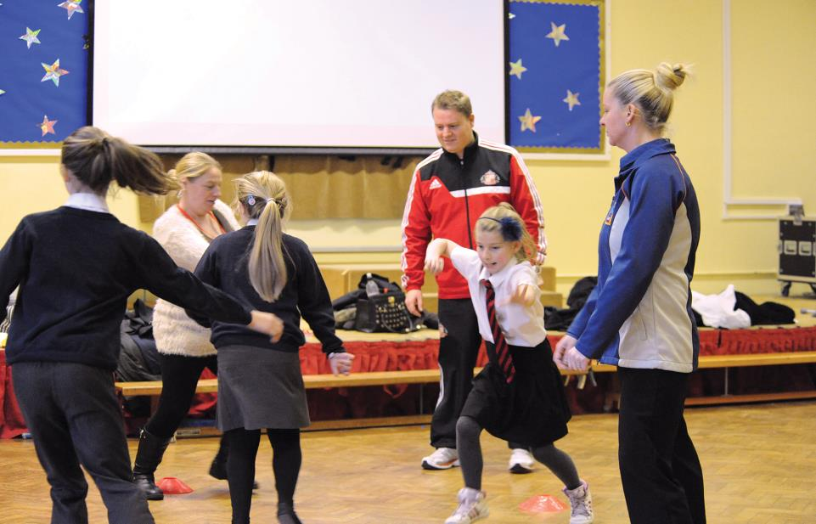

First half, half time, second half, whistle…
The courses deliberately include football terms, not just in the title of the courses but throughout. Trainers use methods such as ‘yellow cards’ in a very skilful way to illustrate to carers and children that lateness and absence have consequences. While this is done in a light-hearted way, families take notice and learn.
Trainers make a point of modelling behaviour with adults and children that is especially motivating. For example, where children become overexcited and stop listening during physical activities, the trainer simply stops all activity using their whistle, waits to gain the children’s attention and calmly corrects individual children when they continue. He repeats phrases such as, ‘You need to listen now. You need to listen to the coach, if you want to be a footballer.’ He demonstrates to parents that by keeping calm and maintaining consistency there is no need to shout or become angry.
Staff are well-qualified. They are usually recruited from a professional football training background and gain teaching qualifications in addition to their vocational qualifications. New staff are supported well by existing staff to be able to deliver to the high standard the Foundation requires.

The range of courses
- Football Coaching: improving social skills, relationships and confidence
- Little Dribblers: improving social skills, relationships and confidence in Early Years
- Making Moves: improving social skills, relationships and confidence in disabled children
- Football Fitness: improving health and fitness
- Family Values: addressing challenging behaviour
- Healthy Minds: Raising awareness of mental health issues
- Ministry of Food: Promoting healthy eating in partnership with the Jamie Oliver Food Foundation
- The Write Result: improving writing skills
- Healthy Balance: improving mathematics skills
- Family IT: improving ICT skills and digital awareness
- Family Finance: improving knowledge to handle everyday finance.

And there’s more…
As well as family learning courses, the Foundation offers courses and activities, both in its own right and with partners, that provide progression opportunities for parents, carers and children. The Foundation is very keen to infect learners of all ages with the learning ‘bug’, not just to develop the next footballers in the community but to develop all-round citizens. It provides programmes with primary, secondary and academy schools to combat racism, promote English, mathematics, health and well-being and to support the disabled.

