

Gambling Act 2005:
Proposals for Gambling Commission Fees from 6 April 2012 (Impact Assessment)
September 2011



Our aim is to improve the quality of life for all through cultural and sporting activities, support the pursuit of excellence, and champion the tourism, creative and leisure industries.

Impact Assessment

- Title:  Adjustments to Gambling Operating Licence Fees  Lead department or agency:  - DCMS/Gambling Commission  Other departments or agencies:
  Impact Assessment (IA)
  IA No:
  Date: 08/04/2010
  Stage: Consultation
  Source of intervention:
  Type of measure:
  Contact for enquiries:
  - TBC

Summary: Intervention and Options

What is the problem under consideration? Why is government intervention necessary?
- The Gambling Act (2005) provides for the cost of regulating gambling operators to be recovered from fees charged for gambling operating licences issued by the Gambling Commission (the Commission). Since becoming operational in September 2007, the Commission has reduced its costs and now with three years experience of regulating on the basis of the Act, has further assessed and reviewed its workload, costs and fees, identifying scope to make some limited changes to fees that move focus away from smaller businesses, rebalance fees to better reflect areas that require considerable ongoing resource (eg sports betting integrity and technology and innovation) and to remove potential barriers to growth inherent in the existing fee structure. This requires an Order made by the Secretary of State to set the new fees.

What are the policy objectives and the intended effects?
- - To ensure that the shift in regulatory focus away from some smaller operators to larger, higher risk operators is reflected in the fees structure.
- - To remove unfair subsidisation of some larger operators by smaller businesses
- - To improve and future proof the resilience of the fees structure to market changes including growth and consolidation
- - To correct some anomalies in the existing fees structure, and correct some mispricing issues
- - To remove a small number of burdens imposed by the Gambling Act 2005 which are disproportionate

What policy options have been considered, including any alternatives to regulation? Please justify preferred option (further details in Evidence Base)
- 1) Make changes to existing fees (preferred option)
- Fees are set for operators of various types and scale by means of an Order made by the Secretary of State, and periodically reviewed in order that fees reflect the changes in the gambling landscape, the focus and direction of the Commission, and are set at a fair and appropriate level. Making changes to the fees would mean that potential barriers to growth inherent in existing bandings would be removed, and that smaller gambling businesses in each sector (and across sectors) would no longer be subsiding regulatory effort focused on larger operators in that sector, or cross subsidising regulation of other gambling sectors.
- 2) Do nothing.

Will the policy be reviewed? It will be reviewed. If applicable, set review date: /2013
What is the basis for this review? PIR. If applicable, set sunset clause date: N/A
Are there arrangements in place that will allow a systematic collection of monitoring information for future policy review?

Sign-off For consultation stage Impact Assessments:
I have read the Impact Assessment and I am satisfied that, given the available evidence, it represents a reasonable view of the likely costs, benefits and impact of the leading options.
Signed by the responsible : |  | Date:

Summary: Analysis and Evidence Policy Option 1
Description:
Adjust Gambling Operating Licence Fees
Price Base Year 2011 | PV Base Year 2011 | Time Period Years 2 | Net Benefit (Present Value (PV)) (£m)
Price Base Year 2011 | PV Base Year 2011 | Time Period Years 2 | Low: 0.97 | High: 1.01 | Best Estimate: 0.99

COSTS (£m) | Total Transition  (Constant Price) Years |  | Average Annual  (excl. Transition) (Constant Price) | Total Cost  (Present Value)
Low | 0 |  | 0 | 0
High | 0 |  | 0 | 0
Best Estimate | 0 |  | 0 | 0
Description and scale of key monetised costs by ‘main affected groups’
- The proposed fee structure does not impose an increase in costs as a whole. A small number of very large operators would see an increase in fees but this will be counteracted by lower fees for a significant proportion of licensees at the smaller end of the market, both in terms of annual and application fees and other small burdens. The higher fees for larger operators reflect the additional effort required by the Commission in regulating them and corrections to some specific mispricing issues.
Other key non-monetised costs by ‘main affected groups’

BENEFITS (£m) | Total Transition  (Constant Price) Years |  | Average Annual  (excl. Transition) (Constant Price) | Total Benefit  (Present Value)
Low | 0 |  | £495k | £0.97m
High | 0 |  | £515k | £1.01m
Best Estimate | 0 |  | £505k | £0.99m
Description and scale of key monetised benefits by ‘main affected groups’
- As a whole the proposed package of fees will reduce the fee burden on the industry by approximately £505k p.a. over the period 2011/12 to 2012/2013, comprising £307k p.a. from changes to the application and annual fees and £188k-£208k p.a. from other minor amendments. These savings largely fall to smaller firms, reflecting the regulatory effort associated with them. The fall in overall fees reflects the Commission continuing to reduce the costs of operating its regulatory regime while taking into account the projected volume of licensees.
Other key non-monetised benefits by ‘main affected groups’
- The proposed fees structure will be fairer, removing subsidisation of some larger operators by smaller businesses and cross subsidisation by industry. It will also be more resilient to market changes including growth and consolidation.
Key assumptions/sensitivities/risks Discount rate (%) |  |  |  |  | 3.5%
- All figures and tables reflect the fee proposals outlined herein, plus the following assumptions:
- An average net-loss churn rate in licences of around 1.3% year-on-year, based on current trends of licences surrendered and new applications received. A small reduction over the period 2011-2013 in the number of non-remote licences held (particularly betting, arcades and machine supply licences), based on current trends, and that all machine suppliers licensed under the 1968 Gaming Act will have applied under the 2005 Gambling Act by 2012.
- A small increase over the same period in the number of remote licences held (reflecting recent trends in pool betting and trading room licence applications).
- An inflation rate of 2.5% for 2012/13, as per the March 2011 budget.

Direct impact on business (Equivalent Annual) £m): |  |  | In scope of OIOO? | Measure qualifies as
Costs: 0 | Benefits: 0.505 | Net: 0.505 | Yes | OUT

Enforcement, Implementation and Wider Impacts
What is the geographic coverage of the policy/option? |  |  | Great Britain
From what date will the policy be implemented? |  |  | 01/04/2012
Which organisation(s) will enforce the policy? |  |  | Gambling Commission
What is the annual change in enforcement cost (£m)? |  |  | N/A
Does enforcement comply with Hampton principles? |  |  | Yes
Does implementation go beyond minimum EU requirements? |  |  | No
What is the CO₂ equivalent change in greenhouse gas emissions?  (Million tonnes CO₂ equivalent) |  |  | Traded:  N/A |  | Non-traded:  N/A
Does the proposal have an impact on competition? |  |  | No
What proportion (%) of Total PV costs/benefits is directly attributable to primary legislation, if applicable? |  |  | Costs:  N/A |  |  | Benefits:  N/A
Distribution of annual cost (%) by organisation size  (excl. Transition) (Constant Price) | Micro  - N/A | < 20  - N/A | Small  - N/A | Medium  - N/A |  |  | Large  - N/A
Are any of these organisations exempt? | No | No | No | No |  |  | No

Specific Impact Tests: Checklist
Set out in the table below where information on any SITs undertaken as part of the analysis of the policy options can be found in the evidence base. For guidance on how to complete each test, double-click on the link for the guidance provided by the relevant department.
Please note this checklist is not intended to list each and every statutory consideration that departments should take into account when deciding which policy option to follow. It is the responsibility of departments to make sure that their duties are complied with.
Does your policy option/proposal have an impact on…? | Impact | Page ref within IA
- Statutory equality duties

- Economic impacts
Competition |  | 42
Small firms |  | 44

- Environmental impacts
Greenhouse gas assessment
Wider environmental issues

- Social impacts
Health and well-being
Human rights
Justice system
Rural proofing

- Sustainable development

Summary: Analysis and Evidence Policy Option 2
Description:
Do Nothing
Price Base Year 2011 | PV Base Year 2011 | Time Period Years 2 | Net Benefit (Present Value (PV)) (£m)
Price Base Year 2011 | PV Base Year 2011 | Time Period Years 2 | Low: 0 | High: 0 | Best Estimate: 0

COSTS (£m) | Total Transition  (Constant Price) Years |  | Average Annual  (excl. Transition) (Constant Price) | Total Cost  (Present Value)
Low | 0 |  | 0 | 0
High | 0 |  | 0 | 0
Best Estimate | 0 |  | 0 | 0
Description and scale of key monetised costs by ‘main affected groups’
The current fee burden would remain unchanged.
Other key non-monetised costs by ‘main affected groups’
Licensees at the smaller end of the market would continue to pay existing fee quanta, subsidising larger operators and consequently bearing an unfair share of the regulatory burden given the shift in regulatory emphasis away from such licensees. Existing fee bands become more inequitable and present barriers to business growth and entry to the industry. Failure to implement other minor deregulatory measures will perpetuate unnecessary burdens from licence applications fees and annual fees that are disproportionate to regulatory effort. The direction of the Commission’s deregulatory policy with regards to smaller operators will be hampered by failure to introduce fee changes.
BENEFITS (£m) | Total Transition  (Constant Price) Years |  | Average Annual  (excl. Transition) (Constant Price) | Total Benefit  (Present Value)
Low | 0 |  | 0 | 0
High | 0 |  | 0 | 0
Best Estimate | 0 |  | 0 | 0
Description and scale of key monetised benefits by ‘main affected groups’
- None. The current fee burden would remain unchanged.
Other key non-monetised benefits by ‘main affected groups’
- None
Key assumptions/sensitivities/risks Discount rate (%)

Direct impact on business (Equivalent Annual) £m): |  |  | In scope of OIOO? | Measure qualifies as
Costs: | Benefits: | Net: |  | OUT

Enforcement, Implementation and Wider Impacts
What is the geographic coverage of the policy/option? |  |  | Great Britain
From what date will the policy be implemented? |  |  | N/A
Which organisation(s) will enforce the policy? |  |  | Gambling Commission
What is the annual change in enforcement cost (£m)? |  |  | N/A
Does enforcement comply with Hampton principles? |  |  | No
Does implementation go beyond minimum EU requirements? |  |  | No
What is the CO₂ equivalent change in greenhouse gas emissions?  (Million tonnes CO₂ equivalent) |  |  | Traded:  N/A |  | Non-traded:  N/A
Does the proposal have an impact on competition? |  |  | No
What proportion (%) of Total PV costs/benefits is directly attributable to primary legislation, if applicable? |  |  | Costs:  N/A |  |  | Benefits:  N/A
Distribution of annual cost (%) by organisation size  (excl. Transition) (Constant Price) | Micro  - N/A | < 20  - N/A | Small  - N/A | Medium  - N/A |  |  | Large  - N/A
Are any of these organisations exempt? | No | No | No | No |  |  | No

Specific Impact Tests: Checklist
Set out in the table below where information on any SITs undertaken as part of the analysis of the policy options can be found in the evidence base. For guidance on how to complete each test, double-click on the link for the guidance provided by the relevant department.
Please note this checklist is not intended to list each and every statutory consideration that departments should take into account when deciding which policy option to follow. It is the responsibility of departments to make sure that their duties are complied with.
Does your policy option/proposal have an impact on…? | Impact | Page ref within IA
- Statutory equality duties

- Economic impacts
Competition |  | 42
Small firms |  | 44

- Environmental impacts
Greenhouse gas assessment
Wider environmental issues

- Social impacts
Health and well-being
Human rights
Justice system
Rural proofing

- Sustainable development

Evidence Base (for summary sheets) – Notes
Use this space to set out the relevant references, evidence, analysis and detailed narrative from which you have generated your policy options or proposal. Please fill in References section.

References
Include the links to relevant legislation and publications, such as public impact assessments of earlier stages (e.g. Consultation, Final, Enactment) and those of the matching IN or OUTs measures.

No. | Legislation or publication
1. | Gambling Act 2005 and Explanatory Notes
2. | The Gambling (Operating Licence and Single-Machine Permit Fees) Regulations 2006
3. | The Gambling (Operating Licence and Single-Machine Permit Fees) (Amendment) Regulations 2007
4. | The Gambling (Operating Licence and Single-Machine Permit Fees) (Amendment) (No. 2) Regulations 2007
5. | The Gambling (Operating licence and Single-Machine Permit Fees) (Amendment) Regulations 2008
6. | The Gambling (Operating Licence and Single-Machine Permit Fees) (Amendment) Regulations 2009
7. | Gambling Act 2005 - Proposals for Gambling Commission Fees from 1st August 2008 and Summary of Consultation Responses
8. | Gambling Act 2005: Proposals for Gambling Commission Fees from 1 August 2009
9. | Gambling Commission - Annual report and accounts 2009-2010

Evidence Base
Ensure that the information in this section provides clear evidence of the information provided in the summary pages of this form (recommended maximum of 30 pages). Complete the Annual profile of monetised costs and benefits (transition and recurring) below over the life of the preferred policy.

Annual profile of monetised costs and benefits* - (£m) constant prices
 | Y₀ | Y₁ | Y₂ | Y₃ | Y₄ | Y₅ | Y₆ | Y₇ | Y₈ | Y₉
Transition costs | 0 | 0
Annual recurring cost | 0 | 0
Total annual costs | 0 | 0
Transition benefits | 0 | 0
Annual recurring benefits | 479k | 532k
Total annual benefits | 479k | 532k
* For non-monetised benefits please see summary pages and main evidence base section

Evidence Base (for summary sheets)

Introduction

The Gambling Act 2005 established the Gambling Commission as the national regulator of commercial gambling in Great Britain. The Commission became fully operational on 1 September 2007.
The Gambling Act 2005 (the Act) gives the Secretary of State for Culture, Olympics, Media and Sport the power to make regulations setting fees to be paid to the Gambling Commission (the Commission). In doing so, the Secretary of State intends to ensure such fees are set in accordance with the Act and HM Treasury’s rules and guidance on fees, and at a level that enables the Commission to recover the full costs of delivering its responsibilities, with no cross subsidisation and ensuring fairness and value for money for the gambling industry.
The Commission is funded entirely from fee income, it receives no public funding. Fees are set on a banded basis by sector (eg bingo, casinos, betting etc), and by mode (ie remote and non-remote gambling), using the best available proxy for scale of activity in each sector.
With the experience of over three years of regulating on the basis of the Act to draw on, the Commission has further assessed and reviewed its workload, cost and fees. In the light of that experience, and the government’s policies on deregulation and on arm’s length bodies, the Commission is proposing a number of changes designed to reduce the burden of regulation so far as possible and to recover the costs of regulation more equitably.

In brief, the proposals seek to:
Reduce fees for many small operators to reflect the benefit of sustained efficiency savings and more targeted compliance and enforcement efforts;
Remove unfair subsidisation by using the accumulated experience of the last three years to spread the costs of regulation more equitably across operators in each sector, and between sectors (most operators would see reductions in fees, although a few very large operators (particularly in betting) would see increases;
Improve the resilience of the fees structure which is currently highly exposed to industry consolidation and other significant developments (eg the current sale of the Tote). Changes to bandings would mitigate this, as well as helping to reduce cross subsidy within bands within sectors;
Correct anomalies which have emerged since original fees were set (due to changes in market and landscape) and which are likely (if unaddressed) to lead to over or under-charging of some operators
Remove administrative burden in the introduction of a range of measures that reduce red tape for businesses (particularly small businesses) and help them to negotiate changes to the business more easily and at a lower cost.
The proposed changes to fees (both decreases and increases) for operators across sectors reflect these factors, and are designed to ensure that (so far as is practicable) fees recover the costs required for effective regulation of different sectors on an equitable and defensible basis. As has been the case to date, fees will be internally reviewed regularly to ensure they remain set at the correct levels, but also maximising stability and certainty for the industry by only making changes that further improve the fairness and transparency of the fees structure.
The current proposals have been drafted by the Commission, which is clear that, despite various upwards pressures on Commission costs (eg increasing sports betting integrity costs) it will maintain the overall fee burden on the industry at the level set in cash terms in 2009, representing a significant reduction in real terms. This reflects the benefit of sustained efficiency savings over the period and clearly targeted compliance and enforcement efforts (aimed mainly at larger and higher impact operators).

Rationale for intervention
The overarching rationale for intervention remains the same as that envisaged and approved by Parliament in the passage of the Act – namely that the costs of regulating the gambling industry should be borne by the industry itself and not by the taxpayer. The fees structure has been in place and operational for several years with fees Orders being laid in 2006 (amended twice in 2007), 2008 and 2009. As stated in the 2009 Proposals for Gambling Commission Fees consultation document, it was the Secretary of State’s expectation at that time that fees would not be further increased until August 2011. Failure to implement the current proposed changes would result in both cross-subsidy of fees, and over and under-recovery of fees from some gambling operators and sectors.
There is a wider programme of deregulation under development but, with the British Gambling Prevalence Survey showing no reduction in the incidence of problem gambling in Britain, there would need to be strong arguments to remove gambling activity from regulatory requirements. If separate policy considerations result in alternatives to regulation, then the principle of the recovery of regulatory costs through licence fees might no longer have application. But while the regulatory framework remains necessary it will also be necessary to ensure that fees are set at the right level, in accordance with this principle.

Policy objectives
The policy objectives of the overall framework remain unchanged. The policy objectives for the package of changes proposed in this document are as follows:
- To ensure Commission fees continue to reflect real effort, and are linked to the changing balance in Commission effort in the light of its more sophisticated understanding of industry risk (and increased focus on high impact operators),
- To reflect the move of Commission resources away from small operators in the betting, bingo and arcade sectors. Compliance work initially focussed on supporting the development of awareness and delivery of the licensing objectives among such operators, which in turn assisted the Commission in the development of its risk-based approach. The Commission is now in a position to concentrate its efforts on working with local licensing authorities to support their efforts in the regulation of such operators.
- To take account of the upward pressures of increasing demand for relatively high cost work (such as sports betting integrity work, remote gambling, or technological development in the machines sector),and the need to recover a higher proportion of certain regulatory costs from larger, higher impact operators;
- To improve resilience of the fees structure in the face of dynamic changes in the market (examples include general consolidation, sale of the Tote etc).

Gambling Commission fees were originally set on best estimates relating to likely costs, and on what was known at that time regarding risks to the licensing objectives. As the Commission is required to charge fees in advance, fee banks were prescribed for different activities and operators to provide the industry with some certainly regarding the level of fees, and to minimise administrative costs from frequent changes in fees, or changing and checking fees for individual operators.
In setting the fee bandings, the commission took account of the shape and size of the industry at that time, and predicted levels of activity and related costs. Fee band ranges were deliberately set to avoid existing operators being very close to the edge of a band, but a number of operators’ businesses have since expanded, bringing them closer to the top end of their respective fee bands. With better information now held on both risk and various industry sectors, the Commission is now in a position to distribute the costs of regulation more fairly across the industry and within sectors. The Commission’s recent assessment of the fees structure suggests that a number of existing fee bands need to be subdivided to provide a more equitable distribution of the costs necessarily incurred in regulating different sectors.
The Commission proposes that the existing non-remote fee bands for the larger adult gaming centre, bingo and general betting standard operators need to be subdivided in order to spread sector costs more fairly across different size operators, and ensure the smaller operators in existing bandings do not subsidise the larger ones by bearing a disproportionate share of that sector’s regulatory costs.
These new bandings are narrower, and link size to fees more closely than the present bandings. The size of an operator (e.g. in terms of the number of premises it operates) can generally be understood as a proxy for the risk posed by that operator to the licence objectives. Where there is an increase in the number of premises run by any one operator, and as generally follows, an increase in the gross gambling yield achieved by such an operator, there is a correlative increase in the potential impact such an operator may have. In terms of the larger betting operators, changes to fees also includes an element of fee increase, reflecting both the relative growth of operators in this sector over the last four years, an element of under-recovery of costs in previous years, and the need to recover some of the high cost areas of Commission work from high impact operators.
Some of the smaller remote betting fee bands will be split to reduce the size of the increments between bands, and to make the recovery of regulatory costs more equitable. In addition, the gross gambling yield threshold for the remote betting (telephone only) licence will be increased from £275,000 to £550,000.
The fee band for the smallest remote society lotteries contains some operators whose remote business is very small, sometimes as part of a largely non-remote businesses; a new licence with a discounted fee for the smallest operators is proposed.
Based on recent experience, the Commission considers that both non-remote External Lottery Manager (ELM) and pool betting fees were originally set too low (in relation to overall regulatory effort required) and without sufficient regard to the size disparities between operators. Changes to these bands are needed at both the lower and the upper end to mitigate this. These changes would alleviate both the current regulatory cross-subsidy costs from other gambling sectors, and increase the fees charged to a more realistic level for these licence types. Whilst the percentage fee increase proposed for ELMs is large, original fees were set unrealistically low (partly because ELMs were effectively treated as charities, rather than businesses whose primary function is that of a commercial entity rather than as a non-commercial society lottery), and it is anticipated the new fees will represent less than 0.5% of proceeds raised, or around 2.5% of a larger ELM’s non-remote commission.
Finally, a shift in emphasis away from compliance visits and work with smaller operators requires a rebalancing of fee burden away from smaller operators in the bingo, betting and arcade sectors, towards the upper end of those sectors. Decreases of 7% are proposed for the smaller operators, with fee increases of 5-10% being proposed for larger operators.
In some cases where re-banding has led to fee increases, the overall combined fee increase for a handful of operators is significant in percentage terms, although still a very small proportion of gross gambling yield. Those operators have grown significantly over the last four years. Moreover, they also have remote operations which add to the Commission’s workload in terms of betting integrity and consumer protection. Because fees are based on number of domestic premises as a proxy of scale, the large betting operators with significant overseas activities are benefiting from that regulatory input without contributing fairly.

Description of options considered (including do nothing);
The two main options considered are as follows:

Option 1
Rebalance the fees structure to reflect the Commission’s better understanding of cost drivers and its plans for future years. In brief, these proposals are to:
- Subdivide a number of fee bands to spread sector costs more fairly across different size operators (with consequent additional application fees)
- Reflect the reduced regulatory focus on smaller arcade, bingo and betting operators with fee reductions averaging 7%
- Recover the costs of increased regulatory efforts focused on higher impact issues and operators from larger arcade, non-remote bingo, and betting operators
- Apply fee increases averaging just under 10% (well below rate of inflation for these larger operators overall) but with some individual large increases (up to 29% where banding changes account for up to 20% of the total change)
- Reduce fees for operators bidding for the new 2005 Act casinos
- Recover a greater proportion of the costs of regulation from non-remote ELMs (businesses running Society Lotteries on a commercial basis) and pool betting operators
- Reduce the administrative burdens that currently make it difficult for businesses to continue to operate (e.g. following the death of a sole trader)
- Reduce fees for varying licence from 25% to 20%
- New remote supplementary licence fee for non-remote lotteries accepting entries over phone or email
- Raised threshold for telephone only betting up to £550k gross gaming yield

Option 2
Maintain the existing fees structure.

Costs and benefits
NB This section subsumes the ‘direct costs and benefits to business’ section. The nature of the gambling operator licence fee is such that the vast majority of costs and benefits fall directly on clearly identifiable businesses – the holders of gambling operating licences.
Option 1
The following analysis seeks to identify the costs and benefits to gambling operators with respect to the following perspectives:
- By individual licence fee (and within fee category)
- By sector
- By size of business (based on FTE)
In addition, the analysis seeks to identify those businesses with the most significant negative impact, and contextualise the costs in comparison with gross gambling yield (GGY). In many ways, the analysis is relatively straightforward, in that it relates largely to the application of known fees to a constituency of businesses (existing Commission licence holders) whose identity and broad (and often detailed) parameters are well known. It is assumed that there will be an average year-on-year net-loss churn rate in the number of licences held of around 1.3%, based on trends experienced in recent years. In the Commission’s experience, although there is a licence surrender rate of around 9-10% per annum, many of these surrendered licences are replaced by new applications.
The analysis examines existing income to the Commission by sector and size, and compares this to income forecast under the fee change proposals, in effect using the resultant change in Commission income from particular groups of businesses as a proxy for impact (whether positive or negative).
For the purposes of the calculations, it is assumed that administrative burden remains unchanged, as it is only the level of the fee that differs in each case. The data is presented in real terms unless otherwise stated. Various analyses of income by source are presented at Annexes A to D; Annexes E and F provide workload and volume forecasts. The rate of inflation that has been applied is 2.5% for 2012/13, as per the March 2011 budget.

Current and proposed new licence fees
Tables setting out the complete suite of current and proposed new licence fees (together with existing and forecast populations) are attached at Annex A. The main features of the changes are as follows:
- Around 1,650 small operators receive a fee cut of 7% in 2012
- Six larger arcade and the two largest bingo operators receive fee increases of 10% (markedly less than inflation over the period)
- The largest non-remote betting operators receive significant fee increases as a result of the re-banding exercise. These changes reflect the extent to which those very large operators have not been paying their equitable share to date, together with the increased costs attributable to them for betting integrity and machines work
- A significant increase to ELM fees (and some pool betting fees) to address current under-recovery of costs (fees remain a very small percentage of proceeds or gross yield)
The proposed new fees structure results in a reduction in the overall burden placed on the industry from application and annual fees of approximately 2.6% in real terms between the 2010/11 financial year and the 2012/13 year. The burden reduces from £12.62m in 2010/11 to £12.34m in 2011/12 and £12.29m in 2012/13, as illustrated in Table 1 below.

Elsewhere a number of specific fees are reduced, set out in the “Other minor amendments” section below, which provide savings to the industry of approximately £188,000 to £208,000 per annum.

Option 2

The existing fee structure is maintained, with no changes to application or annual fee amounts, or the introduction of the simplification measures required to reduce regulatory burden. The costs to the industry of this option are:

- The circa 1,650 smaller operators in the betting, bingo and arcade sectors will pay an annual fee that will represent an over-recovery of the Commission’s regulatory effort costs (given the shift in regulatory emphasis away from the smaller licensees)

- These smaller operators will continue to subsidise the larger operators in those same sectors (along with subsidising betting integrity and legal costs etc. to a disproportionate extent) if the proposed fee increases are not introduced at the top end.

- Some of the current fee bands, if left unchanged, will continue to represent barriers to business growth, being marked by prohibitively large step-ups in annual fee amounts. Maintenance of the existing fee amounts at the lower end would also represent a failure to lower barriers to market entry.

- Maintenance of the existing fee bandings and fee amounts for non-remote ELM and pool betting operators will result in other operators continuing to subsidise the regulation of such licensees.

- Unnecessary regulatory burdens (such as the application fees charged for changes of legal entity etc.) which represent an over-recovery in application and/or annual fees would continue to exist.

Table 1: total income all categories (£)

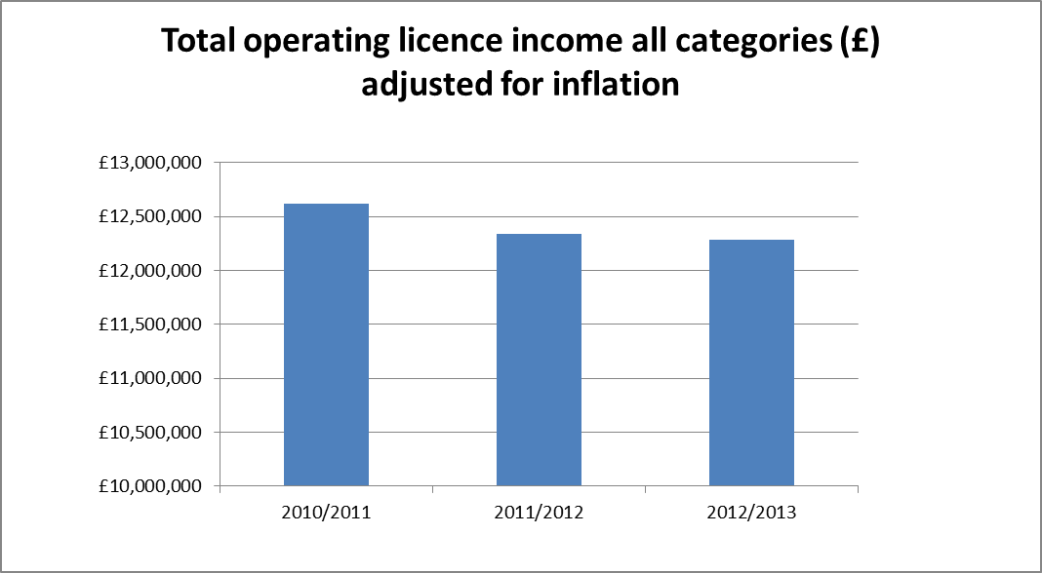

Comparison of current and future income by individual licence fee category
Tables setting out the income forecast from each licence fee category compared to 2010/11 income are set out at Annex B. Taking reduction in income derived from the smaller fee categories, which are determined by various proxies of scale e.g. number of premises, gross gambling yield etc depending on the sector, as an indicator, the overall burden for the smaller licence fee categories (A and B, and the remote category F) sees a reduction in cash terms and real terms from the current fee quanta. There are small increases at the medium and large sized non-remote categories (representing the effects of the 10% fee increase distributed across a limited number of Category D and E operators, and the impact of the fee increases that some medium-sized pool betting and external lottery manager operators will be subject to). The fee increases for larger non-remote operators (and similarly fee decreases for smaller operators in some sectors) is a result of the shift in balance away from smaller operators and towards larger.

Income increases at the remote categories F, G, H and I are in cash terms but not real terms (hence the downward trend for these categories in table 2 below). A small increase in the number of remote licences is predicted over the period 2011 to 2013, but these increases are for the smallest (category F) and generally the cheapest remote licences.

The change in income derived by licence fee category is set out in Table 2 over; source data is at Annex B.

Table 2: Income by fee category

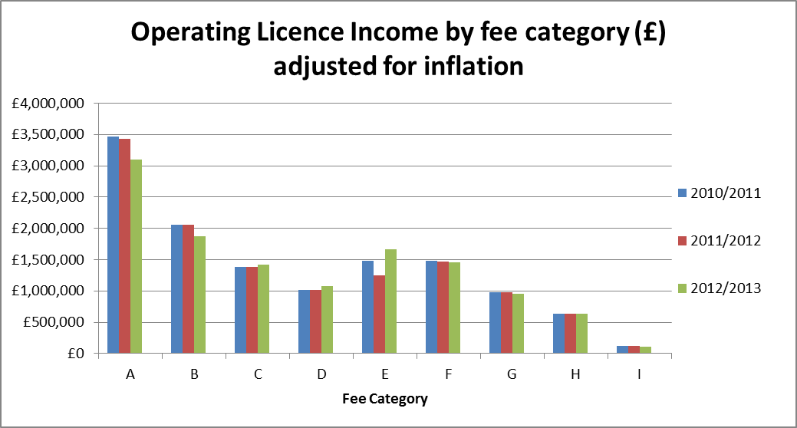

Comparison of current and future income by industry sector
Tables setting out the income forecast from each sector compared to 2010/11 income are set out at Annex C. In a parallel analysis, income from most of the sectors is reduced, with the exception of the lotteries sector, where significant expansion has been seen among External Lottery Managers, and the non-remote betting sector. The small increase in income from the non-remote betting sector reflects the rebanding and the 10% fee increase that will be applied to larger (Category D and E) general betting operators and, to a lesser extent, the rebanding and fee increase for non-remote pool betting operators. These increases are necessary for the Commission to ensure that it fully recovers its regulatory costs. Based on recent experience, the Commission considers non-remote ELM fees were set at too low a level in relation to the overall regulatory effort required, and without sufficient regard to the size disparities between operators within the same band. In the case of operators with proceeds over £10million, the original fees were unrealistically low (at £2,700) and it is anticipated that the new fees (at £15,813) will represent less than 0.5% of proceeds raised. The fee increases that some external lottery managers will be subject to is reflected in the table below.

Table 3: Income by sector

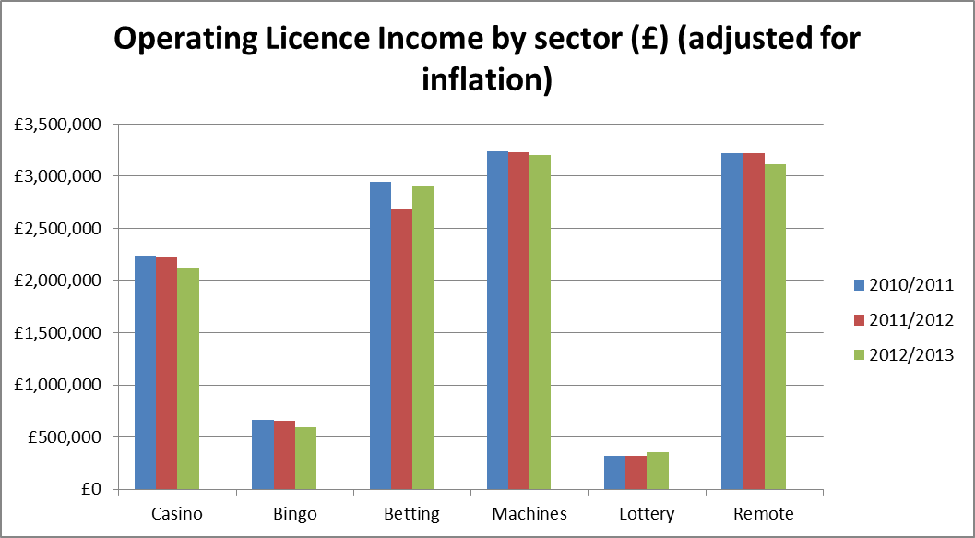

Comparison of current and future income from the smallest operators
Tables setting out the income forecast from each sector compared to 2010/11 income are set out at Annex D. Over the course of the proposed fee settlement, the Commission expects a swing of around 4% in the income base away from SMEs and towards larger operators.

Table 4: Total income from SME operators
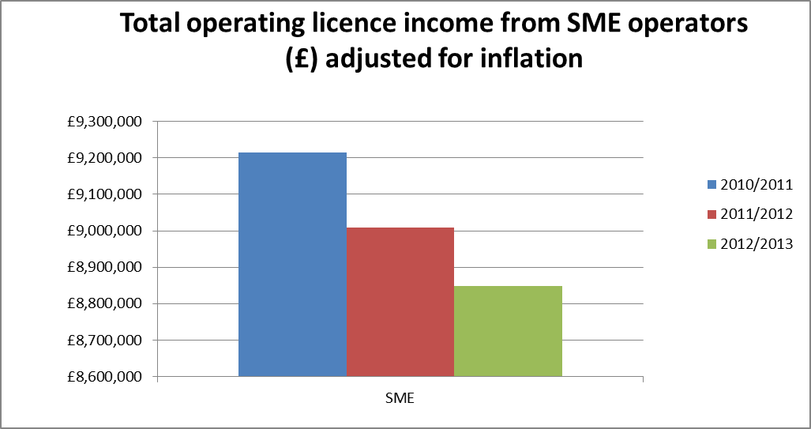

Analysis of the impact of proposals to make fees more equitable within fee bands

Option 1: Making fees more equitable within fee bands

4.5 The Commission proposes to make fees more equitable within fee bands for general betting standard, non-remote and remote pool, remote betting, remote betting intermediary, adult gaming centre and ELM operators.

4.6 As noted in the 2009 consultation document, the current fee bandings were set somewhat pragmatically taking account of the number and size of operators in each sector. Some additional bands were added in 2009 and it was proposed then that a more appropriate approach might be to introduce additional fee bands with the fees calculated on the basis of a fixed element and an additional element proportional to the additional number of premises or GGY.

4.7 The Commission considers this a better approach and one that would make the bandings and associated fees better reflect regulatory effort and make the Commission income more resilient to consolidation within the industry and less at risk of significant over or under recovery of costs as operators change bands. If operators’ businesses in some of the wider bands grow significantly or consolidate with other operators’ businesses, the consequent fee income might well be insufficient for the Commission to fully recover the costs it would incur in regulating operators subject to such expansion or consolidation. For example, if two category E betting operators merged leading to the surrender of one of their licences, the Commission would lose around £237k in annual fees; but that merged entity would generate a substantial proportion of the regulatory costs (e.g. Betting Integrity) previously generated by the two separate entities (over and above what that single entity would pay in annual fees).
4.8 While there are considerable economies of scale in dealing with a single large operator compared to a number of small ones with the same number of premises in aggregate, the costs of regulation increases with organisational complexity and with the potential impact operators’ non-compliance might have. Impact is related to scale of gambling provision. In addition with the reduced focus on premises visits and smaller operators, the proportion of costs attributed to thematic regulatory activity such as combating sports betting corruption or illegal machine supply has grown and needs to be allocated across different sizes of operators on a more equitable basis.

4.9 These new bandings are narrower, and link size (and associated risk) to fees more closely than the present bandings. Splitting the bands as proposed moves the majority of current operators into a new banding, based on their relative size in the sector. In some cases (notably the larger betting operators, and the larger ELMS) the re-banding results in a fairly significant increase to the current fee paid. The extent of the increase reflects the current imbalance in the cost recovery between operators of different sizes in the same fee band. However, for other operators, the re-banding has no significant effect.

4.10 The proposed changes to fee bandings which are described below affect :
- general betting standard (non-remote) (Bands D and E into 8 bands)
- AGCs (Band E split into three bands)
- remote real events betting (Band G split into two bands)
- remote pool betting (Bands F and G split into two bands)
- non -remote pool betting (Bands A-C split into five bands)
- remote betting intermediary (Band G split into two bands)
- ELMs (both remote and non-remote – two extra bands in each)

Table 9: General betting standard (non-remote)
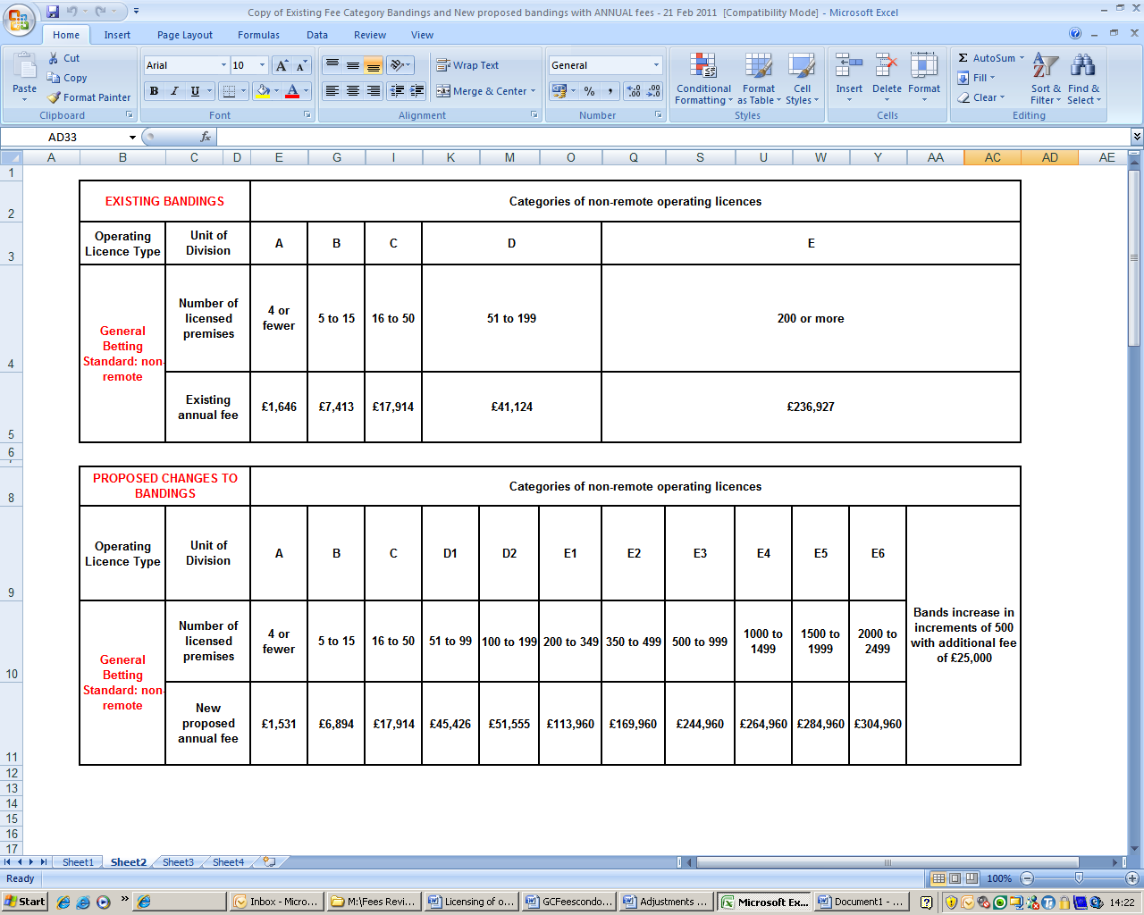

4.11 The existing general betting standard bands (bands D and E) for the larger non remote operators covers all operators with more than 200 premises. Within this very broad banding, the size ranges widely – from just over 500 premises to well over 2,000 premises, but with all operators in this band currently paying the same fee.

4.12 In addition when fees were first set, there were no operators at or around the 200 premises mark, however given growth in the sector and consolidations, there is a growing likelihood an existing operator may breach the 200 premises barrier. Under the current arrangements, that would mean an immediate increase in fees from £41,124 to £236,927.

4.13 To address these issues it is proposed that eight additional bandings be introduced, two to band D and 6 to band E increasing the total number of bandings from five to thirteen. The proposed new banding structure introduces smaller incremental fee increases and narrower bands to provide a more level ‘fee curve’. The proposed fees and rebanding are designed to apportion more equitably the recovery of costs from the differently-sized operators within the sector.

4.14 Up to two-thirds of the fee increases affecting certain category D and E operators is attributable solely to the more equitable recovery of necessary regulatory costs from different sized operators within the same band. However the size of the operators in category E, in terms of the number of premises licences held, has increased in the main over the previous three years. Premises numbers for these operators have risen by approximately 9% on average since 2007 but the growth has not been evenly spread. Increases in estate size have also occurred with some Category D betting operators. The Commission needs to ensure that it fully recovers its regulatory costs, and the proposed banding structure for Categories D and E therefore also incorporate fee increases which provide a basis for full costs to be recovered on a band-by-band basis.

Table 10: Remote General Betting Standard (Real Events) and Remote Betting Intermediary
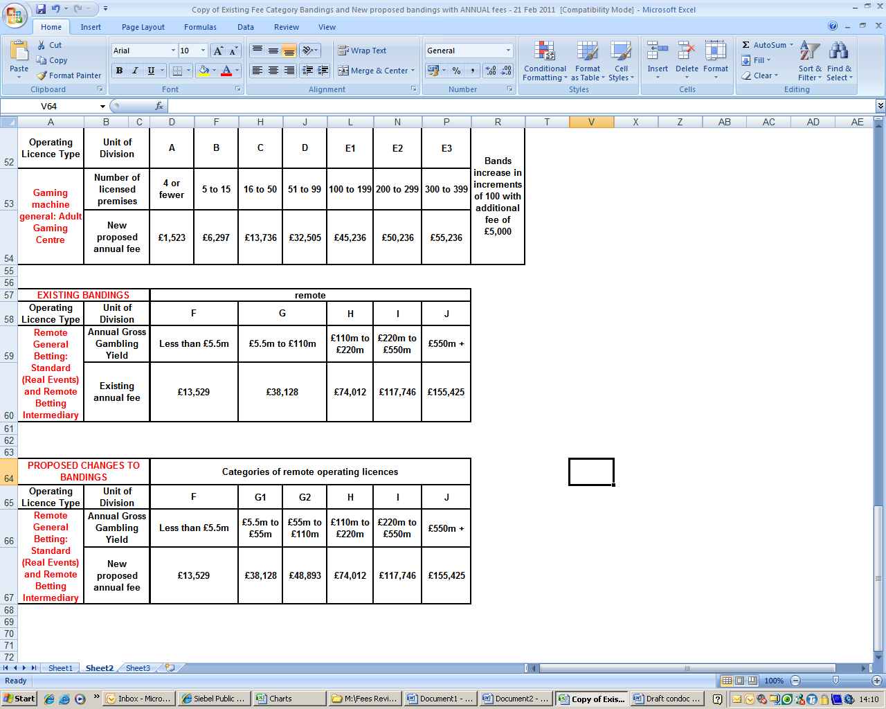

4.15 It is proposed that an additional two bands will be added to both the remote general betting (standard) (real events) and remote betting intermediary licences. The effect is that the existing Category G band which incorporates operators with a GGY of £5.5 million to those with a GGY of £110 million per annum is split to make the increments between bands smaller and the recovery of regulatory costs more equitable.

Table 11: Pool betting
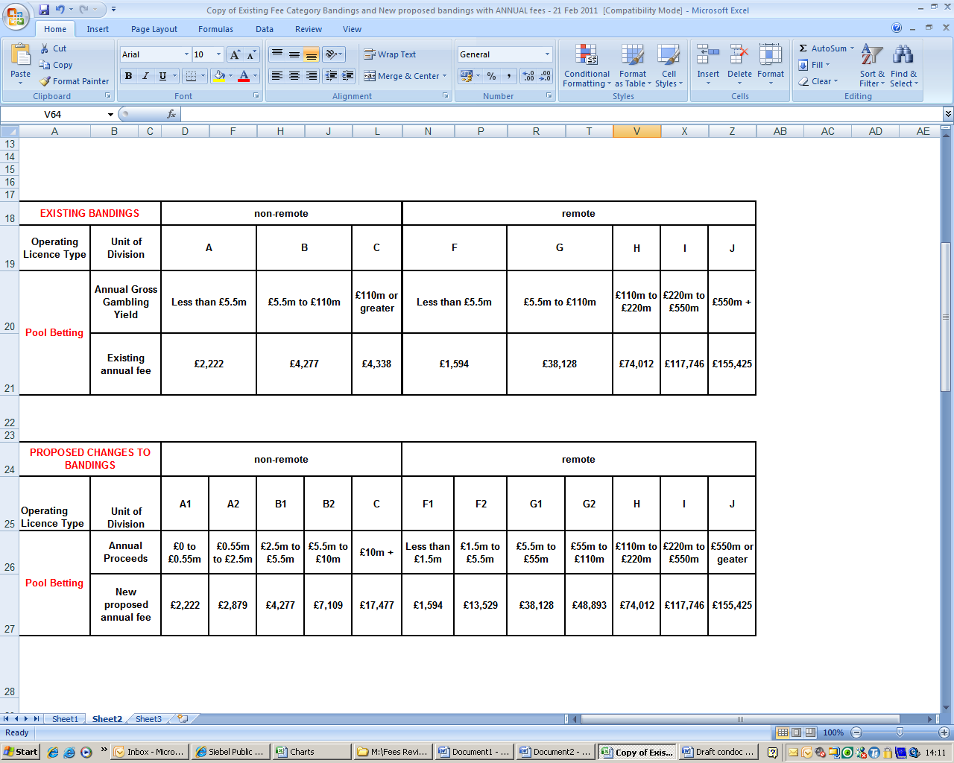

4.16 It is proposed that an additional two bands be added to both non-remote and remote pool betting sectors. In addition, the existing bands would be split to make the increments between bands smaller. The existing fee bands for pool betting are too broad to properly reflect the costs of regulating those operators with expanding businesses. For example, an existing Category B pool betting operator can generate GGY of between £5.5 million and £110 million per annum.

4.17 Based on recent experience, the Commission considers that some of the non-remote pool betting fees were set at too low a level in relation to the overall regulatory effort required, and without sufficient regard to the size disparities between operators within the same band. The changes to these bandings are designed to ensure there is no cross subsidy from other pool betting operators’ fees, and to ensure that the Commission fully recovers its costs from the larger operators that demand greater levels of regulatory effort. While the percentage fee increases proposed are large in the case of operators with yields over £5.5 million, the original fees were unrealistically low; the fee band covered too large a range of operators (and the new fees still represent less than 0.5% of GGY).

Table 12: External Lottery Managers (ELM)
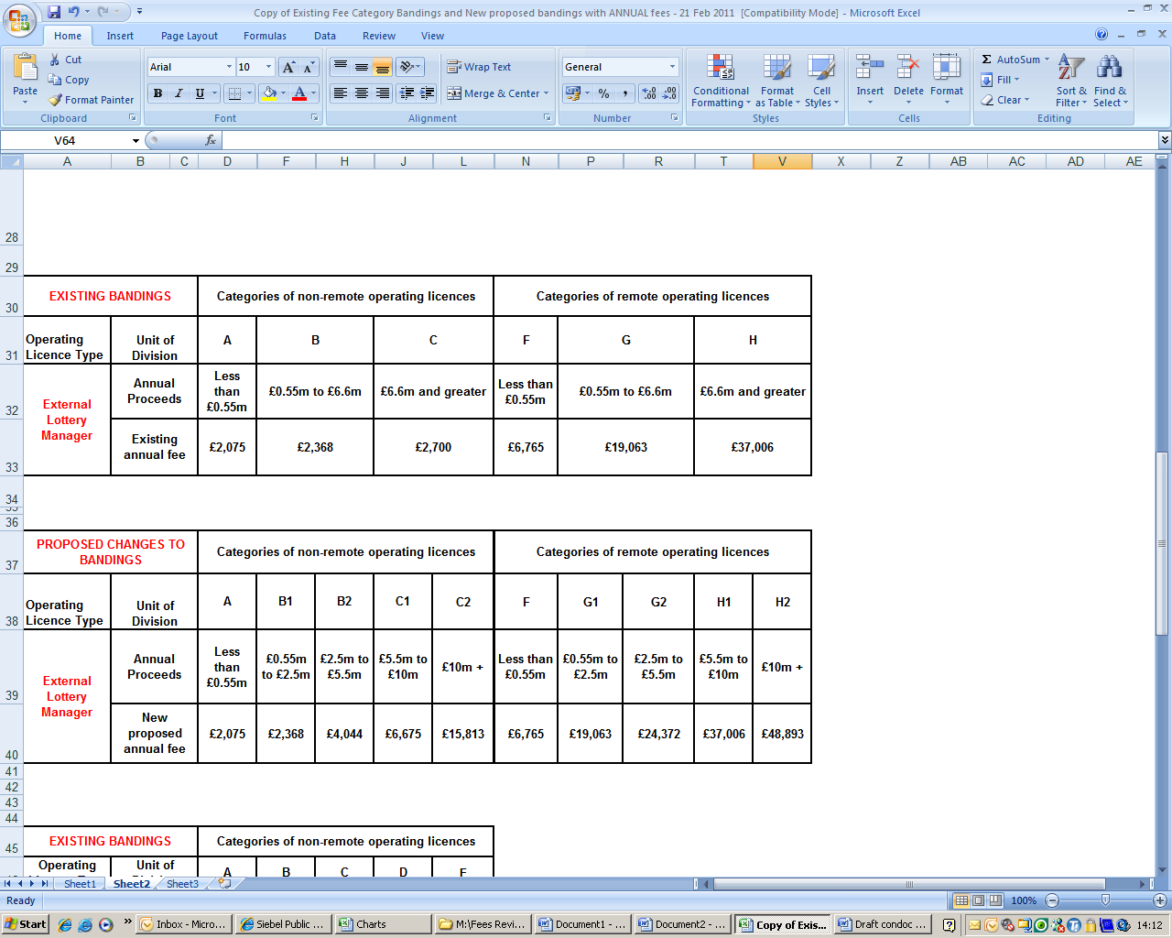

4.18 It is proposed that an additional two bands be added to the non-remote and remote ELM sectors. The existing bands would be split to make the increments between bands smaller. The existing fee bands for ELMs are too broad to properly reflect costs of regulating those operators with expanding businesses. For example, an existing Category G ELM operator can generate annual proceeds from the lotteries it manages ranging between £550,000 and £6.6 million per annum.

4.19 Based on recent experience, the Commission considers that non-remote ELM fees were set at too low a level in relation to the overall regulatory effort required, and without sufficient regard to the size disparities between operators within the same band. The changes to these bandings are designed to ensure that there is no cross subsidy from other ELM operators’ fees; and the increase in fees for the larger ELM operators will represent a more realistic fee level for this licence type in terms of regulatory effort. While the percentage fee increases proposed are large, in the case of operators with proceeds over £10million, the original fees were unrealistically low at £2,700 (and it is anticipated that the new fees at £15,813 will represent less than 0.5% of proceeds raised.)

Table 13: AGC
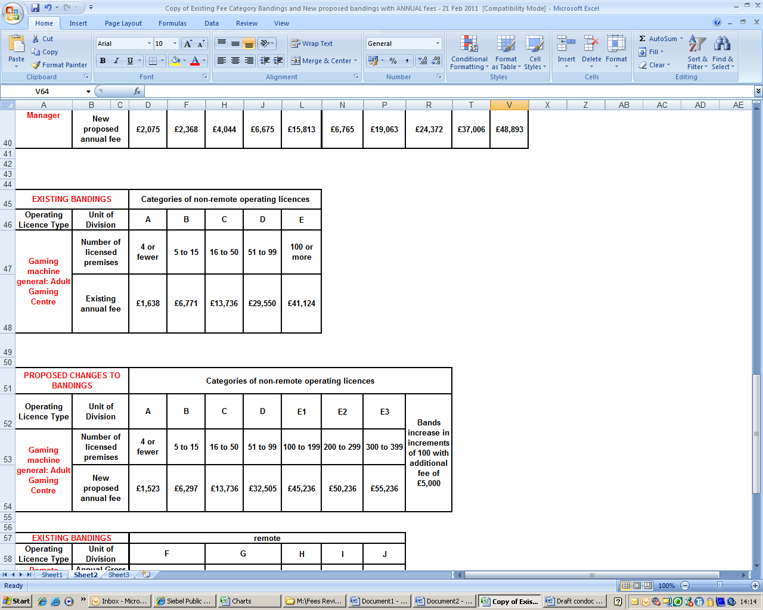

4.20 It is proposed that the bandings for AGCs be changed in a similar fashion to those proposed for General Betting Standard above to create narrower bandings with smaller increments. The existing Category E allows an unlimited quantity of AGC premises to be operated for the same annual fee as for operating 100 premises. This means that an operator with, for example, 1500 premises pays the same annual fee as an operator with 100 premises, despite the larger operator having a potentially higher impact on the licensing objectives and benefiting more from the Commission’s efforts on, for example, combating illegal machine supply.

4.21 It is proposed that additional bandings be introduced to break up the existing Category E, thus increasing the total number of AGC bandings from five to seven although it is not expected that all the higher bandings will be needed currently unless there is an unexpectedly high level of both growth and consolidation in the sector. The formula used (a fixed fee of £45,236 plus a variable component of number of premises: £5,000 for the extra regulatory cost for each 100 premises) could be used to create further fee bands should the sector see massive growth or consolidation.

4.22 There is also a need to change the distribution of cost recovery from operators within the non-remote betting, arcade and bingo sectors.The move in emphasis away from visits and from work with smaller operators requires a shift in the cost recovery from smaller operators to larger ones in these sectors. The proposed fee table (see Annex A) entails a modest decrease in cost recovery, around 7%, from all operators in categories A and B general betting standard, bingo, AGC and FEC and a corresponding modest increase in cost recovery (averaging just under 10%) for all operators in categories D and E in these sectors.

4.23 The decrease in fees for categories A and B reflects the proposed reduced compliance effort in relation to such operators now that the initial educational period is over. While the Commission will continue to need to provide considerable support to local licensing authorities both on specific precedent-setting cases and in terms of more generic advice and guidance for the next two years at least, day to day compliance and enforcement activity in connection with gambling on betting, bingo and arcade premises can largely be left to the local licensing authorities now that the Commission has established a better understanding of the industry especially of the sectors new to it.

4.24 The proposed increase in fees for categories D and E reflects both the increased focus of regulatory effort upon larger and therefore higher impact operators and need to recover a higher proportion of certain regulatory costs e.g in relation to betting integrity and illegal machines from these larger operators.

4.25 In some cases where re-banding has also led to fee increases, the overall combined fee increase for some of the larger betting operators is significant in percentage terms (up to 29%) although again still a relatively small proportion of GGY. Those operators affected have grown significantly over the last four years in terms of premises quantity, and have remote operations which add to the Commission’s workload in relation to British consumers on betting integrity and consumer protection. Because fees are based on the number of domestic premises as a proxy of scale, the large operators with significant overseas operations in addition targeting British consumers are benefiting from Commission regulation of the British market without contributing fairly. Table 14 shows the redistribution of recovery of Commission costs from the smaller to the larger operators in the relevant sectors.

Table 14: Redistribution of recovery of Commission costs
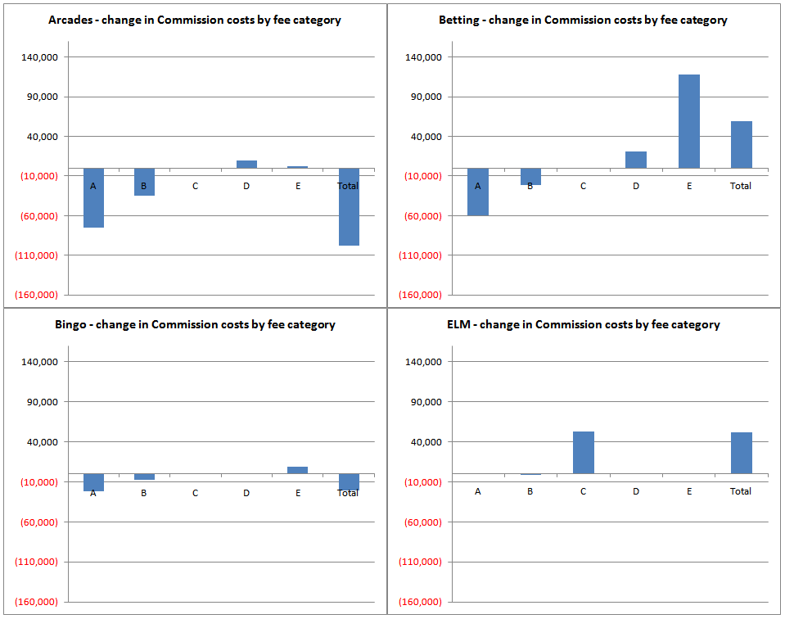

Other minor amendments

- Use of betting exchanges in the course of business
Currently, operators would be required to pay around £13,500 for a remote betting intermediary or remote general betting standard operating licence for the use of exchanges in the course of a business. It is proposed that a new type of operating licence (general betting standard remote trading platform licence) be created. The licence will be free to existing operators who hold a non-remote general betting standard or general betting limited licence. Non-licensed traders who use exchanges to back and lay would pay an application fee of £198 and an annual fee of £280. This fee would be in line with the cost of the non-remote betting intermediary operating licence and would reflect actual Commission regulatory costs. Savings would be neutral to non-remote betting operators.

- Death of a sole trader
Under section 114(1)(a) of the Act, an operating licence lapses upon the death of the holder. It is proposed that a reduced application fee will be charged where a new application is made by the spouse, civil partner or child of the deceased to continue the business previously operated by the deceased (the fee payable will be either 25% or 75% of the usual application fee amount, depending on the level of checks required). It is also proposed that the first annual fee for such applications will be reduced by an amount that relates to the number of calendar months between the date on which the previous licence lapsed and the next anniversary date of the issue of that licence.

- Death or retirement of a partner in two-person partnerships
The death or retirement of one partner in a two-person partnership means that the licence lapses under section 114(2)a of the Act as the partnership ceases to exist as an entity. It is proposed that where the remaining partner applies for an operating licence to continue the business previously undertaken by that partnership, the application fee will be £100 (reflecting the minimal administrative costs to the Commission, as many licensing checks will already have been done). Again, the first annual fee will be reduced by an amount that relates to the number of calendar months between the date on which the previous licence lapsed/was surrendered and the next anniversary date of the issue of that licence.

- Change of legal entity
Section 104(2)(a) of the Act confers that operating licences cannot be transferred from one entity to another. It is proposed that that where the assets of a business are transferred from one entity to another and a new application for an operating licence is therefore necessitated, the fee payable will be either 25% or 75% of the usual application fee amount, depending on the level of checks required (and again, the annual fee will be reduced by an amount that relates to the number of calendar months between the date on which the previous licence was surrendered and the next anniversary date of the issue of that licence). With regards to the proposals concerning the death of a sole trader, the death/retirement of a partner and change of legal entity, savings of approximately £25,000 per annum (within a range of £20,000 to £30,000 per annum: please see table below) are anticipated between all three proposals, based on the trend of applications received 2008 to present.

- Changes to corporate control
Where a new controller is authorised by the Financial Services Authority or is regulated by an EEA member state, the Commission can reasonably reduce the level of its checks. It is therefore proposed that application fees in such circumstances will mirror those payable when the new controller is already the holder of an operating licence (i.e. 25% of the usual fee or £100, depending on the nature of the control).

Further, it is proposed that where two or more licensed companies are subject to changes of corporate control by virtue of those companies being within the same group structure, only that company whose operating licence attracts the highest application fee will pay the usual change of corporate control application amount; the other licence holder(s) within that group structure would pay an administration fee of £100. Savings from these two proposals will vary depending on the licence activities held by the particular operators applying for a change of corporate control (i.e. the application fees for those licence activities). However, it is anticipated that total savings of up to £60,000 in application fees could be seen for operators, based on experience of applications received 2010/11.

- Non-remote 2005 Act Casino First Annual Fees
It is proposed that where an operating licence for a non-remote new casino is granted, the time period for the payment of the first annual fee will be extended from 30 days to six months for the non-remote casino only. Further, the first annual fee discount that is applicable to the non –remote new casino will be increased from 25% (the discount for other non-remote first annual fees) to 50%. This proposal will ensure that unsuccessful bidders do not have to pay disproportionate Commission annual fees. Savings of approximately £54,000 per annum are anticipated, based on the rate of applications received in 2010 and projected trends.

- Remote supplementary society lottery operating licence
For operators that hold both remote and non-remote society lottery operating licences, and where the remote aspect of their business is limited to the acceptance of payments by email, fax, telephone or direct debit, it is proposed to remove the requirement for a full remote licence. A new supplementary licence will be introduced with an application fee of £50 and an annual fee of £100 which will allow remote payments by means of telephone, fax, email and/or direct debit. Savings to lottery operators of around £35,000 per annum are expected (within a range of £30,000 to £40,000 per annum: please see table below), based on the current number of operators that hold both non-remote and remote society lottery operating licences.

- Telephone betting only
General betting (telephone only) operators are currently only permitted annual gross gambling yields of up to £275,000 before a full remote general betting standard licence would be required. It is proposed that this GGY threshold be raised from £275,000 to £550,000. The proposal will have minimal impact upon existing operators, but is likely to allow at least two operators to reduce their annual fees from around £13,500 to £1,600 per annum, based on the gross gambling yields reported by operators that currently hold remote general betting standard (real events) operating licences.

The table below summarizes the minor amendments described above. The approximate savings to industry are anticipated at £188,000 to £208,000 per annum, based on recent and projected trends of applications received. Note that these savings are in addition to the calculations of overall burden reduction.

Details of amendment | Total approximate saving to industry (£)
Introduction of remote trading platform operating licence for operators using exchanges in the course of a business | Neutral
Discounted application/annual fees in instances of the death of a sole trader, death or retirement of a partner in two-person partnerships and changes of legal entity | £25,000 per annum approximately, within range of £20,000 to £30,000. The figure of £20,000 is based on previous trends of such applications, but it should also be taken into account that the removal of existing application fee burdens may encourage more licence applications based on changes of legal entity (e.g. incentive to change entity for tax reasons coupled with new application fee incentive). Such increases in applications may increase the projected saving to £30,000 p.a.
Discounted application fees for certain change of corporate control applications | £60,000 per annum approximately, based on trends of such applications
Reduced first annual fees and extension of payment due date for non-remote 2005 Act Casinos | £54,000 per annum approximately, based on recent and projected trends of such applications.
Introduction of remote supplementary society lottery operating licence | £35,000 per annum, within range of £30,000 to £40,000. Based on existing numbers of operators that hold both non-remote and remote society lottery licences. The £30,000 estimation is based on the majority of such operators with the smallest remote lottery licence (category F) applying for this change, plus a small proportion of such operators with the category G licence applying for this. The £40,000 figure represents the possibility of a greater number of category G or even category H operators taking this licence.
Increase in the permitted GGY threshold for the remote general betting telephone only operating licence, from £275,000 pa to £550,000 pa | £24,000 approximately, based on existing numbers of remote betting operators whose GGY is likely to fall within the increased threshold
Approximate total industry benefit (£) from minor amendments, incorporating ranges referred to above. | £198,000 (within range of £188,000 to £208,000)

Summary
In summary Option 1 is the preferred option as it would mean that potential barriers to growth inherent in existing bandings would be removed, and that smaller gambling businesses in each sector (and across sectors) would no longer be subsiding regulatory effort focused on larger operators in that sector, or cross subsidising regulation of other gambling sectors. In addition, minor amendments would remove a small number of burdens imposed by the Gambling Act 2005 which are disproportionate.

In total this would deliver a reduced burden on the industry of between £0.97m and £1.01m in present value terms over three years, as set out in Table 15 below.

Table 15: Summary of reduced burden on industry in real terms and present values (PV)

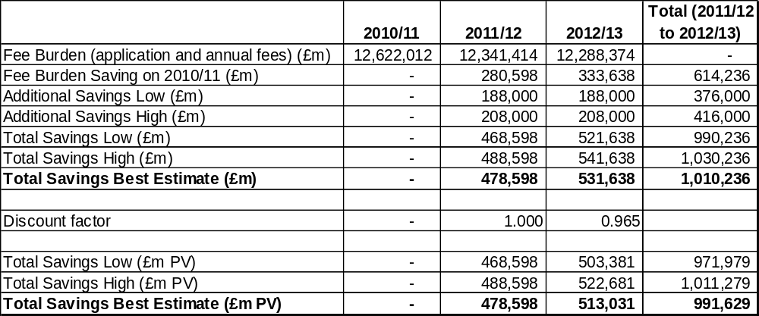

Annexes
Annex 1 should be used to set out the Post Implementation Review Plan as detailed below. Further annexes may be added where the Specific Impact Tests yield information relevant to an overall understanding of policy options.

Annex 1: Post Implementation Review (PIR) Plan
A PIR should be undertaken, usually three to five years after implementation of the policy, but exceptionally a longer period may be more appropriate. If the policy is subject to a sunset clause, the review should be carried out sufficiently early that any renewal or amendment to legislation can be enacted before the expiry date. A PIR should examine the extent to which the implemented regulations have achieved their objectives, assess their costs and benefits and identify whether they are having any unintended consequences. Please set out the PIR Plan as detailed below. If there is no plan to do a PIR please provide reasons below.
Basis of the review: [The basis of the review could be statutory (forming part of the legislation), i.e. a sunset clause or a duty to review , or there could be a political commitment to review (PIR)];
There is a commitment to periodically review fees to ensure they are set at a level that enables the Commission to recover the full costs of delivering its responsibilities, while avoiding cross-subsidisation and ensuring fairness and value for money for the gambling industry.
Review objective: [Is it intended as a proportionate check that regulation is operating as expected to tackle the problem of concern?; or as a wider exploration of the policy approach taken?; or as a link from policy objective to outcome?]
As with previous settlements, the review will examine the overall quantum of income against actual and forecast expenditure according to effort.
Review approach and rationale: [e.g. describe here the review approach (in-depth evaluation, scope review of monitoring data, scan of stakeholder views, etc.) and the rationale that made choosing such an approach]
In-depth evaluation and consultation of stakeholders.
Baseline: [The current (baseline) position against which the change introduced by the legislation can be measured]
The existing fees model as set out in The Gambling (Operating Licence and Single Machine Permit Fees) Regulations 2006, as amended by Amendment Regulations in 2007, 2007 (2), 2008 and 2009.
Success criteria: [Criteria showing achievement of the policy objectives as set out in the final impact assessment; criteria for modifying or replacing the policy if it does not achieve its objectives]
The principle criterion is the extent to which income by sector and scale matches effort.
Monitoring information arrangements: [Provide further details of the planned/existing arrangements in place that will allow a systematic collection systematic collection of monitoring information for future policy review]
The Gambling Commission is entirely funded by licence fee income. Running as a business, we have sophisticated business systems for collating data on fee income and monitoring effort,
Reasons for not planning a review: [If there is no plan to do a PIR please provide reasons here]

Annex A
Existing and proposed annual fees by comparison, with existing and projected licence volumes – non-remote.

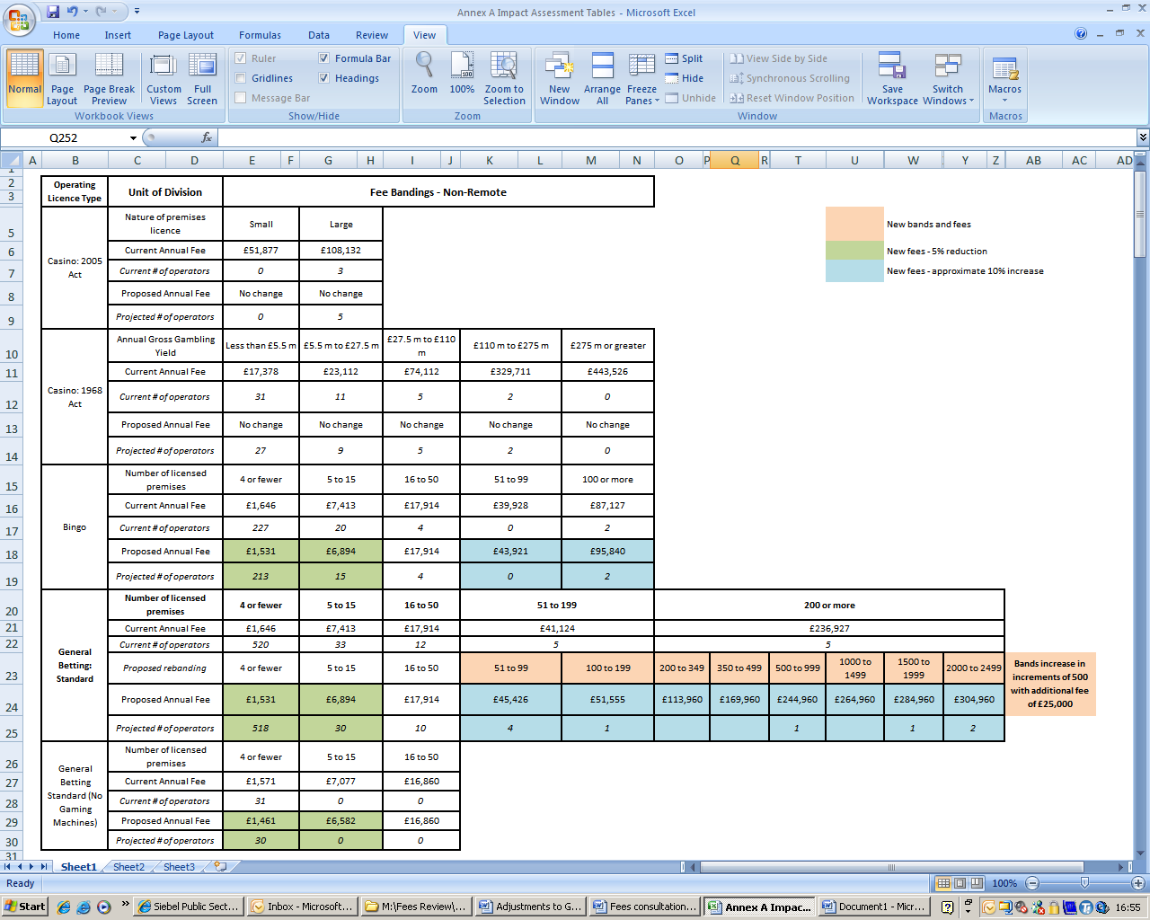
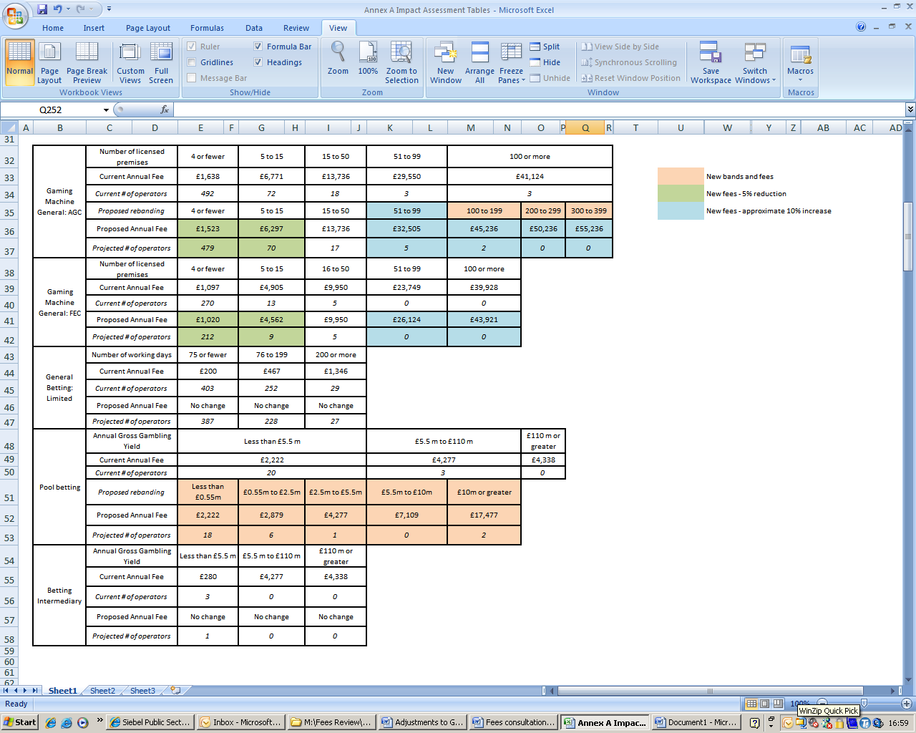

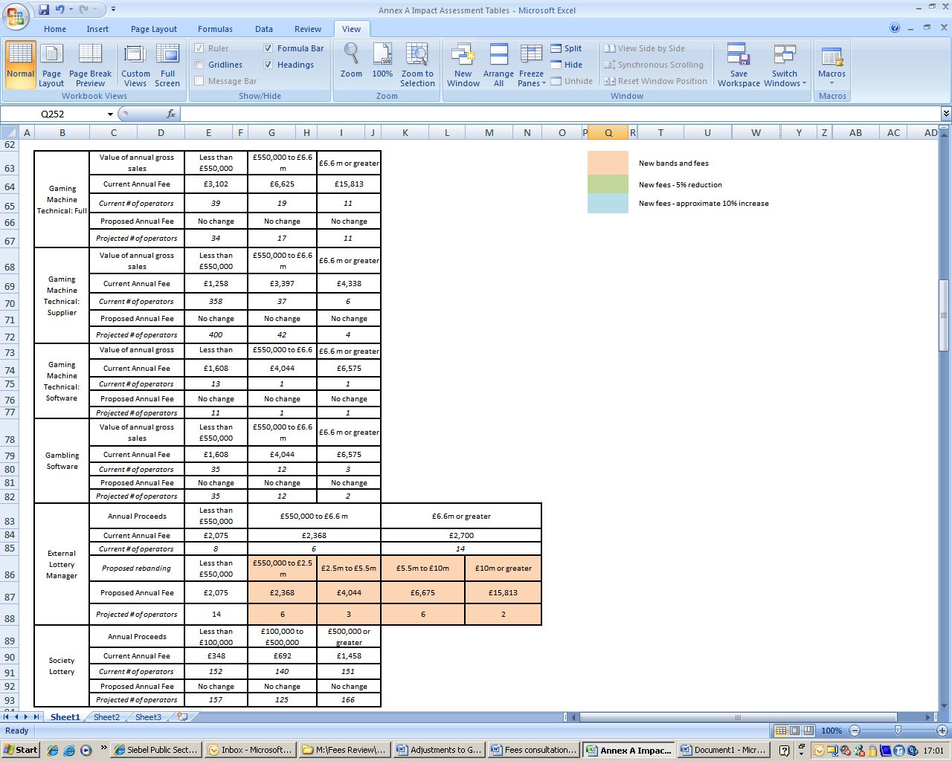

Existing and proposed annual fees by comparison, with existing and projected licence volumes – remote.

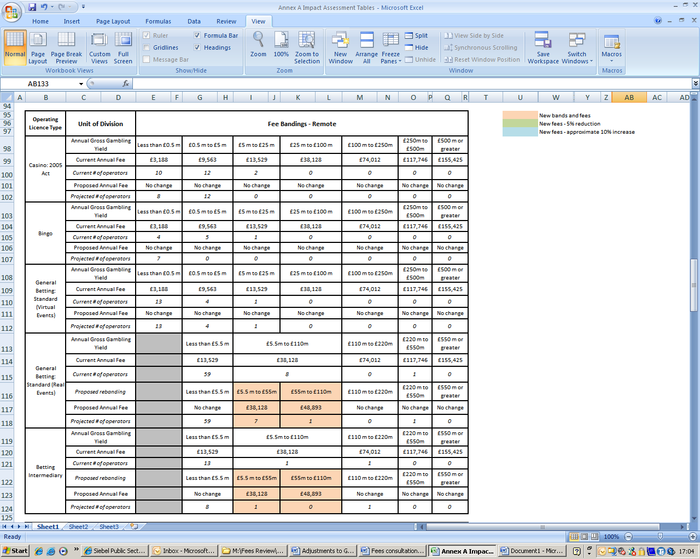
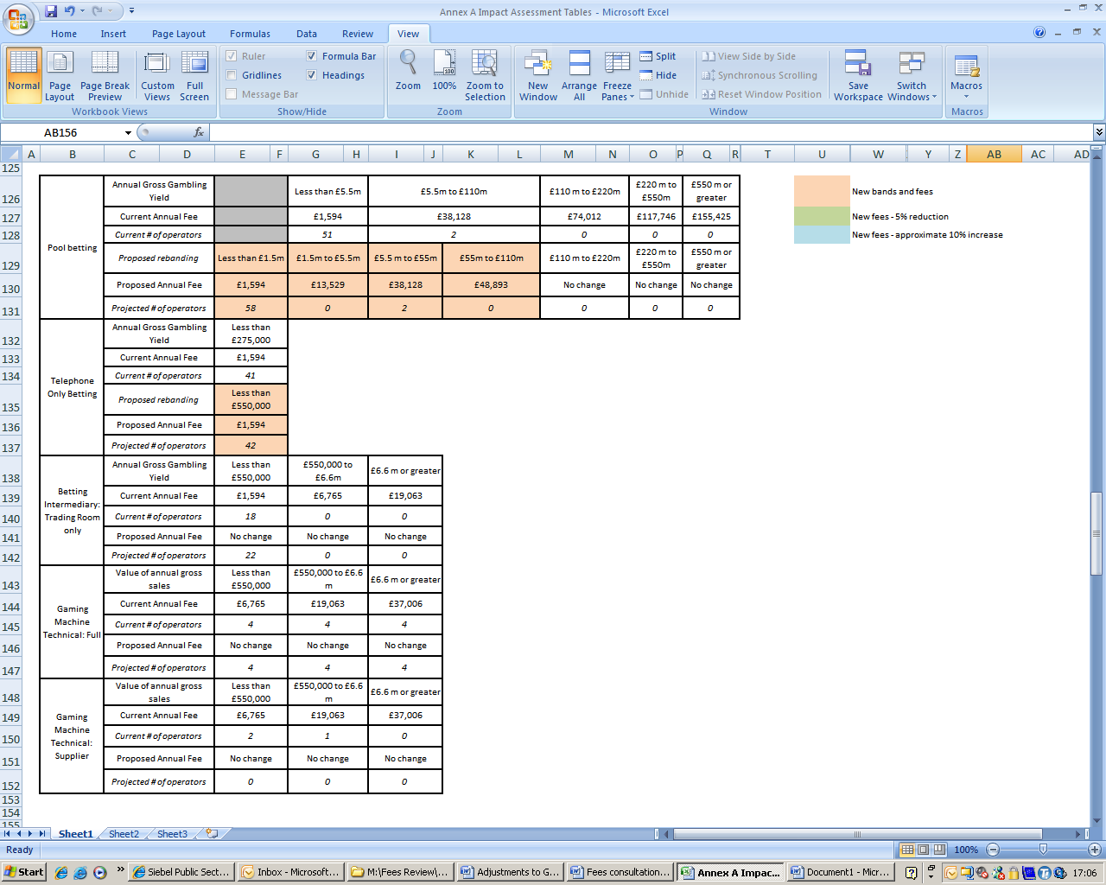



Existing and proposed application fees by comparison (applicable only to the licences below) – non-remote

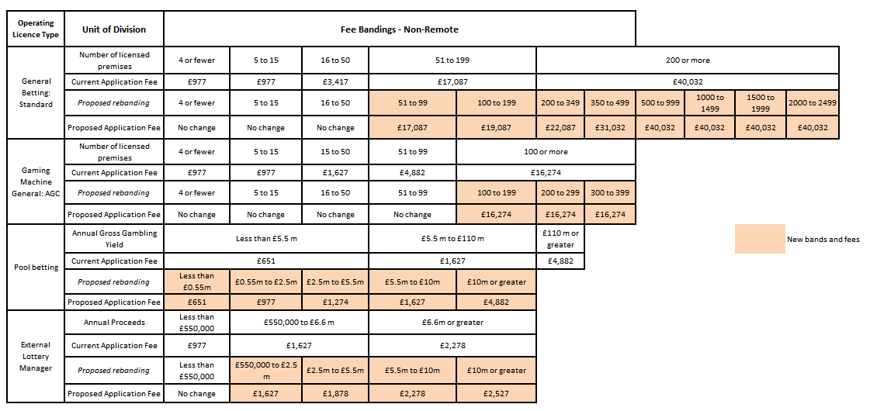

Existing and proposed application fees by comparison (applicable only to the licences below) – remote



Annex B
Comparison of 2011/12 and 2012/13 income by individual licence fee category (as a proxy for change in fee burden)

Table of figures showing income by Fees Category - NB approximate discount applied at Category A to account for combined licence discounts

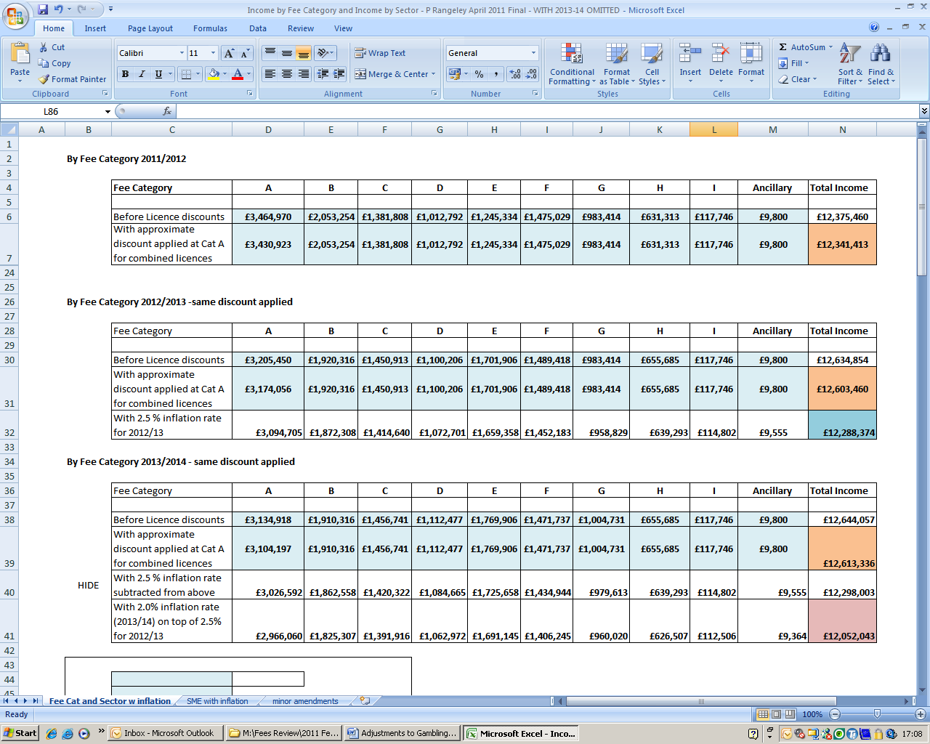

Table of Fees Category Figures for chart (adjusted for inflation)

Category | 2010/2011 | 2011/2012 | 2012/2013
A | £3,471,524 | £3,430,923 | £3,094,705
B | £2,055,697 | £2,053,254 | £1,872,308
C | £1,381,808 | £1,381,808 | £1,414,640
D | £1,012,792 | £1,012,792 | £1,072,701
E | £1,482,261 | £1,245,334 | £1,659,358
F | £1,475,657 | £1,475,029 | £1,452,183
G | £983,414 | £983,414 | £958,829
H | £631,313 | £631,313 | £639,293
I | £117,746 | £117,746 | £114,802

Annex C

Comparison of 2011/12 and 2012/13 income by industry sector
Tables showing income by sector


Table of sector fees for chart (adjusted for inflation)

Sector | 2010/2011 | 2011/2012 | 2012/2013
Casino | £2,240,356 | £2,232,856 | £2,124,927
Bingo | £664,276 | £657,444 | £594,685
Betting | £2,946,366 | £2,686,105 | £2,900,770
Machines | £3,237,778 | £3,230,935 | £3,200,198
Lottery | £315,306 | £316,772 | £352,167
Remote | £3,217,930 | £3,217,301 | £3,115,627

Annex D

Comparison of current and future income from the smallest operators
Table showing income from SME’s, figures adjusted for inflation

 | 2010/2011 | 2011/2012 | 2012/2013
SME | £9,214,069 | £9,009,231 | £8,847,629

Annex E Assumed and actual workload (volume of licences)

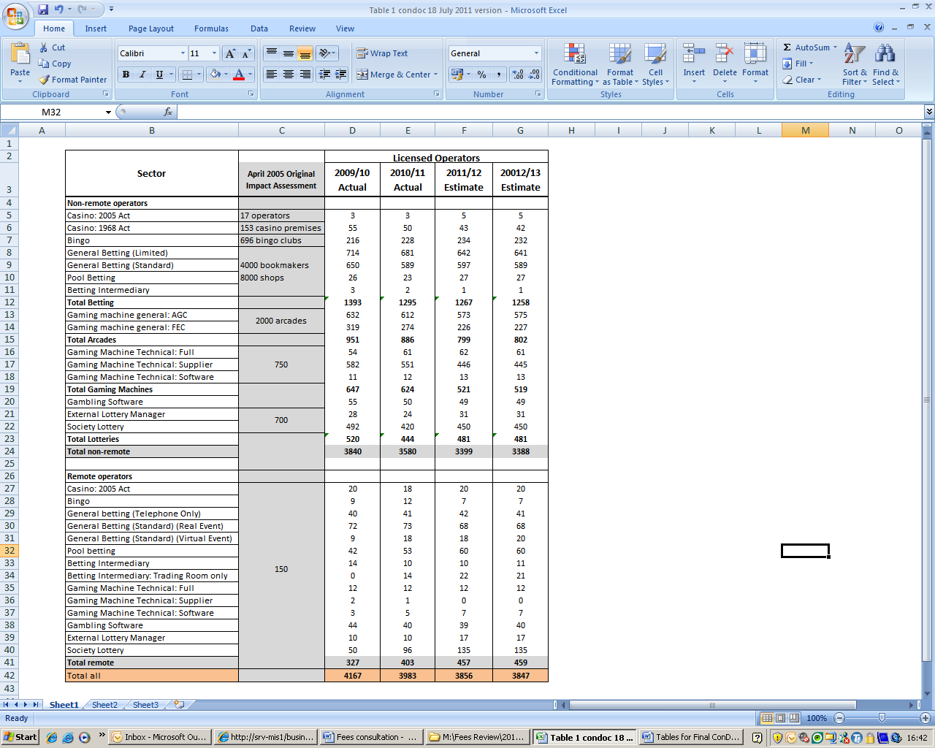

Annex F: Estimated number and types of operating licences 2011/2012

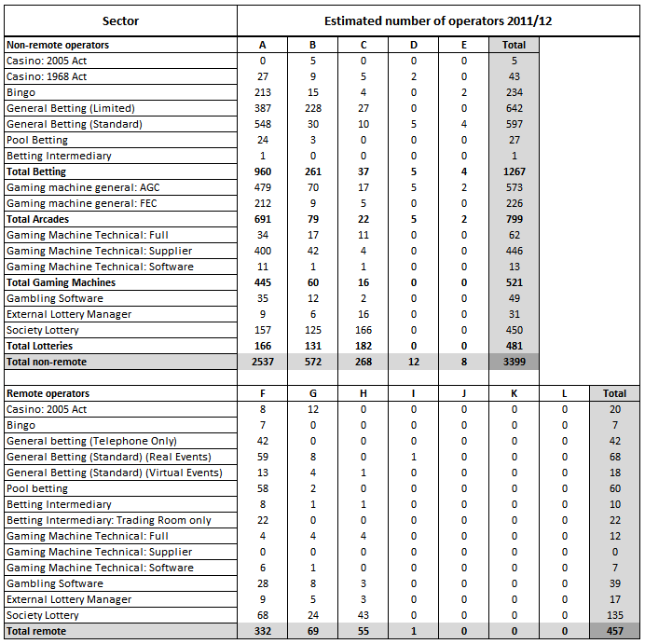

Annex G: Competition Assessment:

Current market

Most commercial gambling in Great Britain is regulated by the Gambling Commission and subject to both application and annual fees in order to enter and then remain in the licensed industry. This encompasses: casinos, bingo, betting, gaming machines (manufacturers, suppliers and operators), lotteries and remote gambling.

There are of the order of 4000 licensed operators (see consultation document table 1 page X for details) which range from a relatively small number of very large businesses, often multinational and multi-sector in scope, to a large number of very small – often micro – businesses, for example independent bookmakers and seaside arcades.

Gambling is a long established leisure activity in Great Britain, enjoyed by millions. The last adult gambling prevalence survey (British Gambling Prevalence Survey 2010, published in February 2011) indicated that including the National Lottery, some 73% of the adult population had participated in gambling within the last year. The industry generated a Gross Gambling Yield of £5.5 billion in the British economy in 2009/10 and employs around 130,000 people.

The most important regulatory development in this market in recent years was the implementation of the Gambling Act on 1 September 2007 (the Act) which introduced a new framework for gambling regulation in Great Britain:

One of the principles on which the Act is based is that the industry must bear the full cost of regulation, and this has now been in operation since the Act received Royal Assent in 2005. Prior to the introduction of the Act, the operation of the regulatory framework had been heavily subsidised by the taxpayer. For example, half of the national regulator’s costs had been provide from the Exchequer through grants from the sponsoring Department (DCMS) and the licensing system run through the Magistrates courts had not been based on full cost recovery. There are essentially two broad locuses for fees charged; operating and personal licence fees, which are administered by the Gambling Commission, and which are the subject of this Impact Assessment, and premises licence fees, which are collected by local authorities (and which individual authorities are free to set, subject to a cap set by the Secretary of State in secondary legislation).

This Impact Assessment relates to adjustments to Gambling Commission fees already set; it does not address the principle that the industry bears the cost of regulation as that is now long established and enshrined in the Act since 2005.

Analysis

Does this policy:
Directly limit the number or range of suppliers? (For example award exclusive rights to a supplier; restrict procurement from a single supplier or restricted group of suppliers; create a form of licensing scheme; or impose a quota on the number of suppliers?)
No

Indirectly limit the number or range of suppliers? (For example significantly raise the costs: for new suppliers relative to existing suppliers; for some existing suppliers relative to others; of entering or exiting an affected market?)
No. Although it might be argued that the principle of cost recovery as set out in the Act constitutes a barrier to entry, it is unlikely that the adjustments to existing fees covered by this impact assessment will have an adverse impact on the number or range of suppliers; indeed, by generally reducing the revenue collected from smaller businesses it may have a (small) positive impact on this parameter.

Limit the ability of suppliers to compete? (For example by: controlling or substantially influencing prices or characteristics of products; limiting innovation; limiting the channels a supplier can use, or the geographic area in which a supplier can operate; substantially restrict the ability of suppliers to advertise their products; or limit their freedom to determine their organisational form?
No. Although the proposals involve some increases in fees for a very small number of the largest operators, those increases remove existing subsidisation (and the individual increases are not material with reference to the scale of the businesses to which they might apply).

Reduce suppliers' incentives to compete vigorously? (For example by exempting suppliers from general competition law; requiring or encouraging the exchange of information on prices, costs, sales or outputs; or increasing the costs to customers of switching between suppliers?
No. The proposals remove disincentives to competition by smoothing variation between fee bandings (and removing barriers to growth that may arise from crossing over fee band boundaries) and by reducing subsidisation of fees for larger operators by smaller ones in higher fee bands.

Consideration
The intentions of the proposed changes in fee levels and arrangements are to reduce burdens on the gambling industry as a whole by bringing down the total cost of regulation. Within the total figure, which is raised from the licensed industry, the proposed policy redistributes costs to better match the regulatory effort required, shifting costs and regulatory focus away from small businesses and towards the larger and higher impact businesses.
The proposals also introduce more flexibility in the fee banding structure to remove disincentives to growth at banding boundaries. For example, in the betting sector, the highest fee banding starts at operators with 200 premises; however the largest companies in the sector may have 2000 premises or more. The net result is that the band covers a very wide range of businesses and creates inherent subsidisation of those at the higher end of the band by those at the lower. For operators in lower bands considering growth, the risk of crossing the boundary into the next band can be a disincentive to growth because of the often significant increase in fees. Smoothing the transitions between fee bands by increasing the number of bands is expected to increase competition in the industry.

Annex H: Small Firms Impact Test

Analysis

Does the proposal affect small business, their customers or competitors?
Yes: Licensed gambling businesses vary in size from the very small (sometimes sole trader) businesses to very large multinational corporations. .

Would a more flexible approach, or possibly exemptions, be appropriate for firms with fewer than 20 employees? Yes: The fee structure builds in a flexible approach; in general terms, fee bandings are assigned according to proxies for scale; the smaller the scale of the business, the lower the fee. The relationship is not linear, however, as economies of scale mean that less effort is required per unit of activity as the scale of the business increases.

In addition to proposals to reduce fees in the fee bands applied to most small gambling businesses, the policy also seeks to make changes to the licensing and fees requirements so as to ease periods of transition for small businesses at times of change. For example, if a sole trader dies and others wish to continue the business; if one half of a partnership retires or dies and the other wishes to take on a new partner; or if there is a change in legal entity. Proposals allowing lower fees to be charged based on prior knowledge of those concerned will make small businesses less vulnerable and more competitive.

Is there potential to fully or partially exempt small business (those with fewer than 50 employees)?
Yes: In effect, the scaling of the fee with the size of the business effectively provides partial relief for smaller businesses. In addition, the whole package is balanced to deliver an overall reduction in the revenue generated from small businesses.

If the smallest businesses were exempted from paying fees, this would mean that the larger businesses were subsidising the smaller, which is against the principles of the 2005 Act. However, small scale operator exemptions are in place so that fore more simply structured businesses, only the operator is licensed and the requirement for key post holders to be personally licensed is removed, thereby reducing the regulatory burden.

Does the impact fall more heavily on small businesses (those with up to 50 employees) than large businesses?
No: One of the key policy intentions of the proposed fees changes is to actively reduce the impact of regulation on small businesses by lowering their fees and taking a lighter touch to regulatory activity with these businesses.

2-4 Cockspur Street
London SW1Y 5DH
www.culture.gov.uk

Public bodies including Whitehall departments are required to consider the impact of their policies and measures on race, disability and gender. It is intended to extend this consideration requirement under the Equality Act 2010 to cover age, sexual orientation, religion or belief and gender reassignment from April 2011 (to Great Britain only). The Toolkit provides advice on statutory equality duties for public authorities with a remit in Northern Ireland.
Public bodies including Whitehall departments are required to consider the impact of their policies and measures on race, disability and gender. It is intended to extend this consideration requirement under the Equality Act 2010 to cover age, sexual orientation, religion or belief and gender reassignment from April 2011 (to Great Britain only). The Toolkit provides advice on statutory equality duties for public authorities with a remit in Northern Ireland.
Annual proceeds being the aggregate of the proceeds of lotteries managed by the external lottery manager.
Gross gambling yield being the amounts paid to the licensee by way of stakes plus the amounts that will otherwise accrue to the licensee, minus the amounts deducted in respect of the provision of prizes or winnings.
Fee categories A to E inclusive represent the non-remote fee bands: category A being the smallest non-remote fee band, category E the largest. Remote fee bands are represented by fee categories F to L inclusive (there are no operators with category J, K or L licences, hence their omission from Table 2): category F being the smallest remote fee band, category L the largest.
Adult Gaming Centres – arcades offering categories B3, B4, C or D gaming machines to which only adults are permitted access.
Family Entertainment Centres – arcades offering categories C or D gaming machines; minors being permitted access to category D machines only.
Terrestrial, premises-based betting
On-course bookmakers
Where multiple licence activities are held on a combined operating licence, the cheaper activities are discounted at a rate of 5% of the full annual fee.

