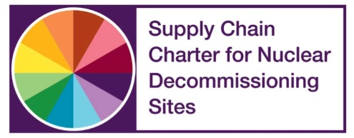
Application Form
NDA Estate Supply Chain Awards 2018 –
Best supply chain collaboration
Name: | Job Title:
Email: | Tel:
Company Name(s):

Company Type(s): NDA Business Yes/No* : Tier 2 Yes/No* : Tier 3/4 Yes/No* : SME Yes/No* * delete those not applicable
Project/Contract/Initiative Title:

NDA Business (client):
Name: Email: Telephone: Site:
Please provide a brief executive summary to introduce the award application (no more than 100 words):

Your submission should include information and responses to the following:
- What were the aims and objectives of the project, contract or goal?
- How was the collaboration successful in achieving the aims and objectives?
- How was the need for collaboration identified and established?
- Who were the parties (companies/organisations) in the collaboration and what were their roles?
- What were the main challenges to the collaboration and how were they overcome?
- What mutual benefits have been realised as a result of the collaboration?
- How will the collaboration support the future success of the organisations involved?
“Collaboration” can be taken in its widest sense.
It is important that every entry relates in some way to benefits achieved. Benefits may be “hard” (for example, cost savings or reduced lead times) or “soft” (for example, improved supplier relations, or process improvements).
Claimed benefits should be recent and supported by facts and figures. Entrants are strongly advised to include validation of these from stakeholders – clients, other suppliers, and so on.
Note: Your written submission must be no more than 1200 words total including this page plus up to four single-sided sheets of supporting material. Please include a publishable photo that represents the collaboration (ideally landscape 960 x 640).

