REPORT of action taken under
CLASS LICENCE WML-CL14

The maintenance of ditches and other water bodies inhabited by the Little Whirlpool Ramshorn Snail, Anisus vorticulus

Wildlife Licensing, Natural England, Horizon House, Deanery Road, Bristol, BS1 5AH
Tel: 020 802 61089
Email: wildlife.scicons@naturalengland.org.uk
Online: https://www.gov.uk/guidance/wildlife-licences
Please remember to submit a report each year you carry out maintenance of ditches and channels where Little Whirlpool Ramshorn Snail are present
Registered Persons are required to submit a report to Natural England detailing maintenance works carried out under the authority of licence WML-CL14 each calendar year works are carried out (please note that you do not need to submit a report for years when no maintenance works were carried out). The report must be returned to Natural England to arrive within a month of the end of the year in which works were carried out (ie 31 January) , but you may find it easier to submit reports as soon as drainage works are completed each year.
Please complete this form in block capitals or type. It may be downloaded, completed on screen, and posted or emailed to us (email is preferred).
Your Details (to be completed by the Registered Person)
Full name |  | Registration No.
Email address |  | Please notify Technical Services of any changes to your contact details
Period covered by this report and during which maintenance works were undertaken |  | From to

Details of ditch and channel maintenance carried out
Date(s) | Location name & Ordinance survey grid reference (minimum of 6 figures)* | Length of ditch cleared (please state units) | Method(s) used eg staggered clearance, clearing one-side of channel etc
Please use another sheet if necessary to record maintenance works.
* if possible, please provide a map marking sections of ditches or other water bodies where drainage works have been undertaken. A map may be provided in place grid reference details. See over page for guidance on maps.

Terminating registration
In the event that you no longer need to carryout ditch management works under the authority of this licence please tick the box below and return the form to Technical Services so we can remove you from the register of licence users.

Using and Sharing Your Information: There is significant public interest in wildlife licensing and in those who benefit from receiving a wildlife licence. We may make information publicly available, for more information, please see our Privacy Notice.

Declaration
To be completed by the Registered Person. I confirm that the details given in this report are correct to the best of my knowledge and belief.
Signed |  | Name |  | Date
If submitting via email, please insert an electronic signature or tick here to confirm acceptance of the declaration.

Map
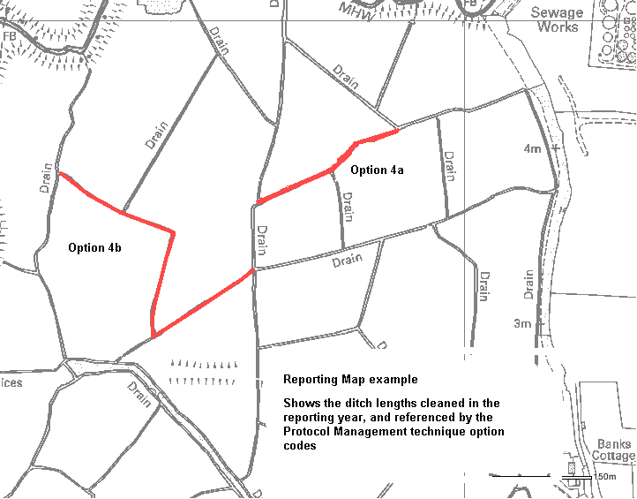 | Please provide a map marking the stretches of ditch where clearance works have been undertaken in the reporting period.  Maps are very helpful for surveying the populations of this species and assessing how well the management protocol is working. Your assistance with this is greatly appreciated.  One way to create maps for this purpose is to use the MAGIC website (http://magic.defra.gov.uk/website/magic/ ). Once you have zoomed into your landholding, press the ‘Screen Print’ function on your computer to copy the map and then paste it into this report below, or into a new document.  The example illustrated here makes use of graphics tools found on most computers, but you can also mark details on by hand and either scan the document or post it to us. Please remember to indicate the type of clearance carried out by reference to the Protocol options.

