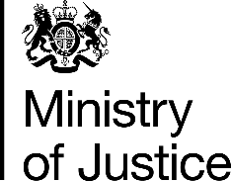 | December 2017

Freedom of Information Act (FOIA) Request – 171218006

You asked for the following information from the Ministry of Justice (MoJ):

I would like data on the overall durations from date of first listing to date of completion of prosecutions for television licence fee evasion (i.e. offence 191 – Wireless Telegraphy Acts) in England and Wales, for the years 2006 to 2016.

Your request has been handled under the FOIA.

I can confirm that the MoJ holds the information that you have requested and I have provided it attached.

The table provided shows the average number of days taken from offence to completion for TV licence evasion cases in England and Wales, annually 2011 – 2016.

Please be aware that we cannot provide figures for 2006 - 2010 because data is not available prior to April 2010.

