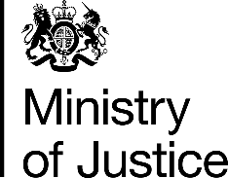 | December 2017

Freedom of Information Act (FOIA) Request – 171204005

You asked for the following information from the Ministry of Justice (MoJ):

If possible could you please provide me with information on the following: The number of prosecutions for non-notifiable offences by age for the year 2016.

Your request has been handled under the FOIA.

I can confirm that the MoJ holds the information that you have requested and I have provided it in the attached annex.

