UK Standards for Microbiology Investigations

Catalase test

Acknowledgments
UK Standards for Microbiology Investigations (UK SMIs) are developed under the auspices of Public Health England (PHE) working in partnership with the National Health Service (NHS), Public Health Wales and with the professional organisations whose logos are displayed below and listed on the website https://www.gov.uk/uk-standards-for-microbiology-investigations-smi-quality-and-consistency-in-clinical-laboratories. UK SMIs are developed, reviewed and revised by various working groups which are overseen by a steering committee (see https://www.gov.uk/government/groups/standards-for-microbiology-investigations-steering-committee).
The contributions of many individuals in clinical, specialist and reference laboratories who have provided information and comments during the development of this document are acknowledged. We are grateful to the medical editors for editing the medical content.
For further information please contact us at:
Standards Unit
National Infection Service
Public Health England
61 Colindale Avenue
London NW9 5EQ
E-mail: standards@phe.gov.uk
Website: https://www.gov.uk/uk-standards-for-microbiology-investigations-smi-quality-and-consistency-in-clinical-laboratories
PHE publications gateway number: 201703
UK Standards for Microbiology Investigations are produced in association with:
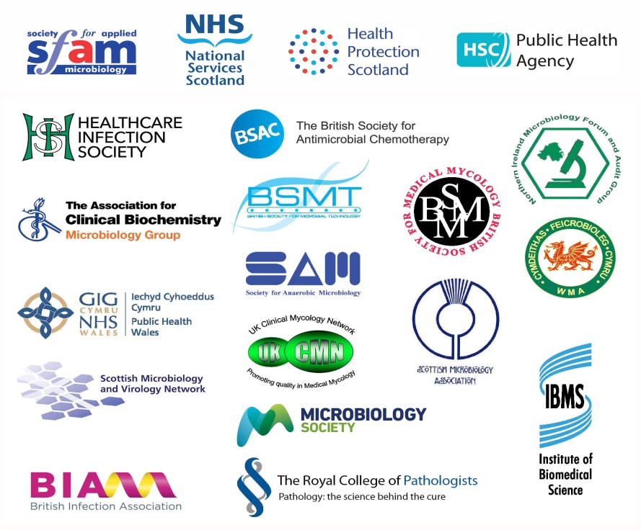
Logos correct at time of publishing.
Contents
Acknowledgments 2
Contents 3
Amendment table 4
UK SMI: scope and purpose 5
Scope of document 7
Introduction 7
Technical information/limitations 7
1 Safety considerations 9
2 Reagents and equipment 9
3 Quality control organisms 9
4 Procedure and results 10
Appendix: Catalase test 11
References 12

Amendment table
Each UK SMI method has an individual record of amendments. The current amendments are listed on this page. The amendment history is available from standards@phe.gov.uk.
New or revised documents should be controlled within the laboratory in accordance with the local quality management system.
Amendment number/date
Issue number discarded | 3
Insert issue number | 4
Anticipated next review date*
Section(s) involved | Amendment
Whole document. | Document and flowchart updated.  Technical limitations updated with subheadings.  References updated with grades.

∗Reviews can be extended up to five years subject to resources available.

UK SMI#: scope and purpose
Users of UK SMIs
Primarily, UK SMIs are intended as a general resource for practising professionals operating in the field of laboratory medicine and infection specialties in the UK. UK SMIs also provide clinicians with information about the available test repertoire and the standard of laboratory services they should expect for the investigation of infection in their patients, as well as providing information that aids the electronic ordering of appropriate tests. The documents also provide commissioners of healthcare services with the appropriateness and standard of microbiology investigations they should be seeking as part of the clinical and public health care package for their population.
Background to UK SMIs
UK SMIs comprise a collection of recommended algorithms and procedures covering all stages of the investigative process in microbiology from the pre-analytical (clinical syndrome) stage to the analytical (laboratory testing) and post analytical (result interpretation and reporting) stages. Syndromic algorithms are supported by more detailed documents containing advice on the investigation of specific diseases and infections. Quality guidance notes describe laboratory processes which underpin quality, for example assay validation.
Standardisation of the diagnostic process through the application of UK SMIs helps to assure the equivalence of investigation strategies in different laboratories across the UK and is essential for public health surveillance, research and development activities.
Equal partnership working
UK SMIs are developed in equal partnership with PHE, NHS, Royal College of Pathologists and professional societies. The list of participating societies may be found at https://www.gov.uk/uk-standards-for-microbiology-investigations-smi-quality-and-consistency-in-clinical-laboratories. Inclusion of a logo in an UK SMI indicates participation of the society in equal partnership and support for the objectives and process of preparing UK SMIs. Nominees of professional societies are members of the Steering Committee and working groups which develop UK SMIs. The views of nominees cannot be rigorously representative of the members of their nominating organisations nor the corporate views of their organisations. Nominees act as a conduit for two way reporting and dialogue. Representative views are sought through the consultation process. UK SMIs are developed, reviewed and updated through a wide consultation process.
Quality assurance
NICE has accredited the process used by the UK SMI working groups to produce UK SMIs. The accreditation is applicable to all guidance produced since October 2009. The process for the development of UK SMIs is certified to ISO 9001:2008. UK SMIs represent a good standard of practice to which all clinical and public health microbiology laboratories in the UK are expected to work. UK SMIs are NICE accredited and represent neither minimum standards of practice nor the highest level of complex laboratory investigation possible. In using UK SMIs, laboratories should take account of local requirements and undertake additional investigations where appropriate. UK SMIs help laboratories to meet accreditation requirements by promoting high quality practices which are auditable. UK SMIs also provide a reference point for method development. The performance of UK SMIs depends on competent staff and appropriate quality reagents and equipment. Laboratories should ensure that all commercial and in-house tests have been validated and shown to be fit for purpose. Laboratories should participate in external quality assessment schemes and undertake relevant internal quality control procedures.
Patient and public involvement
The UK SMI working groups are committed to patient and public involvement in the development of UK SMIs. By involving the public, health professionals, scientists and voluntary organisations the resulting UK SMI will be robust and meet the needs of the user. An opportunity is given to members of the public to contribute to consultations through our open access website.
Information governance and equality
PHE is a Caldicott compliant organisation. It seeks to take every possible precaution to prevent unauthorised disclosure of patient details and to ensure that patient-related records are kept under secure conditions. The development of UK SMIs is subject to PHE Equality objectives https://www.gov.uk/government/organisations/public-health-england/about/equality-and-diversity.
The UK SMI working groups are committed to achieving the equality objectives by effective consultation with members of the public, partners, stakeholders and specialist interest groups.
Legal statement
While every care has been taken in the preparation of UK SMIs, PHE and the partner organisations, shall, to the greatest extent possible under any applicable law, exclude liability for all losses, costs, claims, damages or expenses arising out of or connected with the use of an UK SMI or any information contained therein. If alterations are made by an end user to an UK SMI for local use, it must be made clear where in the document the alterations have been made and by whom such alterations have been made and also acknowledged that PHE and the partner organisations shall bear no liability for such alterations. For the further avoidance of doubt, as UK SMIs have been developed for application within the UK, any application outside the UK shall be at the user’s risk.
The evidence base and microbial taxonomy for the UK SMI is as complete as possible at the date of issue. Any omissions and new material will be considered at the next review. These standards can only be superseded by revisions of the standard, legislative action, or by NICE accredited guidance.
UK SMIs are Crown copyright which should be acknowledged where appropriate.
Suggested citation for this document
Public Health England. (YYYY <tab+enter>). Catalase test. UK Standards for Microbiology Investigations. TP 8 Issue xx. https://www.gov.uk/uk-standards-for-microbiology-investigations-smi-quality-and-consistency-in-clinical-laboratories
Scope of document
This test detects the catalase enzyme present in most cytochrome-containing aerobic and facultative anaerobic bacteria¹. Streptococcus and Enterococcus species are exceptions. Yeasts including Candida species and Cryptococcus neoformans are catalase positive and can be presumptively identified using catalase test².
This UK SMI should be used in conjunction with other UK SMIs.
Introduction
The catalase test is used to detect the presence of catalase enzyme by the decomposition of hydrogen peroxide to release oxygen and water as shown by the following reaction:
2 H2O2 → 2H2O + O2
The catalase reaction is evident by the rapid formation of bubbles.
Hydrogen peroxide is formed by some bacteria as an oxidative end product of the aerobic breakdown of sugars. If allowed to accumulate, it is highly toxic to bacteria and can result in cell death. Catalase either decomposes hydrogen peroxide or oxidises secondary substrates, but it has no effect on other peroxides².
There are method variations of the catalase test and these include the slide test method, the tube or bottle method and the agar slant method³. However, the commonly used methods in microbiology laboratories are the tube or bottle method and the agar slant method because it limits catalase aerosols, which have been shown to carry viable bacterial cells, that if inhaled could cause infections as well as contamination in other laboratory work being set up and work surface areas⁴.
Technical information/limitations
Interpretation of results
Media containing whole red blood cells will contain catalase and could therefore give a false positive result.
The enzyme, catalase is present in viable cultures only, so colony growth must be from an 18 to 24hr culture. Older cultures may lose their catalase activity and give false negative reactions².
Some inoculating loops or wires (nichrome) can react with the hydrogen peroxide to produce false positive reactions⁵.
False positive results can also be produced by dirty glass test tubes or bijoux bottles⁶.
False reactions
A weak catalase or pseudocatalase reaction may be produced by some strains of Aerococcus species. Some strains of Enterococcus species also produce a pseudocatalase.
Cultures of anaerobic bacteria should be exposed to air for 30 min prior to testing².

Quality control
Hydrogen peroxide is unstable and must be refrigerated at all times. Avoid any undue exposure to light.

1 Safety considerations⁷⁻²⁴
Refer to current guidance on the safe handling of all organisms and reagents documented in this SMI.
Catalase testing of bacteria can be hazardous due to the release of bacteria-laden aerosols by liberated oxygen⁴. All work likely to generate aerosols must be performed in a microbiological safety cabinet.
Hydrogen peroxide is a highly corrosive chemical (depending on the concentration); therefore appropriate personal protective clothing must be worn at all times when in use. Extreme care must be taken by persons using this reagent.
The above guidance should be supplemented with local COSHH and risk assessments.
Compliance with postal and transport regulations is essential.
2 Reagents and equipment²
Discrete bacterial/yeast colonies on solid medium
Note: The catalase test should not be performed on colonies taken from media containing whole red blood cells because they contain catalase and could therefore give a false positive result. Colonies taken from chocolate agar plate may be tested as the blood cells have been destroyed².
Inoculated pure agar slant culture
Hydrogen peroxide solution 3–6 %. Commercial preparations are available.
Clean capped test tubes (plastic or glass) or Bijoux bottles
Bacteriological straight platinum wire/loop or disposable alternative
3 Quality control organisms
Positive control
Staphylococcus aureus NCTC 6571
Negative control
Streptococcus mitis NCTC 10712
Note 1: Hydrogen peroxide is unstable and so should undergo a quality control check daily or immediately prior to use. The positive and negative controls should be run simultaneously.
Note 2: These strains have been validated by NCTC to give this result.

4 Procedure and results
4.1 Tube or bottle method³
- Place 4 to 5 drops of hydrogen peroxide solution in a test tube or bijoux bottle
- Carefully pick a colony to be tested with a wire/loop or disposable alternative
- Rub the colony on the inside wall of the bottle just above the surface of the hydrogen peroxide solution
- Cap the tube or bottle and tilt it to allow the hydrogen peroxide solution to cover the colony
- Observe for immediate bubble formation (effervescence)
4.2 Agar slant method^{2,6}
- Add 1.0mL of H₂O₂ directly onto an 18 to 24hr heavily inoculated pure culture grown on a nutrient agar slant and replace the cap
- Observe for immediate bubbling (effervescence)
For both methods,

Positive result
Vigorous bubbling indicates the presence of catalase.

Negative result
No bubbling indicates the absence of catalase.
Note: Both positive and negative controls must be tested alongside the test organism.

Appendix: Catalase test
The flowchart is for guidance only.
References
Modified GRADE table used by UK SMIs when assessing references

Grading of Recommendations, Assessment, Development, and Evaluation (GRADE) is a systematic approach to assessing references. A modified GRADE method is used in UK SMIs for appraising references for inclusion. Each reference is assessed and allocated a grade for strength of recommendation (A-D) and quality of the underlying evidence (I-VI). A summary table which defines the grade is listed below and should be used in conjunction with the reference list.

Strength of recommendation | Quality of evidence
A Strongly recommended | I Evidence from randomised controlled trials, meta-analysis and systematic reviews
B Recommended but other alternatives may be acceptable | II Evidence from non-randomised studies
C Weakly recommended: seek alternatives | III Non-analytical studies, for example, case reports, reviews, case series
D Never recommended | IV Expert opinion and wide acceptance as good practice but with no study evidence
 | V Required by legislation, code of practice or national standard
 | VI Letter or other

1. Doelle HW. Chemosynthesis - aerobic respiration. Bacterial Metabolism. London: Academic Press; 1969. B, IV

2. MacFaddin JF. Catalase-Peroxidase Tests. Biochemical Tests for Identification of Medical Bacteria. 3rd ed. Philadelphia: Lippincott Williams and Wilkins; 2000. p. 78-97. B, III

3. Reiner K. Catalase Test Protocol. ASM Conference for Undergraduate Educators 2010. 2012. B, VIII

4. Duke PB, Jarvis JD. The catalase test--a cautionary tale. Med Lab Technol 1972;29:203-4. B, III

5. Ochei J, Kolhatkar A. Identification Methods. Medical Laboratory Science Theory and Practice; 2000. p. 644-58. B, III

6. GI B, RKA F Cowan and Steel's Manual for the Identification of Medical bacteria. 3rd ed.: Cambridge University Press; 2003. 78-97. B, III

7. European Parliament. UK Standards for Microbiology Investigations (UK SMIs) use the term "CE marked leak proof container" to describe containers bearing the CE marking used for the collection and transport of clinical specimens. The requirements for specimen containers are given in the EU in vitro Diagnostic Medical Devices Directive (98/79/EC Annex 1 B 2.1) which states: "The design must allow easy handling and, where necessary, reduce as far as possible contamination of, and leakage from, the device during use and, in the case of specimen receptacles, the risk of contamination of the specimen. The manufacturing processes must be appropriate for these purposes". 1998. A, V

8. Official Journal of the European Communities. Directive 98/79/EC of the European Parliament and of the Council of 27 October 1998 on in vitro diagnostic medical devices 1998. 1-37. A, V

9. Health and Safety Executive. Safe use of pneumatic air tube transport systems for pathology specimens. 2009. A, V

10. Department for Transport. Transport of Infectious Substances, 2011 Revision 5. 2011. A, V

11. World Health Organization. Guidance on regulations for the Transport of Infectious Substances 2017-2018. 2017. A, V

12. Home Office. Anti-terrorism, Crime and Security Act. 2001. A, V

13. Advisory Committee on Dangerous Pathogens. The Approved List of Biological Agents. Health and Safety Executive 2013. 1-35. A, V

14. Advisory Committee on Dangerous Pathogens. Infections at work: Controlling the risks. Her Majesty's Stationery Office 2003. A, V

15. Advisory Committee on Dangerous Pathogens. Biological agents: Managing the risks in laboratories and healthcare premises. Health and Safety Executive 2005. A, V

16. Advisory Committee on Dangerous Pathogens. Biological Agents: Managing the Risks in Laboratories and Healthcare Premises. Appendix 1.2 Transport of Infectious Substances - Revision. Health and Safety Executive 2008. A, V

17. Centers for Disease Control and Prevention. Guidelines for Safe Work Practices in Human and Animal Medical Diagnostic Laboratories. MMWR Surveill Summ 2012;61:1-102. B, IV

18. Health and Safety Executive. Control of Substances Hazardous to Health Regulations. The Control of Substances Hazardous to Health Regulations 2002 (as amended). HSE Books,. 2013. A, V

19. Health and Safety Executive. Five Steps to Risk Assessment: A Step by Step Guide to a Safer and Healthier Workplace. HSE Books,. 2002. A, V

20. Health and Safety Executive. A Guide to Risk Assessment Requirements: Common Provisions in Health and Safety Law. HSE Books,. 2002. A, V

21. Health Services Advisory Committee. Safe Working and the Prevention of Infection in Clinical Laboratories and Similar Facilities. HSE Books 2003. A, V

22. British Standards Institution (BSI). BS EN12469 - Biotechnology - performance criteria for microbiological safety cabinets 2000. A, V

23. British Standards Institution (BSI). BS 5726:2005 - Microbiological safety cabinets. Information to be supplied by the purchaser and to the vendor and to the installer, and siting and use of cabinets. Recommendations and guidance. 2005. 1-14. A, V

24. Department of Health. Transport of Infectious Substances. Best Practice Guidance for Microbiology Laboratories. Department of Health. 1-13. 2007. A, V

# Microbiology is used as a generic term to include the two GMC-recognised specialties of Medical Microbiology (which includes Bacteriology, Mycology and Parasitology) and Medical Virology.

