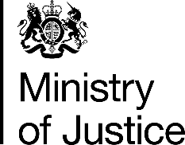 | October 2017

Freedom of Information Act (FOIA) Request – 171009002

You asked for the following information from the Ministry of Justice (MoJ):

Thank you so much for getting back to me on this.

In light of your comments I would like to request the following information under the Freedom of Information Act:

1) The number of offenders convicted of sexual offences in 2016 by ethnicity.

2) The number of offenders convicted of sexual grooming, under sections 14 or 15 or 15A of the Sexual Offences Act 2003, in 2016 by ethnicity.

3) The number of offenders convicted of child sexual exploitation, under sections 48 to 50 of the Sexual Offences Act 2003, in 2016 by ethnicity.

Many thanks for your assistance.

Your request has been handled under the FOIA.

I can confirm that the MoJ holds the information that you have requested and I have provided it in the attached annex

