This document was archived because it is no longer current.

Information and communication technology – not just about computers

URN: EY426392
Area: Middlesex
Date published: 23 March 2012
Reference: 120049

Brief description

This childminder demonstrates how she uses a range of information and communication technology (ICT) resources to support all areas of learning and prepare children for a world that is increasingly dependent on technology.

Overview – the childminder’s message

‘I never knew that there were so many different resources available to promote ICT to young children. I was lucky enough to be given a selection to use for childminding by my local authority. My favourite is the microscope because it is so flexible and it’s brilliant for helping me to answer children’s never-ending questions! I love the fact that these resources add a fun factor to learning. It shows ICT is not just about computers and ICT resources support all areas of learning, not just Knowledge and Understanding of the World.’

The good practice in detail

Which way now?

‘Lucy’ a newly settled four-year-old, was gradually introduced to the ICT resources. On this occasion, she used a robotic bee which comes with a street map for the floor. The robot is designed to teach children control, directional language and programming skills. After a well-
planned demonstration by the childminder,
Lucy chose the grocer’s as the bee’s first destination. She counted three squares to
the park and then pressed the forward arrow
four times. Unsurprisingly, bee went past the destination. ‘Oops!’ Lucy immediately
pressed the backwards arrow, but the bee was already programmed to move three spaces, so of course it was now two squares short of its destination. The childminder reminded Lucy
of the erase button, comparing it to a rubber. Lucy then re-programmed the bee to move forward two spaces. Once it arrived alongside the park, Lucy was guided to re-programme again; to turn left. Then, ‘hey presto!’, the bee arrived at his destination. So excited was she by her success, that Lucy decided to send bee to the florist, followed by the bakers, becoming more and more competent with practise.

Under closer examination

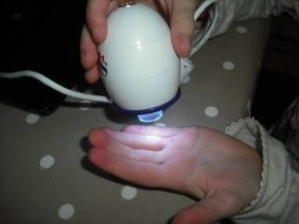The microscope is connected by USB to the computer which amplifies whatever is being examined. A child looking at her hand commented, ‘I have lots
of lines’ and asked to see the childminder’s hand which they
proceeded to examine. ‘Oh my goodness, my lines are deeper than yours, can you see? This is because I am so much older than you!’ explained the childminder. Next they looked at two other children’s hands and had fun noticing their differences, which the childminder explained makes them ‘unique’ and is called DNA.

The child had a scab on her hand, which to the eye was small, dry and brownish in colour. Under the microscope, however, she noticed that it was ‘more yellow and wet’. By examining the scab daily, the childminder was able to help children understand the healing process. A four-year-old boy was helped by the childminder to carefully position the microscope to fulfil his fascination with finding out what it looked like inside his ear and then his nose!

Children have also used the microscope to examine the veins on leaves, which they also discovered had tiny hairs. As the childminder said, ‘the beauty of this device is that children can print an image of their discovery to take home to share with parents’.

Step by step

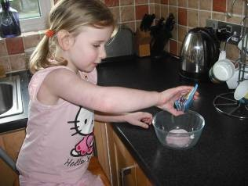The child made a jelly following instructions on the packet that were read out to her. The childminder took photos of each step and then the child used the talking photo album to explain what she was doing, the photo
matching the dialogue. She then
pressed play on each page to check that the text matched the photo. She thought her voice sounded hilarious!

What’s that sound?

The children had made a rocket out of a cardboard box where they ate their tea while going on missions into space. The childminder used a small, portable sound recorder with the children to record rocket sounds and a countdown to bring ‘take-off’ to life. Because this device is pocket sized, it is also ideal for taking on outings to record what the children hear or simply to provide musical accompaniment for singing!

The children have also learnt how to operate two-way portable radios by pressing and releasing buttons to speak and listen. The childminder said that they had used the sound amplifier to listen to crickets and
grasshoppers and had tried and tested the metal detector, although they had yet to strike gold!

The childminder is located in Sunbury-on-Thames. She registered on both the compulsory and voluntary parts of the Childcare Register in 2011. The ground floor area is used for play activities with bedrooms available for sleep and an enclosed garden for outdoor play. Registration is for four children under eight years at any one time; of these no more than one may be in the early years age range.

