This document was archived because it is no longer current.
Learners’ views improving teaching, learning and assessment: HMP Wymott

Region: North West
Remit: Further education and skills

Provider background
HMP Wymott (the prison) is a category C training prison that holds over 1,100 adult male prisoners, many of whom are housed in separate wings for vulnerable prisoners and for those who are sex offenders. The prison is located in central Lancashire. Leaders and managers work in partnership with The Manchester College (the college), which is contracted by the Offender Learning and Skills Service, Skills Funding Agency, to provide education and vocational provision in the prison.

Brief description
The student council comprises two separate groups of learners representing the full prison population and was established in 2013 by the prison’s manager for learning and skills and teachers employed by the college. Through a vision of ‘involve, inspire, improve - empowering learners through learner voice’, teachers and managers seek to enable learners to influence the curriculum offer and the quality of teaching, learning and assessment, as well as developing social skills and confidence in the process. As a result, learners believe that their views are valued and that teaching, learning and assessment meet their needs and enable them to make good progress.
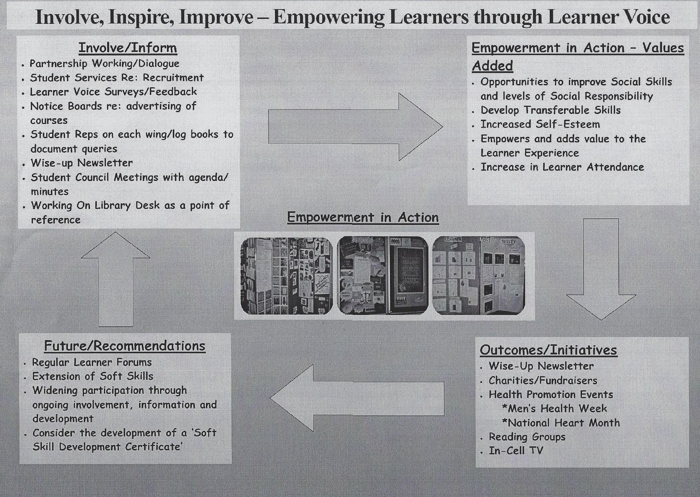

The good practice in detail
Inspectors judged the overall effectiveness of learning and skills and work as good at the prison’s inspection in July 2014. The achievements of prisoners engaged in learning and skills provision and work were also judged as good. The report states ‘the development of a student council to influence and effect improvement in prisoners’ achievement of functional skills was an excellent initiative’. Her Majesty’s Inspectors were joined in their praise by Her Majesty’s Chief Inspector of Prisons who commented that ‘the introduction of a student council to influence quality improvement was an example of good practice’.

Promoting to learners the importance of their views about their learning
The student council promotes and enables learners’ views on the standard of teaching, learning and assessment they experience to inform leaders’ planning and evaluation:
The student council’s mission statement, devised by learners, includes aims to motivate prisoners to engage in learning, promote a positive attitude to learning, encourage all prisoners to view education as an integral part of their life-long learning and enable learners to feed back their experiences of teaching, learning and assessment.
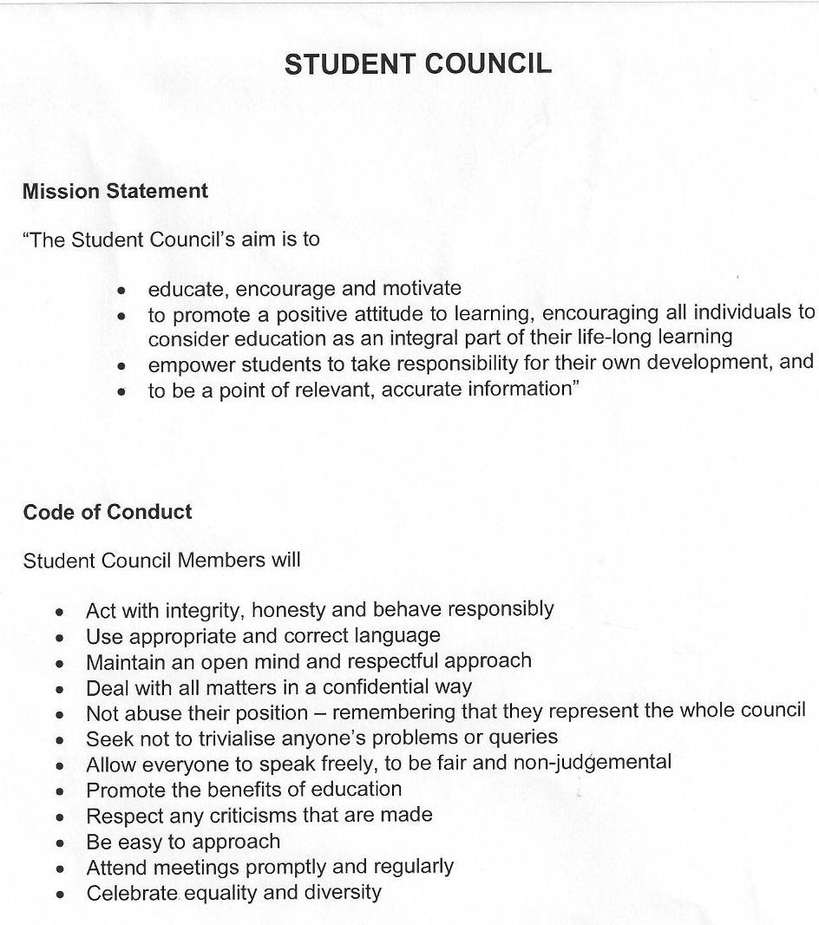

- Members study for a level 2 peer mentoring qualification to enhance their skills in supporting learners in lessons and developing their confidence to reflect and comment on the quality of their learning.
- Members are also responsible for promoting learning to prisoners in a part of the prison wing where they reside and recording prisoners’ views on the curriculum offer, particularly in regard to whether courses on offer will help them find employment on release.
- The student council produces a quarterly newsletter called ‘Wise Up’ to promote the value of learning and the work of both the college and the student council across the prison. A mixture of serious articles, quizzes and humorous stories are submitted by members of the council and prisoners with the intention of boosting prisoners’ reading skills, increasing the number of prisoners enrolling on education courses and promoting the value of learners’ views on the offer and quality of education provision.


Enabling learners to improve teaching, learning and assessment across the prison
- The student council members work with teachers on specific learning initiatives, act as peer mentors in lessons and on prison wings, provide feedback on learners’ views of the teaching, learning and assessment they experience and work with teachers and managers on the prison’s education improvement plan.
- Each of the 18 members of the student council carries a ‘contact log book’ to record the views of learners about the quality of teaching, learning and assessment in education provision. Through the student council, members discuss all their findings with leaders and managers and provide feedback on subsequent decisions and actions to learners and prisoners.
- New council members study a range of theories of how people learn to develop their understanding about teaching, learning and assessment and increase the value of their role in the quality improvement process.
- The elected chair of the student council attends regular review meetings with representatives of the prison and the college to assess the impact of teaching and learning and contribute to making appropriate decisions that promote continuous improvement.
Student Council
Roles and responsibilities

Student Council Chair is to
Represent the Student Council where and when appropriate
Conduct and chair regular Student Council meetings
Set agenda for Student Council meetings
Attend regular review meetings with nomination Education representatives (VSM/CH) to assure that decisions taken and communication exchanged reflect student body desires
Present feedback at each Student Council Meeting of enquiries/actions taken etc
Meet with Head of Education/Learning and Skills if required or as necessary
Role of the Secretary is to
Record attendance at Student Council meetings
Minute topics and action points from Student Council meetings
Post notices of Student Council/ Education Department activities on wing and library notice boards
Send reminders regarding meeting and events out to Student Council members
Send notices to education on behalf of Student Council through agreed channel
Take charge of resources and stationery stock and replenishment
Prepare a feedback report of enquiries/actions taken etc for submission at each Student Council meeting
As necessary to collate options for events and special initiatives etc.

- The student council created and distributed a ‘learner voice’ survey to assess the educational experiences of learners. A total of 202 learners from across the prison responded. Particular emphasis was placed on finding out whether learners felt that their courses suited their needs and abilities and will enable them to find work on release. Questions also focused on what barriers prevented learners from making good progress and whether teachers were enabling learners to achieve their set targets. Findings have informed the prison’s education improvement plan and their progress is monitored at student council meetings.
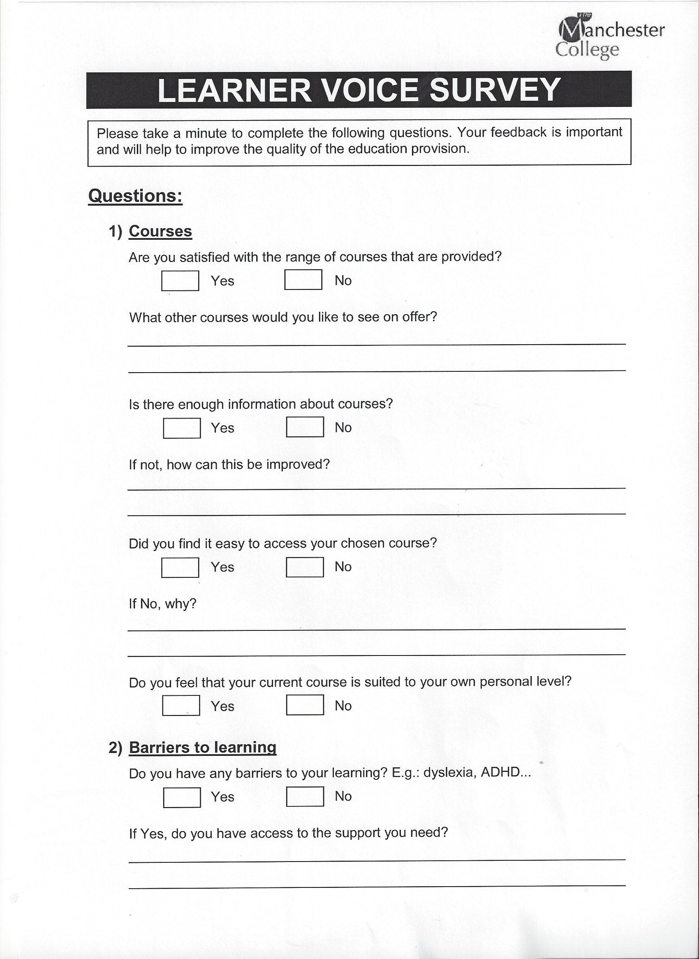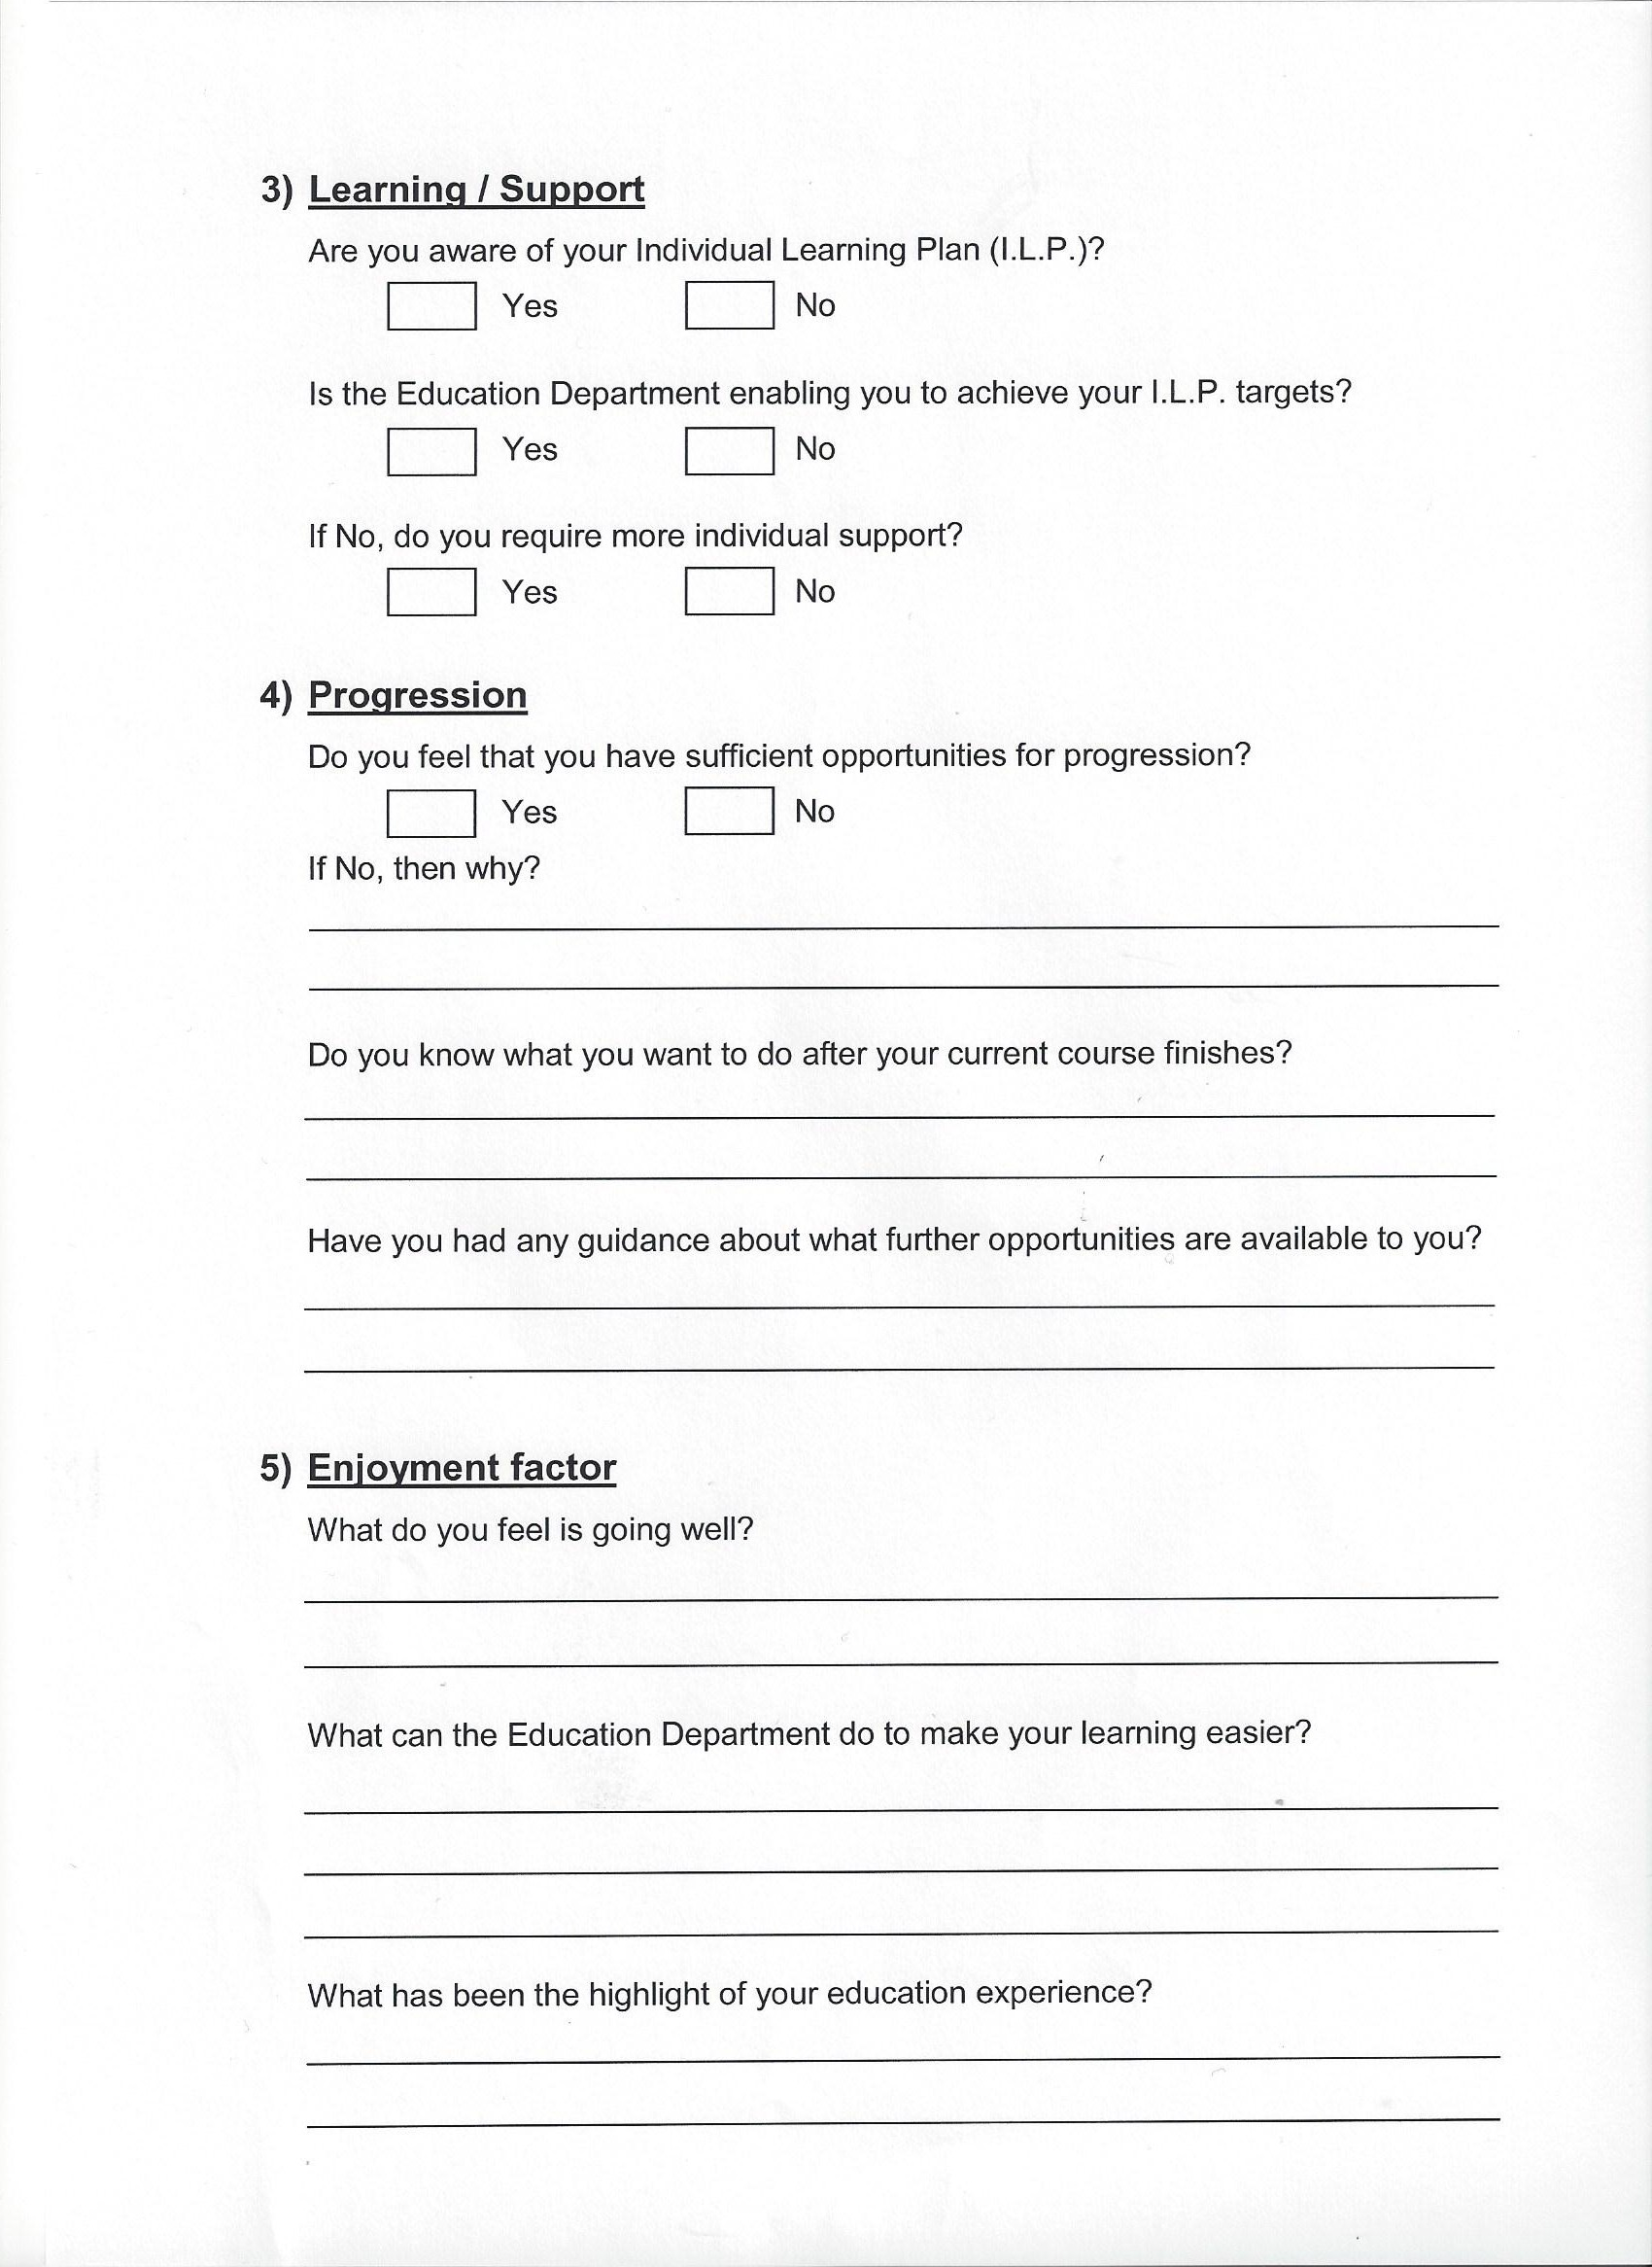

The impact of the effective use of the views of learners

Through the student council, learners are able to make a valued contribution to improving the quality of teaching, learning and assessment in the prison. Leaders and managers view the work of the student council as integral to the prison securing high performance:
- Managers and teachers have carried out a number of improvements in provision in response to feedback from the student council. Consequently, inspectors judged both the achievement of learners and the standards of learners’ work to be good at inspection. The proportion of learners who achieved their functional skills qualifications at entry level is very high.
- Achievement rates are also high on a range of vocational courses and on information and communication technology courses. At the time of inspection, the achievement rates of learners studying functional skills in English and mathematics on level 1 and level 2 courses had improved significantly compared with previous years.
- The student council enables learners to have a readily available and highly credible communication channel to raise concerns regarding their learning experience. Learners feel valued as they see teachers taking appropriate actions to improve their teaching and assessment in response to their views. As a result, they take greater responsibility for their learning and achievement.
- Student council success includes securing additional support for more learners, ensuring that prisoners move between lessons as efficiently as possible leading to punctual starts to lessons and, separately, further improving the management of disruptive learners so as not to affect other learners’ progress. The student council is currently working with teachers and managers on increasing access to more computers for learners and developing opportunities for learners to progress on to courses at a higher level.
- The student council’s efforts to continually promote the value of learning across the prison has raised the profile of the importance of teaching, learning and assessment and successfully widened participation by achieving an exponential rise in the number of new prisoners enrolling to study for qualifications. As a result, more prisoners are better prepared to find work on release from prison.
- Individual progress made by the student council members is particularly significant. All members provide numerous examples of how they have developed greater skills and confidence through their increased knowledge and understanding gained as members of the council and how the experience will help prepare them for life on release from prison.

The good practice case studies that Ofsted publishes highlight specific examples of practice that providers of education, learning and children’s services have used to achieve successful outcomes.
For education, the case studies do not recommend a single particular approach to teaching and learning. Ofsted has no preferred lesson structure or teaching style. We showcase and share a wide range of approaches that providers have found work well for them in achieving good outcomes for children, young people and learners.
Are you thinking of putting these ideas into practice; or already doing something similar that could help other providers; or just interested? We'd welcome your views and ideas. Complete our survey here.
Click here to see other good practice examples.
If you would like a copy of this document in a different format, such as large print or Braille, please telephone 0300 123 1231, or email enquiries@ofsted.gov.uk.

