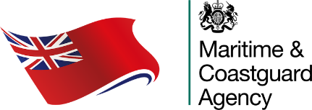 | Confirmation of Receipt of Application (Flag State Endorsement)  Regulation I/10 paragraph 5

Please include CRA as a one page PDF attachment |  | Issuing Administration:  Maritime & Coastguard Agency  Spring Place  105 Commercial Road  SOUTHAMPTON SO15 1EG  Tel.: +44 (0)20 3817 2200  Email: fse@mcga.gov.uk
Company Name:

Office Location (City and Country):

Vessel Name:

Section 1 – To be completed by the Company
I/we attach an application for a Flag State Endorsement for the following seafarer:

Surname/Family Name:

First Name(s):

Date of Birth (DD/MM/YYYY):

CoC Number:

Highest CoC Capacity
(or lower rank if required):

CoC Limitations:

Tanker/IGF Endorsement(s):

Non-UK GMDSS Number:

Declaration (maximum penalty for a false declaration is £5,000)
I declare that the above applicant holds a valid Certificate of Competency, a valid medical fitness certificate, and where appropriate sight test certificate, accepted by the MCA for the issuance of a Flag State Endorsement as detailed in MSN 1867 (M) as amended.

Signed: |  |  | Date: | 17 January 2023
Name: |  |  | Job Title:

Section 2 – To be completed by the MCA
We confirm receipt of the above application on ________________. This notice may be used as documentary evidence that the above application has been submitted to the MCA in accordance with STCW 1978 as amended, Regulation I/10 paragraph 5, and is valid up to and including:

________________ (only valid when stamped, dated and signed by an authorised MCA official).
MCA Stamp
Signed: ___________________________

Name: ____________________________

Authorised MCA official

Issue Date: ________________________

