INTIMIDATION OF PARLIAMENTARY CANDIDATES REVIEW
1:1 MEETINGS

FOLLOW-UP EMAIL FROM GOOGLE
SENT VIA EMAIL ON 1 NOVEMBER 2017

You can also find further information about our 'Trusted Flagger' programme via this link.

We do provide easy to use guidance to YouTube channel owners for how to manage YouTube comments. This guidance can be found here.

Please find answers to your other questions below.

- Do we have a target for how quickly we take down a video on YouTube that has been flagged and violates our policies? They cited of an example of where a video criticising a candidate violated our policies but wasn't taken down for some time.
  - Our target is to review a flagged video and make a decision as quickly as possible. Not every video that's flagged gets taken down. Some videos require us to take more care to make the correct decision, and so some may take slightly longer to seek additional context or expertise. Where certain videos do not cross the line in violating our Community Guidelines, we can take measures short of removal including age restrictions and tougher treatment. For example, we recently started applying tougher treatment to videos that aren’t illegal and don’t violate our Guidelines, but contain controversial religious or supremacist content. These videos remain on YouTube, but they are behind a warning interstitial, aren’t recommended, monetized, and don’t have key features including comments, suggested videos, and likes. This is working as intended and helping us strike a balance between upholding free expression, by providing a historical record of content in the public interest, while also keeping these videos from being widely spread or recommended to others.

  - Do we have a target for how quickly a flagged video should be looked at? Does it matter whether a video is flagged once or a hundred times?
    - Our target is review a flagged video as quickly as possible. We receive over 200,000 flags a day and use a number of techniques to work through the large volume and to help us get to the violative content quickly. The number of times a video is flagged may not always be the best indicator that a video violates our Guidelines. For example, no matter how many times users flag Justin Bieber's Baby video, our most flagged video, it will not come down; it simply does not violate our Guidelines.

  - Would we commit to use AI to tackle abusive comments/ intimidation, as well as the investment that is happening through Jigsaw?
    - We use a mix of machine learning and human review to tackle hate speech and abusive comments. Context is extremely important when evaluating comments and videos alike, as some are used to expose hate speech. That is why we still rely on human reviewers, but we also appreciate insights from experts to provide us more information on hateful content.
    - We offer a range of tools to creators to help moderate the comments on their YouTube channels, including an AI-fueled classifier that will “hold potentially offensive comments for review.” Channel moderators can also add their own keywords to a filtering list.
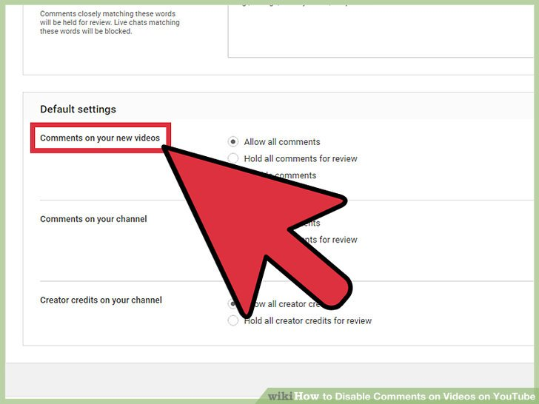
- Like other classifiers that attempt to detect hateful or harassing language, it has a non-trivial error rate. But it gives creators the chance to pre-review possibly offensive comments before they go live.

- When something is flagged to us as illegal, how quickly on average do we take it down. Do we have a target for % taken down within 24 hours? What are our different processes for child abuse images, terrorist material and material that violates copyright?
  - We have a clear process for removals if content violates local laws. Google appreciates that law enforcement and intelligence agencies face extraordinary challenges in protecting citizens against crime and terrorism, and we continue to support those efforts by promptly providing data in response to valid legal process and emergency disclosure requests.
  - In addition, we have separate legal complaint flows for users that believe certain content on the site violates their rights or applicable laws. These resources are available under our trademark, defamation, counterfeit, or other legal complaint flows.
  - Users who believe their copyright-protected work was posted on YouTube without authorization may submit a copyright infringement notification. We ask that they consider whether fair use, fair dealing, or a similar exception to copyright applies before you submit. These requests should only be submitted by the copyright owner or an agent authorized to act on the owner’s behalf. The fastest and simplest way to notify YouTube of alleged copyright infringement is via our webform.
  - The review and takedown process will differ to some degree based on the violation in question. Some determinations are extremely context-dependent. Claims of defamation, for instance, are extremely difficult for a platform to evaluate.
  - Google has a zero tolerance approach to Child Sex Abuse Imagery (CSAI) and will not tolerate it on our platforms. We use hashing technology of known CSAI to identify illegal content and report any CSAI we find to the relevant authorities.
  - Google supports authorities in their legitimate fight against terrorism and other crimes. In addition our YouTube Guidelines strictly prohibit content intended to recruit for terrorist organisations, incite violence, celebrate terrorist attacks or otherwise promote acts of terrorism. We also do not permit terrorist organisations to use YouTube. We have also made strides to improve the use of technology to detect terrorist content, with 83% of our videos we removed for violations of Guidelines detected by machines before receiving a single human flag, and we have doubled our speed and accuracy for removals.
  - YouTube has signed up to the EU Hate Speech Code of Conduct, which calls for us to review the majority of valid notifications of illegal hate speech in less than 24 hours and to removing or disabling access to such content, if necessary, on the basis of national laws transposing European law.

- When something is taken down because it’s illegal, do we encourage users to contact the Police?
  - Users should always work with local law enforcement if they feel threatened on any of our platforms as well as reporting content via our flagging tools and various abuse reporting webforms.

- How does demonetising on YouTube work?
  - A video under tougher treatment is demonetised, meaning that no advertising can be served against it. Age-restricted videos are demonetized as well. All other video are subject to monetisation policies. More broadly, we have our content policies as the baseline for content being allowed to stay on the platform, but on top of that we additional criteria when a creator wants to monetise that content. Once a video is monetised, it may get demonetised if it fails to meet those criteria – which include whether the content is advertiser-friendly, according to guidelines outlined here.

