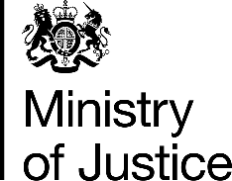 | July 2017

Freedom of Information Act (FOIA) Request – 113127

You asked for the following information from the Ministry of Justice (MoJ):

Many thanks for your helpful response (10th Jul 2017) to my FOI request.

Perhaps I could explain my ultimate aim is to reconcile this new data requested (as below) with FOI request 112108 submitted previously, to explore whether there are percentage differences in the use of immediate custody between police force areas-during the period 2011-2016.

- Towards that pursuit my FOI request would be: The number of women sentenced in each police force area for the years 2011 - 2016. I would like this data broken down by
a) Indictable and either way offences, and
b) summary and non-summary offences.

- Further to your final question I can confirm that I am not looking for a detailed breakdown by sentencing outcome - my focus at this stage is the total number of women sentenced by the courts in each police force area between 2011-2016.

I look forward to hearing from you in due course.

Your request has been handled under the FOIA.

I can confirm that the MoJ holds the information that you have requested and I have provided it in the attached annex.

