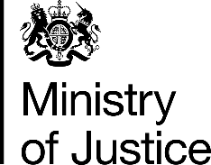 | October 2017

Freedom of Information Act (FOIA) Request – 113478

You asked for the following information from the Ministry of Justice (MoJ):

- Under the Freedom of Information Act, please can you provide me with information about how many people were convicted of offences under the Animal Welfare Act 2006 in each police force area in England and Wales in each of the past two financial years (2014/15 and 2015/16).
If possible, please provide a breakdown by offence type.

- If possible, please could you include information about the number of people convicted of the above offences in each of the past five financial years, who have more than one previous conviction (in any year) for any offence under the Animal Welfare Act.

Your request has been handled under the FOIA, and I apologise sincerely for the severe delay in responding to your request.

I can confirm that the MoJ holds the information that you have requested and I have provided it in the two attached tables. ‘Please note that in Table 1, data has only been provided for those Sections of the Animal Welfare Act for which prosecution data has been reported.’

Please note the data provided in table 1 have been extracted from the Court Proceeding database whereas data on criminal history provided in table 2 have been extracted from the PNC. (Police National Computer). As a result of these data coming from two different administrative datasets the figures in the tables are not comparable.

