Short inspections of good schools
A report on the responses to the consultation
This is a report on the outcomes of the consultation on proposals for changes to Ofsted’s approach to short inspections from October 2017. The changes relate to short inspections of good maintained schools and academies and outstanding and good maintained nurseries, special schools and pupil referral units.
If you would like a version of this document in a different format, such as large print or Braille, please telephone 0300 123 1231 or email enquiries@ofsted.gov.uk.

Contents
Introduction 3
The consultation method 3
Executive summary 3
Summary of findings 4
The way forward 5
Plans for future consultation 6
Findings in full 9
Annex – Pilot inspections: a summary evaluation 18

Introduction
- This report summarises the responses to Ofsted’s consultation, ‘Short inspections of good schools’, which ran from 15 June to 18 August 2017. We sought to gather the views of all interested parties and the consultation was open to the general public. We consulted on the following proposals for changes to short inspections of good schools, to be introduced following October half-term 2017:
- extending the window for the conversion of short inspections to section 5 inspections from the current 48-hour period to a maximum of 15 working days after the short inspection
- some schools receiving a section 5 inspection instead of a short inspection where Ofsted’s risk assessment indicates that inspectors may need to gather more evidence to reach a judgement about the school.

The consultation method
- The consultation was open to the general public and promoted widely on the Ofsted website and through social media, national conferences and the media. We sought the views of all interested parties through a variety of methods.
- The findings in this report are based on quantitative data gathered through the 1,690 responses to the online questionnaire and responses from our online Parents Panel, as well as qualitative feedback gathered through:
- free-text comments received through the online questionnaire
- consultative events, where we met approximately 70 headteachers and leaders
- webinars with around 30 interested parties, including parents
- pilots of the proposed arrangements in 12 good schools.

Executive summary
- Short inspections are a proportionate approach to inspecting maintained schools and academies previously judged to be good. They last for one day and begin with the assumption that the school remains good. They have been widely welcomed since their introduction in September 2015. As one headteacher of a primary school responding to the consultation put it:
‘Of all the inspections I have been involved in over my long teaching career, this most recent has felt like the fairest, most collaborative, least stressful (for the staff and children) one I have undertaken. We were well prepared, were guided appropriately through the process by the HMI leading it and whilst we experienced a good level of challenge, it felt appropriate for our circumstances.’
- Where inspectors need to gather additional information to reach a judgement, however, they convert the short inspection to a section 5 inspection within 48 hours. School leaders and inspectors have told us that the 48-hour conversion period can be challenging.
- The consultation set out to address three significant problems that have emerged from the current approach to conversion:
- Inspection schedules often change at the last minute, which can mean standing down Ofsted Inspectors (OIs) at short notice. OIs are typically busy school leaders and these changes are frustrating and impractical.
- The decision to convert a short inspection is usually taken mid-afternoon and a team of inspectors then arrives on site early the next day. School leaders tell us that this experience can be overwhelming. It can be a particular burden on large schools, where up to eight inspectors are needed for the full section 5 inspection.
- In about 20% of cases, before a short inspection takes place it is already clear that a school is facing complex circumstances that warrant a full inspection. Moving straight to a full inspection would be less disruptive for these schools and a more effective use of OIs.

Summary of findings
- The feedback we have had from the sector – particularly headteachers – and the public shows that they understand the challenges Ofsted is facing and support Ofsted’s desire to improve the way short inspections are converted.
- There is a marked difference, however, in how far respondents are willing to support each of the two main proposals. In short:
- Three fifths of respondents agreed or strongly agreed that some good schools should receive a section 5 inspection instead of a short inspection. The majority of the school leaders and teachers we spoke to as part of our consultation said that they welcomed the clarity of this approach and considered it fair, although they also cautioned that it could give the appearance that Ofsted is treating some good schools unequally. Just under a third of respondents disagreed or disagreed strongly with this proposal.
- Just over half of respondents disagreed with extending the window of conversion to a period of up to 15 days, but some were prepared to accept a shorter period. Headteachers and teachers were concerned about the uncertainty that the 15-day window would create about when the follow-on inspection would take place and what the outcome of that inspection would be. They were concerned that the length of this waiting period would create a high degree of anxiety for teachers. As a result, respondents preferred a shorter waiting period, particularly if this led to greater certainty about when inspectors would return. A number of respondents suggested a conversion window of five to 10 days. The public response of the Association of School and College Leaders (ASCL) emphasised the importance of a tightly defined window for when inspectors would return. This was echoed by the headteachers who participated in the pilots, who believed that uncertainty and anxiety would be reduced if staff knew more clearly when the follow-on inspection would take place.
- The consultation asked whether there were additional factors that Ofsted should consider as part of risk assessment in order to determine whether a good school should receive a short inspection or a section 5 inspection. We received a wide range of suggestions and were pleased to see that each of the factors suggested is already considered as part of Ofsted’s existing risk assessment process. Nevertheless, we will keep our risk assessment process under review over the coming months to see how it can be further refined and improved.
- An additional issue was raised by the National Association of Head Teachers (NAHT) and others over the course of the consultation:
- Should Ofsted send more inspectors to large secondaries? Some respondents expressed concern about two inspectors’ capacity to gather sufficient evidence over the course of one day to confirm whether the largest schools remain good. In response, we analysed the outcomes of these inspections and sought feedback from senior HMI (SHMI) and HMI who have conducted a considerable number of these inspections. We are fully confident that short inspection judgements of large secondary schools have been secure. Nevertheless, it is also clear that, in the case of very large secondary schools, inspectors are under considerable pressure to ensure that all relevant evidence is collected and properly considered.

The way forward
- Ofsted believes that it is important to listen to parents’ views and those of the sector. The responses to the consultation have caused us to reflect and reconsider the initial proposals. We will carry out section 5 inspections for some good schools as proposed in the consultation. However, we will, wherever possible, keep the window of conversion at the current 48 hours, but may go up to a maximum of seven working days, where circumstances dictate that to be necessary. Clearly, some inspections will convert in more than the current 48 hours, but the maximum of seven days is significantly less than the proposal of up to 15 days. Finally, we will send slightly larger teams to conduct short inspections of the largest secondary schools.
- Following October half-term 2017, rather than first carrying out section 8 short inspections of all good schools, Ofsted will begin to conduct section 5 inspections for good schools where our risk assessment tells us that a short inspection would be highly likely to convert. This group currently makes up about 20% of all good schools, although it will vary over time. We will take this change forward in line with our proposals in the public consultation.
- Following October half-term 2017, we will continue where possible to convert within 48 hours, but, where necessary, we will extend the conversion window to a maximum of seven working days. We expect that most short inspections that have to convert will do so within the current timescale. If the follow-on inspection cannot begin within 48 hours, it will not take place later than the end of the week following the week in which the short inspection took place.
- Most good schools will continue to remain good without the need for a conversion and the number of conversions will reduce significantly. A school that remains good will receive a letter, as they do now, confirming that the school remains good. The school can continue to expect that its next inspection will be a short inspection in approximately three years’ time. Because of the increased proportion of section 5 inspections, we expect the number and proportion of short inspections that will convert to reduce substantially.
- Finally, in response to the issues raised by the NAHT and individual respondents, we will take the following action.
- Ofsted will increase the short inspection tariff in large secondaries with more than 1,100 students by one on-site day. While the judgements currently reached in short inspections of large secondaries are secure, we recognise that inspectors are under considerable pressure to ensure that all relevant evidence is collected and properly considered. We will therefore add one inspector to the on-site tariff of a short inspection of any school with 1,100 or more pupils.

Plans for future consultation
- This consultation was launched to address, among other things, the impact of the current approach to conversion on OIs, who are frequently held on contingency and stood down at short notice. This is a frustrating consequence of the current 48-hour conversion period for these busy school leaders. The uncertainty about their timetable makes it harder for them to plan and creates a burden on them and their schools. It is also operationally impractical for Ofsted.
- We have introduced the approach set out in this document because we believe that it strikes the best possible balance between minimising the burden on the sector and being able to deliver the short inspection programme in its current form.
- Nevertheless, the piloting we have undertaken suggests that the conversion window proposed and the reduction in the number of conversions is likely to reduce but not eliminate the challenge for OIs and for Ofsted. Specifically, our piloting of a shorter conversion window showed that some OIs will still have to be held on contingency to accommodate the possibility that inspections may convert.
- We are therefore publishing a fresh consultation alongside this consultation response. While this document sets out the approach Ofsted will take in the autumn term, the revised consultation asks the sector to support new arrangements to be implemented in the spring term 2018.
- The new consultation (www.gov.uk/government/consultations/short-inspections-of-good-schools-maintained-schools-and-academies) proposes that Ofsted will further reduce the number of conversions. In order to ensure that the right conversions take place, we aim to clarify and sharpen the reasons for conversion as follows.
- It proposes that inspectors will continue to convert short inspections within 48 hours or, in certain circumstances, within seven days where the evidence indicates that a school may be inadequate. Inspectors will convert a short inspection if the evidence they have gathered gives rise to concerns that the school may be providing an inadequate quality of education.
- In addition, inspectors will continue to convert short inspections within 48 hours/seven days, and usually sooner, if there are serious safeguarding or behaviour concerns.
- There is a group of schools, however, where the inspector is confident that an adequate quality of education is being provided, behaviour is good and safeguarding is effective, but they cannot be confident that the school would achieve a grade of good if a section 5 inspection were to be carried out immediately. At present, we convert these short inspections; following conversion, a proportion of these schools remain good, but the majority are judged to require improvement. In line with our new corporate strategy, Ofsted can be more of a force for improvement through the short inspection process. We aim to do this at the conclusion of the short inspection by giving these schools some clear areas in which to improve and some more time to make those improvements before returning to the school to carry out a full section 5 inspection. This approach will also allow schools to seek support from, for example, their multi-academy trust, local authority or appropriate school improvement bodies before their next inspection.
- Ofsted also has a responsibility to parents and pupils to ensure that judgements are fair, accurate and transparent, and to hold schools to account where provision may not be good. As a result, the outcome of a short inspection for any school in this group cannot be to judge that the school remains good. The inspection regulations state that if a short inspection finds that a school is still good then the inspection interval is reset and the next inspection can be a short inspection. In contrast, for this group of schools, the clock will not be reset by the short inspection and so their next inspection will be a section 5.
- As a result, some good schools will receive a letter saying that their next inspection will be a section 5 inspection. This would happen where the inspector believes that the evidence suggests that the school might not achieve a grade of good if a section 5 inspection were carried out, but that it nevertheless provides an adequate quality of education, safeguarding is effective and behaviour is not inadequate. The section 5 inspection will take place within the statutory window for inspection; that is, before the end of the five- to six-year period since the school’s previous section 5 inspection. The clock will not be reset by the short inspection because the essential test of the 2015 education inspection regulations has not been met. The school’s current overall effectiveness judgement will stand until a new full inspection is carried out and the letter schools receive will confirm this.
- A school that may be improving towards outstanding will also receive a letter recommending that its next inspection be a section 5 inspection. This letter will confirm that the school remains good, that specific areas of particularly strong education and practice have been identified, and that the inspector will recommend that the next inspection be a section 5 inspection. The decision on timing will be for the relevant Ofsted regional director to determine. Schools may request an early inspection and these requests will be considered, as now, by the Ofsted region.

Findings in full
- This report brings together the feedback we received through a range of engagement activities. For each proposal, we begin by presenting the quantitative data received through the online consultation and the online Parents Panel. We then expand on the qualitative feedback received through the free-text comments to the online questionnaire, our evaluation of the pilot inspections (in relation only to the proposal about extending the ‘conversion window’) and the other engagement events outlined in paragraph 3).
- In this analysis, reference is made to specific groups of respondents, namely headteachers, teachers, parents/carers and inspectors. This is because these respondent types have each submitted over 100 responses. This is not to say that we have not taken account of submissions from the other groups; we have considered all responses. For example, the themes that have emerged from the free-text comments draw on all responses, irrespective of respondent type. However, it would not be appropriate to draw broad conclusions about, say, what governors thought about our proposals based on fewer than 100 responses.
- Where we provide figures or proportions for the ‘other’ respondent category, these include all respondent types with fewer than 100 responses and those who selected ‘prefer not to say’ or left the respondent field blank.
- Nearly two thirds of all respondents were either headteachers and senior leaders or teachers (65%). Just under a fifth of these respondents had experienced a section 8 short inspection that had converted to a section 5 inspection.
- A majority (54%) of all respondents disagreed overall with this proposal, while 40% agreed or strongly agreed. A majority of headteachers (60%) and teachers (62%) also disagreed overall. By contrast, some 57% of inspectors and just over half of parents/carers (51%) who responded agreed with this proposal.
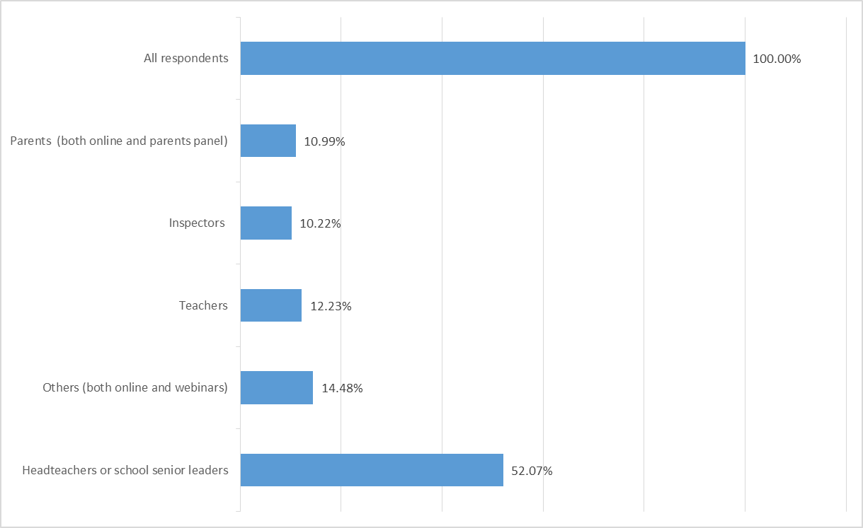

Proposal 1: To what extent do you agree or disagree with Ofsted’s proposal to extend the window of conversion for a short inspection (section 8 inspection) to a section 5 inspection from the current 48 hours to within a maximum of 15 working days?

- Among those who disagreed, the foremost concern was that the proposed change could cause school staff undue levels of stress. They feared that in many cases staff would be undertaking additional work in preparation for the full inspection. Other concerns raised can be summarised as follows:
- Disparity: the variable conversion period might confer an unfair advantage on those schools that have longer to prepare. This was perceived by some as unfair compared with the standard notice period that most schools receive. This concern was also highlighted through our face-to-face meetings and webinars with representatives of the sector. Attendees argued that the much-improved clarity of our framework and the fairness and consistency that had evolved over time could be compromised by this proposal.
- Some schools might undertake additional preparations, which might mean that Ofsted would not see them as they really were.
- The current arrangement works: some respondents were concerned that the proposed change was merely one of convenience for Ofsted and was not in the best interests of schools and pupils.
- Up to 15 days was too long: some respondents would be comfortable with up to five days, while others preferred a maximum of 10 (please see also paragraphs 37 and 38 below).
- Uncertainty: some of those who disagreed felt that the proposal could work much better if schools were told exactly when inspectors were coming back. This view was reinforced by our evaluation of the pilot inspections (please see paragraphs 36 and 37 below and the annex to this report).
- Disruption to school life: there was some concern that schools undergoing the longer conversion period would significantly disrupt their planned activities (such as school trips), which could have a detrimental effect on both staff and pupils. This chimed with the findings of our pilot inspections, where there was some disruption to school routines and the personal arrangements of school staff.
- A step backwards: some respondents perceived this as being at odds with the recent direction of travel – shortening inspection notice periods and combating the ‘preparation for inspection culture’.

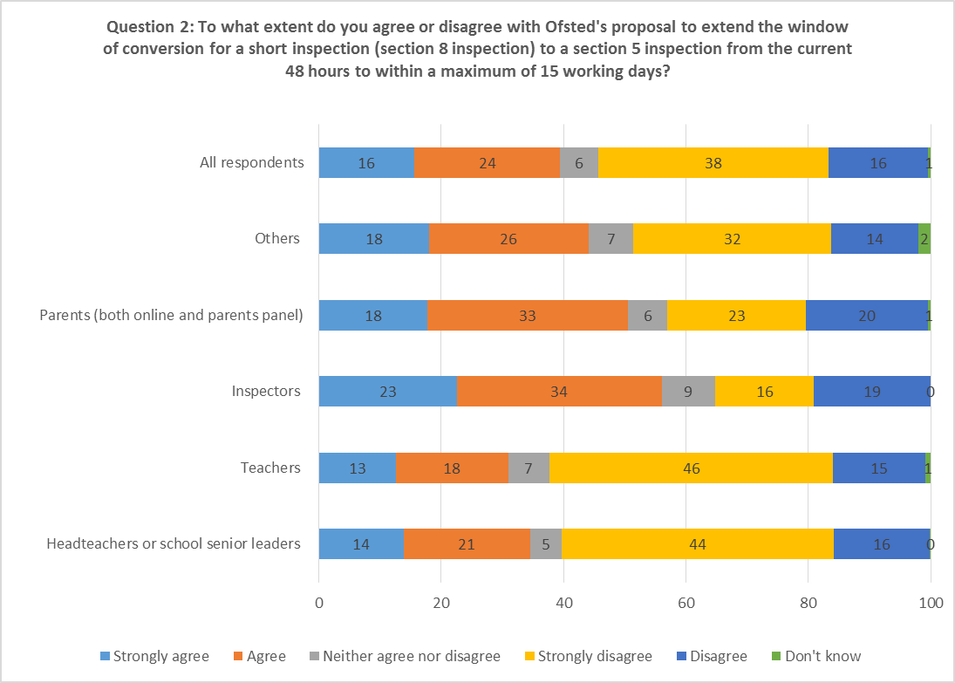

- Among those who agreed overall, the majority (55%) were either headteachers and senior leaders or teachers, although this is likely to be due to the over-representation of these two groups in the overall response. These and other respondents saw a number of benefits to the proposed change:
- On the whole, the proposal could lead to better inspection, with inspectors getting a more accurate picture of the school.
- It would give opportunities to staff to understand the reasons for the conversion better, to reflect and to consider the evidence to present to inspectors.
- It would allow for more informed dialogue when inspectors returned.
- It would provide more opportunity for governors to attend meetings and be more fully involved in the inspection.
- It would remove the logistical challenges of the current conversion period.
- During piloting of the extended window between the short and full inspection, a number of aspects worked well. For example, the transition was by and large managed well and school leaders were generally positive about the handover arrangements. Generally, there was an increase in the volume of responses to Parent View for schools whose inspections converted when comparing responses after the short inspection with those after the full inspection.
- However, in almost all cases, additional work had been undertaken by the school in the interval between the short and full inspections. Although headteachers reported that this mostly affected senior staff, many other staff had also undertaken extra work independently. Around one quarter of class teachers or subject and middle leaders reported that they had undertaken substantial additional work. Almost all of the headteachers and inspectors who took part in the pilot evaluation agreed that this additional work had made little or no difference to the final inspection outcomes. Interestingly, many headteachers reported that the additional work had simply helped them to feel more confident and well-prepared; they did not necessarily believe it had had an impact on the outcome of the section 5 inspection.
- Nearly all the headteachers and staff reported feeling increased levels of stress and anxiety. However, the most significant reason given for this stress was not the additional work undertaken but the uncertainty caused by not knowing the timing of the full inspection more precisely. Some participants in our webinar discussions also raised questions about the timing of the full inspection. They asked whether this could be shared with the school at the time of the short inspection to counteract the uncertainty. Similarly, the headteachers participating in the pilot inspections felt that schools should be provided with some indication about when the full inspection would take place (for example, which week rather than the precise date), to remove the uncertainty and minimise any disruption to planned school activities.
- Our headteacher reference groups also highlighted the potential for disparity caused by the proposed ‘up to 15 days’ window as a key concern. Specifically, they were concerned that the length of time between the short and full inspection would vary between schools. One of the suggestions put forward by the headteacher reference groups was that a minimum timescale should be applied so that the process is more consistent and fair for schools. For this group too, a shorter range, for example five to 10 days, was generally seen as preferable. Again, it was generally the case that those we engaged with felt that current arrangements worked well for them.
- The concern about the length of the proposed window, 15 days, was expressed in the pilot inspections, in responses to the consultation and in our webinars and consultative events. In particular, it was reflected in the responses to the consultation submitted by ASCL and NAHT. Among those responding online who disagreed overall and provided reasons for their disagreement, around 9% did so not because they objected to an extended window in principle but because they felt the window was too long. A common suggestion from this group was that a window of five to 10 days would be more appropriate.
- A number of respondents who disagreed with this proposal did so because they felt that the change was primarily due to the logistical challenges that Ofsted faces under the current model. This was a key concern highlighted in the separate submissions from the teaching unions and professional associations. Throughout this process, Ofsted has been open about the fact that the current model has presented significant challenges to inspection scheduling and the deployment of our inspector workforce. These logistical challenges are an unintended consequence of our policy to involve as many serving practitioners in inspection as possible. Involving serving practitioners is important in ensuring that our inspections operate with maximum transparency. While we have changed our approach in relation to this recommendation, we remain determined to create an inspection model that is more practical and attractive for serving practitioners. This is why we are consulting again on the revised approach set out in paragraphs 16–26.

Proposal 2: To what extent do you agree or disagree that schools whose short inspections (section 8 inspections) are likely to convert to a section 5 inspection should instead receive a full section 5 inspection from the outset?
- There was considerable support for this proposal. Some 62% of all respondents agreed or strongly agreed, while only 29% disagreed overall. It met with approval across all respondent types, including: the very large majority of inspectors (90%); more than three quarters of parents and carers (77%); the majority of teachers (58%) and headteachers or senior leaders (53%); and over two thirds of all ‘other’ respondents (68%).
- Respondents who agreed overall identified many positive features of this approach, including the following:
- clarity for schools about Ofsted’s expectations of them and the process they are to go through
- less pressure or stress placed on schools leaders and staff
- it would not be a surprise to most schools that would undergo a section 5 from the outset, as many schools in this group evaluated themselves as less than good
- a fairer approach, ensuring that every school received the same amount of pre-inspection notice
- it would reduce the pressure on inspectors to make a decision regarding conversion on day one (as required by the current model)
- it makes sense: schools and inspectors will have appropriate opportunities to gather, present, discuss and consider evidence; a full evaluation would result, providing greater clarity for schools and parents.
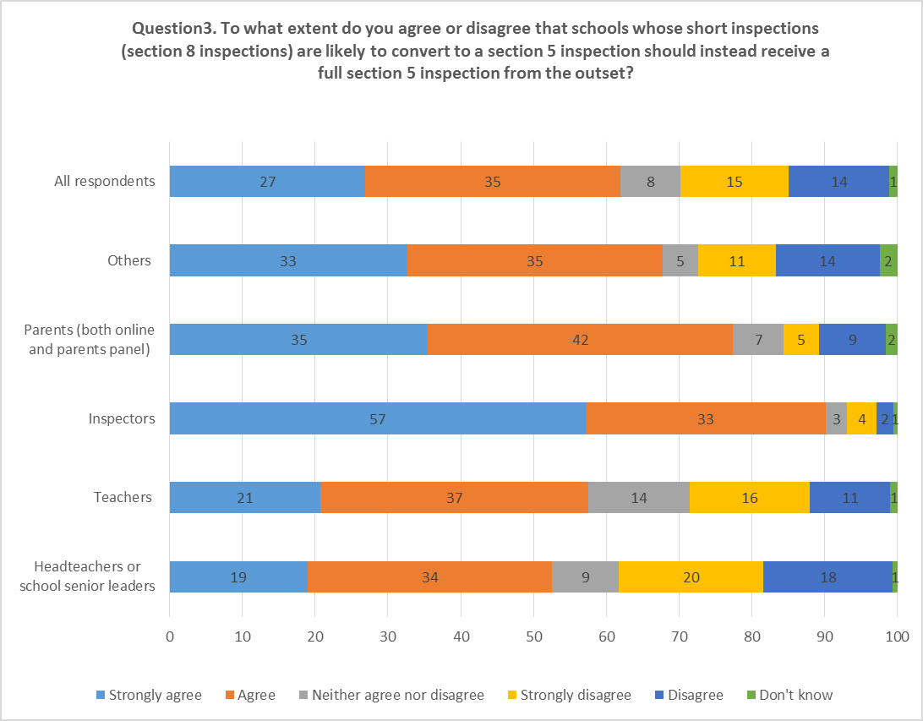
- Among those who disagreed with conducting section 5 inspections of good schools from the outset, the reasons put forward included the following:
- It might be seen as unequal treatment of schools judged good.
- Some may perceive this as Ofsted applying a pre-determined judgement, even though we are clear that any inspection grade is possible in any section 5 inspection.
- There is a concern that this could reinforce negative perceptions that inspections are over-reliant on data.
- It could put schools about which less data is available at a disadvantage; particular concerns were raised about special schools, middle schools and those with high pupil mobility.
- Some respondents were concerned about the recent changes to progress measures, the uncertainty about their impact, and how this might, in turn, affect risk assessment outcomes.
- Many felt that the current model worked well.
- The feedback we received about this proposal through our wider engagement work, such as reference groups and webinars, was positive overall. There was some concern about Ofsted relying on available data, for example Parent View, where response rates might vary considerably, to decide whether to conduct a full inspection from the outset. Those we spoke to emphasised the importance of the context of each school and the need for Ofsted to take account of this in the risk assessment process.
- Those involved in webinar discussions felt that this proposal would, on the whole, be a positive step. Questions were raised as to whether schools that received a section 5 inspection from the outset would be informed of the reasons for this. Some felt that this had the potential to reduce significantly the number of converted inspections and, therefore, to minimise or even negate the need to change the current 48-hour window. Those involved in these discussions asked us to ensure that, as a matter of course, the reasons for the school’s selection for a section 5 rather than a short inspection are made clear to the school by the lead inspector at the start of the inspection. We will do this.
- As we have set out in paragraph 12, we will be taking this change forward. In doing so, we will take account of the concerns raised by those who disagreed. It is important to stress that risk assessment and inspection are two distinct processes. The risk assessment is not a substitute for inspection judgements made on-site in the light of all available first-hand evidence. Inspectors are trained to apply their professional judgement based on evidence gathered at the point of inspection, and they are clear that the full range of judgements is available to them whenever they are conducting a section 5 inspection. While inspectors form initial hypotheses as part of the pre-inspection preparation, as is the case with all inspections, these are explored during inspections and all judgements must be corroborated by the first-hand evidence. Ofsted’s rigorous quality assurance processes will be applied to ensure that all judgements are robust and firmly based on the evidence gathered.

What factors do you think Ofsted should take into account when considering whether to conduct a section 5 inspection of a good school from the outset, rather than a short inspection that may then convert?
- Alongside our two proposals, we asked about the factors that we should consider as part of the risk assessment. To help respondents, we published a document setting out our risk assessment process and provided a link to it in the consultation document.
- Generally, but especially among those who agreed with the proposal to conduct section 5 inspections from the outset, respondents felt that Ofsted should be able to make fairly accurate predictions on the basis of available information. However, many respondents urged that care be taken so that these predictions were not driven solely by attainment data. Many respondents place considerable importance on the school context, such as school type, intake, pupil mobility and whether it operates in an area of deprivation. Factors to be considered, as highlighted by the comments we received, included:
- attainment data over time (for example three-year trends), with care exercised in relation to small cohorts
- school context
- Progress 8 scores
- attendance rates
- exclusions, including rates of repeat exclusions
- changes in leadership
- complaints
- safeguarding concerns
- parental concerns/Parent View
- ‘open source intelligence’, such as local media reports and web trawls.
- It was encouraging to see that Ofsted already considers each of these factors as part of its risk assessment. There was no substantive difference between the feedback on this question and what we already look at as part of the risk assessment process.
- Ofsted’s risk assessment is carried out in two parts. In the first part, Ofsted’s analysts assess each school based on published data. The second part involves a more in-depth review by HMI or senior HMI of the wider evidence at Ofsted’s disposal, including the contextual and ‘open source’ points in the list above.
- We are aware of the concerns in the sector about the potential impact of recent changes to progress measures. For example, we are mindful that ‘outliers’ can impact on Progress 8 scores and will consider this when reviewing our risk assessment methodology over the forthcoming months.

Annex. Pilot inspections: a summary evaluation

Background
To support the consultation, Ofsted piloted short inspections in two Ofsted regions during May and June 2017. Where necessary, conversion was to be followed by a full inspection within 10 or 15 days, rather than within the existing 48-hour window. Where a conversion occurred, the full inspection was led by a different lead inspector to the inspector who had led the short inspection, requiring a ‘handover’ of inspection evidence. In each of the short inspections that converted, the lead inspector was instructed to hold a brief meeting with school staff at the end of the short inspection to explain that staff should not undertake additional planning or other tasks solely in preparation for the full inspection to follow.
In a small number of the pilots, inspections were scheduled such that the short inspection and any subsequent (converted) full inspection would take place either side of the Whitsun half-term school holiday. Under the proposals, Ofsted undertook to complete conversions within a period of up to 10 or 15 days after the short inspection (where the inspection converted). However, where conversion might occur due to safeguarding concerns, Ofsted committed to conversion within two working days. While this did not occur, one of the pilot inspections that converted was completed on the day after the short inspection for practical reasons linked to the tariff and small size of the school concerned.
Pilots were conducted in two Ofsted regions: the South East and North West regions. A total of 32 pilot inspections took place. Each was a previously good school scheduled for a section 8 short inspection. Details of these inspections are summarised in Table 1.
Table 1: Summary of 32 short inspection pilots carried out in the North West and South East regions, May/June 2017

Region | No of inspections | Dates | Phase | Lead type | Outcome
South East | 12 | 23–25 May | Primary: 7  Secondary: 4  Special: 1 | HMI: 5  OI: 7 | Converted: 3  Did not convert: 9
North West | 20 | 23 May – 8 June | Primary: 16  Secondary: 2  Special/pupil referral unit: 2 | SHMI: 1  HMI: 16  OI: 3 | Converted: 10  Did not convert: 10

A total of 13 of these short inspections converted and a subsequent full inspection was scheduled. In one case, the conversion took place immediately (see footnote 7), and this inspection was excluded from the pilot sample. In the remaining 12 conversions, the full inspection took place between nine and 15 working days after the short inspection. A total of five pilots were completed that included the Whitsun half-term school holiday. Details of the full inspections and their outcomes are shown in Table 2.
Table 2: Summary of conversion outcomes for 12 pilot inspections carried out in the North West and South East regions, June 2017

Region | No of conversions | Dates | Length of gap (working days) | Phase | Lead type | Full inspection outcome
South East | 3 | 13–15 June | 14–15 days | Primary: 2  Special: 1 | HMI: 1  OI: 2 | Requires improvement: 2  Outstanding: 1
North West | 9  (see footnote 3) | 7–28 June | 9–14 days | Primary: 8  Secondary: 1 | HMI: 7  OI: 2 | Requires improvement: 6  Good: 2  Outstanding: 1

Main findings
The pilot inspections allowed us to test the practicalities of applying an extended conversion window. They provided valuable lessons on how to manage the conversion over a longer period, for example how to ensure the smooth handover between inspectors undertaking the initial short inspection activity and the extended team that will conduct the full section 5 inspection, and the need to keep school leaders fully informed about next steps and the reasons for the conversion decision arising from the evidence.
Below are some of the most important findings which, alongside the consultation feedback, have informed our thinking about the way forward. They have particularly influenced our thinking about the need for a more narrowly defined window that removes much of the uncertainty about when inspectors will return, the potential for overlap with school holidays and wider concerns about disruption to school routines.
The main findings were:
- Almost all school staff, including headteachers, felt that the impact of delayed conversion on staff welfare and well-being greatly outweighed the impact of additional workload. Headteachers and staff nearly all reported feeling increased levels of stress and anxiety. The most significant factor in this was the uncertainty caused by not knowing the timing of the full inspection more precisely. Many headteachers and staff said that the ‘open-ended’ timing of the full inspection was their biggest concern. Headteachers in particular favoured knowing the timing of the full inspection within a given week. The impact of the half-term holiday within the conversion ‘gap’ was felt to be especially problematic.
- In a small number of responses, headteachers and staff also indicated that uncertainty over the timing of the full inspection had led to disruption to school routines, events and organisation. Responses suggested that disruption to schools could be greatly reduced by identifying one week as the window for the full inspection.
- Around two in five members of staff in the pilot schools said that delayed conversion had led to increased workload. A slightly higher proportion of staff said they independently undertook additional work, despite being told they should not do so. Around one quarter of class teachers or subject/middle leaders said that they had undertaken substantial additional work. Around half of staff said they had attended a meeting with the lead inspector at the end of the inspection to hear about how the inspection would proceed.
- Nevertheless, almost all the headteachers and inspectors surveyed felt that this additional work had made little or no difference to evidence gathered or judgements reached. All quality assurance visitors and all the headteachers from the pilot schools agreed. Many headteachers felt that they had undertaken work which, although having little practical benefit, had helped them to feel more confident and well-prepared.
- Delayed conversions had a positive impact on inspectors’ ability to manage their workload and schedules. This was particularly the case for team OIs and for serving practitioners joining converted full inspections. Many OIs in particular felt that the benefits were considerable. Lead inspectors’ views were generally positive too. Delayed conversions had a positive impact on inspectors’ planning and preparation, particularly for team OIs joining converted full inspections.
- Many inspectors and quality assurance visitors to inspections believed that delayed conversions further enhanced inspection quality and consistency. They felt that the pilot approach had a positive impact on the evidence base and valued being able to explore issues in greater depth. A few short inspection lead inspectors also identified benefits to inspection practice for short inspections. These were mainly to do with greater opportunity for reflection and time to gather more evidence, without the time constraints of ‘calling in’ conversion decisions to regional support teams.

Evaluation methodology
The views of inspectors and school leaders and staff were gathered by means of online surveys and through telephone conversations with headteachers in pilot schools where the inspections converted to full inspections. Details of these surveys are shown in Table 3 below.
Table 3: surveys conducted to inform the pilot inspections evaluation
Survey | Method (number) | Number and type of respondents
Views of lead inspectors of pilot short inspections (converting) | Online survey (13 inspections) | Total: 9  8 HMI and 1 OI
Views of lead inspectors of pilot short inspections (not converting) | Online survey (19 inspections) | Total: 15  7 HMI and 8 OIs
Views of lead inspectors of pilot full inspections (conversions) | Online survey (12 inspections) | Total: 10  7 HMI and 3 OIs (two serving practitioners)
Views of team inspectors of pilot full inspections (conversions) | Online survey (12 inspections) | Total: 10  All OIs (five serving practitioners)
Views of quality assurance (QA) visitors to pilot full inspections (conversions) | Online survey (12 inspections) | Total: 6  All HMI or SHMI
Views of headteachers of pilot schools inspected in full inspections (conversions) | Telephone discussion (12 inspections) | Total: 12  All headteachers
Views of school staff in full inspections (conversions) | Online survey (distributed via headteachers of pilot schools) | Total: 67  Including 46 class teachers/middle leaders


The Office for Standards in Education, Children's Services and Skills (Ofsted) regulates and inspects to achieve excellence in the care of children and young people, and in education and skills for learners of all ages. It regulates and inspects childcare and children's social care, and inspects the Children and Family Court Advisory and Support Service (Cafcass), schools, colleges, initial teacher training, further education and skills, adult and community learning, and education and training in prisons and other secure establishments. It assesses council children’s services, and inspects services for children looked after, safeguarding and child protection.
If you would like a copy of this document in a different format, such as large print or Braille, please telephone 0300 123 1231, or email enquiries@ofsted.gov.uk.
You may reuse this information (not including logos) free of charge in any format or medium, under the terms of the Open Government Licence. To view this licence, visit www.nationalarchives.gov.uk/doc/open-government-licence, write to the Information Policy Team, The National Archives, Kew, London TW9 4DU, or email: psi@nationalarchives.gsi.gov.uk.
This publication is available at www.gov.uk/government/organisations/ofsted.
Interested in our work? You can subscribe to our monthly newsletter for more information and updates: http://eepurl.com/iTrDn.

Piccadilly Gate
Store Street
Manchester
M1 2WD

T: 0300 123 1231
Textphone: 0161 618 8524
E: enquiries@ofsted.gov.uk
W: www.gov.uk/ofsted
No. 170038
© Crown copyright 2017

Whenever we refer to a converted inspection in this document, we mean the section 5 inspection that continues from the short inspection after the decision to convert. When we say that the converted inspection will now take place within 15 days, we mean that the first day of the ongoing section 5 inspection is within 15 working days of the first on-site day of the short inspection.
In accordance with the requirements of The Education (School Inspection) (England) (Amendment) Regulations 2015; www.legislation.gov.uk/uksi/2015/170/contents/made. In order for the inspection to be a ‘relevant inspection’ under the regulations, it must be conducted for the purpose of determining that the school remains good or outstanding, and having been so conducted the Chief Inspector is satisfied that the evidence does not suggest that the school would not achieve such a grade if a section 5 inspection were carried out.
Members of the Ofsted Parents Panel completed the same questionnaire that was available to the general public through the online consultation. We have aggregated the results of the two questionnaires. Figures relating to parents/carers or references to this group of respondents encompass both Parents Panel respondents and those who responded through the public consultation and identified themselves as parents/carers.
Not all respondents completed all the questionnaire fields asking for an answer. Some respondents disagreed or strongly disagreed but did not provide reasons for their disagreement.
A note setting out Ofsted’s risk assessment process for schools can be found here: ‘Methodology note: the risk assessment of good and outstanding further education and skills providers’, www.gov.uk/government/publications/ofsted-standards-for-official-statistics.
For those short inspections that took place on 23, 24 or 25 May and that converted, the subsequent full inspection took place with the Whitsun half-term school holiday in between the two inspections. This was the case in five of the pilot inspections – all three in the South East region and two in the North West region.
Indicates the number of complete working days (excluding school holidays) between the conclusion of the short inspection and the start of the full inspection.

