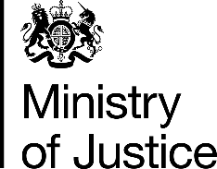 | July 2017

Freedom of Information Act (FOIA) Request – 113086

You asked for the following information from the Ministry of Justice (MoJ):

Thank you for your response in relation to my FOI request. Please can we have an area breakdown for police force. Please can we know whether the defendant were found guilty or not, and the sentencing information.

Thank you once again for your efforts in supplying this information. I look forward to hearing from you at your earliest convenience.

Which was a clarification of the below request

Under the Freedom of Information Act, I would like to make a freedom of information request regarding youth cases in the Crown Court. My question is as follows;

How many youths were tried in Crown Courts in England and Wales between 1st January 2016 and 31st December 2016 (inclusive)? Can this be given in areas? If possible, please can the outcome be stipulated.

Your request has been handled under the FOIA.

I can confirm that the MoJ holds the information that you have requested and I have provided it in the attached annex.

Please note there is no data presented for the City of London Police force area as police force area cases are reported in the statistics by the police force in which the magistrates court in which the initial prosecution took place. City of London Magistrates Court was merged into the Central London Local Justice Area (LJA) from 1 January 2012, and this
LJA reports feed into the Metropolitan Police force area.

