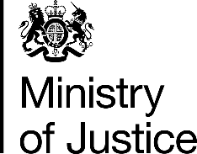 | July 2017

Freedom of Information Act (FOIA) Request – 112722

You asked for the following information from the Ministry of Justice (MoJ):

Trying to follow your suggestion, I will ask you the data about the number of sentenced for criminal offences in England and Wales for the offences contrary to the section 1;2;3;4;5 and 6 of the Bribery Act 2010.
If it is possible, I need these data dived year by year from 2004 to 2015.

Your request has been handled under the FOIA.

I can confirm that the MoJ holds the information that you have requested and I have provided it in the attached annex. Please note the Bribery Act 2010 came into effect on 1 July 2011 and offences apply only to Sections 1, 2 and 6 as per the link to the Act below.

http://www.legislation.gov.uk/ukpga/2010/23/contents

