Tell us what you think

You might want to ask someone to help you fill in this form.

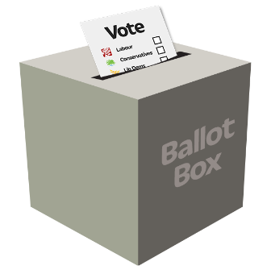
Is easy or hard for you to vote in elections?

Voting in an election is when you choose who will be in charge of your town or country.

If you tell us about what voting is like for you, it might help us make voting easier for everyone.

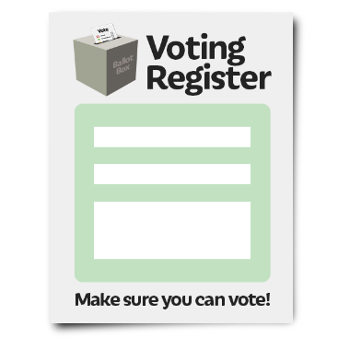
To vote in an election you have to register to vote.

Register to vote is when you tell government where you live so you can vote in an election.

Do you know how to register to vote?
Put your answer here:

If you said yes, was it easy or hard to register to vote?
Put your answer here:

Did someone help you to register to vote?
Put your answer here:

What would make it easier for you to register to vote?

Put your answer here:

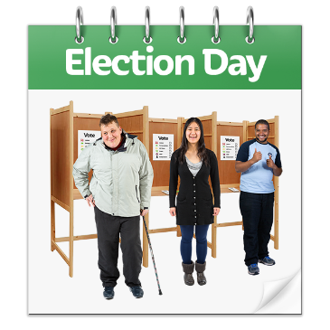
Everyone votes on election day. This is when everyone goes to the polling station to choose who they want to be in charge of their town or country.

Do you know how to vote on election day?
Put your answer here:

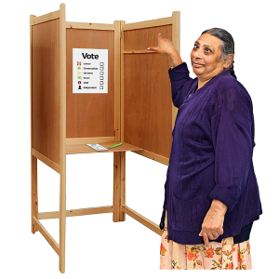
Do you vote in the polling station? In your town the polling station might be a school or library.

Put your answer here:

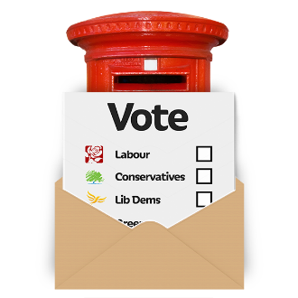
Do you vote by post?

Put your answer here:

Does someone help you to vote?

Put your answer here:

What would make it easier for you to vote?

Put your answer here:

How to tell us your answers

We will not tell everyone your answers but we will tell people in Government who are making voting in elections easier for everyone.

You can put your answers in the boxes and email this document to us: elections@cabinetoffice.gov.uk

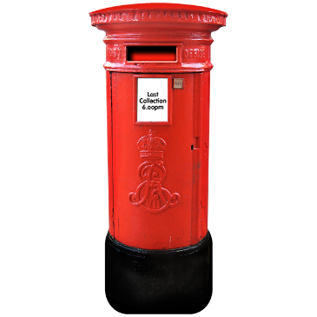
Or you can send your answers by post. This is the address to write on the envelope:

Electoral Administration Team
Cabinet Office
4th floor, Orange Zone
1 Horse Guards Road
London SW1A 2HQ

Thanks to Mencap for their advice in producing this document.

Pictures by photosymbols.

