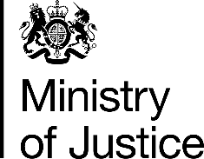 | June 2017

Freedom of Information Act (FOIA) Request – 112410

You asked for the following information from the Ministry of Justice (MoJ):

I would like to know; Out of the 7 males who pleaded not guilty in 2007 what proportion was BME?
Out of the 13 males who pleaded not guilty in 2008 what proportion was BME?

Which referred back to a table supplied for the below query

quoting ref: 049-16 FOI 102723
I would like to inform you that I have already received an answer to this question. However there are other question which related to the main question which I would like to be answered. I do hope that you can provide the answer as soon as possible.
1. Out of the 34 Males who received IPP in 2007. How many pleaded NOT Guilty?
2.Out of the 38 Males who received IPP in 2008. How many pleaded NOT Guilty?
3. How Many women were put on IPP?

Your request has been handled under the FOIA.

I can confirm that the MoJ holds the information that you have requested and I have provided it in the attached table, which shows the number of 17 year old males sentenced to Imprisonment for Public Protection (IPP) who pleaded not guilty, by ethnicity, in England and Wales, in 2007 and 2008.

