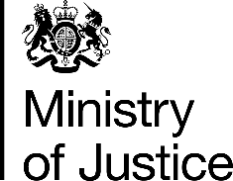 | June 2017

Freedom of Information Act (FOIA) Request – 112134

You asked for the following information from the Ministry of Justice (MoJ):

Would it be possible to get an update on TV licence offences?

I would like to know:
- the number of male and female proceeded against in 2016 at magistrates' court for offences relating to Installing or using a television receiver without the appropriate licence by police force area, and by country (England & Wales separately)
- the number of male and female found guilty for the same offence in 2016, also by police force area and country.
- The average fine in 2016 by country (England & Wales separately)

I believe this information was published yesterday.

Your request has been handled under the FOIA, and we apologise sincerely for the delay in responding.

I can confirm that the MoJ holds the information that you have requested and I have provided it in the attached tables as described below:-

- Table 1 provides the number of male defendants proceeded against at magistrates courts and found guilty at all courts of installing or using a television receiver without the appropriate licence, in England and Wales, by police force area, in 2016
- Table 2 provides the number of female defendants proceeded against at magistrates courts and found guilty at all courts of installing or using a television receiver without the appropriate licence, in England and Wales, by police force area, in 2016
- Table 3 provides the average fine, split between England and Wales, for installing or using a television receiver without the appropriate licence in 2016

Please note that in addition to those included in the tables of male and female defendants, 885 defendants whose gender was not recorded were proceeded against and 664 were found guilty of this offence in 2016.

