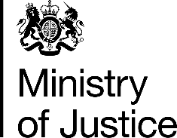 | June 2017

Freedom of Information Act (FOIA) Request – 111956

You asked for the following information from the Ministry of Justice (MoJ):

I would be grateful if you would provide me with a full list of items confiscated from prisoners at Lewes Prison in the 12 months from May 2016.
Your request has been handled under the FOIA.

I can confirm that the MoJ holds the information that you have requested and I have provided it in the excel sheet attached.

