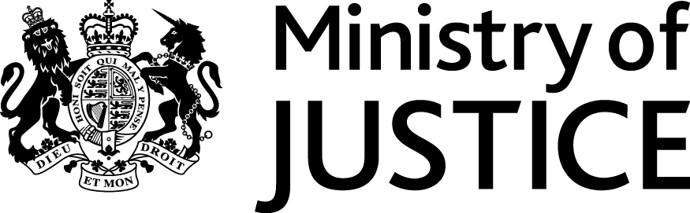
 | Our Reference: 590-16 FOI 108308 |  | June 2017

Freedom of Information Request

You asked for the following information from the Ministry of Justice (MoJ):

As part of a previous FoI response to me [Ref: 179-15 FOI 96797] you supplied me with an answer to the following question:
In a response to a Parliamentary Written Question [Ref: 175877, 175878 and 175879] [22 Nov 2013 : Column 1055W : Animal Welfare Act 2006] you supplied a series of tables in relation to questions about people being prosecuted and sentenced for animal cruelty. Could you please provide me with undated tables on the same basis as the Parliamentary Answer, which I attach for your reference.

Could you now provide me with an updated response to include data for the 2014 and 2015 calendar year?

Your request has been handled under the Freedom of Information Act 2000 (FOIA), and we apologise for the delay in response.

I can confirm that the department holds the information that you have asked for. Please see the attached annex.

