

**16 November 2016**

**DATE OF ISSUE**

**PNS 14/16**

**ISSUE NUMBER**

# **Priority Notice to Staff**

**FOR INFORMATION**

**All Staff**

**UPDATE ON PAY AWARD FOR PRISON STAFF 2016/17**

As you are aware, there have been ongoing discussions regarding the 2016/17 Pay Award for Prison Service grades.

2. I am pleased to inform you that the Department of Finance has approved an overall pay settlement equating to 2.5%. This settlement represents over £1.2 million in additional money and has been achieved following negotiations between the Ministers of Justice and Finance.

3. This settlement has also been achieved against a backdrop of pay restraint of 1% across the public sector. It is therefore a very good deal which acknowledges the unique role prison staff perform for the community in Northern Ireland.

4. The details are as follows:

* Contractual progression.   At the request of the respective staff Associations some staff have received payments in respect of contractual entitlements due. That is one-step progression for qualifying staff and was included in their August 2016 pay.
* 1% non-consolidated, non-pensionable payments for staff on single points and band maximum.
* An increase in the Supplementary Risk Allowance of £460 for eligible members of staff. This equates to a 23% increase on the current allowance.
* PECCS Travel - Extend the travel section only of NICS HR Handbook to this group of staff.

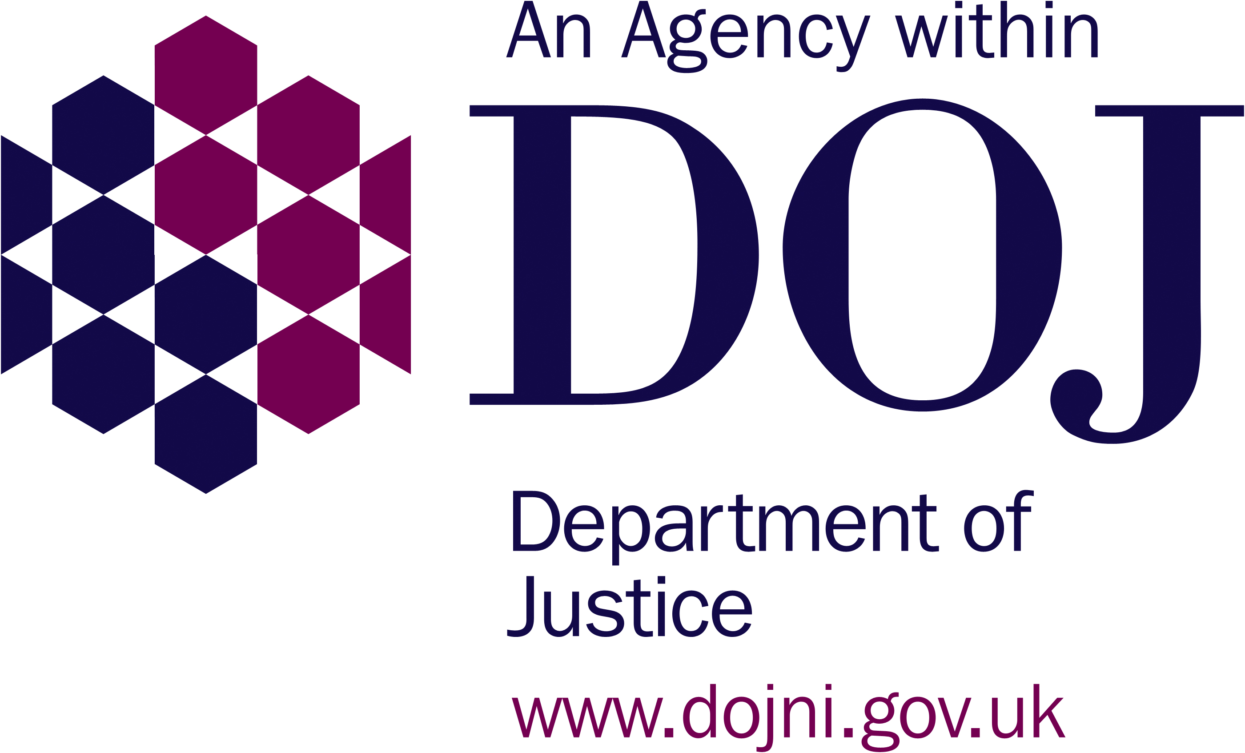

5. I met with the Chairman of the Prison Officers Association yesterday to appraise him of the pay settlement. I have also written separately to the Prison Governors’ Association. Whilst I await a formal response from the PGA, I have received a letter this afternoon from the POA stating “...The Committee has unanimously agreed that it could not recommend the pay offer to our members…” This is very disappointing as this pay award represents the best pay deal anywhere in the public sector and I would ask them to reconsider their decision. If that was to happen, payments could be made to staff in January and backdated to April where appropriate.

6. I am also committed to providing additional support to staff that further recognises the challenges you face working in our prisons. The Minister has requested that Prison Service Management engage with the Police Rehabilitation and Retraining Trust (PRRT) in the coming months to deliver support services to current and former operational prison grades.

7. PRRT exists to assist retired and serving police officers to enjoy optimum mental and physical wellbeing beyond policing. Their services are also available to non-police bodies and NIPS will engage with them to develop customised services to respond to the complexities prison staff experience.

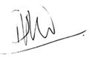

**Phil Wragg**

**Director General (acting)**

**Northern Ireland Prison Service**