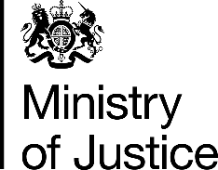 | April 2017

Freedom of Information Act (FOIA) Request – 111303

You asked for the following information from the Ministry of Justice (MoJ):

I am requesting, under the terms of the Freedom of Information Act, information on the number of criminal cases taken to trial for selected cases for 2016.

Specifically, I would like details on criminal trials for selected criminal cases - I have set out the categories of offenses in the table provided in the attachment.

For each category of offense, I would like to know the number of defendants involved (if it is not possible to provide the number of defendants, please provide the number of cases).

Your request has been handled under the FOIA.

I can confirm that the department holds the information that you have asked for. Please see the attached table. The figures previously provided were under the old timeliness methodology that excluded cases with a duration of over ten years, whereas the figures in the attached table are under the new timeliness methodology that include cases where the duration is over ten years.

