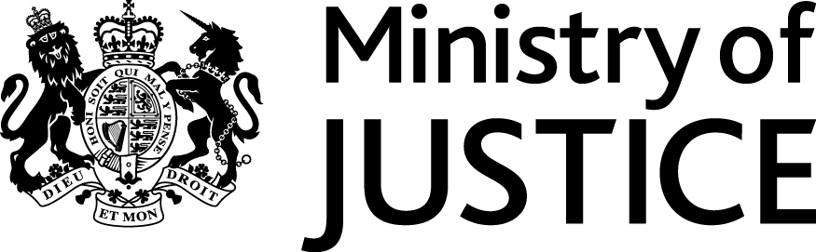
 | Our Reference: 451-16 FOI 106965 |  | May 2017

Freedom of Information Request

You asked for the following information from the Ministry of Justice:
Can you tell me what was the average fine for TV licence offence in 2015? Could you split the data between England and Wales, so that I could see if there is any difference between the two countries?
and

Could you tell me how many people were jailed for TV licence fine default in 2015? It would be handy if the data could show England and Wales separately and indicate genders and the duration of each stay (if not possible, an average would do)

Something like this:

Wales
Sex | Age | duration of stay
male | 55 | 21 days
female | 20 | 17 days

England
Sex | Age | duration of stay
male | ... | ... days
male | ... | ... days
male | ...
female | ...

I know it's a bit more involved, but last year, the list contained only 39 culprits. So, do you think that would be possible? If you can't split England and Wales, that's fine.

Your request has been handled under the Freedom of Information Act 2000 (FOIA). Please accept my apologies for the delay.

I can confirm that the department holds the information that you have asked for however, some of it is exempt from disclosure.

Please see the attached tables as described below

- Table 1 provides average fine for television licence evasion offences, in each of England and Wales, in 2015
- Table 2 provides data the number of sentenced admissions for non-payment of a TV licence and number of days given, in England and Wales, in 2015.

The average fine for England and Wales as a whole is exempt under section 21 of the FOIA because it is reasonably accessible to you, and you can access it as in the link below.

https://www.gov.uk/government/statistics/criminal-justice-system-statistics-quarterly-december-2015

Section 21 of the FOIA exempts disclosure of information that is reasonably accessible by other means, and the terms of the exemption mean that we do not have to consider whether or not it would be in the public interest for you to have the information.

Whilst I have provided you with the total number of sentenced prison admissions for non-payment of a TV licence, a further breakdown into England and Wales regions or specific lengths of sentence have not been provided because of the small of individual prisoners involved. We are not obliged, under section 40(2) of FOIA, to provide information that is the personal information of another person if releasing would contravene any of the provisions in the DPA. This information, if released, could lead to identification of the individuals concerned which would be unlawful under the Data Protection Act 1998 (DPA) as it would be in breach of one or more of the Data Protection Principles.
If a request is made for information and the total figure amounts to five people or fewer, the MoJ must consider whether this could lead to the identification of individuals and whether disclosure of this information would be in breach of our statutory obligations under the DPA. We believe that the release of some of this information would risk identification of the individuals concerned, and therefore be unlawful under the DPA as it would be in breach of one or more of the Data Protection Principles. For this reason, MoJ has chosen to combine the categories of 1, 2 and 3 or more in cases where the true number falls between one and five. However, it should not be assumed that the actual figure represented falls at any particular point within this scale; 'five or fewer' is used as a replacement value from which it would be difficult to isolate or extract any individual data.

