70 YEARS AND COUNTING: THE FINAL OPPORTUNITY?

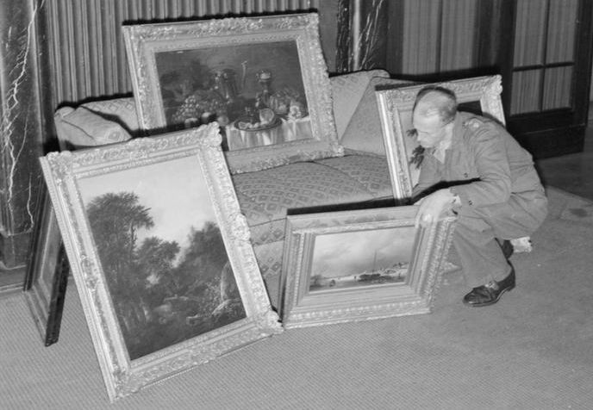

It is estimated that 20 per cent of Europe’s cultural treasures were stolen or plundered by Nazi Germany, most notably from Jewish families, and over 100,000 of these works are still lost, presumed to be in both public and private collections.

70 Years and Counting: The Final Opportunity? will focus on efforts to identify and return works of art lost during the Nazi-era and particularly on how efforts in this area can be accelerated at this late date. The issue is an international one and international cooperation is essential for the achievement of the goal of providing fair and just solutions.

The Washington Principles provide the framework for each stage of the process, from provenance research and its publication, to access to records, to the provision of national claims processes and fair and just solutions. Provenance research is crucial to the process, as is the ability to locate the substantive evidence of the loss and disposal of objects, without both of which national claims panels will be limited in their range and impact.

Without adequate claims processes, justice will remain unavailable in many places or restricted to those few who seek it through the courts. For the existing national claims processes and committees, the questions they encounter as time progresses become ever more critical and central to upholding the very commitment by the international community to provide justice, however difficult that may be and however long that may take.

The Conference will take stock of achievements and explore the current dilemmas and issues faced by those working in each of these essential areas, concluding with a series of recommendations for accelerating progress. The main sessions of the Conference will consist of panel discussions on key themes, following each of which there will be an opportunity for questions from the audience.

70 Years and Counting: The Final Opportunity? Is sponsored by the Commission for Looted Art in Europe.

70 Years and Counting: The Final Opportunity?

Conference Programme

09 30 Conference opens, refreshments available

10 00 Welcome: Dr Gabriele Finaldi, Director, National Gallery

10 05 Outline of the day: Clare Pillman, DCMS Director for Culture, Tourism and Sport

10 10 Sponsor: David Lewis, Co-Chair, Commission for Looted Art in Europe

10 15 Keynote address: John Glen MP, Minister for the Arts, Heritage and Tourism

***

10 30 Session 1: Lost Art: Experience of claimants and institutions

Chair: Sir Paul Jenkins KCB, QC, Former Head of the UK Government Legal Department

Panel: Dr Antonia Boström, Keeper of Sculpture, Metalwork, Ceramics & Glass, Victoria and Albert Museum, London
Imke Gielen, Lawyer, von Trott zu Solz Lammek, Berlin
Simon Goodman, Author of The Orpheus Clock
Anne Webber, Co-Chair, Commission for Looted Art in Europe

The Panel will consider how effective the existing claims processes are for works of art in both public and private collections, the difficulties of making claims in countries that do not have national claims processes or a commitment to return and the role that governments, panels and researchers already play or could play in the provision of justice. It will look at the usefulness of existing provenance research and its publication, consider the challenges faced by claimants in locating missing works of art and accessing records, and explore the contribution and response of museums, art experts and the art trade.

***
11 40 Short break

11 50 Session 2: National claims processes

Chair: Sir Donnell Deeny, Chair UK Spoliation Advisory Panel

Panel: Professor Jan Bank, Member, Restitutions Committee, The Netherlands
Dr Reinhard Binder-Krieglstein, Alternate Member, Art Restitution Advisory Board, Austria
Michel Jeannoutot, Chair, Commission for the Compensation of Victims of Spoliation, France
Professor Reinhard Rürup, Deputy Chair, Advisory Commission, Germany

The Panel will consider the national processes in place across Europe for resolving claims and will look at their success, impartiality and effectiveness. It will look at the emergence of different rulings on the same case in different countries, whether the wishes of museums to keep works of art should be taken into account and the existing barriers to progress. The Panel will consider a wide range of questions including the following. Is there greater scope for information sharing and collaboration between the committees and how should the issue of claims and the passage of time be resolved? Is time limitation part of a fair and just solution and should claimants of the second and third generations or unrelated heirs have lesser rights to recover lost works of art? This session will also report on discussions from the previous day between the committees of the UK, Austria, France, Germany and The Netherlands.

13 00 LUNCH

14 00 Session 3: Unlocking the archives: accessibility and disclosure

Chair: Richard Aronowitz-Mercer, Head of Restitution, Sotheby's Europe

Panel: Christian Fuhrmeister, Project Leader, Research Department, Zentralinstitut für Künstgeschichte, Munich
Kristian Jensen, Head of Collections and Curation, British Library
Johannes Nathan, Nathan Fine Art GmbH, Potsdam, International Art Market Studies Federation

A further speaker will be announced for this session in due course.

The Panel will look at what progress has been made in undertaking and publishing provenance research and in identifying and providing access to museum, art trade, archival and other records. It will discuss the information that is already publicly available and whether its publication is effective, timely and clear, the records that remain inaccessible and what more can be done to publish both works of art and essential records. The Panel will consider what barriers exist to information sharing and accessibility and how these might be overcome.

***
15 15 Session 4: Private Collections

Chair: Pierre Valentin, Constantine Cannon, Partner, Art & Cultural Property

Panel: Monica Dugot, International Director of Restitution, Christie’s
Martin Levy, H. Blairman & Sons Ltd, art dealer and member of the Spoliation Advisory Panel
Katrin Stoll, Managing Partner, Neumeister Auction House, Munich

A further speaker will be announced for this session in due course.

The Panel will consider the issue of looted works in private collections including how private collectors can protect themselves from buying looted art, where they can go for advice and how they can be encouraged to research their collections and reach equitable solutions. The Panel will also discuss the difficulties for claimants in finding works in private collections and how they might seek to recover them, and explore the role of national claims processes and others in providing guidance and fair and just solutions.

16 30 Refreshments

17 00 Session 5: The Way Forward

Tony Baumgartner, Deputy Chair of the Spoliation Advisory Panel and Partner at Clyde & Co, will review and summarise the day, noting the conclusions and recommendations reached by each panel and will propose how these might be taken forward in fulfilment of the aims and objectives of the Conference.

18 00 Drinks Reception

***

