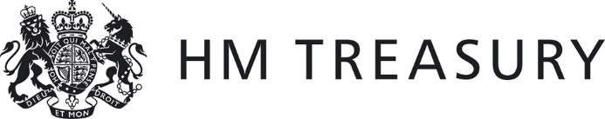 | Form CG02

2016-17 WGA

Notification of the Completion of the WGA Agreement Process

Name of Body: _________________
Body CPID: _________________

I certify that, for the purposes of the 2016-17 Whole of Government Accounts, and in accordance with the 2016-17 WGA Guidance:

- I have agreed all balances at 31 March 2017 and transaction streams in the year ending 31 March 2017 with other central government bodies, which exceeded £5 million on a gross basis (except for taxation balances with HM Revenues and Customs).
- I acknowledge the new requirement to submit the CG-01 form to HM Treasury.
- If transactions and balances have not been agreed on a gross basis, details are provided below:
[PLEASE PROVIDE DETAILS]
- Attached to this form is:
  - A copy of the CG-01.
  - Supporting papers where there are significant differences (more than £200,000) between amounts recorded by two bodies.
  - Annex ‘Departments’ balances with Local Authorities’.
[PLEASE ATTACH]
- Amounts not agreed with differences greater than £200,000 are summarised below.
[PLEASE PROVIDE DETAILS]
Amount | CPID | SCOA | Rationale

- Sub-consolidating Departments’ Declaration [Delete if not applicable]:
All bodies within the departmental consolidation group, and any funds administered by the group, have agreed their 2015-16 transaction streams and balances at 3rd June 2016 in accordance with guidance provided by the Treasury.

Signed:
Consolidation Manager: _______________________ Date: ___________

Bodies should send this form to the Treasury WGA Team - or if they’re a NDPB to their sub-consolidating department - by 30th June 2017.

