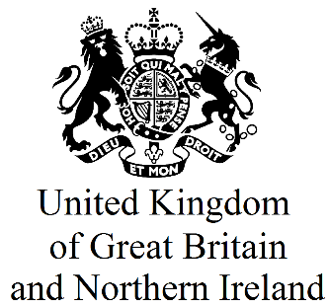
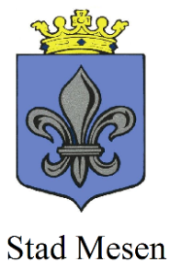
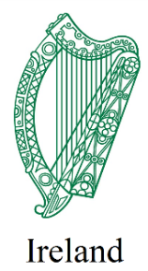

Battle of Messines Ridge

Expression of Interest form for 7th June 2017 Centenary Commemoration – Public Attendance

On 7th June 2017, the centenary of the start of the Battle of Messines Ridge, the Governments of Ireland and the United Kingdom, in partnership with the Mayor of Messines, will lead a shared commemorative event at 14.00 at the Island of Ireland Peace Park. The ceremony will reflect on the engagement, side by side, of the 36th (Ulster) Division and the 16th (Irish) Division at the Battle of Messines, the remembrance of which has become an important symbol of reconciliation on the island of Ireland.
Given the likely level of interest in attending this ceremony, entrance cannot be guaranteed to all who apply and tickets may be issued through a ballot system.
Priority will be given to the relatives of those who participated in the battle and persons who can provide demonstrable evidence of a particular interest in, or link to, commemoration of the Battle of Messines, in a context of reconciliation.
Personal Details:
Name:

Address:

Email:

Phone number:

If you have any mobility issues, please provide details:

Additional Information:
If you are a relative of a participant in the 1917 Battle of Messines Ridge, or have some other demonstrable interest, please provide details:

If travelling as part of a group, please provide name of group and name/contact details of group coordinator:

Please note that this information may be shared with other Government Departments in Ireland and in the UK.

If you would like your contact details to be retained so that we can contact you in relation to other forthcoming official commemorative events please place a check mark in this box.

Please return this form by email to messinesqueries@dfa.ie by Friday 5th May 2017.

