High Level Monitoring and Evaluation (M&E) Guidance

UK Space Agency: International Partnerships Programme

Key Takeaways
- M&E is critical for ODA projects and is a requirement for IPP grantees.
- M&E is a process of setting, checking and assessing your progress against established objectives/impacts and indicators.
- There are standardised frameworks for M&E with tools and processes for you to follow.
- M&E is the responsibility of grantees, and needs to be budgeted (5-15% of overall budget) and resourced by the grantees.
- Project impacts may only become measurable after the implementation ends and evaluations should be scheduled accordingly.
- UKSA have engaged a specialist M&E& partner to provide guidance and quality assurance to grantees for their M&E, but grantees will need to own and execute their M&E activities.

Monitoring and Evaluation (M&E)
The greatest impact on people’s lives in developing and emerging countries will come not from a short term intervention, but from a sustained and long term intervention. To ensure a sustained and long term intervention you need to provide inputs (e.g. resources, equipment), to carry out activities (e.g. software development, equipment installations, field visits), which will lead to outputs (e.g. working equipment/applications, people using special content, tracking), which will lead to outcomes (e.g. flood warnings, illegal logging detection, midwives improving the care offered, behaviours changed), which in turn cause an impact on the ground (e.g. ‘x’ lives saved, infant mortality reduced, ‘y’ disasters averted, ‘z’ hectares of forest not destroyed).

Inputs -> Activities - > Outputs - > Outcomes - > Impact

This sequence will need an underpinning rationale in order to help justify its continuation in a sustainable manner. This often will be because there is a commercial value proposition where someone is prepared to pay for the service (not necessarily the ‘end user’) that helps improve lives. Building a business case in these environments is particularly challenging given the economic climate where the end user is poor, but that is the risk versus reward equation that needs to be considered at the beginning of the programme.
In order to properly evaluate the commercial sustainability of the program, it is therefore essential to have a monitoring and evaluation process in place.

Why Monitor and Evaluate?
For two distinct reasons: One, to ask ourselves if we are doing what we planned, i.e. making the impact we intended, and two, for project management and accountability. In ODA projects, it is especially important to understand if that plan is actually leading to the positive impacts that we wanted.
Figure 1: Impact Chain
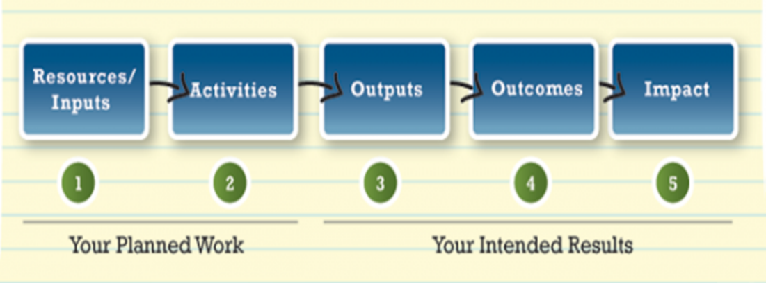

What is M&E?
M&E is a requirement for ODA projects that consists of three stages that show what the project does and what measurable impacts it will have:
- Defining intended impacts
- Checking progress against objectives
- Evaluating (ongoing and final) results

- Defining Intended Impacts
Creating an M&E plan is the first phase of the process and is where you lay out your objectives (outcomes and impacts), how you will measure success, who has responsibility for elements of the process, and when you will monitor (and evaluate) the different pieces.
The basic elements you need to define are:
- Theory of Change
- Objectives (outcomes and impacts)
- Measures of success (targets) for each output, outcome and impact (documented in a Logical Framework)
- Based on your Theory of Change
- They should be qualitative and quantitative, and there will possibly be several for a single outcome or impact
- Targets should be SMART (specific, measurable, attainable, relevant and timebound)
- Plans for how and when you monitor and evaluate the project (documented in an M&E Plan)

Theory of Change
A Theory of Change, typically presented in diagrammatic flow chart form is a comprehensive description and illustration of how and why a desired change is expected to happen in a particular context. It is a tool to help you explain how and why you expect your project activities and outputs to result in the ultimate changes you seek. It provides the logical explanation and flow between project input to outputs, outcomes and finally social, economic and/or environmental impacts, as illustrated in the example below.

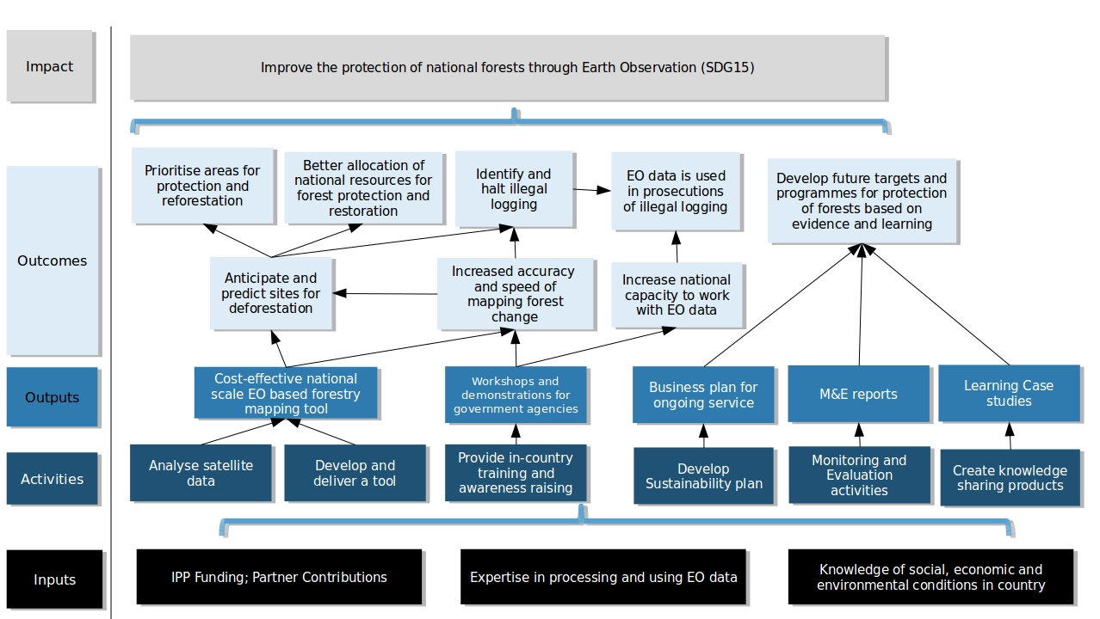
Figure 2: Example Theory of Change for an Earth Observation Deforestation Project

Logical Framework
A Logical Framework (Logframe), is one of the most common planning, monitoring and evaluation tools used to describe the anticipated chain of cause and effect in development interventions. They are based on a simple grid and describe your Theory of Change in a more measurable (and reportable) format.

M&E Plans
M&E plans are the final piece of M&E documentation, which pull together the Theory of Change, Logframe, budget, resources, evaluations and other project planning information into a cohesive document explaining the project’s overall approach to M&E. In IPP, these will be developed with successful grantees after contracts have been signed, with support from the UKSA M&E provider.

- Checking Progress (Monitoring)
Ongoing monitoring helps to track progress against your plans both during the project and after the delivery/implementation has finished. Monitoring is the routine collection and analysis of information based on your M&E plan and is focused on monitoring inputs, activities, outputs and (short term) outcomes. In your M&E plan, you will have defined how you will monitor against these indicators, who will do so and at what frequency; thus monitoring is the implementation of that plan.

- Evaluating Results
Evaluations are the systematic, objective assessment of your intervention's design, implementation and results (impacts). Evaluations should:
- Provide accountability and track/record learnings
- Focus on outcomes and overall impact
- Don’t be fooled into thinking it is all about the inputs and activities.
- Be measured against a baseline assessment, to show the impact (change) that your intervention has had
- Be implemented at the end of all projects, and for projects of 12 months or more, should also have a mid-line evaluation. Note: that is can also be useful to carry out evaluations of some targets at a set time after a project closes, once impacts start to materialise.
- Be able to make some claims about what degrees of results are attributable to the project, through the use of a counterfactual study. (i.e. what would have happened anyway if the project wasn’t implemented?)
- Include an assessment of:
- Process: how was the project implemented?
- Impact: what changed as a result of the project?
- Cost-Effectiveness: was the project cost efficient compared to alternatives?

Evaluation Criteria
Evaluations are typically carried out using the OECD DAC Criteria for Evaluating Development Assistance. Grantees will be expected to plan for, and conduct independent evaluations that assess their project against these criteria:
- Relevance: The extent to which the project is suited to the priorities and policies of the target group, recipient and donor.
- Effectiveness: A measure of the extent to which an project attains its objectives.
- Efficiency: Efficiency measures the outputs -- qualitative and quantitative -- in relation to the inputs. It is an economic term, which signifies that project aid uses the least costly resources possible in order to achieve the desired results.
- Impact: The positive and negative changes produced by a development intervention, directly or indirectly, intended or unintended. This involves the main impacts and effects resulting from the activity on the local social, economic, environmental and other development indicators. The examination should be concerned with both intended and unintended results and must also include the positive and negative impact of external factors, such as changes in terms of trade and financial conditions.
- Sustainability: Sustainability is concerned with measuring whether the benefits of an activity are likely to continue after donor funding has been withdrawn. Projects need to be environmentally as well as financially sustainable.

Figure 3: OECD DAC Evaluation Criteria
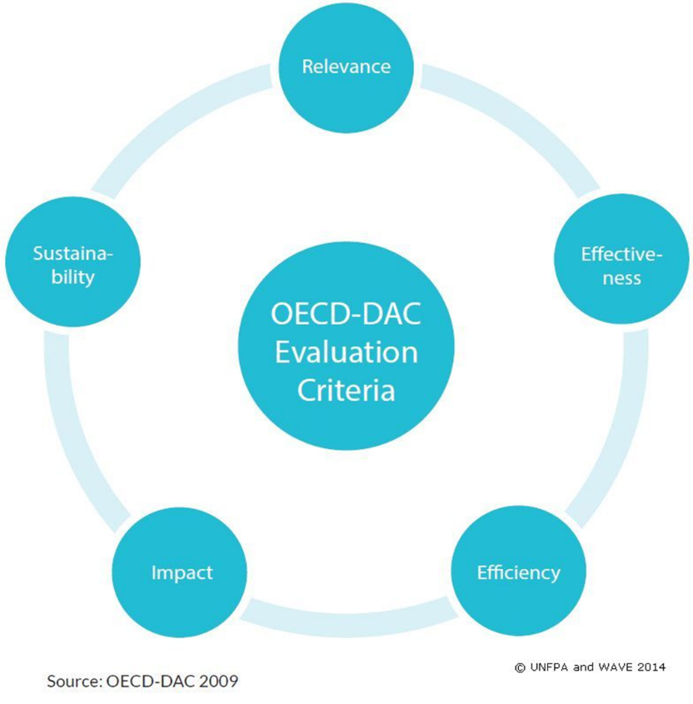

The M&E Process
A typical M&E process will have a few common elements, including baseline and endline evaluations at the start and end of the project. Midline reviews are typically used in projects that are longer than 1 year. Monitoring happens at regular, predictable intervals during the project timeline.

Figure 4: High Level M&E Process
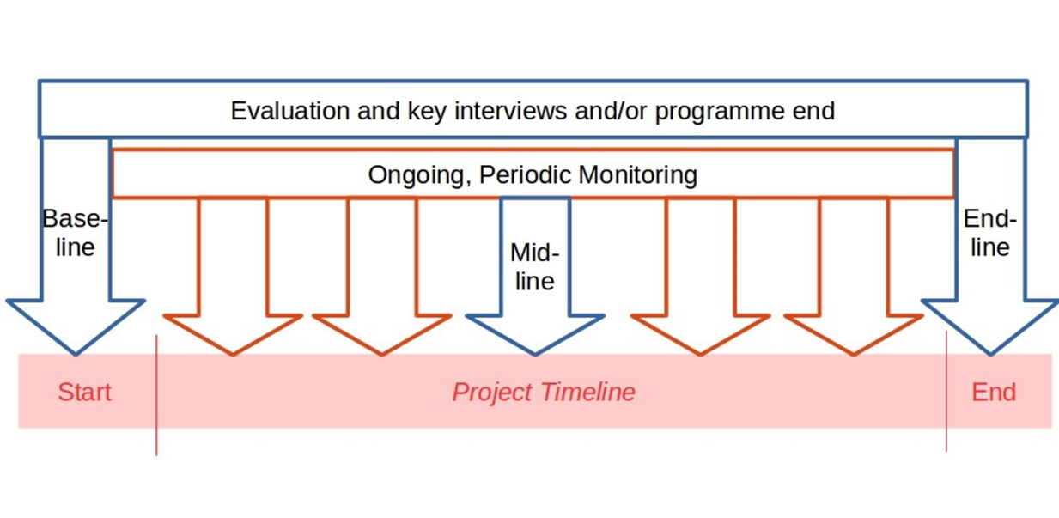

M&E Challenges
- Attribution vs. Contribution
- Attribution is the idea that a change (outcome or impact) is solely due to your intervention, i.e. you can say that with certainty you 'caused' something to happen.
- Contribution is the idea that your influence is just one of many factors which contribute to a change. i.e. you might be able to show that your project contributed to changes in people's behaviour, but you can never be sure that other social, political, economic or environmental factors also influenced the change.
- No one works in a vacuum, so it is very rare that you will know that a change is solely attributable to your intervention.
- So, focus on your contribution to an outcome or impact, rather than attribution and consider other environmental factors that may have an impact.
- Also consider how you can measure ‘what would have happened anyway’ (i.e. the counterfactual).
- Consider how you might make use of a comparison group for evaluating outcomes.
- Comparison groups have similar characteristics to your target group, but do not benefit from intervention of your project.
- Setting the 'right' indicators
- There is always pressure to set quantifiable and easy to measure indicators instead of qualitative information (e.g. about behavioural changes).
- However, there are established tools and processes to gather qualitative data (see the Resources section at the end of this guide as a starting point).
- Remember to consider, when setting your indicators, how you will get baseline measurements for each indicator, and consider a baseline assessment just before or when your project kicks off.
- Reporting on long-term outcome and impacts
- Results may not materialise during project timeline, and may not be evident for significant periods of time to come.
- Be realistic about what you can achieve – and measure – during the project lifespan, and consider if you need to conduct a follow-up evaluation at a time after the project closes.

Planning for M&E
- Consider what templates, tools and resources you may need.
- Allow 5% to 15% of the overall cost of the project for M&E. Don’t underestimate the amount of effort it will take.
- Ensure there is a qualified person, or contracted team, who is responsible for managing the M&E process and enough skilled resources are allocated for implementation.
- Consider both quantitative & qualitative assessments.
- Also, consider the third party resources that may be required, e.g. on the ground resources to carry out the baseline, midline and endline assessments, especially as these may require qualitative assessments. Consider the use of comparison group studies if applicable.
- Consider how you will learn from and communicate the results of your project. The information you will gather from the M&E process can be invaluable to your own project strategy and to others, so find ways to plan for how you will share it.

Benefits of M&E
- It is important for UKSA to be able to quantify the benefits that the IPP programme has had, to demonstrate cost-effectiveness/Value for Money (VFM) and ODA impact.
- Provides for a process to ensure progress towards targets and course corrections if necessary.
- Enables process and product improvement through evaluation of what worked well/didn’t work.
- Provides a unified project vision to provide cohesion and buy-in across the consortium.
- Enables learning for IPP and the wider space and development sector.
- Allows you to communicate the positive impact story with evidence to back it up.
- Provides you with evidence and quantified results that can be used to support future expansion and sale of your services.

Resources
About Theory of Change (reference only, use the template in the Application Form):
Theory of Change Basics (Act Knowledge) (9 Pages)
How does Theory of Change Work? (TheoryofChange.org) (1 page)

About Logframes (reference only, use the template in the Application Form):
Logframe Guidance and Template (Tools 4 Dev)
The logical framework (INTRAC) (4 pages)
How to write a logical framework (Tools 4 Dev)

About M&E Plans:
M&E Plans (INTRAC) (3 pages)
UNDP Handbook on M&E (232 pages)
M&E Plan Template from Tools4Dev

About Evaluation Planning
DFID International Development Evaluation Policy (26 pages)
Plan and Manage an Evaluation (Better Evaluation)

Contacts for help/more Information
Tim Hayward/David Taverner
IPP@cariboudigital.net

Caribou Digital is a research and delivery consultancy dedicated to building ethical, sustainable digital economies.
Collectively we have decades of experience in delivering digital technology projects on the ground in emerging markets and researching the impact of digital platforms on primarily low-income users.
We specialise in the following:
- Understanding digital users and the way digital platforms create new social and cultural digital repertoires
- Understanding digital economies and ecosystems, and the new businesses models within them
- Understanding digital entrepreneurs, and what support and enabling environments they need to succeed
- Understanding digital impact, and developing monitoring & evaluation and learning strategies to assess the impact of programmes

See: http://cariboudigital.net/about/

http://www.oecd.org/dac/evaluation/daccriteriaforevaluatingdevelopmentassistance.htm

