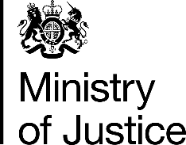 | February 2017

Freedom of Information Act (FOIA) Request – 109671

You asked for the following information from the Ministry of Justice (MoJ):

I am researching LGBT history for a BBC documentary series and need some statistics. Please can you provide me the total number of prosecutions and/or convictions for every year starting from 1965 all the way up to and including 1995 for the following sexual offences, in England and Wales;

• gross indecency and indecency between males
• buggery and attempted buggery
• soliciting/importuning by a man

I can confirm that the department holds the information that you have asked for, however some of it is exempt from disclosure.

Please find attached a table showing the number of offenders found guilty under offences of gross indecency and buggery in England and Wales from 1984 to 1995.

I can confirm that the MoJ holds some of the information that you have requested. However, some of the information held is exempt from disclosure under section 21 of the FOIA, because it is reasonably accessible to you.

Court proceedings statistics prior to 1984, which would include offenders found guilty of offences of gross indecency, soliciting by a man and buggery in England and Wales, can be obtained at this link http://tinyurl.com/gmf68ny.
(Please note this link may not be supported in all web browsers)

