 | 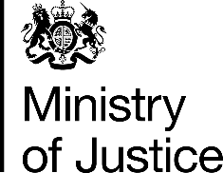
 | Our Reference: FOI 109391 |  | January 2017

Freedom of Information Request

You asked for the following information from the Ministry of Justice:

1] How many cases were brought to Court [HMCTS] under Sections 16-24 Data Protection Act 1998.

and

2] How many people were found guilty under Sections 16-24 Data Protection Act 1998.

Your request has been handled under the Freedom of Information Act 2000 (FOIA).

I can confirm that the department holds the information that you have asked for.

I am pleased to provide you with the attached table, as described below

- The number of defendants proceeded against at magistrates’ courts and found guilty at all courts of offences under Sections 16 to 24 of the Data Protection Act 1998, in England and Wales, from 2011 to 2015.

