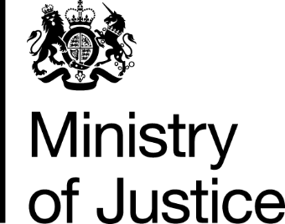

 | Our Reference: 109244 |  | January 2017

Freedom of Information Request

You asked for the following information from the Ministry of Justice (MoJ):

Under the freedom of Information FOI 2000 with regards to the DPA 1998; i kindly require breakdown of costs for the legal aid given to Gupta Law

Your request has been handled under the FOIA.

I can confirm that the MoJ holds the information that you have requested and I have provided it below:

Breakdown of costs for the legal aid given to Gupta Law, 2005 to September 2016

Legal Help:
Representing a total volume of 429 claims:
Year payment made |  | Total value (£)
2005 |  | 71,571
2006 |  | 34,214
2007 |  | 48,151
Civil representation:
Representing a total volume of 18 cases:
Year payment made | Total value (£)
2005 | 2,595
2006 | 36,375
2007 | 13,755
2008 | 31,660
2009 | 705
2016 | 3,264
You may be interested to note that the firm you have enquired about no longer have a legal aid contract. For the avoidance of doubt, the payment information from 2016 relates to an historic matter/matters where the position as to costs was not finalised until sometime after the relevant case/s concluded.

You can find a list of current legal aid providers at https://www.gov.uk/government/publications/directory-of-legal-aid-providers.

