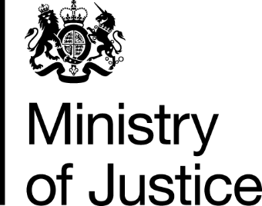  Original request: 109125 | January 2017
Freedom of Information Request

You asked for the following information from the Ministry of Justice (MoJ):

1. “The total number of applications for emergency funding received by the LAA since the introduction of the CCMS from 01 April 2016.

2. The number of applications for emergency funding received by the LAA whose processing time was more than 24 hours or 1 day (processing time meaning the time taken from the Legal Aid Agency’s receipt of the application to the time of a decision to grant or refuse an emergency certificate is made) since the introduction of the CCMS from 01 April 2016.

Your request has been handled under the FOIA.

I can confirm that the MoJ holds the information that you have requested and I have provided it below.

The following table shows the volume of "Assess Emergency Merits" applications submitted to and processed within the Legal Aid Agency’s CCMS computer system during the time period requested.
Period | Volume of applications | Volume where time taken to process exceeds 24hrs
April-2016 | 318 | 188
May-2016 | 339 | 188
June-2016 | 382 | 202
July-2016 | 366 | 250
August-2016 | 341 | 223
September-2016 | 341 | 233
Total | 2,087 | 1,284
Published legal aid statistics are currently only available for the first two quarters of this financial year.

I can confirm we classified processing time as up to the point where a status of Issued, Refused, Reject or Withdrawn was marked against the task on CCMS.

We endeavour to resolve each decision as expediently as possible, subject to the required evidence being provided to the Agency.

