|  |  |  |  |
| --- | --- | --- | --- |
| MoJ_BLK_SML | |  |  |
|  |  |  |
|  | **Our Reference:** 108328 |  | November 2016 |

**Freedom of Information Request**

You asked for the following information from the Ministry of Justice (MoJ):

*“****Rochdale Law Centre and Pennie west Citizens Advice, Oldham – Please can you tell me for both Organisations – regarding their Housing Law contracts Housing law – for the year 2015-16***

***1) How many completed full certificate cases did they submit for clients who live in Oldham?***

***2) How many completed full certificates cases or clients who live in Rochdale?***

***3) How many completed legal help cases did they submit for clients based in Oldham?***

***4) How many [Completed Legal Help Cases did they submit] for clients in Rochdale****”*

Your request has been handled under the Freedom of Information Act 2000 (FOIA).

I can confirm that the department holds information that you have asked for, and this is provided below.

Please note, in order to ensure we are in compliance with Data Protection principles and to ensure no individuals can be identified from the information provided, where the data sample is of five or fewer individuals this is presented as <5.

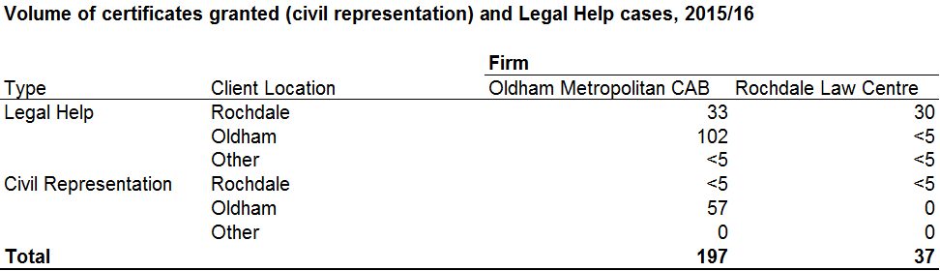

You can also find more information by reading the full text of the Act (available at <http://www.legislation.gov.uk/ukpga/2000/36/contents>).