UK standards for microbiology investigations

Conjunctivitis

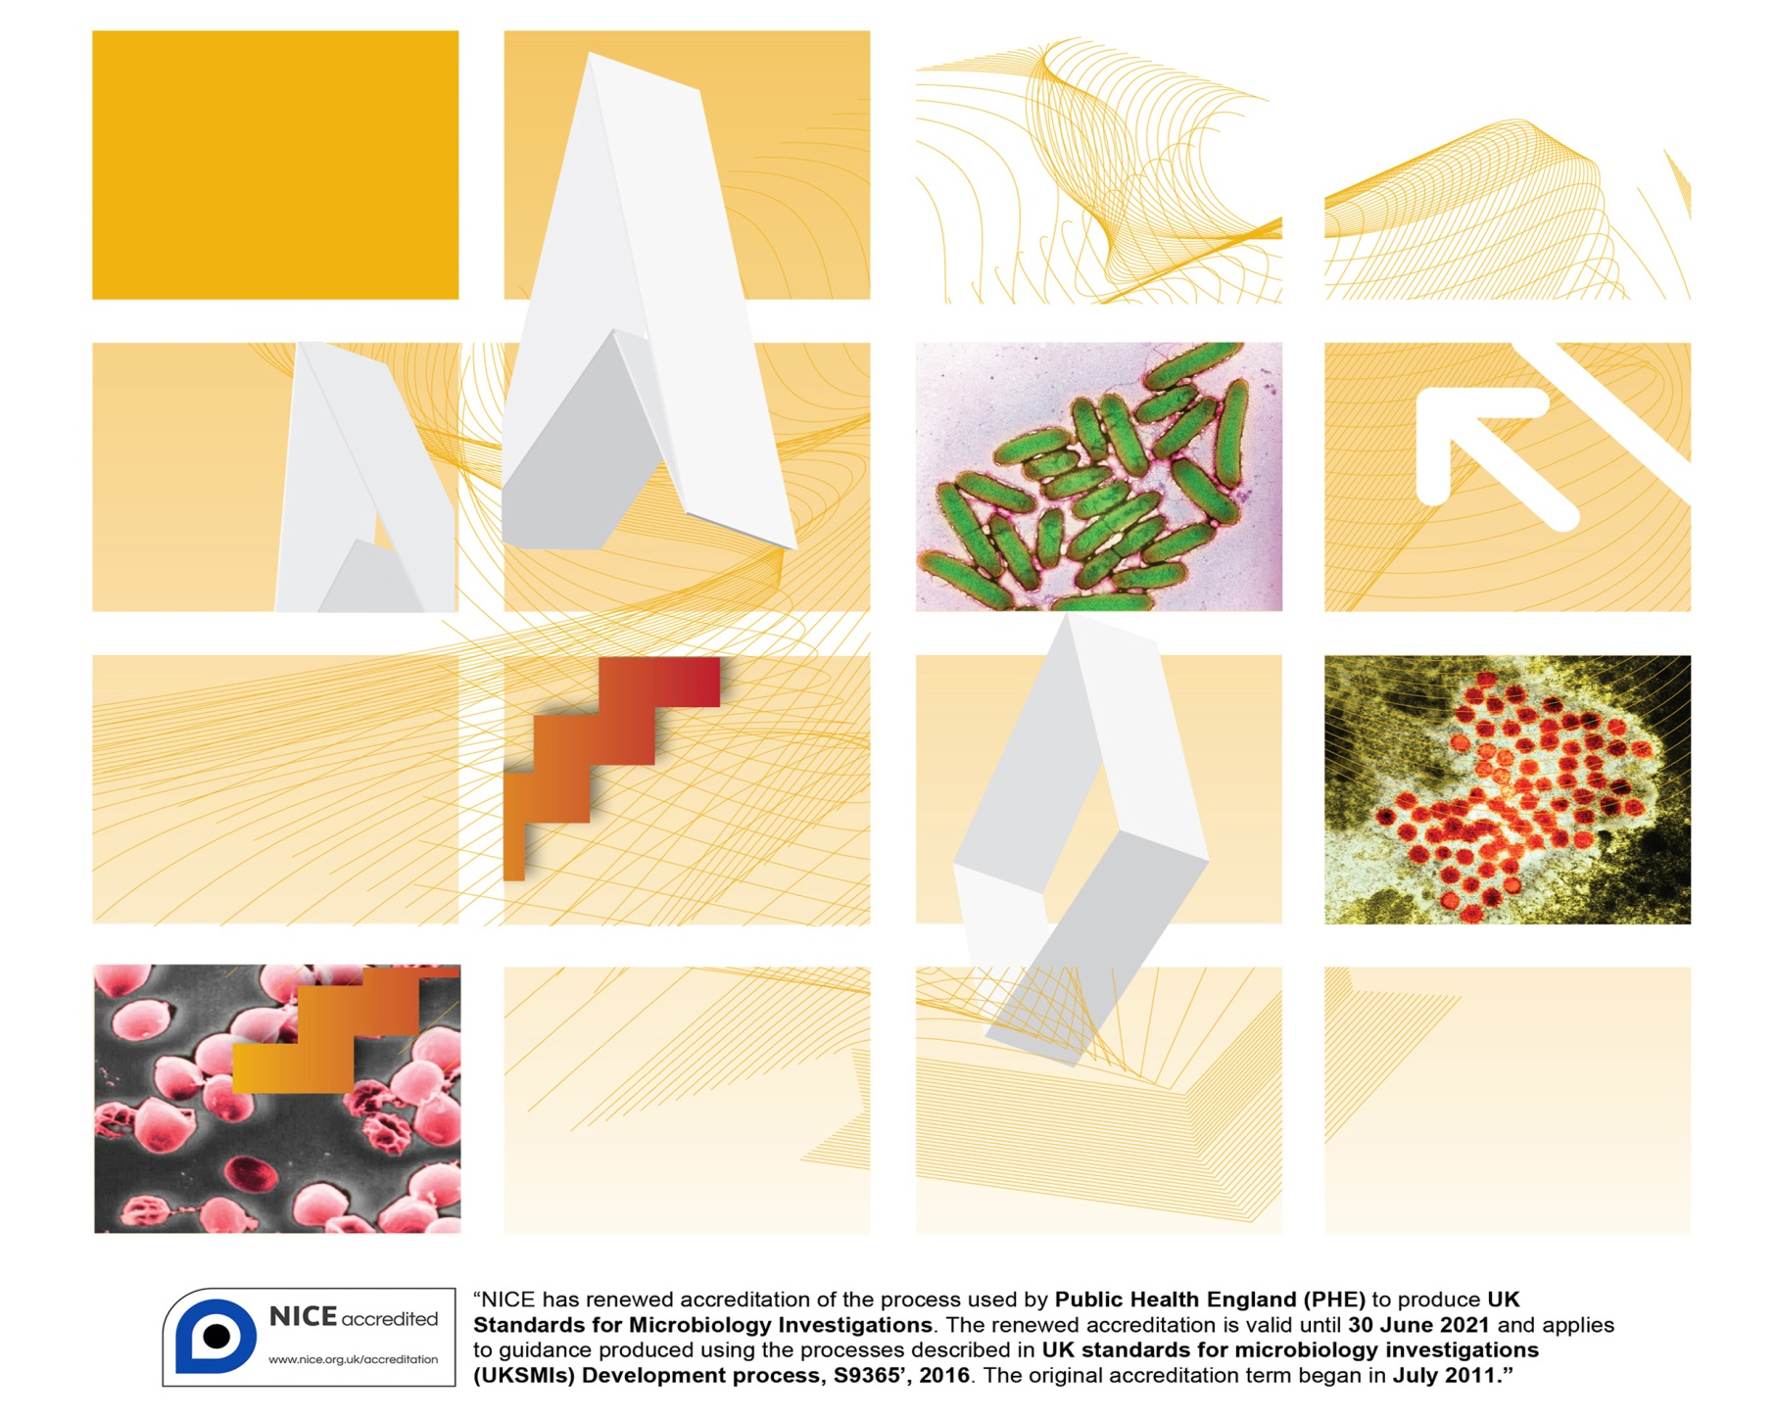

Acknowledgments
UK Standards for Microbiology Investigations (UK SMIs) are developed under the auspices of Public Health England (PHE) working in partnership with the National Health Service (NHS), Public Health Wales and with the professional organisations whose logos are displayed below and listed on the website https://www.gov.uk/uk-standards-for-microbiology-investigations-smi-quality-and-consistency-in-clinical-laboratories. SMIs are developed, reviewed and revised by various working groups which are overseen by a steering committee (see https://www.gov.uk/government/groups/standards-for-microbiology-investigations-steering-committee).
The contributions of many individuals in clinical, specialist and reference laboratories who have provided information and comments during the development of this document are acknowledged. We are grateful to the medical editors for editing the medical content.
For further information please contact us at:
Standards Unit
Microbiology Services
Public Health England
61 Colindale Avenue
London NW9 5EQ
E-mail: standards@phe.gov.uk
Website: https://www.gov.uk/uk-standards-for-microbiology-investigations-smi-quality-and-consistency-in-clinical-laboratories
PHE publication gateway number: 2016401

UK Standards for Microbiology Investigations are produced in association with:
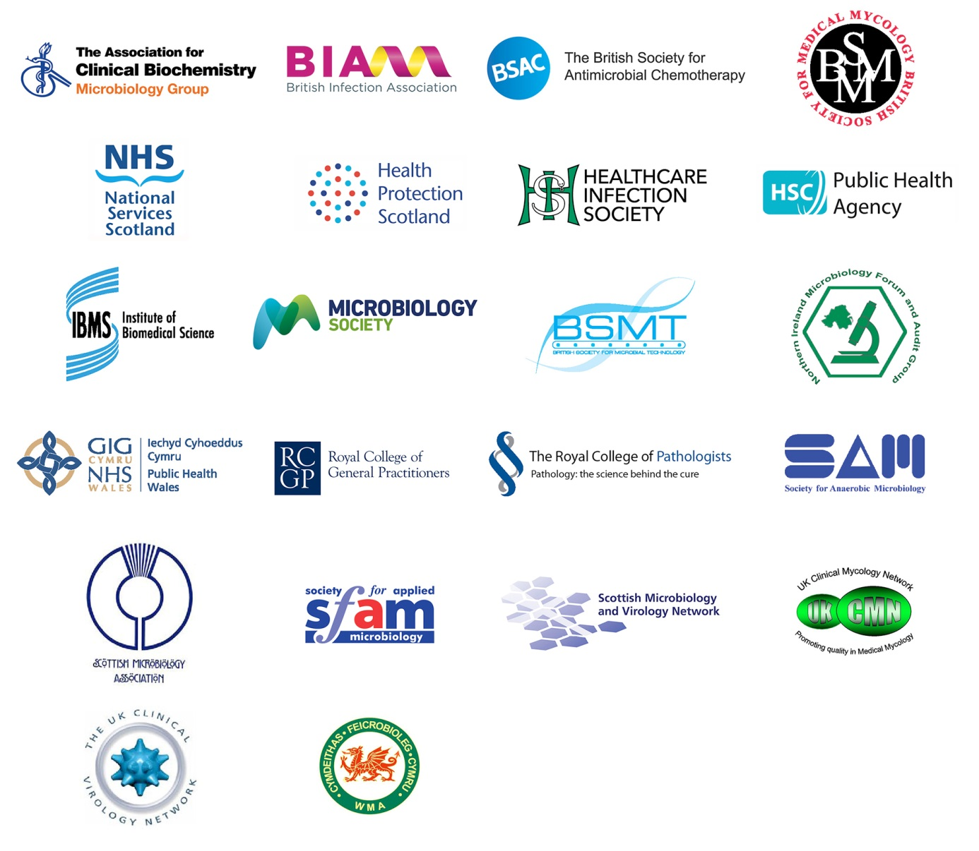
Logos correct at time of publishing.
Contents
Acknowledgments 2
Contents 3
Amendment table 5
UK SMI: scope and purpose 6
User manual template - background 8
Introduction and scope 9
Overview of services offered 10
Locating and contacting the laboratory 10
Consent, collection and transport of specimens 10
Test repertoire- suspected infective conjunctivitis 12
Reporting results 14
Interpreting laboratory results 14
Quality assurance and governance 14
Appendix 1: National user manual conjunctivitis 15
References 17

Amendment table
Each SMI method has an individual record of amendments. The current amendments are listed on this page. The amendment history is available from standards@phe.gov.uk.
New or revised documents should be controlled within the laboratory in accordance with the local quality management system.
Amendment number/date | New amendment number/dd.mm.yy <tab+enter>
Issue number discarded | xx
Insert issue number | #.# <tab+enter>
Anticipated next review date*
Section(s) involved | Amendment

*Reviews can be extended up to five years subject to resources available.

UK SMI#: scope and purpose
Users of SMIs
Primarily, UK SMIs are intended as a general resource for practising professionals operating in the field of laboratory medicine and infection specialties in the UK. UK SMIs also provide clinicians with information about the available test repertoire and the standard of laboratory services they should expect for the investigation of infection in their patients, as well as providing information that aids the electronic ordering of appropriate tests. The documents also provide commissioners of healthcare services with the appropriateness and standard of microbiology investigations they should be seeking as part of the clinical and public health care package for their population.
Background to SMIs
SMIs comprise a collection of recommended algorithms and procedures covering all stages of the investigative process in microbiology from the pre-analytical (clinical syndrome) stage to the analytical (laboratory testing) and post analytical (result interpretation and reporting) stages. Syndromic algorithms are supported by more detailed documents containing advice on the investigation of specific diseases and infections. Guidance notes cover the clinical background, differential diagnosis, and appropriate investigation of particular clinical conditions. Quality guidance notes describe laboratory processes which underpin quality, for example assay validation.
Standardisation of the diagnostic process through the application of SMIs helps to assure the equivalence of investigation strategies in different laboratories across the UK and is essential for public health surveillance, research and development activities.
Equal partnership working
UK SMIs are developed in equal partnership with PHE, NHS, Royal College of Pathologists and professional societies. The list of participating societies may be found at https://www.gov.uk/uk-standards-for-microbiology-investigations-smi-quality-and-consistency-in-clinical-laboratories. Inclusion of a logo in an SMI indicates participation of the society in equal partnership and support for the objectives and process of preparing UK SMIs. Nominees of professional societies are members of the Steering Committee and working groups which develop UK SMIs. The views of nominees cannot be rigorously representative of the members of their nominating organisations nor the corporate views of their organisations. Nominees act as a conduit for two way reporting and dialogue. Representative views are sought through the consultation process. UK SMIs are developed, reviewed and updated through a wide consultation process.
Quality assurance
NICE has accredited the process used by the UK SMI working groups to produce SMIs. The accreditation is applicable to all guidance produced since October 2009. The process for the development of UK SMIs is certified to ISO 9001:2008. UK SMIs represent a good standard of practice to which all clinical and public health microbiology laboratories in the UK are expected to work. SMIs are NICE accredited and represent neither minimum standards of practice nor the highest level of complex laboratory investigation possible. In using SMIs, laboratories should take account of local requirements and undertake additional investigations where appropriate. SMIs help laboratories to meet accreditation requirements by promoting high quality practices which are auditable. SMIs also provide a reference point for method development. The performance of SMIs depends on competent staff and appropriate quality reagents and equipment. Laboratories should ensure that all commercial and in-house tests have been validated and shown to be fit for purpose. Laboratories should participate in external quality assessment schemes and undertake relevant internal quality control procedures.
Patient and public involvement
The SMI working groups are committed to patient and public involvement in the development of SMIs. By involving the public, health professionals, scientists and voluntary organisations the resulting SMI will be robust and meet the needs of the user. An opportunity is given to members of the public to contribute to consultations through our open access website.
Information governance and equality
PHE is a Caldicott compliant organisation. It seeks to take every possible precaution to prevent unauthorised disclosure of patient details and to ensure that patient-related records are kept under secure conditions. The development of SMIs is subject to PHE Equality objectives https://www.gov.uk/government/organisations/public-health-england/about/equality-and-diversity.
The SMI working groups are committed to achieving the equality objectives by effective consultation with members of the public, partners, stakeholders and specialist interest groups.
Legal statement
While every care has been taken in the preparation of SMIs, PHE and the partner organisations, shall, to the greatest extent possible under any applicable law, exclude liability for all losses, costs, claims, damages or expenses arising out of or connected with the use of an SMI or any information contained therein. If alterations are made by an end user to an SMI for local use, it must be made clear where in the document the alterations have been made and by whom such alterations have been made and also acknowledged that PHE and the partner organisations shall bear no liability for such alterations. For the further avoidance of doubt, as SMIs have been developed for application within the UK, any application outside the UK shall be at the user’s risk.
The evidence base and microbial taxonomy for the SMI is as complete as possible at the date of issue. Any omissions and new material will be considered at the next review. These standards can only be superseded by revisions of the standard, legislative action, or by NICE accredited guidance.
SMIs are Crown copyright which should be acknowledged where appropriate.
Suggested citation for this document
Public Health England. (YYYY <tab+enter>). Conjunctivitis. UK Standards for Microbiology Investigations. U # <tab+enter> Issue #.# <tab+enter>. https://www.gov.uk/uk-standards-for-microbiology-investigations-smi-quality-and-consistency-in-clinical-laboratories
User manual template - background
The user manual template has been developed by an SMI joint working group of microbiologists. The document aims to help microbiology service providers produce a comprehensive user manual meeting the current ISO standards. The ISO standards should be used in conjunction with this template¹. Duplications within the document are intended to emphasise key points. The document should be considered a template, with suggested headings providing the basis on which individual labs or services can develop their own user manual.
The suggested ordering and content of this user manual can be changed but we recommend all suggested content remains included, for example, it may be possible to encompass many elements in a single hyperlinked table of services and tests offered.
The microbiology service provider’s user manual is intended as a general resource for practising healthcare professionals.
It is recommended that user manuals are made available to general practitioners through their local Clinical Commissioning Group (CCG). Although not intended for public and patient groups, they may find the user manual a useful source of information.
The use of plain English is recommended.

Introduction and scope
Conjunctivitis is a common condition that causes redness and inflammation of the thin
layer of tissue that covers the front of the eye- the conjunctiva. Conjunctivitis is
sometimes called pink eye. Aside from red eye(s), other symptoms of conjunctivitis
include itchiness and watering of the eyes, and sometimes a sticky coating on the
eyelashes. Conjunctivitis can affect one eye at first, but usually affects both eyes after
a few hours.

Features such as the clinical appearance of the eye, the age of the patient, and the
exposure history should be taken into account in assessing the likely cause of this
condition.

Some causes of red eye are serious and require urgent specialist opinion, for example
glaucoma, iritis, keratitis. If there is any of moderate or severe eye pain, changes in
vision or photophobia (not wanting to look at bright lights), seek a specialist opinion.
There are two main types of conjunctivitis – allergic and infective; another type is irritant. Irritant conjunctivitis occurs when something irritates the conjunctiva, such as shampoo, or a loose eyelash.

Allergic conjunctivitis occurs when the immune system of the body attacks something that is not an infectious agent, such as pollen or make-up, causing inflammation. The eyes are typically itchy.
Infective conjunctivitis accounts for around 35% of all eye problems presenting in
general practice. Symptoms of infective conjunctivitis include hyperaemic red
conjunctiva and a mucopurulent discharge. It often starts in one eye and
moves to involve the other eye. There may be history of contact with another infected
person, and/ or symptoms of upper respiratory tract infection. Infective conjunctivitis is
caused by several different types of viruses, bacteria, fungi or parasites infecting the
eye. Estimates of the proportion of infective conjunctivitis that are bacterial vary widely
between studies. Recent studies in primary care estimate that between 33% and 78%
of cases are bacterial in origin. Bacterial conjunctivitis is most commonly caused by
Staphylococcus species, Streptococcus pneumoniae, Haemophilus influenzae, and
Moraxella catarrhalis. Viral conjunctivitis is most commonly caused by adenovirus.
Chlamydia presents with a chronic conjunctivitis in newborns and people who are
sexually active. Neonatal conjunctivitis (previously called ophthalmia neonatorum) is
defined as any conjunctivitis of the newborn that occurs within the first 28 days of life.
It may be caused by infection or be a toxic response to topical treatments applied to
the eye. The most important causes are gonorrhoea because it can result in a serious
localized infection, and chlamydia which can be associated with the development of
pneumonia.
In most scenarios there is no requirement to test, however conjunctivitis can be a feature of systemic illness (notably measles)^{2,3}. Persistent, hyperacute (very rapid onset), or persistent (over 3 weeks) cases should be investigated.

For consultation purposes this introduction and scope is an example only, and could contain less, more, and/or different content specific to the user needs.
Overview of services offered
You should include:
- detail of basic services (diagnostic testing, clinical advice, infection control, infectious diseases, outbreak management, antibiotic stewardship, etc)
- listing of specialist areas, for example, regional or national reference facilities and provision of immunoglobulins and vaccines
Locating and contacting the laboratory
You should include:
- location maps for both outside and inside the hospital (or links to the relevant source)
- specimen reception opening times and out of hours contact instructions
- instructions on making enquiries for results and requests for additional tests on existing samples
- availability of clinical advice on ordering of examinations and interpretation of examination results
- details of any out-of-hours service or shift system at the laboratory. Outline which services will always be provided and which will only be provided after consultation
- contact details for key members of staff including availability times, email addresses of key members of staff, how to obtain results and clinical advice for out of hours service
- whether the public has access to the laboratory or not and where phlebotomy (and paediatric phlebotomy) services are located
- clear advice to patients on how to obtain results; explain whether patients should or should not call the laboratory directly for results – indicating consideration of data security and clinical risk
Consent, collection and transport of specimens
You may wish to include generic advice on collecting and transporting specimens such as:
- instructions for preparation for sample collection (for example, for caregivers, phlebotomists, sample collectors and patients)
- recording the use of anti-infective treatments, topical or systemic and other topical eye treatments
- procedures for the safe collection and handling of primary samples, including appropriate health and safety advice on labelling and transporting high risk samples, such as those containing radioactive isotopes. Information for users on whether certain samples should be regarded as high risk should be clear. Universal precautions should be recommended
- instructions for sample collectors, including instructions for patient-collected samples, for example: type and amount of the primary sample(s) to be collected; descriptions of the primary sample containers (pictures may be helpful) and any necessary additives; special timing of collection, where needed; how and where to provide clinical information relevant to or affecting sample collection, test performance or result interpretation (for example, drug dosages and timings); information on how to order supplies of the relevant containers, forms, labels etc. This may be displayed in table format or images/pictures and may be linked or cross referenced to patient information sheets
- information on the appropriate amount of specimens required for multiple requests (this may be automatically calculated by electronic test order software)
- instructions for proper storage conditions and maximum times for storage before collected samples are delivered to the laboratory and in a manner that ensures the integrity of the sample and safety for the carrier, general public and receiving laboratory, in compliance with established requirements. You should refer to the applicable ISO standard
- instructions for transportation of samples, including any special handling needs (such as high risk samples, radioactive isotopes, samples on dry ice). You may wish to describe specific or defined details of the transport times as well as cut off times for receipt at individual laboratories, if applicable
For consultation purposes- the content relating to the yellow highlighted test above can be placed in the testing table or detailed separately.

Test repertoire- suspected infective conjunctivitis this is an example of format only
Clinical Setting | First line investigation and target pathogens | Second line  investigation and  target pathogens | Rationale | Notes | Hyperlinks
Uncomplicated suspected infective conjunctivitis- not neonate | Bacterial eye swab – S. aureus, S. pneumoniae, S. pyogenes, M. catarrhalis, H. influenzae, N. gonorrhoeae, etc.  Viral eye swab - adenovirus/HSV | Eye swab for NAAT  C. trachomatis  Rare bacterial pathogens  Viral eye swab, lesion swab – VZV, enterovirus  Acanthamoeba detection in contact lens wearers |  | Haemorrhagic conjunctivitis -enterovirus 70, 71 and coxsackievirus A24, B2  Adenovirus 8, 19 – associated with keratoconjunctivitis. Notify laboratory if an outbreak is suspected | As above.  Consider BASHH guidelines on NAAT for non-genital samples
Neonate (under 28 days old) | Eye swab for NAAT. Add laboratory specific detail on kit used.  For detection of C. trachomatis and N. gonorrhoea  Bacterial eye swab – S. aureus, S. pneumoniae, S. pyogenes, M. catarrhalis, H. influenzae, N. gonorrhoeae, etc. | Eye swab for virus  detection Add laboratory specific detail on kit used. | Chlamydia and gonorrhoea are the most important cause with potential for eye damage and systemic illness, plus implications for mother and her sexual contacts.  Most laboratories can offer chlamydia and gonorrhoea molecular detection as a set of tests on a single sample.  Viral conjunctivitis in neonates is relatively rare and uncomplicated but can be serious if HSV. | Suspected neonatal HSV should trigger urgent paediatric referral.  If C. trachomatis or N. gonorrhoeae detected, mother and her sexual contacts should be offered testing and will require paediatric referral due to risk of systemic infection and problems such as pneumonitis.. | Specimen type page which should include picture of kits/ instructions on how to take samples/ pitfalls of tests/ turnaround times/sample storage duration/ if referred to another laboratory/ etc.  Duplicate links to professional guidance here (links must be maintained however)
Conjunctivitis as a feature of systemic illness | Depends on illness- see sections on rash |  | In some of these, eye  swab will detect  pathogen, some not | Conjunctivitis can be a  feature of serious  systemic infectious  disease, e.g. measles,  viral haemorrhagic  fever, Zika virus,  Leptospirosis. | Links to pages on rash illness,  and other relevant pages.  Warnings about high risk  Samples.
Specific conditions | Molluscum contagiosum - EM/PCR of vesicle material; Papillomavirus 6,11 – Swab/ biopsy for NAAT; amoebic etc
You should include the following:
- examinations offered by the laboratory. Include logical listings or tables of tests and turnaround times), primary sample volumes, specific specimen containers, special precautions, and procedures for medico-legal samples
- details of relevant clinical algorithms, with links to local or national policies
- lists of referred tests, including the names, addresses and accreditation status of laboratories to which work is routinely referred
- a table to state the duration of storage for samples that may need re-testing, with information on disease incubation periods, testing interval and time limits for requesting additional tests
You may also wish to include information on the costs of tests.

Reporting results
You should include the following:
- provide instructions for making result enquiries
- advice to review electronic reporting systems before phoning for results
- explanation of different report status categories (interim, final, amended)
Interpreting laboratory results this would normally be in another section but can be duplicated here as text or some can go in table above, e.g. technical test performance characteristics
You should include relevant information on:
- biological reference intervals or clinical decision values (document their basis)
- a list of factors known to significantly affect the performance of the examination (uncertainty of measurement) or the interpretation of the results
- performance characteristics – sensitivity/specificity of the tests
You may wish to include:
- pitfalls of serology, PCR, culture etc. As well as having such things embedded within individual tests, consider a brief explanation of passively acquired antibody, cross reactivities for IgM assays and the effects of sample quality
Quality assurance and governance
You should include details of:
- the quality assurance and governance structure for the laboratory
- the complaints procedure
- the laboratory’s policy on protection of personal information; and the fax and email policy
- ensure that the manual is consistent with ISO15189 guidance (reference the ISO guidance in this section)¹
- a statement on the accreditation status, link to the accreditation body, and list of which (if any) tests are excluded from the accredited scope of practice (accreditation status of test repertoire)
- how to obtain validation/verification data
- compliance with Human Tissue Act

Appendix 1: National user manual conjunctivitis example of format only

Footnotes
  - Also refer to B 2 Investigations of Eye Swabs and Canalicular Pus, B 28 – Investigation of Genital Tract and Associated Specimens, V 21 – Isolation of Viruses Associated with Infections of the Eye: Keratoconjunctivitis, V 37 – Chlamydia Infection – Testing by Nucleic Acid Amplification Test (NAATS)
  - Only carried out if shingles is indicated in the clinical details

References
1. European committee on Standardization. Medical laboratories - Requirements for quality and competence (ISO 15189:2012). British Standards Institution. 1-50. 2012.

2. Royal College of General Practitioners. Management of infective conjunctivitis in primary care. 1-5. 2014.

3. The Royal College of Opthalmologists. Commissioning better eye care. 1-17. 2013.

# Microbiology is used as a generic term to include the two GMC-recognised specialties of Medical Microbiology (which includes Bacteriology, Mycology and Parasitology) and Medical Virology.

