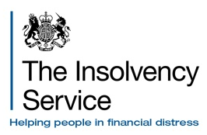 | Rule 7.42

Company Winding-up – Statement of Affairs
STATEMENT OF CONCURRENCE
Enter court details  Insert full name of company to which statement of affairs relates  Insert date the statement of affairs was made on which this statement of concurrence refers  Insert full name of person who signed the statement of affairs being concurred with  Insert full name and address of person making this statement of truth  *Mark with an ‘x’ as applicable  List any matters in the statement of affairs which you are not in agreement with, or which you consider to be erroneous or misleading, or matters to which you have no direct knowledge and indicate reason for listing them  *Mark with an ‘x’ if subject to qualifications | Company name
 | (IN LIQUIDATION)
 | In the |  |  |  |  |  |  |  | Number
 | Company registration number
 | With regards to the Statement of Affairs of
 | made on
 | by
 | Statement of truth
 | I
 | of
 |  |  | * concur with the Statement of Affairs of the above company and I believe that the facts stated in the Statement of Affairs are a full, true and complete statement of the affairs of the company on the date that it entered liquidation.
 |  |  | OR
 |  |  | *concur with the Statement of Affairs of the above company, subject to the following qualifications
 |  |  | and believe that, the facts stated in the Statement of Affairs are a full, true and complete statement of the affairs of the company on the date that it entered liquidation.

Full name

Signed

Dated
NOTE: You must deliver the statement of concurrence (with a copy) to the official receiver before the end of the period of five business days (or such other period as the official receiver has agreed with you) beginning with the day on which you received the statement of affairs.

