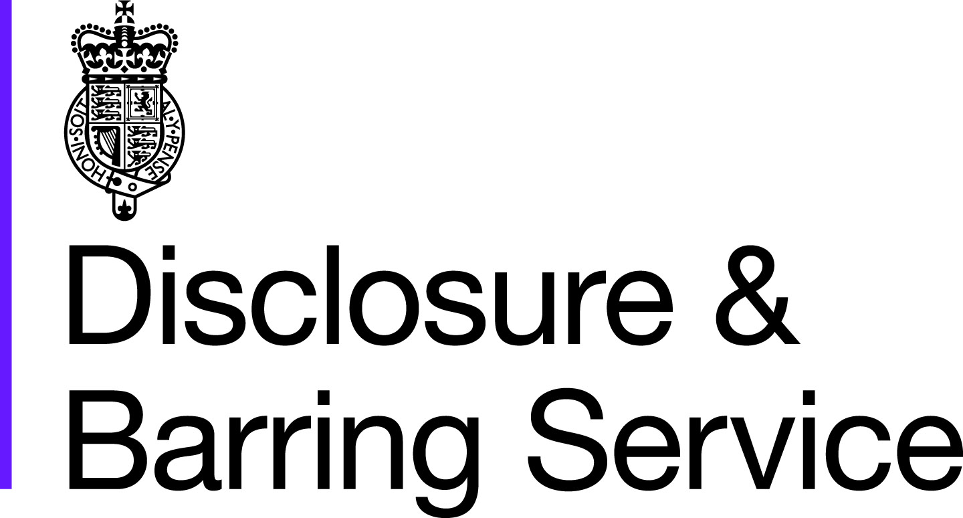
DBS certificate reprint request form
(applicant only)

To request a certificate reprint the criteria in the guidance must be met and all sections of this form need to be completed.

If you don’t meet the guidance criteria or complete the form in full your request will be rejected.

Your details
Your details
Surname
Forename(s)
Date of birth
Address
Postcode
Reason for request
Position applied for
Name of employer
Application Ref.
Date of certificate issue
Level of Disclosure (Standard or Enhanced)
Email this form to DBSReprints@dbs.gov.uk
We can’t guarantee the security of information until it is in our possession, and will not take responsibility for information until we receive it.
The reprint team can’t respond to any other type of query you may have. Please go to our website homepage to find out more about the DBS.

