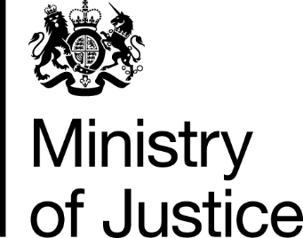
 | Our Reference: 534-16 FOI 107914 |  | October 2016

Freedom of Information Request

You asked for the following information from the Ministry of Justice (MoJ):

How many children have been convicted of murder in the UK in the last year / decade / last 20 years.

Also am researching the same information for the US.

Any help with research on these stats and/or putting us in touch with another organisation who could help, would be much appreciated.

Your request has been handled under the Freedom of Information Act 2000 (FOIA). Please accept my apologies for the delay in this response.

I can confirm that the department holds information for England and Wales. The attached table provides the number of juveniles (who are aged under 18) found guilty at all courts of murder from 1996 to 2004. Data for the later years is exempt under section 21 of the FOIA because it is reasonably accessible to you via the following link.

https://www.gov.uk/government/statistics/criminal-justice-system-statistics-quarterly-december-2015

Section 21 of the FOIA exempts disclosure of information that is reasonably accessible by other means, and the terms of the exemption mean that we do not have to consider whether or not it would be in the public interest for you to have the information.

You can find out more about section 21 by reading the extract from FOIA and some guidance points we consider when applying this exemption, attached at the end of this letter.

If you wish to receive statistics on court proceedings in Scotland or Northern Ireland, these are under the remit of the Scottish Government and the Department of Justice Northern Ireland. Contact details can be found at the following links:

http://www.scotland.gov.uk/About/Information/FOI
http://www.dojni.gov.uk/index/foi.htm

