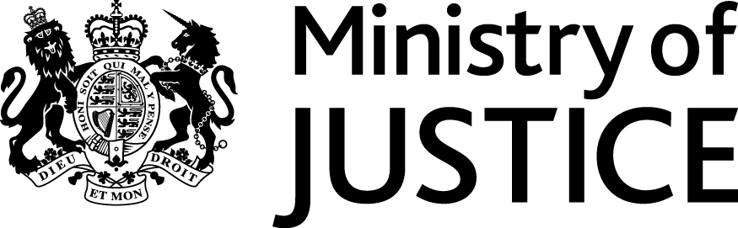
 | Our Reference: 474-16 FOI 107177 |  | January 2017

Freedom of Information Request

You asked for the following information from the Ministry of Justice (MoJ):

I am writing to ask if you can provide me with statistics for the number of young people under 25 years being convicted of any crime. I am contrasting 1950 (or thereabouts) and the latest figure (2014/5?).

Your request has been handled under the Freedom of Information Act 2000 (FOIA). Please accept my apologies with the delay in this response.

I can confirm that the department holds the information that you have asked for.

The attached annex provides the number of offenders aged under 25 years found guilty by each offence, in England and Wales 2015.

Please note that court proceedings statistics, which would include offenders found guilty of all offences, in England and Wales, from 1885 to 1983, can be obtained from The Stationery Office bookshop at http://www.tsoshop.co.uk – search for “Criminal Statistics England and Wales”. Copies of these publications may also be found in the British Library at: http://www.bl.uk/.

