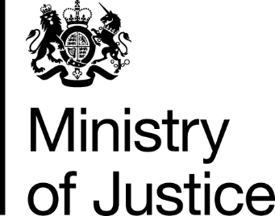
 | Our Reference: 647-16 FOI 108798 |  | November 2016

Freedom of Information Request

You asked for the following information from the Ministry of Justice (MoJ):

I am seeking some statistics on male and female sentencing for all crimes In the United Kingdom. I am looking for as up to date records as you possibly have and I do not necessarily require details of crime although useful, I require age and gender. If you could assist me with this I would be very grateful.

Your request has been handled under the Freedom of Information Act 2000 (FOIA).

I can confirm that the department holds some of the information that you have asked for. However, the information that is held is exempt under section 21 of the FOI Act because it is reasonably accessible to you, and I am pleased to inform you that you can access it via the following links.

The number of offenders found guilty and sentenced at all courts, in England and Wales, from 2005 to 2015 (latest figures available), can be found in the Criminal Justice Statistics Outcomes by Offence section in the latest annual Criminal Justice Statistics publication. A wider offence list for those offences contained in the ‘offence’ drop down list is contained in the ‘offence group classifications’ further down the page the link provides. You will note the drop down boxes for gender and age.

https://www.gov.uk/government/statistics/criminal-justice-system-statistics-quarterly-december-2015

Further data is available in the recently published Women and the Criminal Justice System 2015 publication, available at the below link:-

https://www.gov.uk/government/statistics/women-and-the-criminal-justice-system-statistics-2015

Section 21 of the Freedom of Information Act exempts disclosure of information that is reasonably accessible by other means, and the terms of the exemption mean that we do not have to consider whether or not it would be in the public interest for you to have the information.

