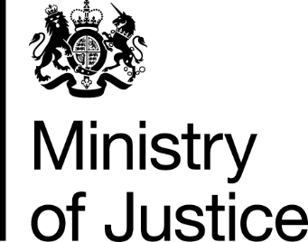
 | Our Reference: 626-16 FOI 108613 |  | November 2016

Freedom of Information Request

You asked for the following information from the Ministry of Justice (MoJ):

I would like the statistics of sexual assaults that were first, reported, then recorded, and then lead onto convictions.

Your request has been handled under the Freedom of Information Act 2000 (FOIA).

I can confirm that the department holds some of the information that you have asked for. However, the information that is held is exempt under section 21 of the FOI Act because it is reasonably accessible to you, and I am pleased to inform you that you can access it via the following links.

The number of offenders found guilty of sexual assault at all courts, in England and Wales, from 2005 to 2015, can be found in the Criminal Justice statistics Outcomes by Offence data tool in the latest annual Criminal Justice Statistics publication and the link to that publication is below: .

https://www.gov.uk/government/statistics/criminal-justice-system-statistics-quarterly-december-2015

Select from the drop-down boxes these offences:-

17B.1 Sexual assault of a male child under 13 - penetration
17B.2 Sexual assault of a male child under 13
17A.2 Sexual assault on a male
17C Indecent assault on male under 16 (historic offence)
17A.1 Sexual assault on a male – penetration
20B.1 Sexual assault of a female child under 13 - penetration
20B.2 Sexual assault of a female child under 13
20A.1 Sexual assault on a female - penetration
20A.2 Sexual assault on a female
20C Indecent assault on female under 16 (historic offence)

Section 21 of the Freedom of Information Act exempts disclosure of information that is reasonably accessible by other means, and the terms of the exemption mean that we do not have to consider whether or not it would be in the public interest for you to have the information.

I can confirm that the Department does not hold the information you requested concerning the data on statistics on reported or recorded sexual assaults.

I conducted a thorough search, and made enquiries within the Criminal Justice System Statistics Team within Justice Statistics Analytical Services. When assessing whether or not information was held adequate and reasonable searches for the requested information were made of:

- Electronic records on the Ministry of Justice Court Proceedings Database.

If the information was held by MoJ it would be have to be held by the above mentioned business area. It may help if I clarify that information is not held by MoJ because there is no legal or business requirement for MoJ to hold the information being requested.

The MoJ Court Proceedings Database holds information on defendants proceeded against, found guilty and sentenced for criminal offences in England and Wales. Responsibility for statistics concerning recorded crime in England and Wales falls within the remit of the Home Office. You can contact or make a request to the Home Office by using the following link:

crimestats@homeoffice.gsi.gov.uk

Please be advised that the FOIA does not oblige a public authority to create information to answer a request if the requested information is not held. It does not place a duty upon public authorities to answer a question unless recorded information exists. The FOIA duty is to only provide the recorded information held.

