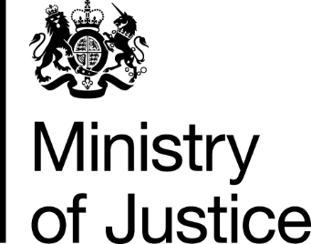
 | Our Reference: 594-16 FOI 108282 |  | November 2016

Freedom of Information Request

You asked for the following information from the Ministry of Justice (MoJ):

I am seeking information on the ethnic categories of convicted criminals, specifically in Merseyside. Current or recent stats would suffice. A historical perspective in less relevant.

I am finding information on the ethnicity of victims …but not perpetrators.

Can you point me in an appropriate direction within or without your site?

Your request has been handled under the Freedom of Information Act 2000 (FOIA).

I can confirm that the department holds the information that you have asked for, and am pleased to provide the attached table, which provides the number of offenders found guilty at all courts in the Merseyside Police Force Area, by self-identified ethnicity, from 2011 to 2015

