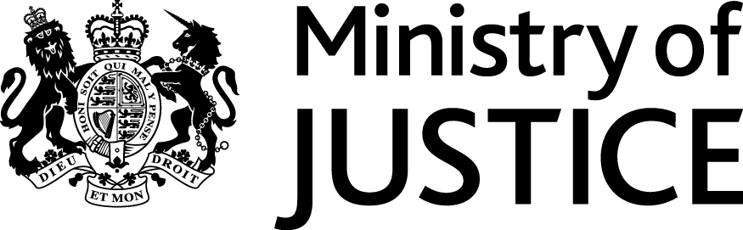
 | Our Reference: 554-16 FOI 108043 |  | November 2016

Freedom of Information Request

You asked for the following information from the Ministry of Justice:

Please can you provide the following information regarding prosecutions brought under section 141 of the Licensing Act 2003.

1. How many prosecutions have been brought for each of the last 5 years, by county, under section 141 of the Licensing Act 2003

2. How many of these prosecutions resulted in a conviction (also for each of the last 5 years, by county)

3. How many of these prosecutions resulted in the loss of a personal license by the defendant (also for each of the last 5 years, by county).

Your request has been handled under the Freedom of Information Act 2000 (FOIA).

I can confirm that the department holds some of the information that you have asked for. With regard to the request for ‘county’, this has been interpreted as a request for a breakdown by police force area.

On that basis, I am pleased to provide the attached tables, as detailed below:-

- Table 1 provides the number of defendants proceeded against at magistrates courts for offences under Section 141 Licensing Act 2003, in England and Wales, by police force area, from 2011 to 2015
- Table 2 provides the number of offenders found guilty at all courts of offences under Section 1411 Licensing Act 2003, in England and Wales, by police force area, from 2011 to 2015

Please note that if a police force area is not listed in the tables, there was no data reported for these police force areas in the period in question.

I can confirm that the Department does not hold the information you requested in question 3 relating to loss of or evocation of personal licences. To establish whether the requested information was held I conducted a thorough search, and made enquiries within the Criminal Justice System Statistics Team within Justice Statistics Analytical Services. When assessing whether or not information was held adequate and reasonable searches for the requested information were made of:

- Electronic records on the Ministry of Justice Court Proceedings Database.

If the information was held by MoJ it would be have to be held by the above mentioned business area. It may help if I clarify that information is not held by MoJ because there is no legal or business requirement for MoJ to hold the information being requested.

The MoJ Court Proceedings Database holds information on defendants proceeded against, found guilty and sentenced for criminal offences in England and Wales. Responsibility issuing and revoking personal alcohol licences is a matter for the local authority in question and, as such, is not held by the Ministry of Justice. If you wish to make a Freedom of information request to each local authority within the police force areas in question, they would have their own Freedom of Information procedures.

